MIGRATION MONITORING AT

CABOT HEAD

SPRING 2016

by

Stéphane Menu, Ph.D.
501487 Grey Road #1
Ontario, N0H 2T0
stefmenu@gmail.com

prepared
for

BRUCE PENINSULA BIRD OBSERVATORY

August 2016
Table of Contents
Preface 4
Executive Summary 5
1.0 Methods 6
2.0 Season Summary 6
April 6
May 12
June 17
3.0 Unusual Records 18
4.0 Banding Data Analysis 21
4.1 Weather 27
4.2 Recaptures 28
4.3 Net Analysis 31
5.0 Mist net coverage 32
6.0 Personnel 32
7.0 Conclusion 33
Acknowledgements 34
Literature Cited 35
Appendix 36

Figure 1. Numbers of banded Golden-crowned (top) and Ruby-crowned (bottom) Kinglets by month and year at Cabot Head Research Station, 2002 – 2016. 8
Figure 2. Numbers of banded Brown Creepers (top) and Slate-coloured Juncos (bottom) by month and year at Cabot Head Research Station, 2002 – 2016. 9
Figure 3. Numbers of banded American Tree Sparrows by month and year at Cabot Head Research Station, 2002 – 2016. 10
Figure 4. Daily and cumulative numbers of species of warblers detected at Cabot Head Research Station in spring 2016. 14
early migrant: Myrtle Warbler (mywa), Western Palm Warbler (wpwa), Black-throated Warbler (btnw); average: Common Yellowthroat (coye), Magnolia Warbler (mawa), American Redstart (amre); late migrant: Blackpoll Warbler (blpw), Tennessee Warbler (tewa), Wilson’s Warbler (wiwa). 16
Figure 5. Number of new species of birds observed at Cabot Head Research Station per day in spring 2016. 16
Figure 6. Number of Common Nighthawks observed during informal evening sessions at the end of May at Cabot Head Research Station in spring 2016. 20
Table 2. Number of species banded in spring 2016 at Cabot Head Research Station according to their banding total. 24
Figure 8. Weekly number of banded birds at Cabot Head Research Station for springs (2002, average 2003-2015 and 2016). Error bars show Standard Deviation. 25
Figure 9. Weekly proportion of realized mist net hours at Cabot Head Research Station for springs (average 2002-2007 and 2016). Error bars show Standard Deviation. 26
Figure 10. Daily number of captured and recaptured birds at Cabot Head Research Station, spring 2016. 26
Figure 11. Wind pattern (strength on the Beaufort scale, direction and proportion of time) at Cabot Head Research Station, spring 2016. 28
Figure 12. Age and sex composition of captures and recaptures (according to time of capture) of American Redstarts at Cabot Head in spring 2016 (sample sizes on top of bars). 30

Table 1. Dates of first arrival for selected warblers at Cabot Head Research Station in spring, 2002 – 2016. 15
Table 2. Banding total of species in spring 2016 at Cabot Head Research Station, average (and standard deviation) over 2002-2014, maximum and minimum totals and their respective year. 23
Table 3. Total recaptures by species in relation with the year of banding. (Only one recapture per individual is included and within-season recaptures are excluded) 30
Table 4. Volunteer effort, spring 2016. 32
Table 5. Estimated Total of species observed in spring 2016 at Cabot Head Research Station, with daily average, maximum and minimum daily ET, and dates of first and last observation. 36

Citation:

Menu, S. September 2016. Migration Monitoring at Cabot Head, Spring 2016. Unpublished report for Bruce Peninsula Bird Observatory

Preface

Cabot Head is a promontory of the northeast headland of the upper Bruce Peninsula in south-central Ontario. Cabot Head Research Station (CHRS) is situated on the western side of Wingfield Basin (at 45°15’N, 81°18’W) near the community of Dyer’s Bay. In 2001, Cabot Head was designated as an Important Bird Area (IBA) by Birdlife International for its significant concentrations of migratory bird species (Cheskey and Wilson, 2001). Both Ontario Parks and Bruce Peninsula Bird Observatory (BPBO) manage the Cabot Head Research Station.

The Breeding Bird Survey (BBS) is the principle method for monitoring bird populations in the United States and southern Canada. However, breeding ranges of many species in northern Canada are inaccessible to roadside surveys and are therefore poorly monitored by the BBS method. The Canadian Migration Monitoring Network (CMMN) is a nation-wide, Bird Studies Canada initiative, enacted to assess changes in populations during migration. There are 21 stations across Canada where data are being collected for each bird species during the spring and fall migrations, typically through a standardized capture and observation protocol. Through continuous data collection since 1998, the BPBO has demonstrated that Cabot Head is a significant site for monitoring migratory landbirds. In recognition of its importance and established migration monitoring effort, BPBO became a member of the CMMN in fall 2003.

BPBO was incorporated as a non-profit charitable organization in 2001 to initiate and direct ornithological assessments and monitoring at Cabot Head and the surrounding areas. Migration monitoring has been the primary focus of bird research at Cabot Head since 1998. This document reports on results of the spring 2016 migration monitoring season at the CHRS.

Executive Summary

In this document are summarized the results of migration monitoring at Cabot Head in spring 2016. Spring fieldwork began on April 15 and ended on June 10 for a total of 57 consecutive days of coverage. A total of 164 species were detected during the monitoring period. A complete list of all species observed, with season Estimated Totals, days with observation, maximum and minimum daily totals, is provided in the appendix (as Table 5). A total of 2355 birds of 66 species were banded and 104 birds of 17 species were recaptured. Recapture data suggest that overall stopover rates at Cabot Head are low. Analysis of capture rate per net location indicates a large degree of variation associated with habitat characteristics.

The defining characteristic of spring 2016 was of relatively good weather throughout much of the season. There were some periods of rain (five days) or strong winds (three days) during the monitoring period that precluded banding operation on a total of eight days (16% of the monitoring period). However, there were a high number of days with very good coverage (more than 80 mist net hours out of a potential of 90 for a given day): 40 days (i.e. 70% of the monitoring period). Spring 2016, and in sharp contrast with the previous spring, the banding total was the second highest in 15 years of monitoring and is quite a bit above the spring average of 1492 ± 442 banded birds (high of 2622 birds in spring 2002 and low of 876 in spring 2014). Three species, Golden-crowned Kinglet, Ruby-crowned Kinglet, and Brown Creeper (in decreasing order), represented 46% of the banding total. For most species, banding totals are far above the 2002-2014 spring averages (see Appendix). There were 14 days with banding totals over 50 birds (half of them having banding totals over 100 birds). The greatest number of captures was on April 17 with 386 birds banded. On May 25 and 23, 86 and 78 species, respectively, were detected, the highest diversity of the spring. No new species were added to the BPBO checklist during the spring 2016 season.

The 2016 spring migration monitoring season was a success thanks to the efforts of the 13 volunteer field biologists who contributed their time to this project.

1.0 Methods

The migration monitoring program at Cabot Head like all CMMN stations follows a field protocol (established by Heagy et al. 2003, modified from Heagy 2002) as it is essential for the production of population indices that data collection be consistent over the long term. At CHRS, fifteen mist nets are operated for six hours commencing no later than 30 minutes before sunrise, weather permitting. Personnel also complete a census done for one hour along a fixed route starting an hour after sunrise, where all birds seen or heard are recorded. Supplemental surveys such as visible migration counts and bay watches are completed when circumstances permit, but casual observation occurs all throughout the count period of seven hours.

2.0 Season Summary

April

Fieldwork for spring migration monitoring began at CHRS on April 15 with the full array of methods: banding, census, and casual observation. All nets were up and ready to go by 6:00am, except for C13 given that once again, a massive snow bank blocked the lane. However, after some shovelling, that net was in operation from April 20 onwards. Weather during the last two weeks of April was at first relatively mild but turned cold, with episodes of snow on April 25 and 26, when banding was not possible. For the rest of the month, weather conditions allowed for almost complete coverage with some mist net hours being lost on account of high wind on three days. In total, about 76% of potential mist net hours were realized in April, a remarkable good coverage for this early-season period.
90 species were detected (55% of the season total) in April, of which 16 species were detected only this month (early migrants: Fox Sparrow, Lapland Longspur and Horned Lark; occasional species: Northern Pintail, Vesper Sparrow, and Northern Cardinal; rare species: Tundra Swan, Snow Goose and Townsend’s Solitaire). A daily average of 36 species were detected (range: 16 – 51 species). A record total of 1159 birds of 25 species were banded in April. Banding in April is highly variable: From 2002 – 2014, on average, 322 birds are banded during the two weeks in April in which nets are open, but numbers have fluctuated from a low of 135 in spring 2004 to a (previous record) high of 812 in spring 2009, an almost seven-fold difference! The banding total of the two weeks of April 2016 was unprecedented: fewer birds were banded during the entire spring season in 2015. More than half of the 2016 April total comes from two days of banding: On April 16 and 17, 216 and 386 birds were banded, respectively (both record breaking daily totals). Golden-crowned Kinglets comprised 64% and 81% of the totals for these two days. On April 17, 314 Golden-crowned Kinglets were banded which is more birds banded in one day for this species than in a “normal” spring season. Likewise, 42 Brown Creepers were banded on that day, which is more than the individual seasonal totals for Brown Creepers for the ten previous springs. Two other days in April had banding totals over 100 birds: April 21 and 22 with 110 and 105 birds banded respectively (Fig.10 in Banding Data Analysis).
To summarize captures in spring 2016, 82.7% of the April banding total is composed of only three species: Golden-crowned Kinglet, with a record shattering of 666 birds banded (low of 3 in 2008 and previous high of 430 in 2009), Brown Creeper, with an equally record shattering of 200 birds banded (low of 3 in 2002 and previous high of 54 in 2009), and Ruby-crowned Kinglet (with 98 birds banded; low of 18 in 2002 and 2003 and high of 147 in 2006). These three species, as well as Slate-coloured Junco (the fourth most numerous species banded in April 2016 at 90 birds), are overwhelmingly responsible for the large yearly fluctuations in numbers of birds banded in April (Figs.1&2). Among these species, only Ruby-crowned Kinglet has most of its migration covered during the monitoring period. For the other three species, a variable portion of their migration is covered depending on the year, with Golden-crowned Kinglet being the most striking example: its migration tends to happen before opening time at CHRS each spring, as very few birds species are typically captured (Fig.1). Surprisingly, when spring phenology was late in 2014 and 2015, numbers captured were still quite low. In 2015, periods of warm and favourable weather happened in early April, potentially allowing for an early migration of Golden-crowned Kinglets. In contrast, after a somewhat mild winter, early April in 2016 was cold and snowy, which might have blocked the kinglet migration. As with most migratory species, male Golden-crowned Kinglets migrate earlier than females. The sex-ratio of captured kinglets this spring was 0.69, indicating more females captured than males. It is thus possible that some male Golden-crowned Kinglets migrated before April 15 and were missed.
The American Tree Sparrow is also an early migrant, mostly missed at Cabot Head. For nine of the previous 13 springs, only a very small number of birds were banded. This year, however, a total of 17 American Tree Sparrows were banded from April 16 to May 3 (Fig.3).
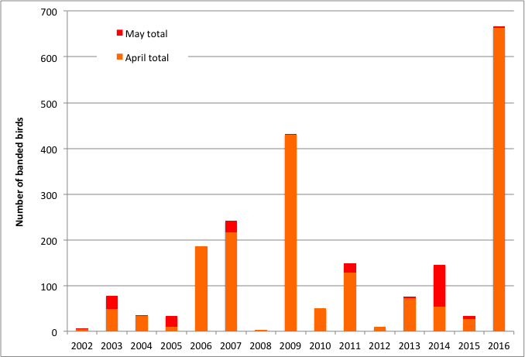

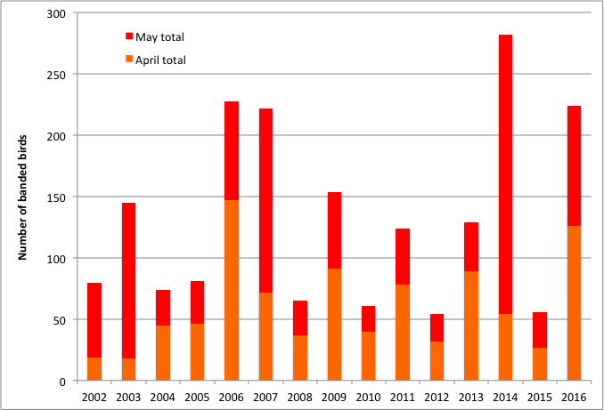
Figure 1. Numbers of banded Golden-crowned (top) and Ruby-crowned (bottom) Kinglets by month and year at CHRS, 2002 – 2016.

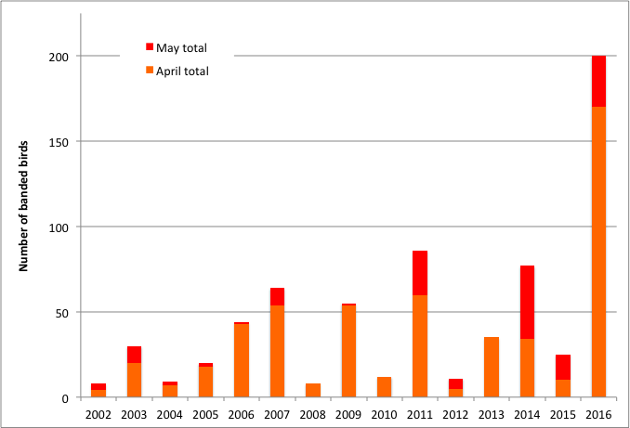

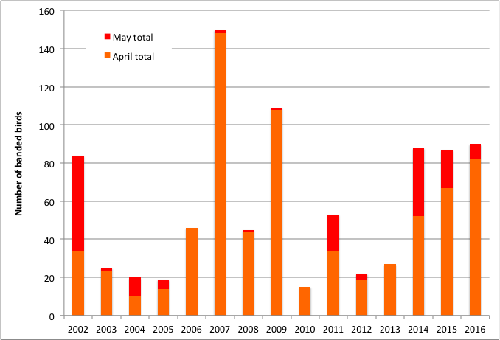
Figure 2. Numbers of banded Brown Creepers (top) and Slate-coloured Juncos (bottom) by month and year at CHRS, 2002 – 2016.

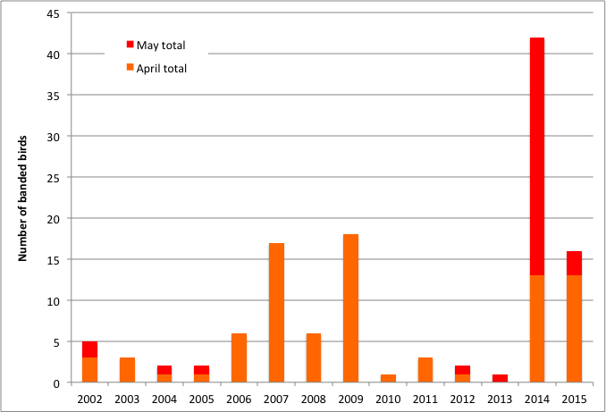
Figure 3. Numbers of banded American Tree Sparrows by month and year at CHRS, 2002 – 2016.

A Pine Warbler, one of the earliest of the warblers, was detected on the first day of monitoring, April 16. This species was then detected only occasionally for the rest of April but reached a daily high of eight on April 30. Yellow-rumped Warblers, another of the earliest warblers to arrive at Cabot Head, were first seen on April 16 with three individuals and, then, were detected daily afterwards for the rest of the month (except on April 19). Another early species of warbler, the Palm Warbler, was detected on April 17 but the next observation was not until April 30. Two other species of warblers were detected in April: one Black-throated Green Warbler on April 29 and one Black-and-white Warbler on April 30. The first swallow detected was a Tree Swallow on April 17, followed two days later by a flock of 15 birds. The first Barn Swallow was seen on April 21.
Visual movements of birds were somewhat limited this April. It is usually a time when impressive numbers (with daily totals in the hundreds) of American Robins, Northern Flickers, Red-winged Blackbirds, and Yellow-rumped Warblers are occasionally seen. This spring, numbers were quite small in comparisons: Maximum Estimated Totals (ET) were of 52 American Robins on April 15 (highest daily ET of 1400 Robins on April 20, 2003); 296 Common Grackles on April 24, with smaller totals of 104 and 128 on April 27 and 28, respectively (highest daily ET of 1200 on April 30, 2010); 102 and 85 Yellow-shafted Flickers on April 17 and 18, respectively (highest daily ET of 261 on April 28, 2015); 65 Red-winged Blackbirds on April 30; (highest daily ET of 435 on April 30, 2014) 61 Yellow-rumped Warblers on April 30 (highest daily ET of 2068 on April 30, 2012). Likewise, migration of Sharp-shinned Hawk was notably low in April, with daily ET ranging from three to eight, except on April 16 and 19 with 10 and 16, respectively (highest daily ET of 150 on April 20, 2003). The flow steadily increased into May, with notable, though still small, peaks (ET of 41 birds on May 4 and 25 on May 5; highest daily ET in May of 400 on May 1, 2011).
Waterfowl migration through the Great Lakes region typically peaks in March and April. As was the case the spring of 2015, but with completely different ice conditions (no ice in 2016 compared to lots of ice remnants in 2015) from those of 2015, very few waterfowl were observed this spring, despite a good observation effort. Long-tailed Ducks were observed only once with seven birds on May 11. Red-necked Grebes were seen off Cabot Head on a few occasions, with a maximum of 40 birds on April 17. White-winged Scoters were observed on May 15, with four individuals, the only observation of scoters this spring. Buffleheads and Common Goldeneyes, usually quite common, especially in Wingfield Basin, were rarely seen this spring: Goldeneyes were seen only on April 17 and 18, with two and one birds respectively; Buffleheads were barely seen more: only five days with observation, with a maximum of eight birds on April 15. Mergansers (a mix of migrants and residents) were observed throughout the entire spring. Hooded Mergansers are always observed in very small numbers on Wingfield Basin: they tend to use the shallower, marsh-like lakes closer to the bluffs. Very few Red-breasted Mergansers were seen this spring, with a maximum ET of six on April 24. The biggest flocks of Common Mergansers were seen at the end of the season, with tight groups of mostly males feeding and resting together (maximum of 33 birds on June 2). It is likely that they are non-breeders or young.
The water level in Georgian Bay and Wingfield Basin continues to be at its highest since 2002 (personal observation). Most of the rocks on the eastern side of the Basin are now underwater and cannot be used as roosting sites for gulls and cormorants as they have historically been. Thus, much smaller numbers of these species are seen now compared to previous years.

May

May is usually the busiest and certainly the most diverse month for spring migration. This year, 148 species were detected (90% of the seasonal total), of which 44 species were detected during only this month. A daily average of 54 species was detected in May but with a wide range: a low of 22 species on May 15 during a very cold (high of 4C!) and windy morning; four days with over 70 species; and a high of 86 species on May 25. A total of 127 species were detected over the course of 10 days during the most diverse period, from May 19 to 28. A total of 1152 birds of 66 species were banded in May, with American Redstart being the most common (13% of the total), followed by Magnolia Warbler, Ruby-crowned Kinglet, and White-throated Sparrow (8% for each). As always, numbers caught on any given day were highly variable: three “big days” (114, 120, and 124 birds banded on May 7, 12, and 24, respectively), a few very slow days, and most days with 11 to 50 birds captured. An American Pipit was banded on May 12, the first of this species to be captured in spring (one bird was banded on fall 2002 and 2004). A total of three Scarlet Tanagers were banded this spring, one on May 7 and two on May 25. This species is regularly banded in small numbers in fall but it has only been banded in one previous spring (2014). The first ever Red-bellied Woodpecker banded in spring was captured on May 26. This species has previously been captured only four times, always in fall (2003, 2004, 2010, and 2012).
Weather during May was variable but relatively good overall in relation to banding. Only a few episodes of rain and/or of strong wind occurred throughout the month, precluding all banding activity on four days and part of banding on three days. As a consequence of the relatively good weather, 81% of potential mist net hours were realized. The number of birds captured in May ranged from five (on May 9) to 124 (on May 24), with a daily average of 44 birds banded. Nets were opened for the normal period of six hours on May 9 but a strong North wind blew all morning, possibly the cause for the very low total for that day.
After only a few early-migrant species of warblers in April, there was the expected constant stream of arrivals in May. In the first week of the month, it was a steady but slow arrival of new species of warblers, with one or two species every day or so. On May 9, the cumulative number of warbler species reached 13, half the season total of 26 species of warblers. On the following day, May 10, there was a small “spurt” of arrivals, with five new species of warblers detected, for a daily total of 17 species (the highest warbler total for that day across all springs). By mid-May, 21 species of warblers have been detected, a numerical expression of the bursting of life in spring. Even the last warblers to arrive were detected shortly after mid-May, with Tennessee Warblers on May 17, Blackpoll Warbler on May 18, and Golden-winged and Wilson’s Warblers both on May 21. The last species of warblers to be detected this spring was the Mourning Warbler on May 22 (Fig. 4). The sequence of warbler arrivals is relatively consistent between years, from early- to late-migrant species, although dates of first arrivals do vary for individual species (Table 1).
Overall species diversity increased rapidly in the first half of May as many species arrived at the upper Bruce Peninsula: numbers of species detected grew from 90 on April 30 (i.e., 55% of the season total) to 135 on May 15 (82% of the spring total). From May 16 to May 21, another 15 new arrivals were detected, bringing the total number of species detected to 92% of the spring total. The remaining 19 days of monitoring only brought 13 additional species, the so-called late migrants. Almost every day of monitoring up to the end of May brought new species, with marked spikes in early, mid, and late May (Fig.5). There is an obvious high number of new species detected per day in the first few days of monitoring in April (with 43 species detected on the first day, April 15).
As with the warblers discussed above, there can be variations in dates of first detection within a general time window for a specific species. For example, two species easily detected when first present, Ruby-throated Hummingbird and Common Yellowthroat provide some perspective in fluctuations in arrival dates. This spring, they arrived on the same day, May 10. The median date of arrival, based on the past 15 years, is May 9 for the hummingbird (range: May 3 in 2012; May 15 in 2003) and May 12 for the yellowthroat (range: April 29 in 2013; May 18 in 2005). These observations indicate, albeit with a small sample size, a great range of variations between years and species in timing of first arrival. Among the nine species of warblers examined in Table 1, it appears that Common Yellowthroat has the widest range of first arrival.
The highest diversity of species observed with in the spring season was achieved on May 25, a warm, calm, and clear day: a total of 85 species (and an additional species, Common Nighthawk, in the evening) were detected on that day, with, among others, Eastern Wood-Pewee, Yellow-bellied, Alder, and Least Flycatchers, and Eastern Phoebe. There were also 22 species of warblers detected that day, the highest one-day total of the spring, as well as six species of sparrows (Song, Chipping, Lincoln’s, White-throated, White-crowned Sparrows and Eastern Towhee). The four species of Vireos (Blue-headed, Philadelphia, Warbling, and Red-eyed) were also observed on that day. A total of 124 birds of 30 species were banded on May 25, the highest daily total for May.
At the end of May, birds were starting to establish territories, sing and chase potential competitors and mates. Migration always slows down at this time of year, with only the late migrants continuing to move through Cabot Head. Weather started to feel more summer-like with highs reaching 25°C on some days. On May 29, a strong south wind blew all day, precluding any banding.

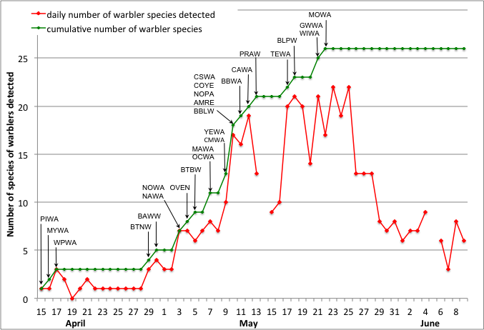
Figure 4. Daily and cumulative numbers of species of warblers detected at CHRS in spring 2016. Alpha codes denote date of first of year observation/capture. (PIWA: Pine Warbler; MYWA: Myrtle Warbler; WPWA: Western Palm Warbler; BTNW: Black-throated Green Warbler; BAWW: Black-and-White Warbler; NOWA: Northern Waterthrush; NAWA: Nashville Warbler; OVEN: Ovenbird; BTBW: Black-throated Blue Warbler; OCWA: Orange-crowned Warbler; MAWA: Magnolia Warbler; CMWA: Cape May Warbler; YEWA: Yellow Warbler; CSWA: Chestnut-sided Warbler; COYE: Common Yellowthroat; NOPA: Northern Parula; AMRE: American Redstart; BLBW: Blackburnian Warbler; BBWA: Bay-breasted Warbler; CAWA: Canada Warbler; PRAW: Prairie Warbler; BLPW: Blackpoll Warbler; TEWA: Tennessee Warbler; WIWA: Wilson’s Warbler; GWWA: Golden-winged Warbler; MOWA: Mourning Warbler)
Table 1. Dates of first arrival for selected warblers at CHRS in spring, 2002 – 2016.
Month | Day | 2002 | 2003 | 2004 | 2005 | 2006 | 2007 | 2008 | 2009 | 2010 | 2011 | 2012 | 2013 | 2014 | 2015 | 2016
April | 15 |  |  |  |  |  |  |  |  |  |  | mywa
 | 16 |  |  |  | mywa |  |  |  |  |  |  |  |  |  |  | mywa
 | 17 | mywa |  |  |  |  |  | mywa |  |  |  |  |  |  |  | wpwa
 | 18 |  |  |  |  |  | mywa
 | 19 |  | mywa |  |  | mywa |  |  |  | mywa |  | wpwa | mywa |  | mywa
 | 20 |  |  | mywa |  |  |  |  |  |  |  |  |  | mywa
 | 21
 | 22 |  |  |  |  |  |  |  |  |  | mywa
 | 23 |  |  |  |  | wpwa |  |  | mywa |  |  |  | btnw
 | 24 |  |  |  |  |  | wpwa |  |  |  |  |  | wpwa
 | 25 |  |  |  |  |  |  |  | wpwa
 |  |  |  |  |  |  |  |  | btnw
 | 26 | wpwa
 | 27 |  |  | wpwa | btnw |  |  | wpwa |  |  | wpwa | btnw
 | 28 |  | wpwa
 | 29 | btnw |  | btnw |  |  |  |  |  | wpwa |  |  | coye
 | 30 |  |  |  |  |  |  |  |  | btnw | btnw |  |  | btnw |  | btnw
May | 1 |  |  |  | wpwa | btnw |  | btnw |  |  |  |  |  |  | wpwa
 | 2 |  |  |  |  | mawa |  |  |  |  |  |  | amre | wpwa | btnw
 | 3
 | 4 |  | btnw |  |  |  | btnw |  |  | amre |  | mawa |  | mawa
 | 5 |  |  |  |  |  |  |  |  |  |  |  | mawa
 | 6 | mawa | mawa
 |  | coye
 | 7 |  |  |  |  |  | mawa | mawa | mawa |  |  |  | tewa |  |  | mawa
 | 8 |  |  |  |  |  | coye |  | coye |  |  | coye |  |  | mawa
 |  |  |  |  | amre |  |  | amre | amre |  |  |  |  |  | amre
 | 9 |  |  |  | mawa |  | blpw |  |  | mawa | amre | amre |  | amre
 |  |  |  |  |  |  |  |  |  |  |  |  |  | coye
 | 10 |  | amre |  |  | amre | amre |  |  |  |  |  |  |  |  | amre
 |  |  |  |  |  |  |  |  |  |  |  |  |  |  |  | coye
 | 11 | tewa |  |  |  |  | wiwa |  |  |  | mawa | tewa
 | 12 |  |  | coye |  | coye
 |  |  |  | amre
 |  |  |  | mawa
 |  |  |  | blpw
 | 13 | amre |  |  |  |  |  |  | wiwa | wiwa | coye
 | 14 |  | coye |  |  |  |  |  |  | coye |  | blpw
 |  |  |  |  |  |  |  |  |  |  |  | wiwa
 | 15 |  | tewa |  |  |  |  |  | tewa |  |  |  |  |  | coye
 | 16 | blpw |  | wiwa |  |  |  | coye
 | 17 |  | blpw |  |  |  |  |  |  | blpw |  |  |  |  | blpw
 |  | wiwa |  |  |  |  |  |  |  |  |  |  |  |  | wiwa
 |  |  |  |  |  |  |  |  |  | tewa |  |  |  |  | tewa | tewa
 | 18 |  |  | tewa | tewa |  |  | blpw |  |  | tewa |  |  |  |  | blpw
 |  |  | wiwa |  | wiwa |  |  |  |  |  |  |  | wiwa
 |  |  |  |  | coye
 | 19 |  |  |  |  | tewa |  |  |  |  | blpw |  |  | tewa
 | 20 |  |  |  | blpw | blpw |  |  |  |  |  |  |  | blpw
 |  |  |  |  |  |  |  |  |  |  |  |  |  | wiwa
 | 21 |  |  |  |  |  |  |  |  |  | wiwa |  |  |  |  | wiwa
 | 22
 | 23 |  |  |  |  |  |  |  | blpw
 | 24 |  |  |  |  | wiwa |  |  |  |  |  |  | blpw
 | 25 |  |  |  |  |  |  | tewa
 | 26 |  |  |  |  |  |  | wiwa
Early migrant: Myrtle Warbler (mywa), Western Palm Warbler (wpwa), Black-throated Warbler (btnw). Mid-migrant: Common Yellowthroat (coye), Magnolia Warbler (mawa), American Redstart (amre). Late migrant: Blackpoll Warbler (blpw), Tennessee Warbler (tewa), Wilson’s Warbler (wiwa).

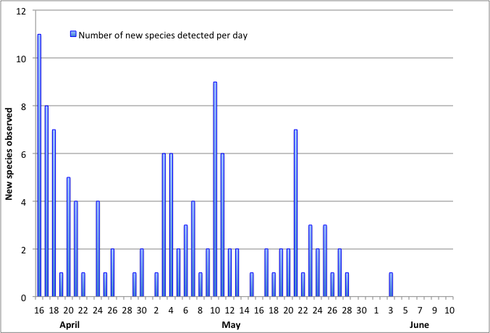
Figure 5. Number of new species of birds observed at CHRS per day in spring 2016.

June

Relatively inclement weather prevailed during the migration monitoring period in June, allowing moderate coverage, with only 63% of potential mist net-hours realized (two days with no banding at all and two other days with very reduced coverage). In the 10 days of monitoring in June, only 73 species of birds were detected (44% of the seasonal total) with only House Sparrow added as a new species for the month (a species almost never seen at Cabot Head: it was detected only in spring in four years during the period 2002 to 2015). A daily average of 32 species were detected (range: 21 – 41 species seen on any given day). Possibly because of the mediocre monitoring conditions, the total numbers of banded birds for June are the lowest since 2002 (excluding 2010 when coverage ended on June 2). Only 44 birds of 20 species were banded with American Redstart comprising 32% of the total, Red-eyed Vireo 9%, and Magnolia Warbler 7%. Between 2002 and 2014 (excluding June 2010), an average of 162 birds are banded in June using June 10 as the last day of banding. The highest total was in 2003 with 275 birds banded and the (previous) lowest was in 2012 with 77.
The Yellow-bellied Flycatcher is one of the latest migrants arriving on our shores, with, typically, the first birds showing up at the end of May. Indeed, it is a species with one of the shortest stays on its breeding grounds, starting its fall migration in early August. In 2016, the first Yellow-bellied Flycatchers were detected on May 23, an average date. The earliest arrival was noted on May 14 in 2012, while the latest was on May 28 in 2002, 2006, and 2015. This spring, Yellow-bellied Flycatchers were detected almost every day in May after their arrival on May 23 but only once in June, on June 3. Only eight birds were banded this spring, well below average. Banding totals for this species are highly variable between springs, with a low of three birds in 2013 and a high of 28 birds in 2015.
The first Black-billed Cuckoos were heard on May 27 and, again, on May 29 and June 2 (as well as seen escaping a net on that day!), but none were captured. This species is slightly too big for the mesh size used, which could explain while it has been captured only in five springs during the 15 years of monitoring at CHRS.
Large flocks of Canada Geese are usually seen in June. These late movements are a moult migration, when failed breeders and non-breeders go north to a remote location to moult their flight feathers all at once. However, the only major movements of Canada Geese in late spring this year occurred in May 28 and 29 with totals of 111 and 68 birds, respectively.

3.0 Unusual Records

No new species were added for the Cabot Head area this spring. There are many ways an observation can be considered an unusual record at Cabot Head: a bird out of range; a bird with an overall low population on the Northern Bruce; a bird which preferred habitats are not present at Cabot Head; a bird which is rare overall, either at provincial or continental levels.
Before monitoring started, casual observations were made during net set-ups. On April 14, while the two resident adult Bald Eagles were perched atop a tree on the shore of Wingfield Basin, seven (7!) immature Bald Eagles were flying together over Middle Bluffs. It is – so far – the largest group of this species ever seen at Cabot Head.
On the first day of monitoring, April 15, during census, a small flock of five Tundra Swans were seen flying over Cabot Head in a northwest direction. During the same census, two Snow Geese were seen in a big flock of Canada Geese, the first time that species was detected in spring (the two other occasions, in 2006 and 2008, were in the fall). Also on that first day and first census, a Townsend’s Solitaire was seen perched in a Jack Pine and, shortly, in flight. Likewise, it is the first spring detection for this species, previously seen in the falls of 2004 and 2005.
A Northern Cardinal was detected on April 18, the only observation of the spring. On that same day, 12 Northern Pintails were observed, the second spring ever with detections (two birds in spring 2012. Five birds in fall 2005 are the other observation of this species at Cabot Head).
An immature Golden Eagle was seen riding the sky above Middle Bluffs on April 24, mobbed a few times by a Red-tailed Hawk and perching shortly on the edge of Middle Bluff. Another observation of an immature Golden Eagle was made on April 30. It was not possible to determine if it was the same individual.
On April 24, a Horned Lark and a Lapland Longspur were detected during census. A Vesper Sparrow was seen the same day, a species, which had been detected only during six springs of the previous 14 seasons. It was seen only once afterward on April 27.
As opposed to the previous spring, there were just a few observations of Peregrine Falcon: one individual on April 26, one on May 4, and the last one on May 25. Rough-legged Hawks were also seen only on three occasions, with only a single individual each time: April 26, May 5 and 28. The latter observation is the second-lat `est date for this species, after May 29 of 2011.
Cooper’s Hawks were observed only twice this spring, on May 2 and 9. This species has been seen almost every spring (missed in 2004 and 2007) but only with two to nine days of observations. No Northern Goshawks were detected this spring. This species is usually detected in very small numbers (one to six observations per spring) but was missed in only two previous spring seasons (2006 and 2009)
There were six days, from May 3 to May 28, with observations of one Clay-coloured Sparrow. It is, of course, impossible to tell if it was the same individual. A very common bird in the western prairies, its breeding range extends a narrow finger into the Great Lakes. It is detected only in very small numbers and occasions at Cabot Head and was completely missed in 2006, 2008, 2010 and 2012.
One Blue-gray Gnatcatcher was seen on May 6, and again, on May 10 and 11. A male Prairie Warbler was observed on May 13 feeding on midges amongst the cedars near the station, during a morning of strong west wind and after an early morning of rain. A few hours later, a female Prairie Warbler was seen around the same cedars! That species has been seen only in the year 2007, with one on May 10 and one on August 24. Prairie Warblers have a very restricted distribution in Ontario given that this is the northern extent of their breeding range, with most breeding birds on the eastern side of Georgian Bay.
A Solitary Sandpiper was seen flying over Cabot Head on May 17. A Golden-winged Warbler was seen during Birdathon at Cabot Head, on May 21, the only one seen this spring. This Species-at-Risk has been detected almost every spring, except in 2003, 2006, 2008, and 2010. During the Birdathon but outside the Cabot Head monitoring area, we detected another six to eight individuals of this species, a significant number.
Chimney Swifts are fast flying, cigar-shaped, birds of the ether. They only perch at their breeding site, either deep in a chimney, or, extremely rarely these days, in a big, hollowed-out tree trunk, their historic breeding habitat. As the other members of the aerial insectivore guild, its population is declining. If detected at all at Cabot Head, it is usually a few seconds of high-speed interaction. This spring, two birds were seen on May 24, while observations of one individual occurred on May 25 and 30. Despite the intrinsic difficulties of detection, this species has been detected in every spring but three. Another declining species across southern Ontario, an adult Red-headed Woodpecker was observed briefly on May 21. This species has been observed in eight years, with sightings every spring since 2011.
Wood Thrush is detected every spring at Cabot Head. This year, six birds were banded throughout May, the highest spring total ever. Another species at the limit of its range is the Northern Mockingbird, observed this spring on May 24. The Northern Mockingbird was observed in ten out of the 14 previous springs (but banded only once!).
As the days warmed and got longer, we started to enjoy having dinner in front of the station. It is during one such evening, on May 25, that we heard and then saw a few Common Nighthawks. We repeated the informal “nighthawk watch” the following evenings (Fig.6): for four evenings, there was a steady movement of Common Nighthawks over Cabot Head, culminating in the evening of May 28 with 70 individuals observed. Most birds seemed to head out over Georgian Bay and, especially on May 28, were in loose flocks of up to a dozen individuals. On May 31 and onwards, no Nighthawks were seen again. During this period, winds shifted to the North. They tended to call while flying, which is how we detected them in the first place. For next spring, we will try to do a more consistent monitoring at the end of May and early June.

Figure 6. Number of Common Nighthawks observed during informal evening sessions at the end of May at CHRS in spring 2016.

4.0 Banding Data Analysis

Spring 2016 has the second highest banding total since migration monitoring started in its present form in 2002, with 2355 birds of 66 species banded in total (Table 2). It is almost 800 birds more than the spring banding average of 2002 - 2015 (1575 ± 470 birds). It was most definitively a record season, with nine of the banded species having their highest totals ever and an additional 14 species having above-average totals. Golden-crowned Kinglet, with 666 birds banded, represents 28% of the seasonal total and a record high, in comparison to previous seasons. The previous highest number was in spring 2009 with 431 birds banded, followed by spring 2006 with 186 Golden-crowned Kinglets banded.
The next three species in numbers - in decreasing order, Ruby-crowned Kinglet, Brown Creeper, and American Redstart - represent between 7 and 9.5% of the total. There was a record number of Brown Creepers banded: with 200 birds, it is more than twice the number of the previous high total of 86 Creepers in spring 2011. Ruby-crowned Kinglets, with 224 birds banded this spring, did not break the record of 292 birds in 2014 and were just four individuals shy of the second highest total of 228 birds in spring 2006. American Redstarts, on the other hand, were banded in below-average number this spring, with only 166 birds captured, while the record high is 273 birds in spring 2009 (average of 193 ± 44 birds).
The top five species account for 58% of the banding total this spring. Typically, only a few species are captured in numbers over 50 individuals while most species are banded in low to very low numbers (Table 2). Numerous variables could affect the capture rates including population dynamics, weather conditions during migration, vegetation changes at the site, food availability, etc.
Capture rates varied greatly on a weekly basis (Fig.7). The capture rate is determined by dividing the number of birds caught in a net, or a group of nets, by the number of hours for which the net or nets were operated. Thus, variation in capture rate reflects variation in those two parameters, which are themselves dependent upon various conditions (weather being the major one). Mist net hours are primarily lost when weather conditions (i.e. rain or strong wind) render it unsafe to capture birds thus forcing net closure. In spring 2016, weekly capture rates were variable throughout the season: extremely high during the first week of April, extremely low during the last two weeks, and around average for the rest of the season except for the first week of May when the capture rate was about double the average.
Weekly numbers of banded birds partially reflect variation in capture rates (Fig.8). The first week of monitoring (defined as April 16 to 23) was extremely variable: many birds can be missed if it is an early spring and many mist net hours can also be lost due to bad weather. Weekly banded totals for this time period have ranged from 15 in 2004 to 640 in 2009. With 990 birds banded during this week in 2016, it is the highest total ever and will most certainly represent an outlier for many years. The following week was about average. The first week of May showed an above-average banding total of 340 birds. As for the first week of monitoring, extreme variations in number of banded birds occur during this week, with a low of 35 birds in 2008 and a high of 648 birds in 2014! The third week of May also had a high total of banding birds: with 363 banded birds, it is the second highest total after spring 2006 (448 birds). In contrast, the last two weeks of the spring had the lowest ever banding totals for that period, with 51 and 17 banded birds, respectively.
In spring 2016, 76% of the potential mist net hours were realized, compared to 58% to 92% for the other springs (no data for 2012-2014). Weather conditions were generally favourable for banding, resulting in a good percentage of realized mist-net hours (Fig.9). Rain, snow, and/or wind precluded any banding on nine days, about 16% of the monitoring period, spread throughout the season. For the rest of the season, conditions allowed for a complete banding operation (all 15 mist nets opened for six hours, i.e. 90 mist-net hours a day) during 58% of the monitoring period. Coverage of 80 mist-net hours or more was realized 70% of the monitoring period. Coverage was thus relatively good this spring. Daily numbers of banded birds at Cabot Head show extreme fluctuations, reflecting weather conditions and, at least to some extent, the high variability in volume of migrants aloft (Fig.9).

Table 2. Banding total of species in spring 2016 at CHRS, average (and standard deviation) over 2002-2014, maximum and minimum totals and their respective year. Record high captures noted in red. stdev = standard deviation.
Species | 2016 | average | stdev | Max | Year | Min | Year
Sharp-shinned Hawk | 21 | 20 | 7 | 34 | 2011 | 10 | 2004-2005
Red-bellied Woodpecker | 1
Yellow-bellied Sapsucker | 2 | 2 | 1 | 5 | 2009 | 1 | many years
Downy Woodpecker | 1 | 1 | 0 | 1 | 2002
Yellow-Shafted Flicker | 7 | 4 | 3 | 12 | 2007 | 1
Yellow-bellied Flycatcher | 8 | 13 | 7 | 22 | 2005 | 3 | 2014
Traill’s Flycatcher | 7 | 16 | 9 | 32 | 2009 | 4 | 2014
Least Flycatcher | 8 | 15 | 5 | 22 | 2004 | 8 | 2006
Eastern phoebe | 11 | 4 | 3 | 10 | 2009 | 1 | 2010-2012
Blue-headed Vireo | 4 | 4 | 2 | 8 | 2014 | 1 | 2005
Red-eyed Vireo | 6 | 16 | 8 | 31 | 2013 | 9 | 2010
Blue Jay | 23 | 71 | 95 | 88 | 2004 | 10 | 2011
Black-capped Chickadee | 6 | 57 | 99 | 342 | 2002 | 4 | 2003-2005
Brown Creeper | 200 | 35 | 27 | 86 | 2011 | 6 | 2002-2009
Winter Wren | 3 | 2 | 1 | 4 | 2015 | 1 | many years
Golden-crowned Kinglet | 666 | 106 | 119 | 431 | 2009 | 3 | 2008
Ruby-crowned Kinglet | 224 | 126 | 75 | 258 | 2014 | 54 | 2012
Veery | 11 | 10 | 6 | 21 | 2006 | 1 | 2002
Gray-cheeked Thrush | 1 | 3 | 2 | 8 | 2010 | 1 | 2002-06-08
Swainson’s Thrush | 17 | 27 | 10 | 43 | 2011 | 12 | 2004
Hermit Thrush | 30 | 14 | 4 | 21 | 2007 | 6 | 2004
Wood Thrush | 6 | 2 | 1 | 5 | 2006 | 1 | many years
American Robin | 7 | 7 | 4 | 15 | 2014 | 3 | 2008
Gray Catbird | 19 | 11 | 4 | 18 | 2006 | 3 | 2013
Brown Thrasher | 6 | 6 | 3 | 12 | 2008 | 2 | 2007
American Pipit | 1
Tennessee Warbler | 2 | 2 | 2 | 6 | 2002 | 1 | many years
Orange-crowned Warbler | 16 | 9 | 8 | 29 | 2002 | 1 | 2014
Nashville Warbler | 39 | 49 | 56 | 227 | 2002 | 18 | 2004
Yellow Warbler | 4 | 12 | 7 | 25 | 2002-2013 | 0 | 2015
Chestnut-sided Warbler | 15 | 15 | 6 | 26 | 2002 | 8 | 2008
Magnolia Warbler | 105 | 96 | 41 | 184 | 2002 | 53 | 2013
Cape May Warbler | 3 | 4 | 3 | 9 | 20021 |  | 2003-2011
Black-throated Blue Warbler | 26 | 27 | 12 | 64 | 2003 | 18 | 2005
Myrtle Warbler | 35 | 64 | 61 | 244 | 2002 | 21 | 2011
Black-throated Green Warbler | 14 | 26 | 7 | 38 | 2002 | 15 | 2005
Blackburnian Warbler | 9 | 5 | 4 | 13 | 2002 | 1 | 2014
Species | 2016 | average | stdev | Max | Year | Min | Year
Pine Warbler | 2 | 2 | 1 | 4 | 2002-2011 | 1 | many years
Palm Warbler | 79 | 72 | 51 | 216 | 2002 | 37 | 2014
Bay-breasted Warbler | 4 | 4 | 3 | 11 | 2002 | 1 | many years
Blackpoll Warbler | 5 | 2 | 1 | 4 | 2002 | 1 | many years
Black and White Warbler | 51 | 55 | 19 | 85 | 2014 | 31 | 2008
American Redstart | 166 | 195 | 45 | 273 | 2009 | 146 | 2011
Ovenbird | 53 | 28 | 9 | 40 | 2002 | 19 | 2011
Northern Waterthrush | 3 | 5 | 3 | 13 | 2010 | 1 | 2008
Mourning Warbler | 9 | 9 | 4 | 17 | 2009 | 2 | 2014
Common Yellowthroat | 38 | 38 | 14 | 56 | 2002 | 23 | 2007-2012
Wilson’s Warbler | 12 | 16 | 8 | 32 | 2002 | 6 | 2014
Canada Warbler | 8 | 18 | 5 | 24 | 2013 | 11 | 2008
Scarlet Tanager | 3 | 1 |  | 1 | 2014
American Tree Sparrow | 17 | 11 | 13 | 42 | 2014 | 1 | 2010
Chipping Sparrow | 12 | 27 | 29 | 47 | 2002 | 7 | 2008
Savannah Sparrow | 1 | 3 | 3 | 10 | 2014 | 1 | many years
Fox Sparrow | 2 | 2 | 1 | 4 | 2009 | 1 | many years
Song Sparrow | 23 | 14 | 7 | 26 | 2009 | 4 | 2010
Lincoln’s Sparrow | 24 | 12 | 6 | 25 | 2005 | 4 | 2012
Swamp Sparrow | 13 | 5 | 2 | 9 | 2009 | 3 | 2002-2015
White-throated Sparrow | 104 | 57 | 20 | 91 | 2005 | 25 | 2004
Eastern White-crowned Sparrow | 51 | 25 | 17 | 69 | 2005 | 4 | 2011
Slate-coloured Junco | 90 | 58 | 40 | 150 | 2007 | 15 | 2010
Rose-breasted Grosbeak | 7 | 5 | 4 | 8 | 2014 | 1 | 2007
Indigo Bunting | 2 | 3 | 2 | 6 | 2009 | 1 | 2003-2012
Baltimore Oriole | 4 | 4 | 3 | 9 | 2002 | 1 | 2013
Purple Finch | 2 | 2 | 1 | 3 | 2007 | 1 | many years
Pine Siskin | 3 | 2 | 1 | 3 | 2009 | 1 | 2002-07-15
American Goldfinch | 3 | 5 | 11 | 41 | 2002 | 1
Banding total | 2355 | 1575 | 471 | 2610 | 2002 | 1145 | 2010
Species total | 66 | 68 | 5

Table 2. Number of species banded in spring 2016 at CHRS according to their banding total.
Banding total | 1 - 10 | 11 – 50 | 51 – 100 | >101
Number of species | 35 | 20 | 5 | 6

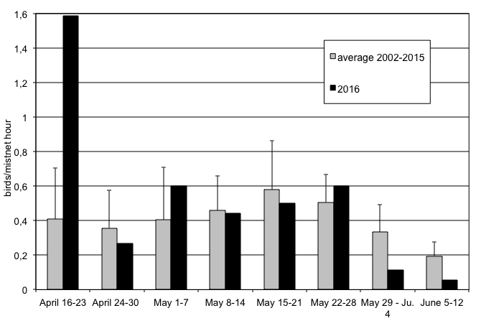
Figure 7. Weekly capture rates at CHRS during the spring season (average 2003-2015 and 2016). Error bars show Standard Deviation.
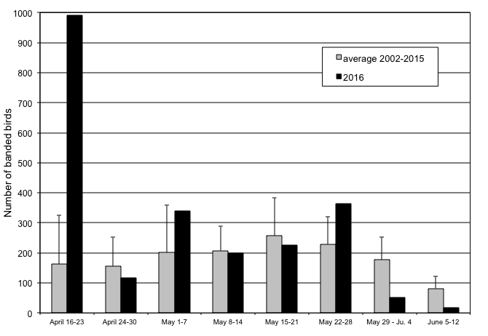
Figure 8. Weekly number of banded birds at CHRS during the spring season (average 2003-2015 and 2016). Error bars show Standard Deviation.

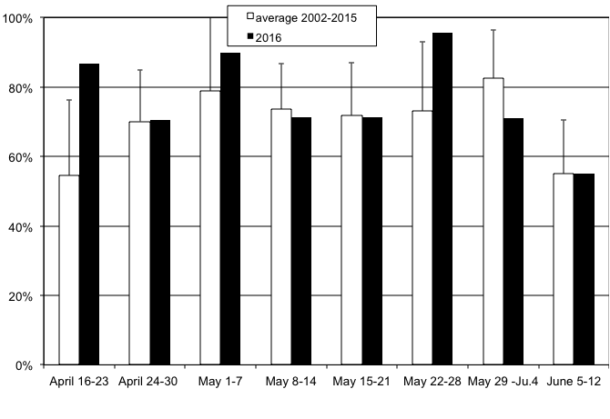
Figure 9. Weekly proportion of realized mist net hours at CHRS during the spring season (average 2002-2007 and 2016). Error bars show Standard Deviation.
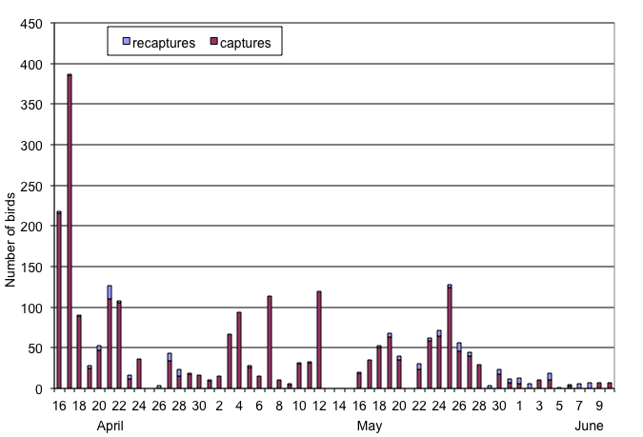
Figure 10. Daily number of captured and recaptured birds at CHRS, spring 2016.

4.1 Weather

As mentioned earlier, the weather was extremely variable during the spring of 2016, with two consecutive days with snow (April 25 and 26). The notable characteristics of the spring were many periods of precipitation, fog, and/or strong winds. There were nine days with recorded precipitation, sometimes heavy and lasting all day, other times a short shower, during the count period, with three more days of rain occurring during the afternoon and/or evening. Periods of high wind also occurred very frequently this spring, mostly in April and June: storm-force winds (five or more on the Beaufort scale) occurred in 14 days (with only six days in May), i.e. about a quarter of the season! These strong winds did not last all the time during the entire morning but they nonetheless affected banding operations, as nets in their paths had to be closed.
With rain, wind is a major factor that influences migration. It is difficult to accurately quantify such a dynamic component of the weather, especially because wind strength and direction are recorded only at the start and end of the count period. To characterize wind strength (on the Beaufort scale) and direction, we considered only the strongest wind during the count period of seven hours. Undoubtedly, this method would tend to over-represent strong winds. However, strong winds affect migration tremendously and their effect could probably be felt before they develop into a full windstorm. This spring, strong winds (at least five on the Beaufort scale) occurred on 14 days (25% of the season). Almost half of the season (46%) experienced moderate wind (three to four on the Beaufort scale). Therefore, most of the monitoring period experienced strong to moderate winds (Fig.11).

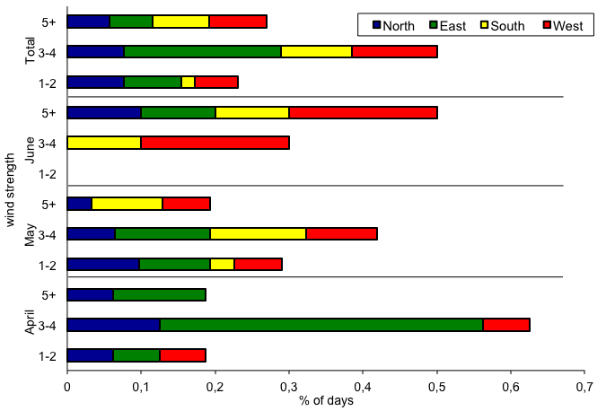
Figure 11. Wind pattern (strength on the Beaufort scale, direction and proportion of time) at CHRS, spring 2016.

4.2 Recaptures

The rate of recapture (recaptures include birds banded within the spring season and birds from previous years or other locations) at Cabot Head was relatively high in spring 2016. There were a total of 164 recaptures for 104 individuals of 17 species from April 17 to June 9. Among the recaptured birds this spring, 35 individuals of eight species were banded in a previous seasons at Cabot Head and one Indigo Bunting and one Slate-coloured Junco were “foreign recaptures”, that is, banded at another location. About 70% of the recaptured birds (71 individuals) were recaptured only once and another 17 birds were recaptured on two occasions. Only 14 birds were recaptured on more than two occasions, with an American Redstart recaptured a record eight times. Most birds recaptured three times or more were American Redstarts (11 birds), almost certainly being local breeders at Cabot Head. The other birds are two Golden-crowned Kinglets and one Ruby-crowned Kinglet, being each recaptured three times. Besides American Redstarts, the low rate of multiple recaptures demonstrates that birds are not heavily using this site as a stopover location for rest and refuelling in the spring.
This spring, the Golden-crowned Kinglet is the species with the most recaptures, 32 birds all banded during the spring. However, the recaptured birds represent only about 5% of the spring banding total of this species.
Of the 31 American Redstarts recaptured this spring, only nine were newly banded (i.e. from spring 2016), with the remaining 22 were banded in the previous seasons at Cabot Head, mostly in the previous two years. The oldest known recaptures this spring were of two American Redstarts both banded as after-hatch-year birds in fall 2011, thus at least six years old. Age and sex composition of recaptured American Redstarts differs greatly from the one of newly captured individuals (Fig.12). No young American Redstarts banded last fall were recaptured this spring, whereas about half of the newly captured birds this spring were second-year birds. Among recaptured redstarts banded in previous years, males represented about 60% of the total. In contrast, among after-second-year redstarts first captured this spring, females were dominant, with 66% of the total. If returning birds are local breeders, it is possible that males are more often captured as they establish territory, chase other males, and in general move more than females. It is also possible that site faithfulness is stronger in males or that there is a differential mortality among sexes in the wintering grounds, where adult males tend to occupy the best quality habitats, fiercely excluding young and females from them.
Birds banded in previous years and recaptured in the spring (Table 3) are most likely local resident breeders. For example, the Black-capped Chickadee originally banded in the fall 2014 was also recaptured in spring and fall 2015. However, none of the three Red-eyed Vireos recaptured this spring had ever been recaptured previously.

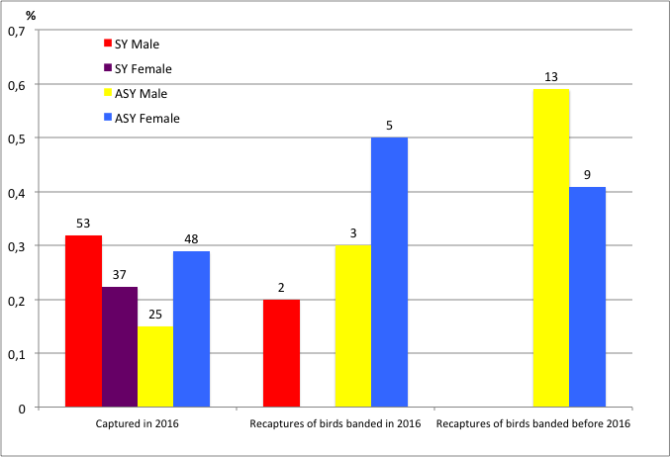
Figure 12. Age and sex composition of captures and recaptures (according to time of capture) of American Redstarts at CHRS in spring 2016 (sample sizes on top of bars).

Table 3. Total recaptures by species in relation with the year of banding. (Only one recapture per individual is included and within-season recaptures are excluded). S: spring; F: fall.
Species | 2011 | 2012 | 2013 |  | 2014 |  | 2015 |  | Foreign recapture | Total
 | F | S | S | F | S | F | S | F
Downy Woodpecker |  |  |  |  |  |  |  | 1 |  | 1
Red-eyed Vireo |  | 1 |  | 1 |  |  | 1 |  |  | 3
Black-capped Chickadee |  |  |  |  | 1 |  |  | 1 |  | 2
Gray Catbird |  |  |  |  |  | 1 |  | 1 |  | 2
Magnolia Warbler |  |  |  |  |  | 2 |  |  |  | 2
Black-and-white Warbler |  |  |  |  | 1 |  |  | 1 |  | 2
American Redstart | 2 |  | 2 | 2 | 4 | 4 | 2 | 6 |  | 22
Common Yellowthroat |  |  |  |  |  | 1 |  |  |  | 1
Slate-coloured Junco |  |  |  |  |  |  |  |  | 1 | 1
Indigo Bunting |  |  |  |  |  |  |  |  | 1 | 1
Total Recaptures | 2 | 1 | 2 | 3 | 6 | 8 | 3 | 10 | 2 | 37
Species Total | 1 | 1 | 1 | 2 | 3 | 4 | 2 | 5 | 2 | 10

4.3 Net Analysis

Mist net locations at Cabot Head have been permanently set in place and any changes to this array will have to be carefully considered with respect to protocol and existing data sets. The standard net array in spring 2016 has not been changed since 2002 and is located primarily in forest edge assemblages, although a few nets are in relatively open, shrub habitat (A1-2, B8, & C14). As usual, there was a significant amount of variation in capture rates for each net (Fig.13; no electronic data for 2012-2014). The five nets with the highest capture rate (A1, A2 & A3, C14 & C15, in decreasing order) were scattered throughout the net array but with the best nets located in or close to the shrubby areas. The least productive nets this spring were the usual ones (A4, B6, B7, C11, and C12). Almost all nets had a capture rate higher than the average, a likely consequence of the overall high number of birds captured this spring. The biggest difference compared to average capture rate is for net A5, a usually poorly performing net. This spring, 160 birds were captured in A5, with about half of them Golden-crowned Kinglets. As is similar during most spring seasons, captures were concentrated in a few nets, as the five best nets accounted for only 57% of the total capture. The least productive five nets accounted for only 15%. All nets have approximately the same numbers of hours in operation.
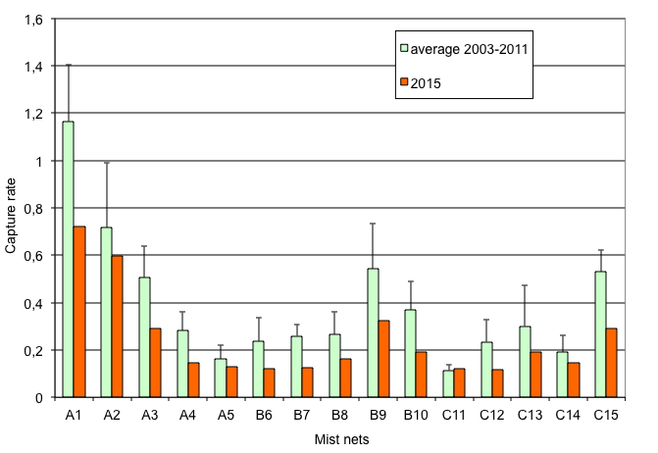
Figure 13. Capture rates per mist net for springs (average 2003-2011 and 2016). A1-C15 are net codes referring to specific net locations.

5.0 Mist net coverage

On account in inclement weather (rain and wind), 24% of mist netting coverage (in hours) was lost. This spring, there were an above-average number of days with complete coverage (33 out of 57, i.e. 58%)(Fig.14). There were nine days of no mist net coverage, the third highest since 2003 (range of one to 11 days with no banding from 2003 to 2011). Due to the density of habitat at Cabot Head, at least a portion of the nets can usually be operated on windy days.
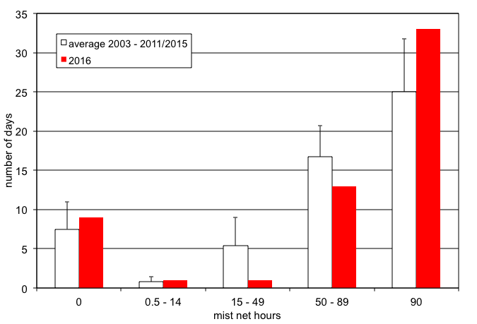
Figure 14. Coverage (in mist net hour) at CHRS, spring 2016.

6.0 Personnel

Thirteen volunteers contributed 95 person-days to the spring migration monitoring season (Table 4). The volunteers this spring were a healthy mix of local and faraway people.
Table 4. Volunteer effort, spring 2016.
21+ Days | 5 - 20 Days | 4 - 14 Days | 1-3 Days
 | Marco Basile | Rachel Vallender | Al Woodhouse
Alex Cappadona | Violette Bertrand | Ariel Lenske | Esme Batten
 | Michael Butler | Todd Pepper | Tricia Stinnissen
 | Tanya Havelka | Francis Aigyle | Gillian Ceaser

7.0 Conclusion

For a fifteenth spring, bird migration monitoring at Cabot Head was done daily from April 15 to June 10, thanks notably to a dedicated team of volunteers. The continuing monitoring effort throughout the years keeps providing a more detailed and precise picture of bird migration on the Bruce Peninsula, revealing insights in bird migration.
As always with nature, this spring brought its share of surprises, but the most unexpected one was the very high number of birds banded and observed! The seasonal banding total was the second highest in 15 springs. Golden-crowned Kinglets reached an all time record of 666 birds banded and contributed disproportionally to the banding total. This spring banding stands in sharp contrast with the previous spring of 2014, when the lowest banding total was achieved. It is complicated to untangle the threads of factors affecting bird migration and numbers. Besides population fluctuations, regional and local weather most likely influenced greatly the migration patterns.
Being present every day during migration, whether in spring or fall, is key in not missing any unusual event, as migration is a highly variable phenomenon. It is paramount to conduct monitoring daily in order to get first sightings, big “waves”, and so on. The daily variation in number of species detected and banded and in new arrivals shows the “boom and bust” nature of bird migration. There were a fair number of unusual records, indicating a good observation pressure. The most notable sighting was a Townsend’s Solitaire, the third record for Cabot Head since 2002, and the first in spring. It is difficult to rank sightings and every observation brings its own reward, and increases our knowledge, understanding, and appreciation of the natural world. For example, the sighting of seven immature Bald Eagles soaring together over Middle Bluff indicates a possibility that only a few years ago would have seen impossible. Similarly, witnessing the evening migration of dozens of Common Nighthawks in late May adds a new dimension.
Cabot Head is truly an amazing place to experience and share the beauty of nature. Continuing migration monitoring at CHRS contributes to the efforts of the CMMN and ultimately to the understanding and monitoring of bird populations.

Acknowledgements

As a non-profit, volunteer-based initiative, the Bruce Peninsula Bird Observatory would not be operable without the overwhelming support of its membership, financial supporters and volunteers. BPBO wishes to thank Ontario Park and Parks Canada (Bruce Peninsula National Park), for their continued support.
The author wishes to thank all the members of the Bruce Peninsula Bird Observatory, as well as the hard-working Mike and Sara Jane Van Der Laap for their support during the field season. I would also like to commend the 13 volunteers who helped make the field season efficient and enjoyable. It is an honour and a privilege to work again for BPBO.

Literature Cited

Badzinski, D.S. and C.M. Francis. 2000. An evaluation of species coverage by the Canadian Migration Monitoring Network. Unpublished report by Bird Studies Canada.

Beheler, A.S., O.E. Rhodes, and P.W. Jr. Harmon. 2003. Breeding site fidelity in Eastern Phoebes (Sayornis phoebe) in Indiana. The Auk 120(4): 990-999.

Cadman, M.D., D.A. Sutherland, G.G. Beck, D. Lepage, and A.R. Couturier (eds.). 2007. Atlas of the breeding birds of Ontario, 2001-2005. Bird Studies Canada, Environment Canada, Ontario Field Ornithologists, Ontario Ministry of Natural Resources, and Ontario Nature, xxii+706pp.

Cheskey, E.D. and W.G. Wilson. 2001. Cabot Head Important Bird Area Conservation Plan. Can. Nature Fed., Bird Studies Canada., Fed. Of Ont. Naturalists. 32 pp.

Derbyshire, D. G. July, 2002. Migration Monitoring at Cabot Head, Spring 2002.Unpublished report for Bruce Peninsula Bird Observatory

Heagy, A., E.D. Cheskey, and D. G.Derbyshire. March 2003. Migration Monitoring at Cabot Head Research Station, Cabot Head, Ontario: Recommended Protocol for Monitoring Small Landbirds.

Heagy, A.. April 2002. Migration Monitoring at Cabot Head Research Station, Cabot Head, Ontario: Recommended Protocol for Monitoring Small Landbirds.

Heagy, Audrey. January 2000. Landbird Migration Monitoring at Cabot Head, Ontario, 2001. Unpublished report by Bruce Peninsula Bird Observatory.

Hussell, D.J.T. and C.J.Ralph. Recommended Methods for Monitoring Bird Populations by Counting and Capture of Migrants. Report of Intensive Sites Technical Committee of the US/Canada Migration Monitoring Council.

Menu, S. 2007. Bird Migration Monitoring at Cabot Head: The First Five Years (2002-2006). Report for Bruce Peninsula Bird Observatory

Appendix

Table 5. Estimated Total of species observed in spring 2016 at Cabot Head Research Station, with daily average, maximum and minimum daily ET, and dates of first and last observation.

Group | Species | Season Total | Average | Max.  Daily ET | Min. Daily ET | Days with obs. | Earliest date | Latest date
waterbirds | Common Loon | 211 | 5 | 18 | 1 | 41 | 21 April | 10 June
 | Horned Grebe | 9 | 5 | 6 | 3 | 2 | 18 April | 8 May
 | Red-necked Grebe | 85 | 12 | 40 | 1 | 7 | 17 April | 11 May
 | Double-crested Cormorant | 122 | 4 | 19 | 1 | 32 | 18 April | 10 June
 | Great Blue Heron | 16 | 1 | 3 | 1 | 11 | 18 April | 7 June
 | Green Heron | 2 | 1 | 1 | 1 | 2 | 27 May | 1 June
raptors | Turkey Vulture | 419 | 10 | 48 | 1 | 44 | 15 April | 8 June
waterbirds | Snow Goose | 2 | 2 | 2 | 2 | 1 | 15 April | 15 April
 | Canada Goose | 1089 | 24 | 199 | 1 | 45 | 15 April | 10 June
 | Tundra Swan | 5 | 5 | 5 | 5 | 1 | 15 April | 15 April
 | Wood Duck | 21 | 4 | 12 | 1 | 6 | 21 April | 25 May
 | Mallard | 44 | 2 | 5 | 1 | 19 | 16 April | 10 June
 | Northern Pintail | 12 | 12 | 12 | 12 | 1 | 18 April | 18 April
 | Ring-necked Duck | 14 | 4 | 4 | 2 | 4 | 15 April | 30 April
 | White-winged Scoter | 4 | 4 | 4 | 4 | 1 | 15 May | 15 May
 | Long-tailed Duck | 7 | 7 | 7 | 7 | 1 | 11 May | 11 May
 | Bufflehead | 20 | 4 | 8 | 1 | 5 | 15 April | 7 May
 | Common Goldeneye | 3 | 2 | 2 | 1 | 2 | 17 April | 18 April
 | Hooded Merganser | 10 | 1 | 3 | 1 | 7 | 16 April | 3 June
 | Common Merganser | 454 | 9 | 33 | 1 | 51 | 15 April | 9 June
 | Red-breasted Merganser | 57 | 4 | 25 | 1 | 15 | 16 April | 7 June
raptors | Osprey | 9 | 1 | 2 | 1 | 8 | 25 April | 29 May
 | Bald Eagle | 90 | 2 | 5 | 1 | 47 | 15 April | 9 June
 | Northern Harrier | 21 | 2 | 5 | 1 | 13 | 16 April | 8 June
 | Sharp-shinned Hawk | 263 | 7 | 41 | 1 | 38 | 15 April | 30 May
 | Cooper's Hawk | 3 | 2 | 2 | 1 | 2 | 2 May | 9 May
 | Red-shouldered Hawk | 61 | 7 | 45 | 1 | 9 | 20 April | 29 May
 | Broad-winged Hawk | 268 | 19 | 71 | 1 | 14 | 20 April | 19 May
 | Red-tailed Hawk | 71 | 3 | 9 | 1 | 22 | 15 April | 1 June
 | Rough-legged Hawk | 3 | 1 | 1 | 1 | 3 | 26 April | 28 May
 | Golden Eagle | 2 | 1 | 1 | 1 | 2 | 24 April | 30 April
 | American Kestrel | 14 | 1 | 2 | 1 | 11 | 18 April | 31 May
 | Merlin | 27 | 1 | 3 | 1 | 19 | 18 April | 3 June
 | Peregrine Falcon | 3 | 1 | 1 | 0 | 4 | 26 April | 25 May
grouse | Ruffed Grouse | 53 | 2 | 4 | 1 | 30 | 15 April | 3 June
 | Wild Turkey | 4 | 1 | 2 | 1 | 3 | 19 April | 13 May
shorebirds | Sandhill Crane | 93 | 3 | 11 | 1 | 32 | 15 April | 6 June
 | Killdeer | 19 | 1 | 2 | 1 | 15 | 20 April | 29 May
 | Greater Yellowlegs | 17 | 2 | 5 | 1 | 9 | 21 April | 19 May
 | Lincoln's Sparrow | 64 | 6 | 50 | 1 | 11 | 3 May | 28 May
 | Solitary Sandpiper | 1 | 1 | 1 | 1 | 1 | 17 May | 17 May
 | Spotted Sandpiper | 21 | 1 | 3 | 1 | 16 | 10 May | 10 June
 | Wilson's Snipe | 2 | 1 | 1 | 1 | 2 | 25 May | 28 May
 | American Woodcock | 1 | 1 | 1 | 1 | 1 | 17 April | 17 April
gulls | Ring-billed Gull | 588 | 12 | 40 | 1 | 48 | 15 April | 10 June
 | Herring Gull | 62 | 3 | 7 | 1 | 23 | 15 April | 9 June
 | Caspian Tern | 4 | 1 | 2 | 1 | 3 | 21 May | 9 June
 | Common Tern | 52 | 2 | 5 | 1 | 22 | 19 May | 10 June
columbidae | Rock Pigeon | 2 | 2 | 2 | 2 | 1 | 6 May | 6 May
 | Mourning Dove | 28 | 2 | 7 | 1 | 13 | 16 April | 8 June
cuckoos | Black-billed Cuckoo | 3 | 1 | 1 | 1 | 3 | 27 May | 2 June
caprimulgidae | Common Nighthawk | 0 | 0 | 0 | 0 | 3 | 25 May | 28 May
 | Eastern Whip-poor-will | 8 | 1 | 2 | 1 | 7 | 4 May | 7 June
apodidae | Chimney Swift | 4 | 1 | 2 | 1 | 3 | 24 May | 30 May
hummingbirds | Ruby-throated Hummingbird | 70 | 2 | 6 | 1 | 29 | 10 May | 10 June
kingfishers | Belted Kingfisher | 30 | 1 | 3 | 1 | 24 | 15 April | 31 May
woodpeckers | Red-headed Woodpecker | 1 | 1 | 1 | 1 | 1 | 21 May | 21 May
 | Red-bellied Woodpecker | 5 | 1 | 1 | 1 | 5 | 23 May | 29 May
 | Yellow-bellied Sapsucker | 10 | 1 | 2 | 1 | 9 | 15 April | 12 May
 | Downy Woodpecker | 15 | 2 | 3 | 1 | 10 | 15 April | 28 May
 | Hairy Woodpecker | 11 | 1 | 2 | 1 | 10 | 22 April | 3 June
 | Northern Flicker | 821 | 23 | 102 | 1 | 35 | 15 April | 30 May
 | Pileated Woodpecker | 41 | 2 | 4 | 1 | 27 | 15 April | 10 June
flycatchers | Eastern Wood-Pewee | 15 | 2 | 3 | 1 | 9 | 23 May | 4 June
 | Yellow-bellied Flycatcher | 16 | 2 | 4 | 1 | 8 | 23 May | 3 June
 | Alder Flycatcher | 4 | 1 | 1 | 1 | 4 | 25 May | 2 June
 | Traill's Flycatcher | 12 | 2 | 5 | 1 | 6 | 20 May | 3 June
 | Least Flycatcher | 20 | 2 | 5 | 1 | 13 | 7 May | 9 June
 | Eastern Phoebe | 36 | 2 | 8 | 1 | 18 | 15 April | 28 May
 | Great Crested Flycatcher | 9 | 1 | 3 | 1 | 7 | 21 May | 10 June
 | Eastern Kingbird | 20 | 2 | 5 | 1 | 11 | 11 May | 10 June
vireos | Blue-headed Vireo | 23 | 2 | 4 | 1 | 13 | 3 May | 25 May
 | Warbling Vireo | 7 | 1 | 2 | 1 | 6 | 11 May | 25 May
 | Philadelphia Vireo | 6 | 3 | 4 | 2 | 2 | 21 May | 25 May
 | Red-eyed Vireo | 92 | 5 | 11 | 1 | 18 | 21 May | 10 June
corvids | Blue Jay | 2966 | 78 | 300 | 1 | 38 | 15 April | 10 June
 | American Crow | 529 | 10 | 55 | 1 | 54 | 15 April | 10 June
 | Common Raven | 185 | 4 | 15 | 1 | 47 | 15 April | 8 June
larks | Horned Lark | 1 | 1 | 1 | 1 | 1 | 24 April | 24 April
swallows | Northern Rough-winged Swallow | 3 | 1 | 1 | 1 | 3 | 6 May | 25 May
 | Tree Swallow | 106 | 3 | 15 | 1 | 34 | 17 April | 4 June
 | Bank Swallow | 4 | 1 | 2 | 1 | 3 | 19 May | 24 May
 | Cliff Swallow | 8 | 1 | 2 | 1 | 7 | 5 May | 27 May
 | Barn Swallow | 141 | 4 | 8 | 1 | 37 | 21 April | 10 June
paridae | Black-capped Chickadee | 128 | 3 | 10 | 1 | 39 | 15 April | 10 June
nuthatches | Red-breasted Nuthatch | 154 | 3 | 13 | 1 | 48 | 15 April | 10 June
 | White-breasted Nuthatch | 1 | 1 | 1 | 1 | 1 | 15 April | 15 April
creepers | Brown Creeper | 252 | 11 | 44 | 1 | 24 | 15 April | 18 May
wrens | House Wren | 2 | 1 | 1 | 1 | 2 | 4 May | 25 May
 | Winter Wren | 29 | 2 | 5 | 1 | 16 | 15 April | 2 June
kinglets | Golden-crowned Kinglet | 1696 | 85 | 491 | 1 | 20 | 15 April | 25 May
 | Ruby-crowned Kinglet | 888 | 23 | 100 | 1 | 38 | 16 April | 4 June
gnatcatchers | Blue-gray Gnatcatcher | 3 | 1 | 1 | 1 | 3 | 6 May | 11 May
turdidae | Townsend's Solitaire | 1 | 1 | 1 | 1 | 1 | 15 April | 15 April
 | Eastern Bluebird | 52 | 2 | 7 | 1 | 25 | 16 April | 10 June
 | Veery | 16 | 1 | 2 | 1 | 12 | 4 May | 10 June
 | Gray-cheeked Thrush | 1 | 1 | 1 | 1 | 1 | 28 May | 28 May
 | Swainson's Thrush | 21 | 2 | 5 | 1 | 11 | 11 May | 29 May
 | Hermit Thrush | 56 | 3 | 20 | 1 | 19 | 15 April | 6 June
 | Wood Thrush | 9 | 2 | 4 | 1 | 4 | 12 May | 26 May
 | American Robin | 496 | 12 | 156 | 1 | 43 | 15 April | 10 June
mimidae | Gray Catbird | 63 | 3 | 12 | 1 | 24 | 30 April | 7 June
 | Northern Mockingbird | 1 | 1 | 1 | 1 | 1 | 24 May | 24 May
 | Brown Thrasher | 40 | 1 | 3 | 1 | 28 | 16 April | 10 June
starlings | European Starling | 140 | 9 | 33 | 1 | 15 | 15 April | 26 May
pipits | American Pipit | 7 | 2 | 3 | 1 | 4 | 7 May | 17 May
bombycillidae | Cedar Waxwing | 205 | 17 | 41 | 1 | 12 | 26 May | 10 June
warblers | Golden-winged Warbler | 1 | 1 | 1 | 1 | 1 | 21 May | 21 May
 | Tennessee Warbler | 31 | 3 | 9 | 1 | 9 | 17 May | 27 May
 | Orange-crowned Warbler | 47 | 3 | 16 | 1 | 14 | 7 May | 1 June
 | Nashville Warbler | 188 | 6 | 33 | 1 | 34 | 3 May | 10 June
 | Northern Parula | 53 | 4 | 16 | 1 | 13 | 10 May | 10 June
 | Yellow Warbler | 79 | 6 | 22 | 1 | 13 | 9 May | 30 May
 | Chestnut-sided Warbler | 100 | 7 | 22 | 1 | 14 | 10 May | 1 June
 | Magnolia Warbler | 249 | 9 | 50 | 1 | 28 | 7 May | 9 June
 | Cape May Warbler | 68 | 5 | 12 | 1 | 14 | 9 May | 29 May
 | Black-throated Blue Warbler | 73 | 4 | 12 | 1 | 17 | 5 May | 27 May
 | Myrtle Warbler | 1209 | 34 | 400 | 1 | 36 | 16 April | 25 May
 | Black-throated Green Warbler | 217 | 6 | 29 | 1 | 34 | 29 April | 10 June
 | Blackburnian Warbler | 92 | 7 | 15 | 1 | 13 | 10 May | 28 May
 | Pine Warbler | 98 | 3 | 8 | 1 | 35 | 15 April | 8 June
 | Prairie Warbler | 2 | 2 | 2 | 2 | 1 | 13 May | 13 May
 | Western Palm Warbler | 662 | 25 | 100 | 1 | 26 | 17 April | 25 May
 | Bay-breasted Warbler | 41 | 5 | 26 | 1 | 8 | 11 May | 25 May
 | Blackpoll Warbler | 44 | 5 | 18 | 1 | 9 | 18 May | 28 May
 | Black-and-white Warbler | 191 | 6 | 20 | 1 | 33 | 30 April | 10 June
 | American Redstart | 848 | 28 | 83 | 1 | 30 | 10 May | 10 June
 | Ovenbird | 92 | 4 | 14 | 1 | 24 | 4 May | 6 June
 | Northern Waterthrush | 4 | 1 | 1 | 1 | 4 | 3 May | 20 May
 | Mourning Warbler | 12 | 2 | 3 | 1 | 7 | 22 May | 2 June
 | Common Yellowthroat | 149 | 5 | 19 | 1 | 28 | 10 May | 10 June
 | Wilson's Warbler | 27 | 3 | 17 | 1 | 8 | 21 May | 10 June
 | Canada Warbler | 15 | 2 | 4 | 1 | 9 | 12 May | 28 May
tanagers | Scarlet Tanager | 16 | 1 | 3 | 1 | 11 | 8 May | 10 June
sparrows | Eastern Towhee | 5 | 1 | 1 | 1 | 5 | 4 May | 9 June
 | American Tree Sparrow | 34 | 3 | 9 | 1 | 10 | 16 April | 3 May
 | Chipping Sparrow | 216 | 6 | 53 | 1 | 37 | 17 April | 10 June
 | Clay-colored Sparrow | 6 | 1 | 1 | 1 | 6 | 3 May | 28 May
 | Field Sparrow | 2 | 1 | 1 | 1 | 2 | 13 May | 26 May
 | Vesper Sparrow | 2 | 1 | 1 | 1 | 2 | 24 April | 27 April
 | Savannah Sparrow | 9 | 1 | 3 | 1 | 7 | 4 May | 26 May
 | Fox Sparrow | 5 | 1 | 2 | 1 | 4 | 15 April | 20 April
 | Song Sparrow | 121 | 3 | 12 | 1 | 45 | 15 April | 10 June
 | Swamp Sparrow | 17 | 2 | 3 | 1 | 11 | 17 April | 24 May
 | White-throated Sparrow | 451 | 15 | 200 | 1 | 30 | 16 April | 7 June
 | White-crowned Sparrow | 241 | 13 | 100 | 1 | 18 | 3 May | 28 May
 | Dark-eyed Junco | 195 | 7 | 27 | 1 | 27 | 15 April | 18 May
 | Lapland Longspur | 1 | 1 | 1 | 1 | 1 | 24 April | 24 April
 | Northern Cardinal | 1 | 1 | 1 | 1 | 1 | 18 April | 18 April
 | Rose-breasted Grosbeak | 43 | 4 | 9 | 1 | 12 | 10 May | 27 May
 | Indigo Bunting | 7 | 2 | 3 | 1 | 4 | 20 May | 2 June
icteridae | Bobolink | 6 | 2 | 3 | 1 | 4 | 11 May | 24 May
 | Red-winged Blackbird | 396 | 12 | 65 | 1 | 32 | 15 April | 10 June
 | Eastern Meadowlark | 6 | 1 | 2 | 1 | 5 | 15 April | 29 April
 | Rusty Blackbird | 96 | 8 | 71 | 1 | 12 | 17 April | 16 May
 | Common Grackle | 1234 | 29 | 296 | 1 | 43 | 15 April | 10 June
 | Brown-headed Cowbird | 88 | 7 | 30 | 1 | 13 | 15 April | 12 May
 | Baltimore Oriole | 52 | 4 | 12 | 1 | 14 | 10 May | 9 June
finches | Purple Finch | 104 | 7 | 83 | 1 | 14 | 15 April | 9 June
 | Pine Siskin | 162 | 7 | 23 | 1 | 22 | 15 April | 25 May
 | American Goldfinch | 327 | 10 | 39 | 1 | 34 | 20 April | 10 June
 | Evening Grosbeak | 1 | 1 | 1 | 1 | 1 | 20 April | 20 April
passeridae | House Sparrow | 1 | 1 | 1 | 1 | 1 | 3 June | 3 June

Detailed report on the Townsend’s Solitaire observation:

On April 15, 2016, at around 9 am, I (Stéphane Menu) observed a Townsend’s Solitaire in jack pines at the Cabot Head Nature Reserve, on the Bruce Peninsula, Ontario. The day was cool, sunny, with a moderate East wind.
A call attracted my attention to a bird sitting almost on top of a Jack Pine. I could, at first, only see the head and upper body. It had a roundish head, plumage completely grey, with a white eye-ring, a short, stubby, black bill. It took off and flew away, giving me a glimpse of a buffy wing stripe. Shortly afterward, it flew towards me against the wind, without making much headway. I had then a complete view of the bird: plumage completely grey, except for the white outer tail feathers, long tail (about the size of the body), short, roundish wings, with a buffy wing stripe across. The wing beat was of rapid flapping interspaced with wings folded against the body. After fighting the wind for a short period, it turned around and disappeared behind the jack pines. It was not seen again.
My observations were made using a 10X40 Zeiss pair of binoculars. My other experiences with this species are: one observation at Cabot Head in the fall of 2005 and one observation in the Cypress Hills of AB-SK in summer 2006.

