MIGRATION MONITORING AT CABOT HEAD

Fall 2015

Fall fieldwork began on August 17 and ended on October 31 for a total of 76 consecutive days of coverage. A total of 130 species of birds were detected in the standard count area over the course of the field season. In total, 1,462 birds of 71 species were banded and 176 birds of 29 species were recaptured. The defining characteristic of fall migration in 2015 was a good coverage; however, a below average number of species were seen this fall (average: 136; range: 127 species in falls 2006 and 2008 – 156 species in fall 2002;). Most species were caught at slightly below average numbers this fall with only a few caught in record numbers, most notably American Tree Sparrow. As a consequence, the banding total is below average. A Hooded Warbler and a Clay-coloured Sparrow were banded at Cabot Head, the second ever individual of these species ever banded in fall. The highest one-day species total was 42, recorded on September 3 and 23. As expected, there is a tremendous variation in diversity and abundance throughout the season (Fig.1).
Banding totals for fall 2015 represent a well below average year, being the fourth-lowest total ever. For the 23 species with more than 15 individuals captured, 8 species have banding totals above average and 10 have banding totals below average, although 5 species are very close to the average. Among the 71 species banded this fall, 8 species have the highest banding total ever this fall, most notably Swainson’s Thrush, Blackpoll Warbler, American Tree Sparrow, and Slate-colored Junco. On the opposite range, 6 species (Common Yellowthroats and Song Sparrows, for example) have the lowest banding total. Numerous variables could affect the capture rates: population dynamics, weather conditions during migration, food availability and vegetation changes at the site. As a consequence, daily captures are highly variable (Fig.2)
No new species was added to the area checklist this fall. However, a number of unusual species were seen and/or banded. Some interesting birds banded this fall were: one Yellow-billed Cuckoo was banded on September 21, a species banded relatively regularly in fall (only missed in 5 falls) but always in small numbers (1 or 2 individuals at the most); a young female and a young male Pileated Woodpeckers were banded on October 20 and 26, respectively. This species is a common resident at Cabot Head but its large size prevents easy capture, as birds can relatively easily escape from the nets. Thus, only a total of 10 Pileated Woodpeckers (3 in spring and 7 in fall) have been banded from 2002 to 2014; an adult male White-breasted Nuthatch was banded on October 27. Only 4 birds of this species have been banded in previous falls (one in 2005, 2 in 2007, and one in 2012); 2 Eastern Wood-Pewees were banded this fall, a species banded only twice in previous falls (in 2009 and 2013); a Blue-gray Gnatcatcher was observed on August 29 and 31. This species is seen every spring (except in 2015) but not every fall: it has, in fact, been observed only in 6 falls prior to 2015, as early as August 19 (in 2006) and late as October 7 (in 2014); a species more often heard or seen flying overhead, an American Pipit was banded on September 30. A bird of open spaces, it is extremely unusual to capture this species in the net set-up of Cabot Head: previously, only one bird banded both in 2002 and 2004; a Brown Thrasher was banded on October 3. Although this species is present at Cabot Head every year, Brown Thrasher manages to elude the mistnets in fall, with captures only in 2002, 2012, and 2013, for a total of 5 birds; this fall, 2 Northern Parulas were banded, early (September 2) and late (October 14) in the season. It is very rarely banded (and observed as well) in fall, with only 2 other captures in the previous 13 years: one on September 9, 2005, and one on October 15, 2008; Pine Warblers breed at Cabot Head and are observed every spring and fall, although not very often captured in fall. Only one bird was banded this fall in early September. A total of 11 Pine Warblers have been previously banded in 6 years from 2002 to 2014, with captures from August 23 to October 13; on the opposite, no Hooded Warblers breed at Cabot Head or on the Bruce Peninsula except for a possible pair at Cape Crocker. A young female was banded on September 29 this year, the second only ever to be banded in the fall at Cabot Head (with the previous one, a young male, on October 4, 2010); two Scarlet Tanagers were banded: a young on September 21 and an adult male on October 5 (see photo 1). Previously, a total of 10 scarlet tanagers were banded in 6 fall seasons, as early as August 21 and late as October 3; Northern Cardinals, on the other hand, are captured almost every fall (missed only in 2006, 2013, and 2014), albeit in small numbers (from one to 3 individuals per season). This fall, two adult females were banded on October 20 and 31; only one Rose-breasted Grosbeak was banded this fall, on August 21. This species is captured in small numbers in the fall (high of 8 birds in 2011) and was missed in 5 seasons; the second-ever Clay-colored Sparrow was banded on October 8. One was banded previously in 2002. It is a rare species at Cabot Head: besides the ones banded, it was observed in only 4 other years; a late migrant, a Common Redpoll was banded this year, on October 20. This species was banded in only 2 other falls previously, with 5 birds in 2005 and 6 in 2007.
Other noteworthy observations are: on the evening of August 25, 1 Common Nighthawks were seen flying above “Compass Lake” (the lake between Middle and West Bluffs), a rare sight of a declining species; an evening watch was operated at the station in August and early September with no sightings at all of nighthawks! Peregrine Falcons were seen 6 times this fall, from September 15 to October 5; for only the 4th time in the fall, a Vesper Sparrow was observed near the station feeding on September 22. All the previous observations were in October, from the 1st to the 21st; a few Rusty Blackbirds were observed throughout the season, with the first on September 30 and the last on October 9, with a high of 6 birds on October 8. More birds were seen in the Pine Barrens and around Compass Lake; one very famished young Lapland Longspur was observed feeding frantically on the ground on October 16 (and again on October 17). This species has been observed only in 4 other falls (2002, 2012, 2013, and 2014); a Northern Shrike was observed very briefly during census on October 24, a blustery, though warm, day; a Northern Goshawk was seen very briefly on October 25; Snow Buntings were detected only twice with just one individual each, on October 27 and 30. This species is observed every fall, mostly after mid-October, and sometimes in big numbers: for example, 89 Snow Buntings were observed on October 28, 2004.
A White-winged Scoter stayed on Wingfield Basin for an extended period of time in October, probably because it was in poor conditions. One afternoon in late October, as a strong wind was blowing, we observed an adult Bald Eagle trying to catch the white-winged scoter for several minutes: it would hover right over it as the scoter surfaced for air and dove again to escape the eagle. Just when it seemed the eagle was about to get the scoter, another adult bald eagle arrived on the scene and chased off the other eagle. It is possible although impossible to prove that the second eagle was the resident eagle, fighting off a transient adult.

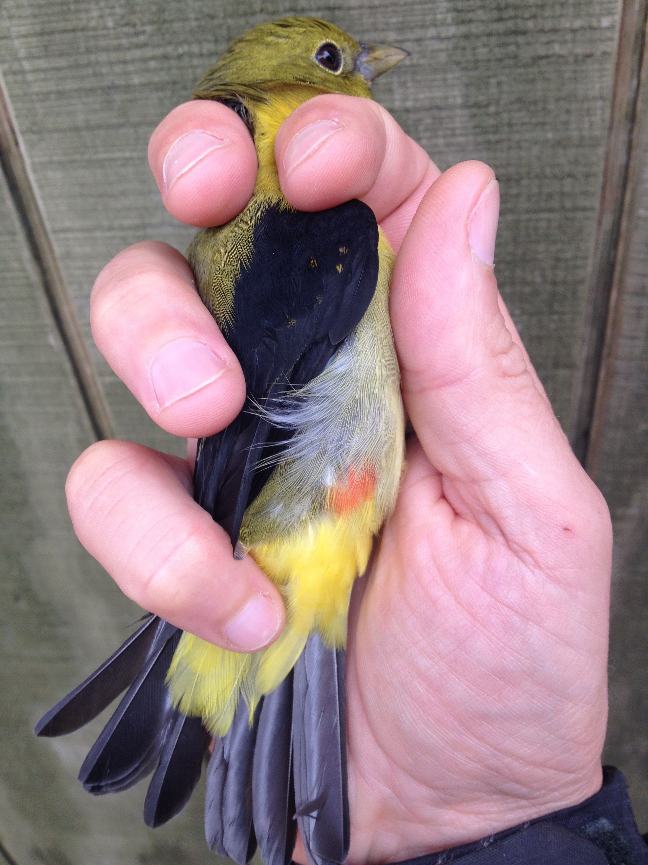
Photo 1: Male adult Scarlet Tanager banded at Cabot Head, fall 2015.

This fall, 9 volunteers contributed a total of 157 person-days to the fall migration monitoring season (Table 4). This fall, volunteers hailed from Ontario, Wisconsin, Virginia, Alberta, and Québec. Some stayed for just a few days, while others were long-term, most notably Tristan (40 days) and Annick (62 days). Volunteers are an essential part of the success of the operations at Cabot Head and all help is appreciated.

Overall, fall 2015 was a thrilling season, with dedicated volunteers, beautiful birds, and an unseasonal warm weather lasting into fall. Cabot Head is truly a wonderful place, where one can observe Otters fishing in Wingfield Basin, or a Black Bear walking on its shore, or simply, the slow turning of seasons in their eternal cycle.

Stéphane Menu
Station Scientist

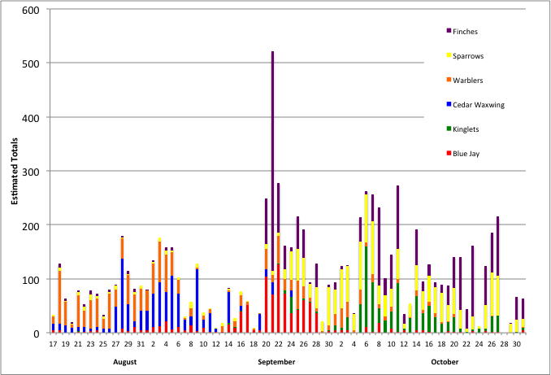
Figure 1. Estimated Totals of the most common species throughout the monitoring period at Cabot Head Research Station, fall 2015.

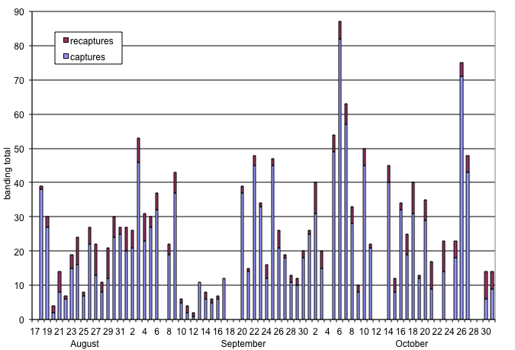
Figure 2. Daily banding and recapture total at Cabot Head Research Station, fall 2015.

Fall banding total 2015
Group | Species | 2015 | Av. ± stdev. |  | Max. | Year | Min. | Year | #
raptors | Sharp-shinned Hawk | 4 | 3 | 1 | 5 | 2011 - 2013 | 1 | 2009 - 2012 | 12
cuckoos | Yellow-billed Cuckoo | 1 | 2 | 0 | 2 | several years | 1 | 2005 - 2010 | 8
woodpeckers | Downy Woodpecker | 19 | 9 | 8 | 31 | 2009 | 2 | 2002 | 13
 | Hairy Woodpecker | 2 | 6 | 3 | 12 | 2007 | 2 | 2005 | 11
 | Yellow-Shafted Flicker | 3 | 4 | 2 | 8 | 2012 | 1 | 2005 | 12
 | Pileated Woodpecker | 2 | 1 | 0 | 1 | several years |  |  | 7
flycatchers | Eastern Wood-pewee | 2 | 1 | 0 | 1 | 2009 - 2013 |  |  | 2
 | Yellow-bellied Flycatcher | 4 | 2 | 2 | 7 | 2014 | 1 | several years | 11
 | Traill’s Flycatcher | 6 | 7 | 4 | 16 | 2007 | 1 | 2011 | 13
 | Least Flycatcher | 7 | 5 | 2 | 9 | 2010 | 3 | several years | 13
vireos | Blue-headed Vireo | 13 | 6 | 3 | 11 | 2005 | 1 | 2002 - 2007 | 13
 | Philadelphia Vireo | 1 | 3 | 2 | 5 | 2012 | 1 | 2003/07/10 | 9
 | Red-eyed Vireo | 66 | 87 | 56 | 239 | 2005 | 24 | 2009 | 13
corvids | Blue Jay | 5 | 5 | 4 | 16 | 2014 | 1 | 2007 | 12
paridae | Black-capped Chickadee | 11 | 176 | 190 | 717 | 2005 | 12 | 2006 | 13
nuthatches | Red-breasted Nuthatch | 10 | 50 | 44 | 160 | 2012 | 12 | 2013 | 13
 | White-breasted Nuthatch | 1 | 2 | 1 | 2 | 2007 | 1 | 2005 | 2
creepers | Brown Creeper | 27 | 42 | 17 | 71 | 2012 | 19 | 2009 | 13
wrens | Winter Wren | 2 | 5 | 2 | 8 | 2007/08/13 | 1 | 2003 | 12
kinglets | Golden-crowned Kinglet | 189 | 345 | 185 | 758 | 2013 | 113 | 2005 | 13
 | Ruby-crowned Kinglet | 40 | 62 | 32 | 122 | 2003 | 20 | 2005 | 13
turdidae | Veery | 10 | 3 | 2 | 6 | 2007 | 1 | 2010 | 10
 | Gray-cheeked Thrush | 17 | 13 | 6 | 23 | 2002 | 6 | 2010 | 13
 | Swainson’s Thrush | 79 | 28 | 13 | 50 | 2009 | 10 | 2006 | 13
 | Hermit Thrush | 26 | 43 | 19 | 87 | 2011 | 16 | 2002 | 13
 | American Robin | 12 | 18 | 9 | 36 | 2006 | 1 | 2007 | 13
mimidae | Gray Catbird | 7 | 6 | 4 | 17 | 2002 | 2 | 2010 - 2014 | 13
 | Brown Thrasher | 1 | 2 | 1 | 2 | 2012 - 2013 | 1 | 2002 | 3
pipits | American Pipit | 1 | 1 | 0 | 1 | 2002 - 2004 | 1 |  | 2
bombycillidae | Cedar Waxwing | 49 | 37 | 38 | 117 | 2005 | 1 | 2014 | 12
warblers | Tennessee Warbler | 11 | 11 | 14 | 44 | 2005 | 2 | 2009 | 12
 | Orange-crowned Warbler | 21 | 15 | 9 | 28 | 2014 | 3 | 2005 | 13
 | Nashville Warbler | 52 | 34 | 16 | 78 | 2005 | 19 | 2010 | 13
 | Northern Parula | 2 | 1 | 0 | 1 | 2005 - 2008 |  |  | 2
 | Yellow Warbler | 1 | 4 | 3 | 13 | 2003 | 1 | 2007/08/14 | 13
 | Chestnut-sided Warbler | 1 | 2 | 1 | 5 | 2002 | 1 | several years | 11
 | Magnolia Warbler | 22 | 23 | 5 | 34 | 2005 | 16 | 2012 - 2013 | 13
 | Cape May Warbler | 7 | 2 | 1 | 3 | 2003 - 2007 | 1 | several years | 9
 | Black-throat. Blue Warbler | 7 | 14 | 5 | 22 | 2002 | 2 | 2014 | 13
Group | Species | 2015 | Av. ± stdev. |  | Max. | Year | Min. | Year | #
warblers | Myrtle Warbler | 62 | 85 | 47 | 204 | 2005 | 34 | 2004 | 13
 | Black-thr. Green Warbler | 44 | 63 | 36 | 120 | 2002 | 15 | 2007 | 13
 | Blackburnian Warbler | 1 | 4 | 3 | 10 | 2005 | 1 | 2012 | 10
 | Pine Warbler | 1 | 2 | 1 | 3 | 2011 | 1 | 2010 - 2014 | 6
 | Palm Warbler | 5 | 8 | 6 | 22 | 2012 | 1 | 2004 | 13
 | Bay-breasted Warbler | 6 | 5 | 3 | 10 | 2013 | 1 | 2009 | 11
 | Blackpoll Warbler | 31 | 11 | 7 | 23 | 2005 | 5 | 2006 | 13
 | Black and White Warbler | 26 | 24 | 9 | 37 | 2013 | 12 | 2006 - 2007 | 13
 | American Redstart | 77 | 105 | 47 | 198 | 2003 | 44 | 2007 | 13
 | Ovenbird | 20 | 18 | 6 | 31 | 2012 | 10 | 2007 | 13
 | Northern Waterthrush | 8 | 6 | 4 | 15 | 2010 | 1 | 2005 | 13
 | Common Yellowthroat | 17 | 26 | 6 | 39 | 2010 | 17 | 2008 | 13
 | Hooded Warbler | 1 | 1 |  | 1 | 2010 |  |  | 1
 | Wilson’s Warbler | 9 | 7 | 3 | 12 | 2009 | 2 | 2004 | 13
 | Canada Warbler | 6 | 4 | 2 | 8 | 2002 | 1 | 2004 - 2006 | 13
tanagers | Scarlet Tanager | 2 | 2 | 1 | 2 | several years | 1 | 2002 - 2010 | 6
sparrows | American Tree Sparrow | 94 | 28 | 22 | 88 | 2010 | 11 | 2002 | 13
 | Clay-coloured Sparrow | 1 | 1 |  | 1 | 2002 |  |  | 1
 | Fox Sparrow | 7 | 3 | 1 | 5 | 2009 - 2011 | 1 | 2003/07/14 | 12
 | Song Sparrow | 7 | 15 | 6 | 28 | 2002 | 8 | 2012 | 13
 | Lincoln’s Sparrow | 3 | 6 | 3 | 13 | 2010 | 2 | 2003 | 12
 | Swamp Sparrow | 1 | 5 | 2 | 11 | 2003 | 2 | 2007 | 13
 | White-throated Sparrow | 69 | 85 | 47 | 199 | 2005 | 39 | 2007 | 13
 | White-crowned Sparrow | 66 | 40 | 32 | 126 | 2007 | 11 | 2013 | 13
 | Slate-coloured Junco | 141 | 82 | 23 | 133 | 2014 | 47 | 2002 | 13
 | Northern Cardinal | 2 | 2 | 1 | 3 | 2003 | 1 | several years | 10
 | Rose-breasted Grosbeak | 1 | 4 | 3 | 8 | 2011 | 1 | 2002 - 2008 | 7
 | Indigo Bunting | 1 | 2 | 2 | 5 | 2003 - 2004 | 1 | several years | 9
finches | Common Redpoll | 1 | 6 | 1 | 6 | 2007 | 5 | 2005 | 2
 | Pine Siskin | 8 | 33 | 57 | 170 | 2011 | 2 | 2014 | 8
 | American Goldfinch | 2 | 4 | 6 | 19 | 2014 | 1 | 2008/10/11 | 8
Total |  | 2015 | Av. ± stdev. |  | Max. | Year | Min. | Year | #
 |  | 1462 | 1758 | 314 | 2477 | 2005 | 1418 | 2007 | 13

Record for fall 2015: highest, number highlighted in red; lowest, number highlighted in blue;

Black-throat. Blue Warbler: Black-throated Blue Warbler

Black-thr. Green Warbler: Black-throated Green Warbler

Av. ± stdev.: Average ± standard deviation

Max. : Maximum; Min.: Minimum; # : number of fall seasons with banding

Detected Totals of species observed in fall from 2002 to 2015 at Cabot Head Research Station
Group | Species | Season total | Average | Max. daily ET | Min. daily ET | Days with obs. | First obs. | Last obs.
waterbirds | Common Loon | 110 | 3 | 16 | 1 | 36 | 21 Au. | 31 Oc.
 | Red-necked Grebe | 7 | 2 | 4 | 1 | 3 | 23 Se. | 18 Oc.
 | Horned Grebe | 4 | 2 | 3 | 1 | 2 | 23 Se. | 24 Se.
 | Double-crested Cormorant | 367 | 11 | 40 | 1 | 34 | 17 Au. | 30 Se.
 | Great Blue Heron | 17 | 1 | 2 | 1 | 16 | 17 Au. | 20 Oc.
raptors | Turkey Vulture | 10 | 2 | 4 | 1 | 6 | 20 Au. | 1 Oc.
waterbirds | Canada Goose | 328 | 9 | 66 | 1 | 37 | 18 Au. | 21 Oc.
 | Mallard | 18 | 6 | 9 | 4 | 3 | 19 Au. | 11 Oc.
 | Ring-necked Duck | 2 | 2 | 2 | 2 | 1 | 2 Oc. | 2 Oc.
 | White-winged Scoter | 64 | 7 | 47 | 1 | 9 | 29 Se. | 31 Oc.
 | Long-tailed Duck | 29 | 5 | 8 | 1 | 6 | 16 Oc. | 24 Oc.
 | Common Goldeneye | 8 | 4 | 7 | 1 | 2 | 8 Oc. | 24 Oc.
 | Hooded Merganser | 6 | 2 | 2 | 2 | 3 | 21 Au. | 15 Oc.
 | Common Merganser | 25 | 2 | 3 | 1 | 16 | 19 Au. | 16 Oc.
 | Red-breasted Merganser | 6 | 2 | 2 | 1 | 4 | 28 Au. | 31 Oc.
raptors | Bald Eagle | 100 | 2 | 5 | 1 | 54 | 17 Au. | 31 Oc.
 | Northern Harrier | 2 | 1 | 1 | 1 | 2 | 30 Se. | 20 Oc.
 | Sharp-shinned Hawk | 26 | 1 | 3 | 1 | 18 | 18 Au. | 31 Oc.
 | Northern Goshawk | 1 |  |  |  | 1 | 25 Oc.
 | Broad-winged Hawk | 2 | 1 | 1 | 1 | 2 | 19 Au. | 20 Au.
 | Red-tailed Hawk | 1 |  |  |  | 1 | 26 Oc.
 | Rough-legged Hawk | 1 |  |  |  | 1 | 23 Oc.
 | American Kestrel | 1 |  |  |  | 1 | 11 Oc.
 | Merlin | 28 | 1 | 2 | 1 | 24 | 24 Au. | 19 Oc.
 | Peregrine Falcon | 5 | 1 | 1 | 1 | 6 | 5 Se. | 5 Oc.
grouse | Ruffed Grouse | 47 | 2 | 4 | 1 | 25 | 3 Se. | 31 Oc.
shorebirds | Sandhill Crane | 5 | 2 | 2 | 1 | 3 | 22 Se. | 27 Se.
 | Greater Yellowlegs | 5 | 1 | 2 | 1 | 4 | 30 Au. | 23 Oc.
 | Spotted Sandpiper | 3 | 1 | 1 | 1 | 3 | 31 Au. | 8 Se.
 | Wilson's Snipe | 1 |  |  |  | 1 | 16 Oc.
 | American Woodcock | 3 | 1 | 1 | 1 | 3 | 14 Se. | 23 Se.
gulls | Ring-billed Gull | 352 | 5 | 25 | 1 | 65 | 19 Au. | 31 Oc.
 | Herring Gull | 37 | 5 | 25 | 1 | 7 | 19 Au. | 12 Oc.
 | Common Tern | 3 | 2 | 2 | 1 | 2 | 18 Au. | 5 Se.
Group | Species | Season total | Average | Max. daily ET | Min. daily ET | Days with obs. | First obs. | Last obs.
columbidae | Mourning Dove | 1 |  |  |  | 1 | 19 Au.
cuckoos | Yellow-billed Cuckoo | 2 | 1 | 1 | 1 | 2 | 22 Se. | 24 Se.
caprimulgidae | Eastern Whip-poor-will | 7 | 1 | 1 | 1 | 12 | 18 Au. | 23 Se.
hummingbirds | Ruby-throated Hummingbird | 71 | 2 | 8 | 1 | 29 | 19 Au. | 24 Se.
kingfishers | Belted Kingfisher | 30 | 1 | 2 | 1 | 26 | 17 Au. | 14 Oc.
woodpeckers | Red-headed Woodpecker | 2 | 1 | 1 | 1 | 2 | 9 Se. | 12 Oc.
 | Yellow-bellied Sapsucker | 3 | 1 | 1 | 1 | 3 | 1 Oc. | 11 Oc.
 | Downy Woodpecker | 160 | 3 | 12 | 1 | 56 | 18 Au. | 31 Oc.
 | Hairy Woodpecker | 23 | 1 | 3 | 1 | 18 | 30 Au. | 26 Oc.
 | Northern Flicker | 134 | 3 | 11 | 1 | 49 | 17 Au. | 16 Oc.
 | Pileated Woodpecker | 12 | 1 | 2 | 1 | 10 | 28 Au. | 26 Oc.
flycatchers | Eastern Wood-Pewee | 2 | 2 | 2 | 2 | 1 | 5 Se. | 5 Se.
 | Yellow-bellied Flycatcher | 4 | 1 | 1 | 1 | 4 | 28 Au. | 16 Se.
 | Traill's Flycatcher | 7 | 1 | 2 | 1 | 6 | 18 Au. | 10 Se.
 | Least Flycatcher | 14 | 2 | 4 | 1 | 9 | 19 Au. | 3 Se.
 | Eastern Phoebe | 1 |  |  |  | 1 | 27 Au.
 | Eastern Kingbird | 1 |  |  |  | 1 | 22 Au.
shrikes | Northern Shrike | 1 |  |  |  | 1 | 24 Oc.
vireos | Blue-headed Vireo | 15 | 1 | 2 | 1 | 13 | 20 Se. | 16 Oc.
 | Warbling Vireo | 2 | 1 | 1 | 1 | 2 | 27 Au. | 2 Se.
 | Philadelphia Vireo | 3 | 2 | 2 | 1 | 2 | 5 Se. | 21 Se.
 | Red-eyed Vireo | 203 | 6 | 20 | 1 | 33 | 17 Au. | 5 Oc.
corvids | Blue Jay | 964 | 16 | 127 | 1 | 59 | 17 Au. | 31 Oc.
 | American Crow | 153 | 4 | 11 | 1 | 43 | 18 Au. | 21 Oc.
 | Common Raven | 143 | 3 | 12 | 1 | 53 | 19 Au. | 31 Oc.
larks | Horned Lark | 17 | 3 | 10 | 1 | 5 | 13 Se. | 23 Oc.
swallows | Cliff Swallow | 1 |  |  |  | 1 | 19 Au.
 | Barn Swallow | 62 | 5 | 12 | 1 | 13 | 17 Au. | 15 Se.
paridae | Black-capped Chickadee | 212 | 4 | 33 | 1 | 50 | 17 Au. | 31 Oc.
nuthatches | Red-breasted Nuthatch | 322 | 5 | 13 | 1 | 70 | 17 Au. | 31 Oc.
 | White-breasted Nuthatch | 1 |  |  |  | 1 | 27 Oc.
creepers | Brown Creeper | 47 | 3 | 9 | 1 | 18 | 18 Au. | 27 Oc.
wrens | House Wren | 1 |  |  |  | 1 | 15 Se.
 | Winter Wren | 4 | 1 | 2 | 1 | 3 | 2 Se. | 6 Oc.
kinglets | Golden-crowned Kinglet | 710 | 19 | 100 | 1 | 38 | 14 Se. | 31 Oc.
 | Ruby-crowned Kinglet | 201 | 7 | 50 | 1 | 27 | 21 Au. | 31 Oc.
gnatcatchers | Blue-gray Gnatcatcher | 2 | 1 | 1 | 1 | 2 | 29 Au. | 31 Au.
Group | Species | Season total | Average | Max. daily ET | Min. daily ET | Days with obs. | First obs. | Last obs.
turdidae | Veery | 15 | 1 | 3 | 1 | 12 | 22 Au. | 14 Se.
 | Gray-cheeked Thrush | 18 | 1 | 3 | 1 | 14 | 2 Se. | 2 Oc.
 | Swainson's Thrush | 133 | 4 | 20 | 1 | 32 | 29 Au. | 10 Oc.
 | Hermit Thrush | 34 | 2 | 5 | 1 | 16 | 25 Se. | 27 Oc.
 | American Robin | 157 | 3 | 16 | 1 | 48 | 17 Au. | 27 Oc.
mimidae | Gray Catbird | 55 | 2 | 4 | 1 | 34 | 17 Au. | 11 Oc.
 | Brown Thrasher | 1 |  |  |  | 1 | 3 Oc.
starlings | European Starling | 2 | 1 | 1 | 1 | 2 | 18 Oc. | 19 Oc.
pipits | American Pipit | 105 | 4 | 33 | 1 | 24 | 16 Se. | 26 Oc.
bombycillidae | Cedar Waxwing | 1111 | 33 | 129 | 1 | 34 | 17 Au. | 24 Se.
warblers | Tennessee Warbler | 18 | 2 | 3 | 1 | 11 | 27 Au. | 7 Oc.
 | Orange-crowned Warbler | 44 | 2 | 5 | 1 | 20 | 20 Se. | 26 Oc.
 | Nashville Warbler | 58 | 3 | 16 | 1 | 20 | 18 Au. | 7 Oc.
 | Northern Parula | 3 | 1 | 1 | 1 | 3 | 17 Au. | 14 Oc.
 | Yellow Warbler | 7 | 1 | 2 | 1 | 5 | 18 Au. | 3 Se.
 | Chestnut-sided Warbler | 2 | 1 | 1 | 1 | 2 | 19 Au. | 23 Au.
 | Magnolia Warbler | 82 | 4 | 20 | 1 | 23 | 18 Au. | 26 Se.
 | Cape May Warbler | 23 | 8 | 20 | 1 | 3 | 4 Se. | 6 Se.
 | Black-throated Blue Warbler | 9 | 1 | 2 | 1 | 8 | 18 Au. | 23 Se.
 | Myrtle Warbler | 324 | 6 | 30 | 1 | 53 | 21 Au. | 31 Oc.
 | Black-throated Green Warbler | 144 | 5 | 20 | 1 | 32 | 17 Au. | 5 Oc.
 | Blackburnian Warbler | 5 | 1 | 1 | 1 | 5 | 28 Au. | 26 Se.
 | Pine Warbler | 10 | 3 | 4 | 1 | 4 | 23 Au. | 3 Se.
 | Western Palm Warbler | 10 | 1 | 2 | 1 | 8 | 3 Se. | 6 Oc.
 | Bay-breasted Warbler | 9 | 2 | 3 | 1 | 5 | 5 Se. | 25 Se.
 | Blackpoll Warbler | 62 | 4 | 14 | 1 | 15 | 3 Se. | 27 Se.
 | Black-and-white Warbler | 65 | 3 | 8 | 1 | 22 | 18 Au. | 11 Se.
 | American Redstart | 443 | 14 | 50 | 1 | 32 | 17 Au. | 3 Oc.
 | Ovenbird | 28 | 2 | 5 | 1 | 16 | 22 Au. | 27 Se.
 | Northern Waterthrush | 8 | 2 | 3 | 1 | 5 | 29 Au. | 20 Oc.
 | Common Yellowthroat | 138 | 5 | 20 | 1 | 30 | 17 Au. | 8 Oc.
 | Hooded Warbler | 1 |  |  |  | 1 | 29 Se.
 | Wilson's Warbler | 20 | 3 | 10 | 1 | 8 | 27 Au. | 16 Se.
 | Canada Warbler | 7 | 1 | 2 | 1 | 5 | 23 Au. | 3 Se.
tanagers | Scarlet Tanager | 2 | 1 | 1 | 1 | 2 | 21 Se. | 5 Oc.
Group | Species | Season total | Average | Max. daily ET | Min. daily ET | Days with obs. | First obs. | Last obs.
sparrows | American Tree Sparrow | 202 | 10 | 53 | 1 | 21 | 1 Oc. | 31 Oc.
 | Chipping Sparrow | 8 | 1 | 3 | 1 | 6 | 30 Au. | 2 Oc.
 | Clay-colored Sparrow | 5 | 1 | 2 | 1 | 4 | 8 Oc. | 21 Oc.
 | Vesper Sparrow | 1 |  |  |  | 1 | 22 Se.
 | Savannah Sparrow | 2 | 1 | 1 | 1 | 2 | 16 Oc. | 17 Oc.
 | Fox Sparrow | 13 | 2 | 3 | 1 | 8 | 17 Oc. | 31 Oc.
 | Song Sparrow | 127 | 3 | 11 | 1 | 38 | 17 Au. | 9 Oc.
 | Lincoln's Sparrow | 3 | 2 | 2 | 1 | 2 | 6 Se. | 8 Se.
 | Swamp Sparrow | 1 |  |  |  | 1 | 27 Au.
 | White-throated Sparrow | 290 | 8 | 31 | 1 | 38 | 28 Au. | 27 Oc.
 | White-crowned Sparrow | 651 | 17 | 46 | 1 | 39 | 27 Au. | 30 Oc.
 | Dark-eyed Junco | 520 | 13 | 32 | 1 | 41 | 3 Se. | 30 Oc.
 | Lapland Longspur | 2 | 1 | 1 | 1 | 2 | 16 Oc. | 17 Oc.
 | Snow Bunting | 2 | 1 | 1 | 1 | 2 | 27 Oc. | 30 Oc.
 | Northern Cardinal | 2 | 1 | 1 | 1 | 2 | 20 Oc. | 31 Oc.
 | Rose-breasted Grosbeak | 1 |  |  |  | 1 | 21 Au.
sparrows | Indigo Bunting | 1 |  |  |  | 1 | 27 Au.
icteridae | Red-winged Blackbird | 2 | 1 | 1 | 1 | 2 | 17 Oc. | 23 Oc.
 | Rusty Blackbird | 11 | 2 | 6 | 1 | 6 | 29 Se. | 9 Oc.
finches | Pine Grosbeak | 2 | 2 | 2 | 2 | 1 | 31 Oc. | 31 Oc.
 | White-winged Crossbill | 1 |  |  |  | 1 | 27 Oc.
 | Common Redpoll | 1 |  |  |  | 1 | 20 Oc.
 | Pine Siskin | 2027 | 55 | 403 | 1 | 37 | 20 Se. | 31 Oc.
 | American Goldfinch | 170 | 4 | 24 | 1 | 38 | 18 Au. | 31 Oc.
Average: average 2002 – 2014.
Max. daily ET: Maximum daily ET in fall 2015; Min. daily ET: Minimum in fall 2015.
First and last obs.: First and last observation in fall 2015.

Photo gallery
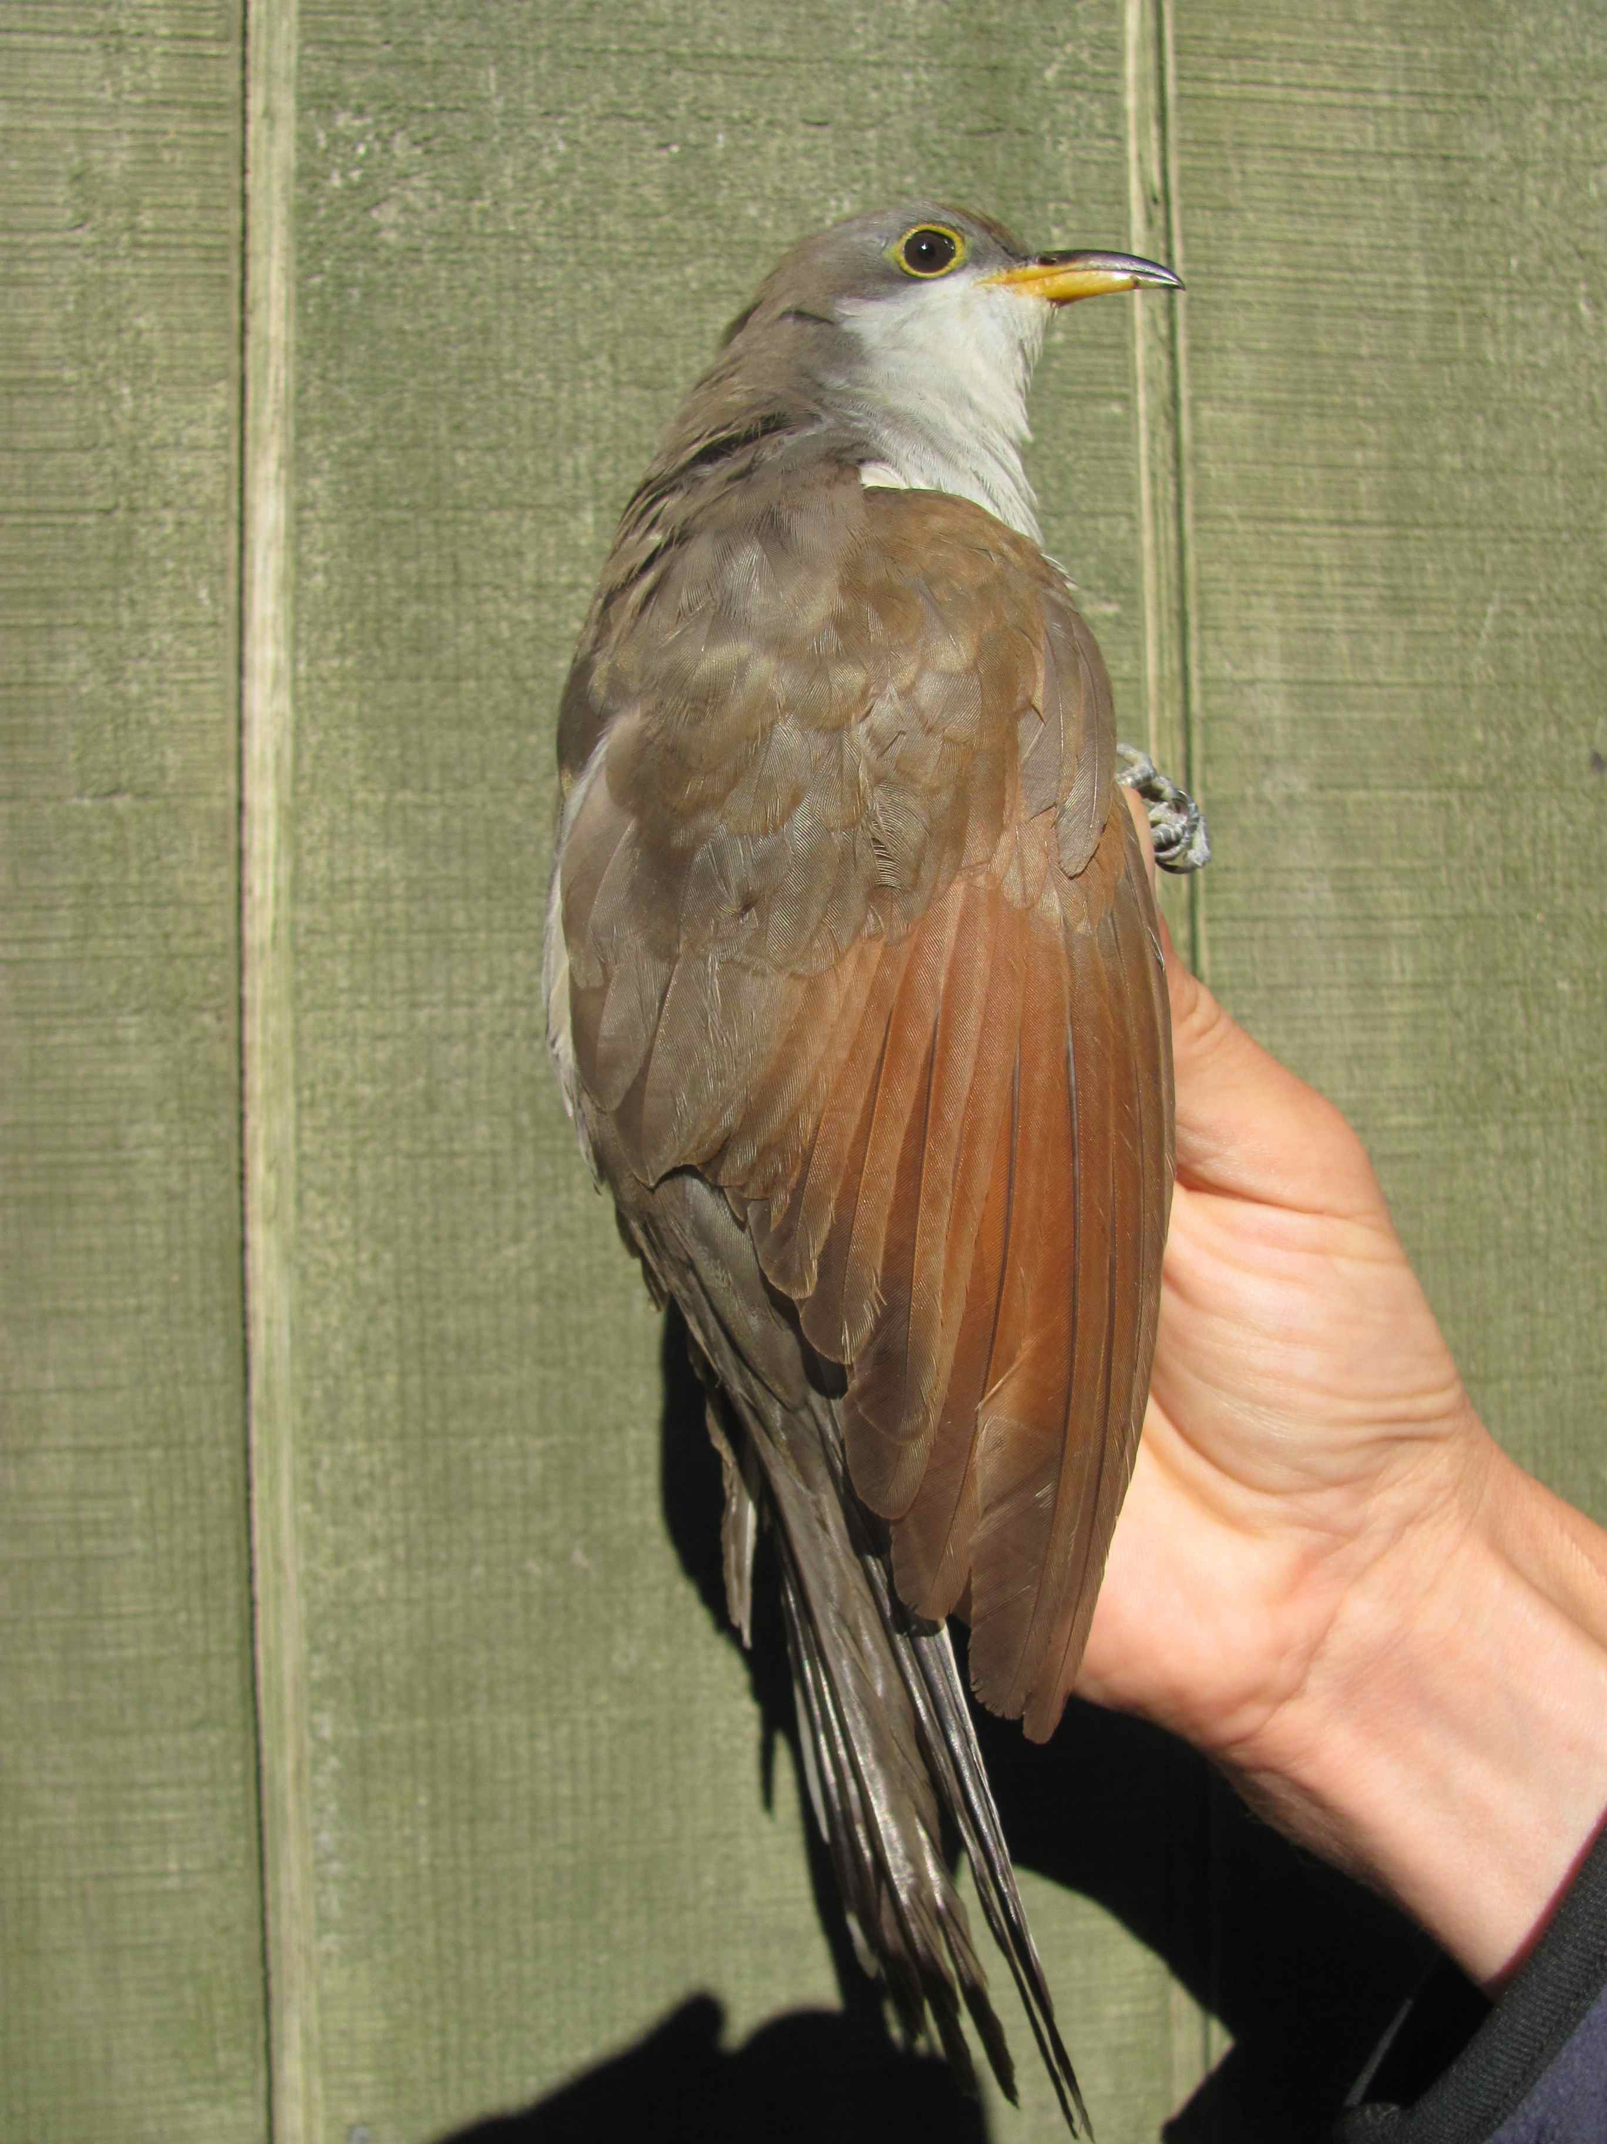
Yellow-billed Cuckoo
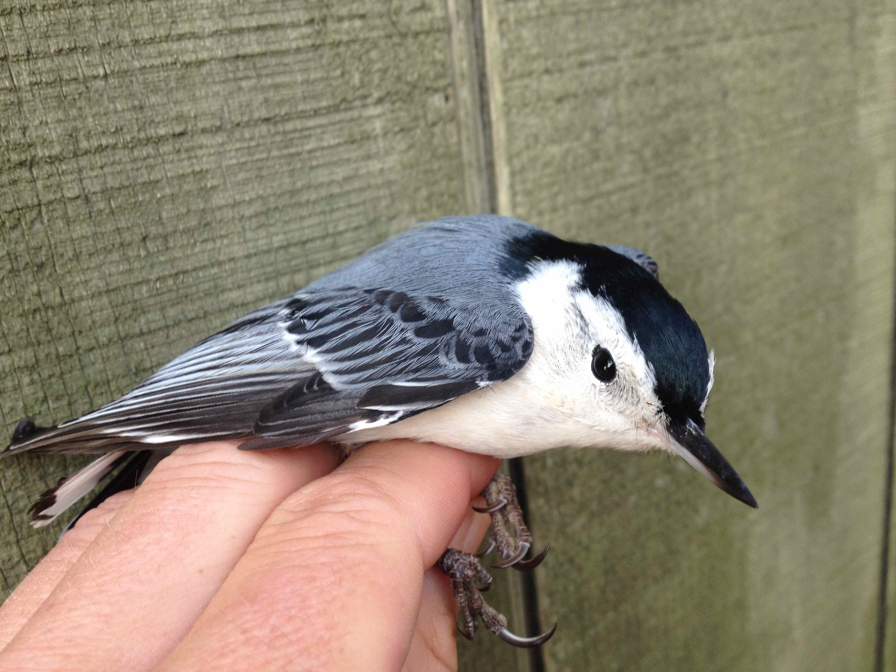
White-breasted Nuthatch
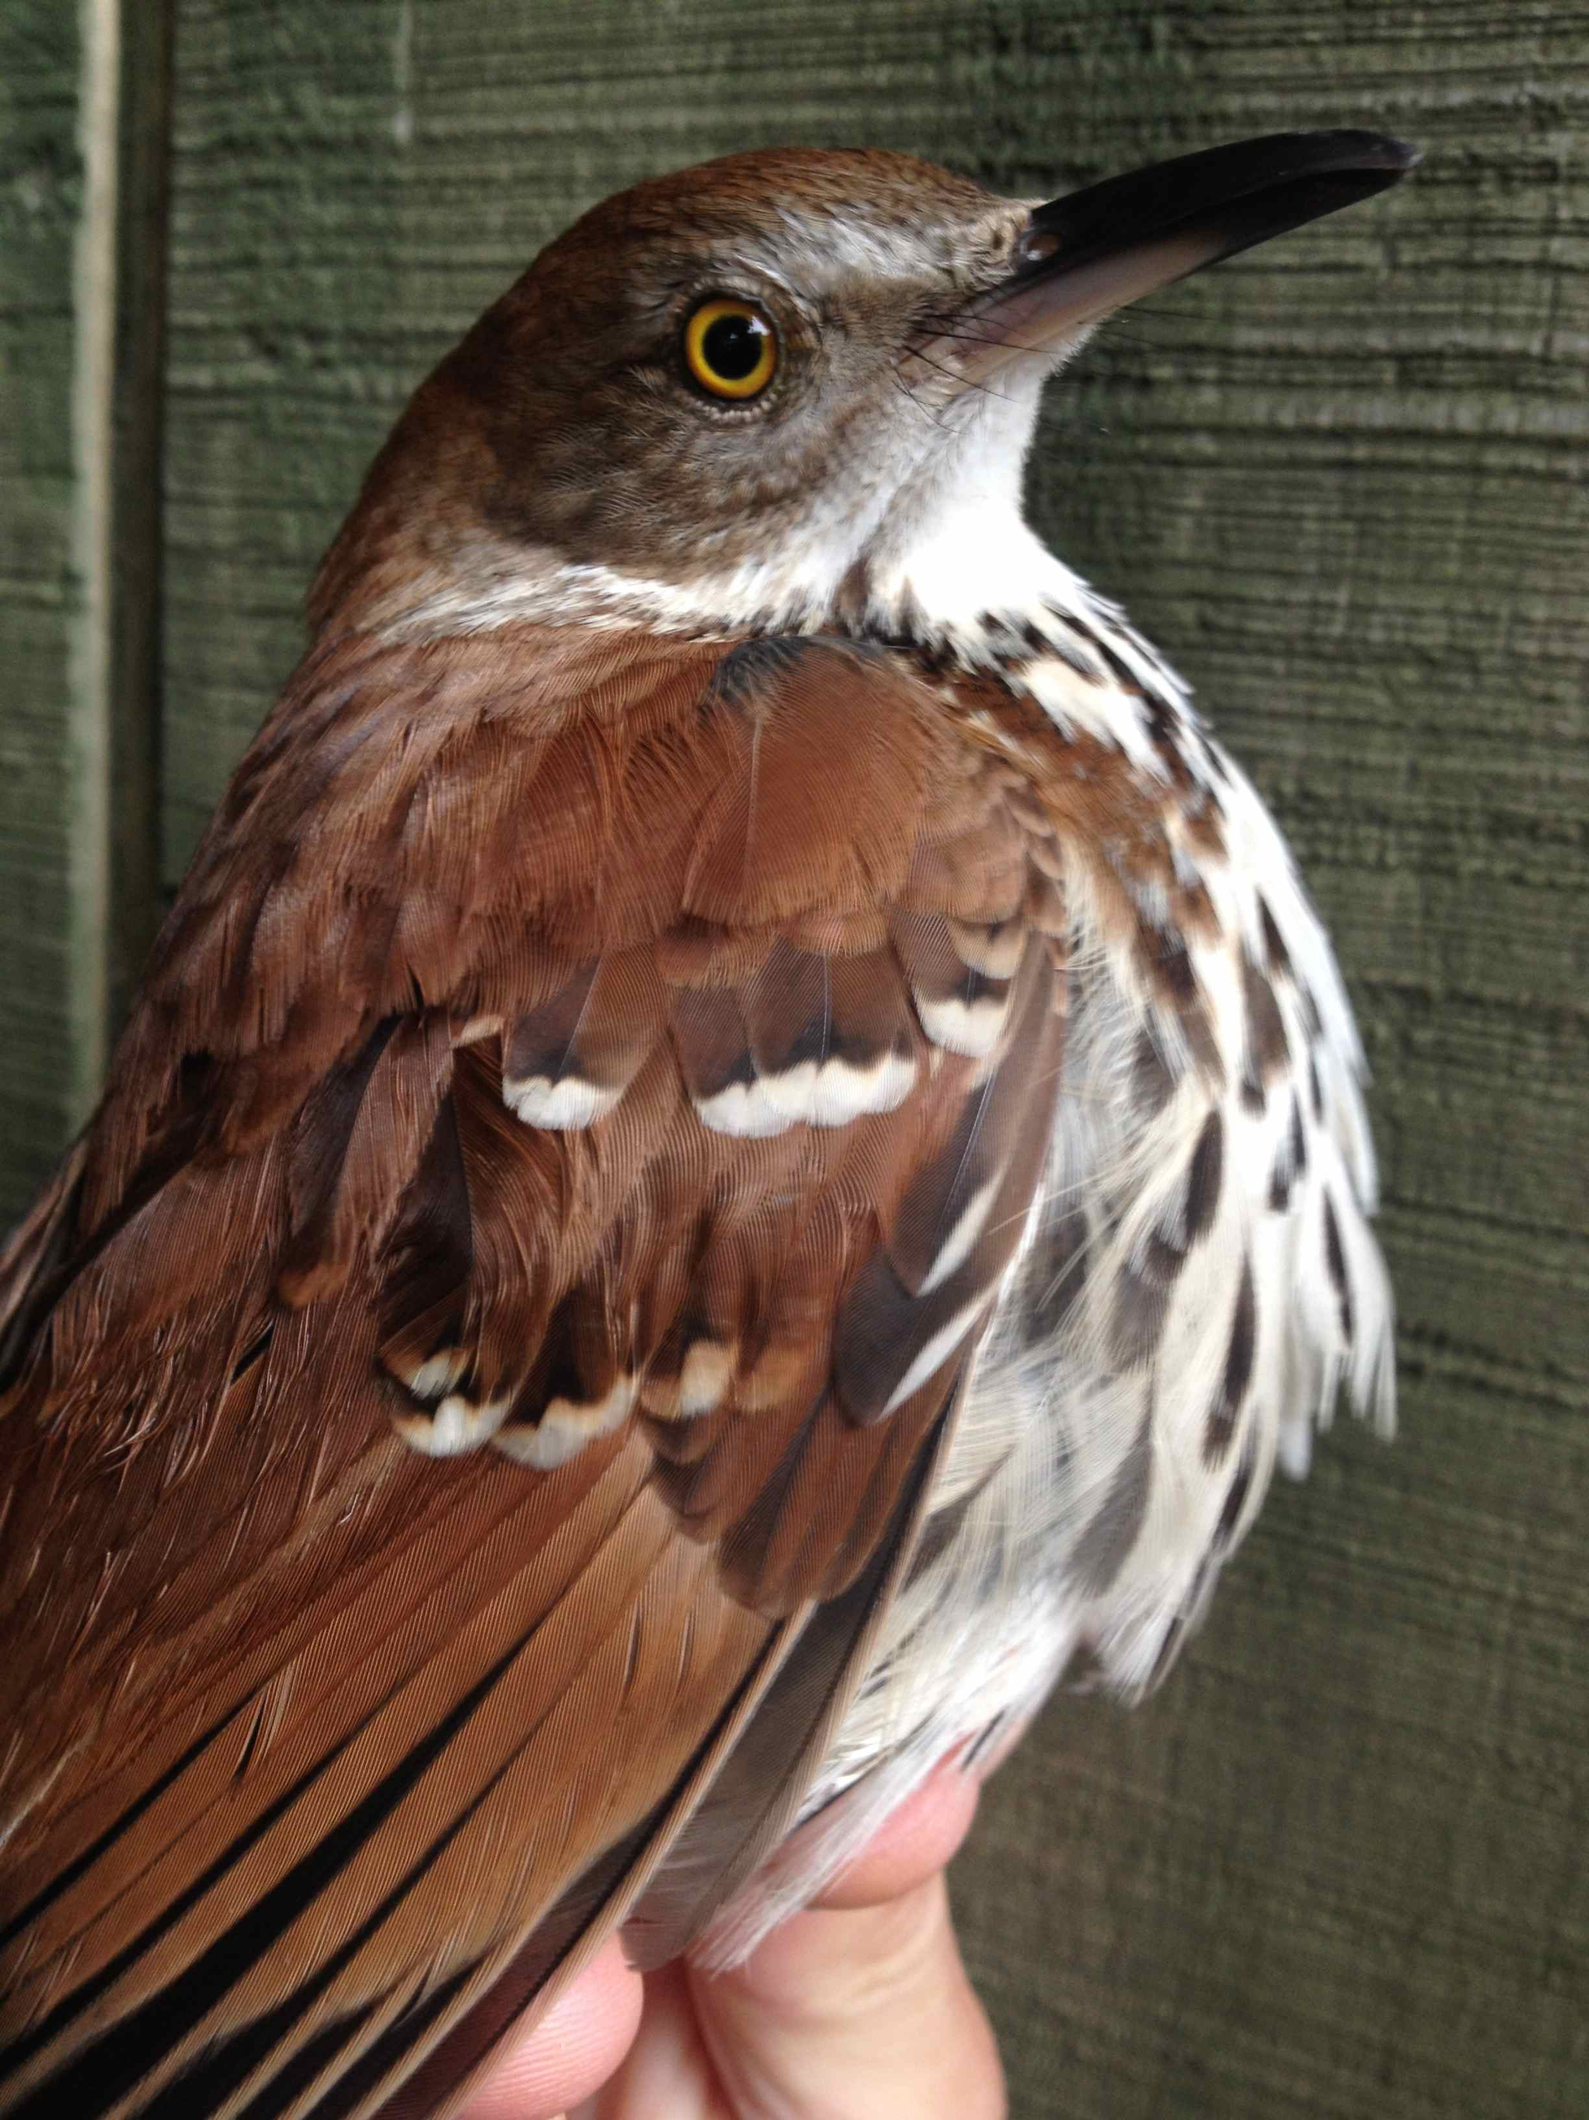
Brown Thrasher

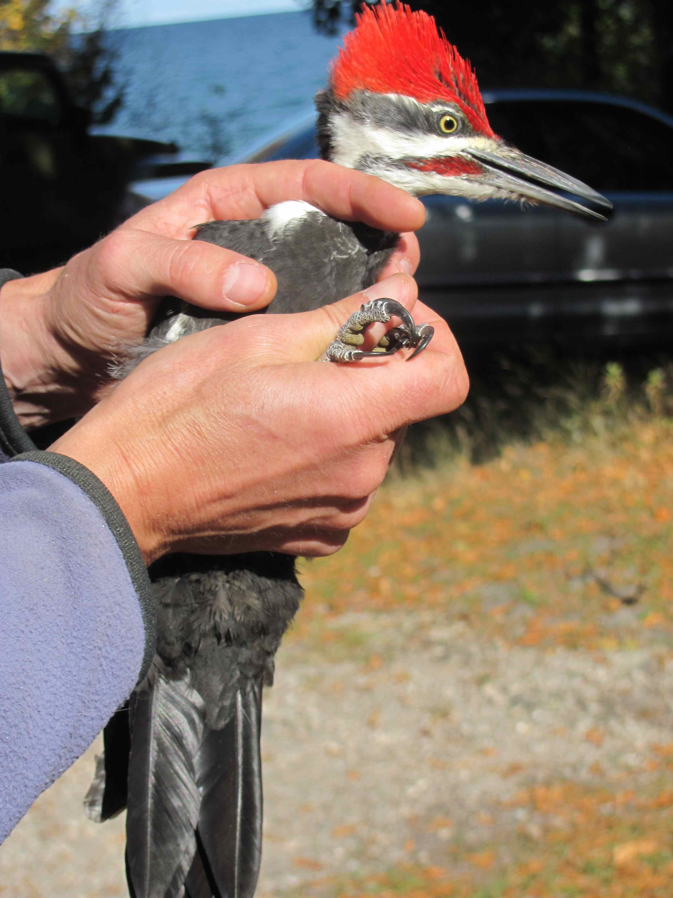
Pileated Woodpecker
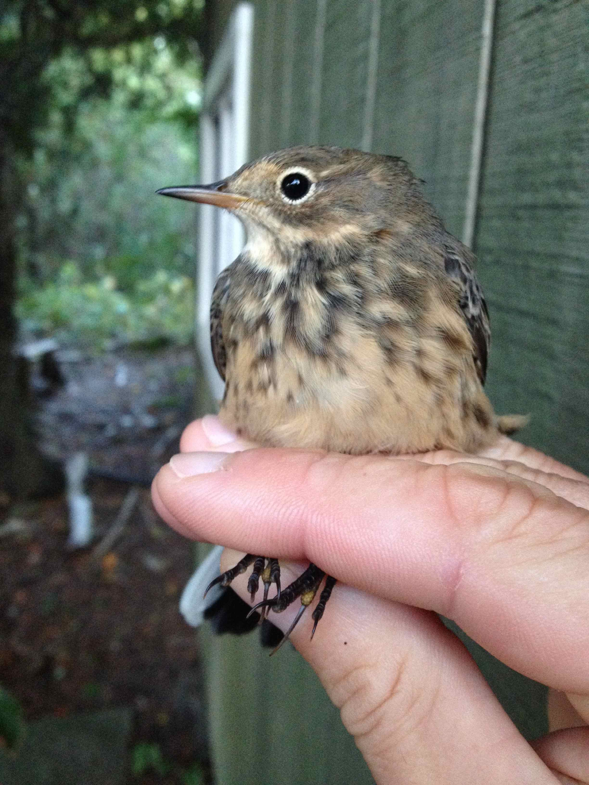
American Pipit
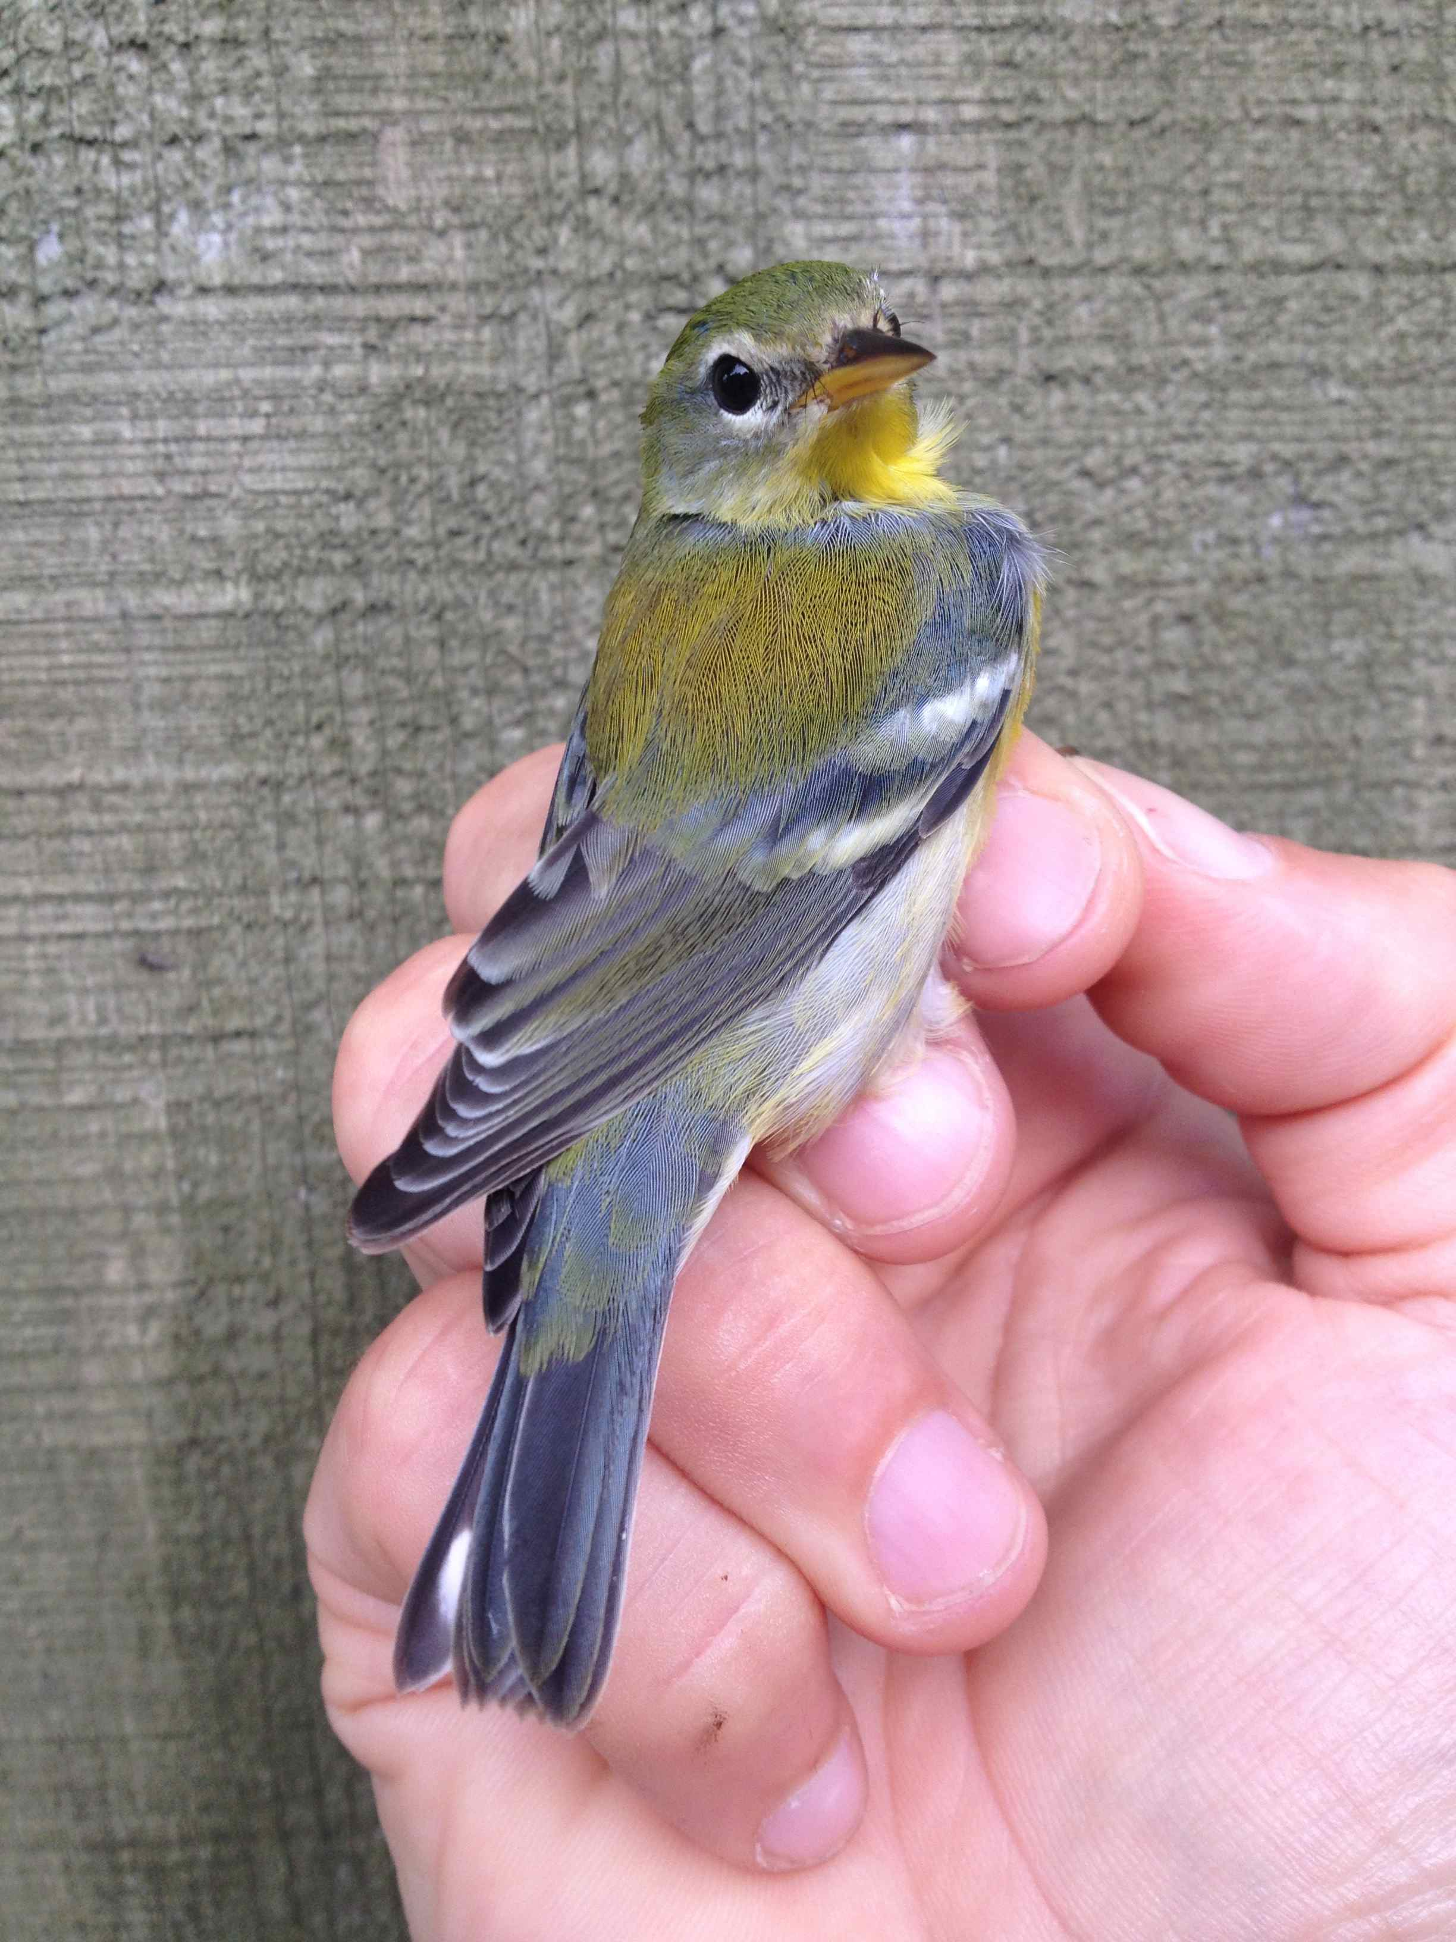
Northern Parula
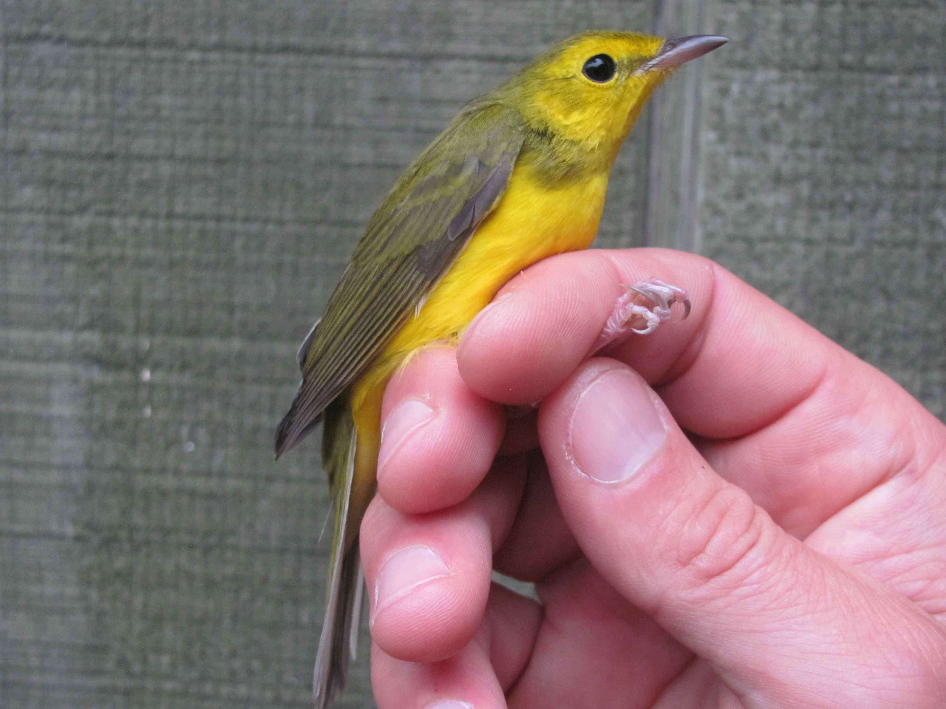
Hooded Warbler

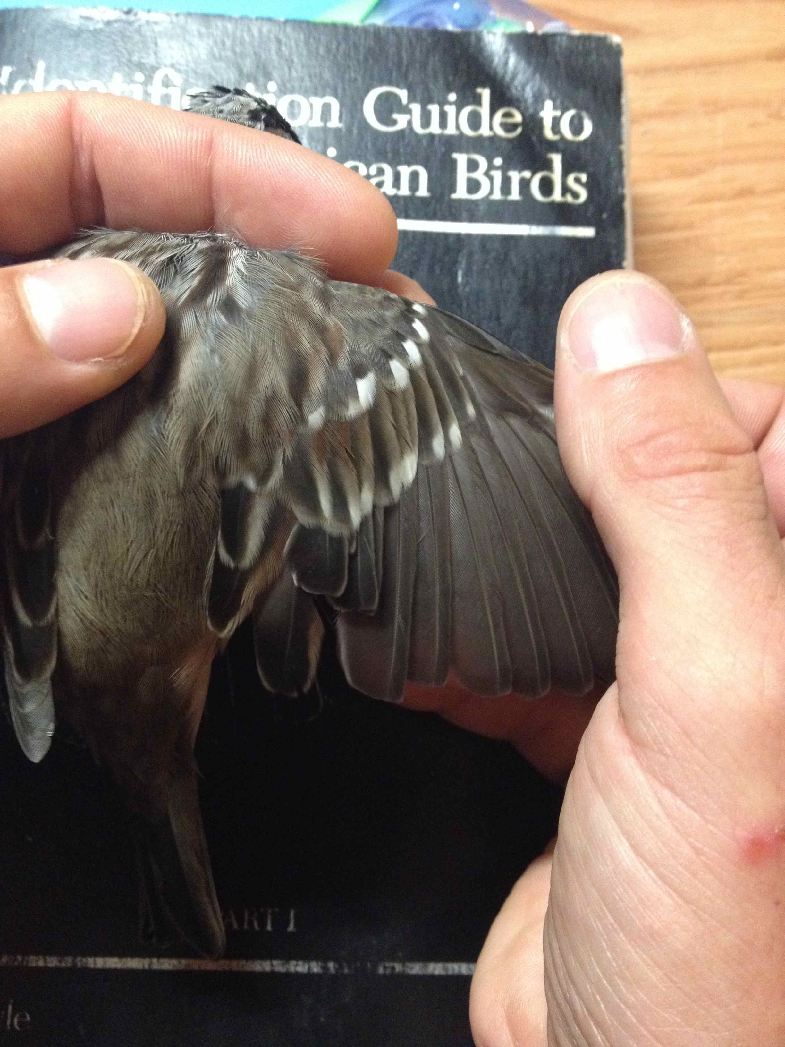
White-crowned Sparrow with moulting wing in August
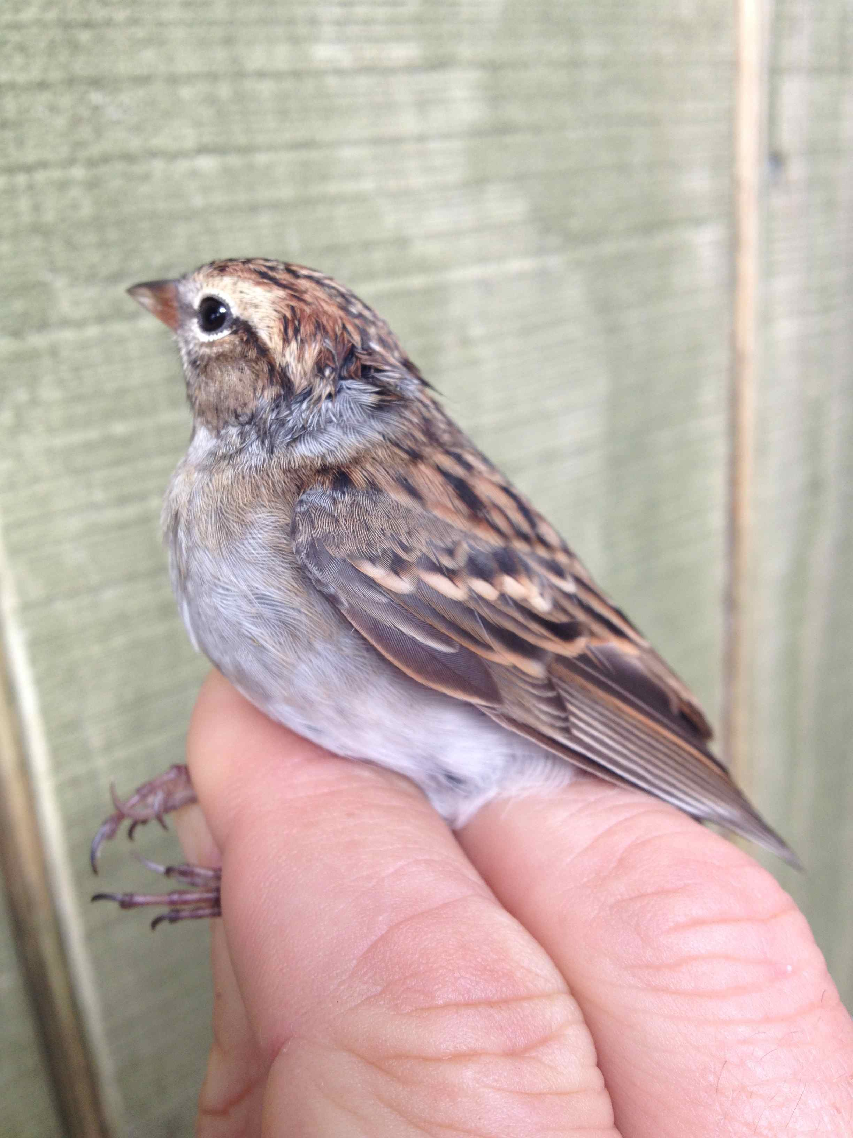
Clay-coloured Sparrow

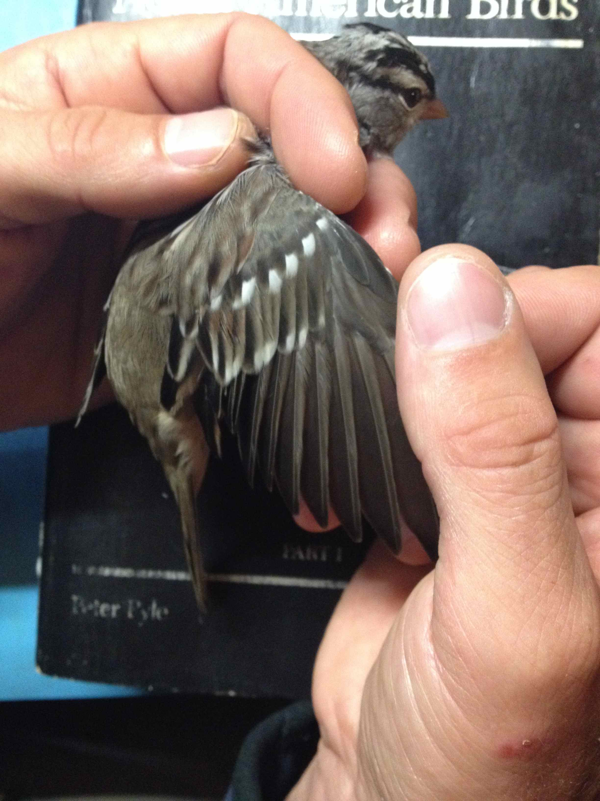

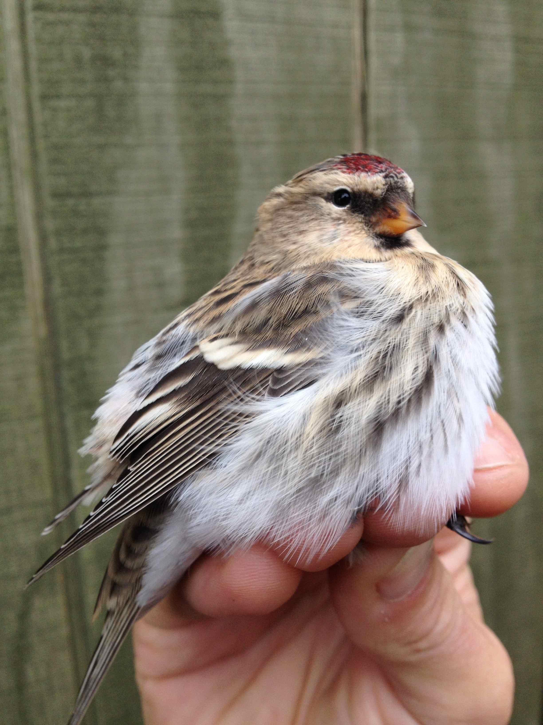
Common Redpoll

