MIGRATION MONITORING AT

CABOT HEAD

SPRING 2015

by

Stéphane Menu, Ph.D.
501487 Grey Road #1
Ontario, N0H 2T0
stefmenu@gmail.com

prepared
for

BRUCE PENINSULA BIRD OBSERVATORY

June 2015
Table des matières
Preface 4
Executive Summary 5
1.0 Methods 6
2.0 Season Summary 6
April 6
May 13
June 18
3.0 Unusual Records 20
4.0 Banding Data Analysis 23
4.1 Weather 29
4.2 Recaptures 30
4.3 Net Analysis 36
5.0 Mist net coverage 38
6.0 Personnel 38
7.0 Conclusion 39
Acknowledgements 40
Literature Cited 41
Appendix 42

Figure 1. Numbers of banded Golden-crowned (top) and Ruby-crowned (bottom) Kinglets by month and year at Cabot Head Research Station, 2002 – 2015. 8
Figure 2. Numbers of banded Brown Creepers (top) and Slate-coloured Juncos (bottom) by month and year at Cabot Head Research Station, 2002 – 2015. 9
Figure 3. Numbers of banded American Tree Sparrows by month and year at Cabot Head Research Station, 2002 – 2015. 10
Figure 4. Daily and cumulative numbers of species of warblers detected at Cabot Head Research Station in spring 2015. 17
Figure 5. Weekly capture rates at Cabot Head Research Station for springs (2002, average 2003-2008 and 2015). Error bars show Standard Deviation. 27
Figure 6. Weekly number of banded birds at Cabot Head Research Station for springs (2002, average 2003-2008 and 2015). Error bars show Standard Deviation. 27
Figure 7. Weekly proportion of realized mist net hours at Cabot Head Research Station for springs (average 2002-2007 and 2015). Error bars show Standard Deviation. 28
Figure 8. Daily number of captured and recaptured birds at Cabot Head Research Station, spring 2015. 28
Figure 9. Wind pattern (strength on the Beaufort scale, direction and proportion of time) at Cabot Head Research Station, spring 2015. 30
Figure 10. Age and sex composition of captures and recaptures (according to time of capture) of American Redstarts at Cabot Head in spring 2015 (sample sizes on top of bars). 32
Figure11: Proportion of second-year birds among birds of known age (second-year and after-second-year birds) and of after-hatch-year birds in banding totals in spring banding at Cabot Head from 2002 to 2015 in a selection of species. Numbers of banded birds are on top of bars. 35

Table 1. Banding total of species in spring 2015 at Cabot Head Research Station. 25
Table 2. Number of species banded in spring 2015 at Cabot Head Research Station according to their banding total. 26
Table 3. Total recaptures by species in relation with the year of banding. 33
Table 4. Volunteer effort, spring 2015. 38
Table 5. Estimated Total of species observed in spring 2015 at Cabot Head Research Station. 42

Photo 1: Ice extent off the shore of Cabot Head, with Compass Lake in the foreground and West Bluff to the left. Take on April 26, 2015. 12
Photo 2: The Black-billed Cuckoo captured on June 7. 19
Photo 3: A potential intergrade Flicker with a black and red moustache. 22
Photo 4: View of the Palm Warbler wing, with an unusual great covert (red arrow). 22
Photo 5: Birches still standing near A1. 37

Citation:

Menu, S. September 2015. Migration Monitoring at Cabot Head, Spring 2015. Unpublished report for Bruce Peninsula Bird Observatory

Preface

Cabot Head is a promontory of the northeast headland of the upper Bruce Peninsula in south-central Ontario. Cabot Head Research Station (CHRS) is situated on the western side of Wingfield Basin (at 45°15’N, 81°18’W) near the community of Dyer’s Bay. In 2001, Cabot Head was designated as an Important Bird Area (IBA) by Birdlife International for its significant concentrations of migratory bird species (Cheskey and Wilson, 2001). Ontario Parks and Bruce Peninsula Bird Observatory (BPBO) manage Cabot Head Research Station.

The Breeding Bird Survey (BBS) is the principle method for monitoring bird populations in the United States. However, breeding ranges of many species in northern Canada are inaccessible to roadside surveys and are therefore poorly monitored by the BBS method. The Canadian Migration Monitoring Network (CMMN) is a nation wide Bird Studies Canada initiative, enacted to assess changes in populations during migration. There are 21 stations across Canada where data are being collected for each bird species during the spring and fall migrations, typically through a standardized capture and observation protocol. Bruce Peninsula Bird Observatory has demonstrated through data collection since 1998 that Cabot Head is a significant site for monitoring migrating landbirds. In recognition of its importance and established migration monitoring effort, BPBO became a member of the CMMN in fall 2003.

Bruce Peninsula Bird Observatory was incorporated as a non-profit charitable organization in 2001 to initiate and direct ornithological assessments and monitoring at Cabot Head and surrounding areas. Migration monitoring has been the primary focus of bird research at Cabot Head since 1998. This document reports on results of the spring, 2015, migration monitoring season at Cabot Head Research Station.

Executive Summary

In this document are summarized the results of migration monitoring at Cabot Head in spring, 2015. Spring fieldwork began on April 19 (with banding coverage starting on April 20) and ended on June 10 for a total of 53 consecutive days of coverage. A total of 153 species were detected during the monitoring period. A complete list of all species observed, with season Estimated Total, days with observation, maximum and minimum daily totals, is provided in the appendix (as Table 5). A total of 876 birds of 61 species were banded and 59 birds of 18 species were recaptured. Recapture data indicates that overall stopover rates at Cabot Head are low. Analysis of capture rate per net location indicates a large degree of variation associated with habitat characteristics.

The defining characteristic of spring 2015 was of a cold weather throughout much of the season. There were many periods of rain (for 6 days) or strong winds (for 7 days) during the monitoring period precluding all of the banding operation in a total of 9 days (17% of the monitoring period). However, there were a high number of days with very good coverage (more than 80 mist net hours in a day for a potential of 90) this spring: 37 days, i.e. 71% of the monitoring period. Nonetheless, the banding total is the lowest in 14 years of monitoring: with 876 birds banded, it is far below the spring average of 1540 ± 421banded birds (high of 2622 birds in spring 2002 and previous low of 1161 in spring 2008). Three species, American Redstart, Slate-coloured Junco, and Ruby-crowned Kinglets (in decreasing order), represent 40% of the banding total. For most species, banding totals are far below the 2002-2014 average compared to previous springs (see Appendix). There were only 4 days with banding total over 50 birds, with the highest day for the spring being April 29 with 75 birds banded. On May 17 and 7, 72 and 71 species, respectively, were detected, the highest diversity of the spring. No new species were added to the BPBO checklist this spring.

The 2015 spring migration monitoring season was a success thanks to the efforts of the 10 volunteer field biologists who contributed their time to this project.

1.0 Methods

The migration monitoring program at Cabot Head like all CMMN stations follows a field protocol (established by Heagy et al, 2003, modified from Heagy 2002) as it is essential for the production of population indices that data collection be consistent over the long term. At Cabot Head Research Station, fifteen mist nets are operated for 6 hours commencing no later than 1 half hour before sunrise, weather permitting. Personnel also complete a census done for one hour along a fixed route starting an hour after sunrise, where all birds seen or heard are recorded. Supplemental surveys such as visible migration counts and bay watches are completed when circumstances permit, but casual observation occurs all throughout the count period of 7 hours.

2.0 Season Summary

April

Fieldwork for spring migration monitoring began at Cabot Head Research Station on April 19 with census and casual observation, while setting up the nets. Snow on the access road delayed the station opening again this spring, like in 2014. All nets were up and ready to go on April 20, except for C13. Once again, a massive snow bank blocked the lane! After some shoveling, that net was in operation from April 29 on. Weather in April was cold, with mostly west or northwest winds. Banding was not possible in only 3 days due to rain and/or strong wind, all during the truncated first week of monitoring (April 20 – 23). For the rest of the month, weather conditions allowed for complete coverage and the only mist net hours missed were due to C13 being not set up. It is quite unusual to have such good coverage in April, a usually tumultuous period for weather.
In April 80 species were detected (52% of the season total), of which 2 species were detected only this month (American Black Duck and American Woodcock). A daily average of 34 species were detected (range: 22 – 53 species seen on any given day, except during the 2 rainy days, with only 12 and 8 species). Despite the excellent coverage, a relatively low total of 192 birds of 18 species were banded in April. Banding in April is highly variable: On average, 322 birds are banded during these 2 weeks over the period 2002 – 2014, but numbers fluctuate from a low of 135 in spring 2004 to a high of 812 in spring 2009, an almost seven-fold difference! In spring 2015, 62.5% of the banding total of April is composed of only three species: Slate-coloured Junco, with 67 birds banded, Ruby-crowned Kinglet (with 27), and Golden-crowned Kinglet (with 26). These 3 species, as well as Brown Creeper to some extent, are overwhelmingly responsible for the large yearly fluctuations in numbers of birds banded in April (Figs. 1&2). Among these species, only Ruby-crowned Kinglet has most of its migration covered during the monitoring period. For the other 3 species, a variable portion of their migration is covered depending on the year, with Golden-crowned Kinglet being the most striking example: its migration tends to happen most spring before opening time at Cabot Head Research Station, as very few birds species are captured most springs (Fig.1). Surprisingly, in the late springs in 2014 and 2015, numbers captured were still quite low. This year, periods of warm and favourable weather happened in early April, potentially allowing for migration of Golden-crowned Kinglets.
American Tree Sparrow is also an early migrant, usually all but miss at Cabot Head after April 15. For 9 of the previous 13 springs, only a very small number (from 1 to 6) of birds were banded. This year, a total of 16 American Tree Sparrows were banded, almost all of them of on April 29, when 12 birds were banded (Fig.3).
Early migrant species, like American Tree Sparrow, Slate-coloured Junco, Brown Creeper, Golden-crowned Kinglet, and to a lesser extent, Ruby-crowned Kinglet, have been caught in good numbers only in a few springs, most notably in 2007, 2009, 2011, and 2014, with considerable variations among years and species. It is certainly the consequence of colder springs in early April in those years, so-called late springs. It is more difficult to classify spring 2015 as either a late or an early spring: American Tree Sparrows and Slate-coloured Juncos were captured in good numbers, whereas the 3 other species were not, most strikingly Golden-crowned Kinglets. As noted before, it is likely that birds took advantage of periods of good weather occurring before mid-April, at least for some species. Except for Ruby-crowned Kinglet, few birds of these species are usually captured in May and that was still the case in 2015. In contrast, a large proportion of captures in 2014 happened in May for these early migrants.

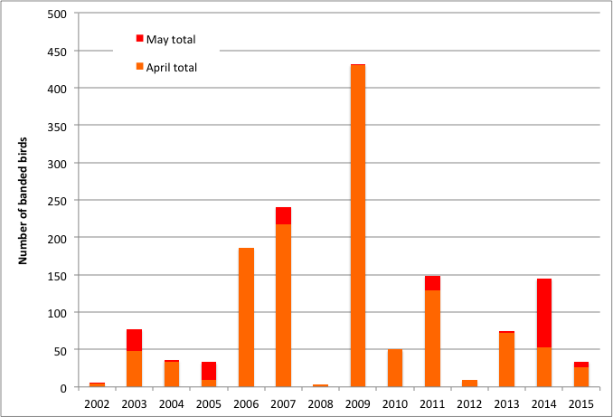

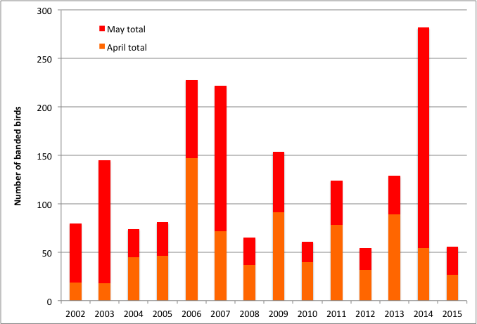
Figure 1. Numbers of banded Golden-crowned (top) and Ruby-crowned (bottom) Kinglets by month and year at Cabot Head Research Station, 2002 – 2015.

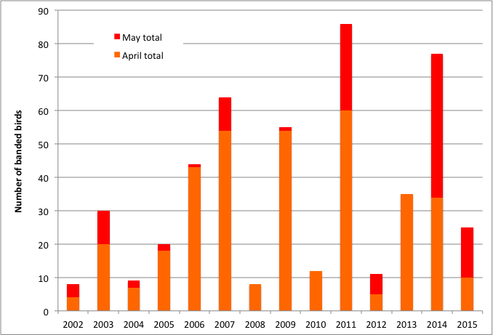

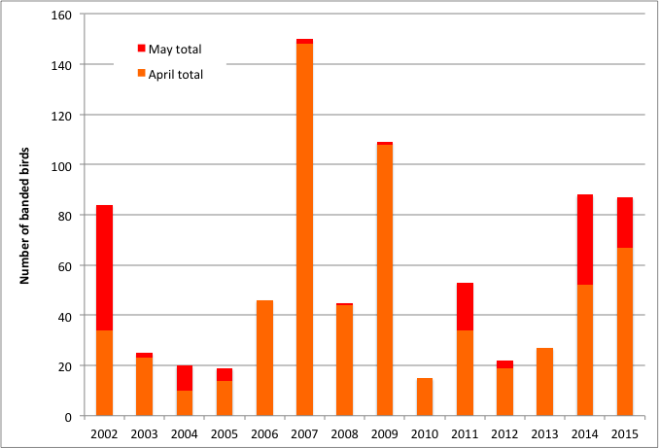
Figure 2. Numbers of banded Brown Creepers (top) and Slate-coloured Juncos (bottom) by month and year at Cabot Head Research Station, 2002 – 2015.

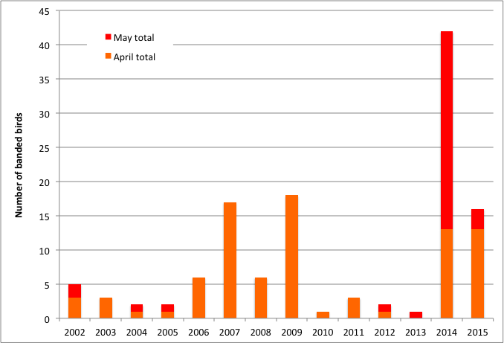
Figure 3. Numbers of banded American Tree Sparrows by month and year at Cabot Head Research Station, 2002 – 2015.

One Yellow-rumped Warbler, the earliest of the warblers, was detected on the first day of monitoring, April 19. Except for some individuals on April 21, Yellow-rumped Warblers were not seen again until April 25, but were detected daily afterwards for the rest of the month. Only one other species of warbler, the Pine Warbler, was detected in April this spring, with the first bird on April 29 and again on April 30. Afterwards, this species was observed almost daily until June 8. It was always only one individual, except on May 17 with 2 birds and May 21 with 3. A male Pine Warbler sings and holds a territory in the Jack Pines near the Pine Barrens. This is where it is detected almost every day at census, through its singing. It doesn’t seem that many more Pine Warblers migrate through Cabot Head. This spring, no other warblers were detected in April; an indication of how cold it was during this time.
As opposed to most years, there were no big movements of birds in April. It is usually a time when impressive numbers (with daily totals in the hundreds) of American Robins, Northern Flickers, Blackbirds, and Yellow-rumped Warblers are commonly seen. This spring, however, numbers were quite small in comparisons: Maximum Estimated Totals were of 75 American Robins on April 29; 130 Common Grackles on April 28; 100 Yellow-shafted Flickers and 50 Myrtle Warblers on April 30. No single day in April was prominent in its migration for these species. However, it happened on May 1, with ET of 120 American Robins, 200 Yellow-shafted Flickers, 100 Myrtle Warblers, 150 Slate-coloured Juncos, 100 Common Grackles, and 100 Red-winged Blackbirds! Likewise, migration of Sharp-shinned Hawk was notably slow in April, with daily Estimated Totals ranging from 2 to 5, except on April 21 and 30 with 20. The flow steadily increased into May, with notable, though small, peaks (ET of 50 birds on May 3, 13, and 17).
Waterfowl migration through the Great Lakes region typically peaks in March and April. As in 2014, the Great Lakes froze over during the winter of 2015, reaching a maximum of 93% of their entire area covered with ice in late March. Georgian Bay had still a lot of ice in mid-April when monitoring began, although the shoreline of Cabot Head and Wingfield Basin were clear of ice. However, a strong northwest wind blew lots of ice back to the shoreline on April 23. The ice extended from the shore to a couple of hundred meters outward (Photo 1), obviously diminishing the potential for staging waterfowl. The ice lasted 10 days along the shore until a strong south wind blew from the south on May 3 and pushed it away. Perhaps because of the ice conditions, very few waterfowl were observed this spring, despite a good observation effort (a standardized 5 minutes every hour of lake watch). Long-tailed Ducks were observed only in 7 days, with small numbers except on April 21 (ET of 50) and May 7 (ET of 24). Red-necked Grebes were seen off Cabot Head only in 3 days, again in small numbers. White-winged Scoters were observed on May 15, with 6 individuals, the only observation of scoters this spring. Buffleheads and Common Goldeneyes were more common, being present in Wingfield Basin in relatively good numbers until early May: maximum ET of 30 Buffleheads on April 24, last individual seen on May 28; maximum ET of 26 Common Goldeneyes on April 26. Surprisingly, a small flock of 7 male Goldeneyes was seen on June 7! Mergansers (a mix of migrants and residents) were observed throughout the entire spring. Hooded Mergansers are always observed in very small numbers on Wingfield Basin: they tend to use the shallower, marshier lakes closer to the bluffs. Very few Red-breasted Mergansers were seen this spring, with a maximum ET of 5 on April 26 and 29 and May 7. The biggest flocks of Common Mergansers were seen at the end of the season, with tight groups of mostly males feeding and resting together (maximum of 29 birds on June 8). It is likely that they are non-breeders or young.
The water level in Georgian Bay and Wingfield Basin is at its highest since 2002 (personal observation). Most of the rocks on the eastern side of the Basin are now underwater and cannot be used as roosting sites for gulls and cormorants as they used to. Thus, much smaller numbers of these species are seen now compared to previous years.

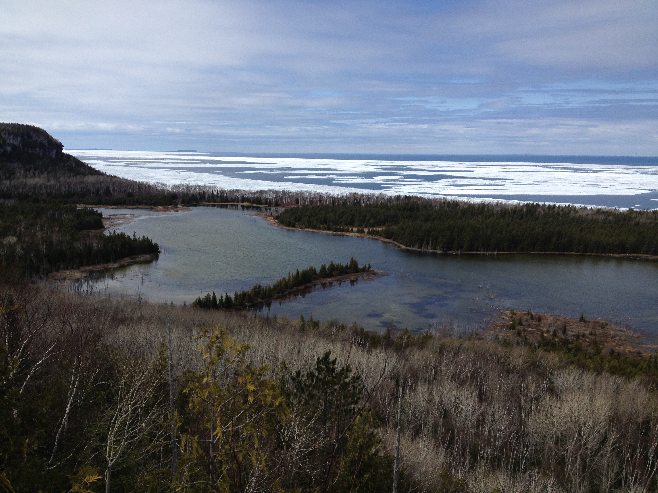
Photo 1: Ice extent off the shore of Cabot Head, with Compass Lake in the foreground and West Bluff to the left. Take on April 26, 2015.

May

May is usually the busiest and certainly the most diverse month for spring migration. This year, in May, 148 species were detected (97% of the season total), of which 28 species were detected only this month. A relatively low daily average of 50 species were detected in May but with a wide range: a low of 21 species on May 9 during a rainy, cold, and foggy morning; a high of 72 species on May 17. A total of 113 species were detected over the course of 5 days during the most diverse period, from May 14 to 18. A total of 582 birds of 55 species were banded in May, with American Redstarts the most common (16% of the total), followed by Magnolia Warblers, Swainson’s Thrush, and Western Palm Warblers (6% for each). As always, numbers caught on any given day were very variable: two “big days” (61 birds banded on May 7 and 64 on May 29), a few very slow days, and most days with 10 to 50 birds captured.
Weather during May was still cold most of the time, interspersed with a few warmer days. Frequent episodes of rain and/or of strong wind occurred throughout the month, precluding part or all of banding on 3 and 5 days, respectively. Fog was also a recurrent theme in May, with 7 mornings experiencing foggy conditions, sometimes mixed with rain. As a consequence of the inclement weather, only 75% of potential mist net hours were possible. Numbers of birds captured in May range from 2 (on May 30) to 64 (on May 29), with a daily average of 22 birds banded. Nets were opened only for an hour on May 30, as rain started in early morning; hence, the very low total for that day. As a contrast, the highest number of banded birds in May occurred the previous day, on May 29. It is possible that the incoming rain prompted a stronger movement of birds in the nights prior to the approaching depression.
Based on banding and ET, the 3-day period from April 29 to May 1 showed a strong movement of some early-spring migrants: 76 Slate-coloured Juncos were banded during these 3 days (with 18 on May 1), about 87% of the season total; a total of 14 Brown Creepers were banded on May 1, more than half the season total. It is also the highest one-day banding total in May for this species ever. The now second-highest daily banding total was in 2014, also a late spring, with 13 Brown Creepers in May 7; Golden-crowned Kinglets were remarkably sparse during this 3-day period, whereas 17 Ruby-crowned Kinglets (all males) were banded on April 29; 12 American Tree Sparrows were also banded on that day. As mentioned earlier, there was a strong visible migration on May 1 (see April for more details).
There is a strong sexual difference in migration timing in Ruby-crowned Kinglets: male Kinglets migrate at Cabot Head, on average, 15 days earlier than the females (see Menu, 2012). This spring, migration seemed to have been more compressed, with the banding peak for female Ruby-crowned Kinglets happening on May 7, only 9 days after the peak for the males: all 10 ruby-crowned kinglets banded that day were female.
After a poor showing of warblers in April, with only 2 species, there was a constant stream of arrivals in May: in the first week, 11 new species of warblers were detected, almost half the season total of 24 species of warblers. The usual early warbler species were seen in the first days of May: Palm Warbler on May 1; Black-throated Green Warbler on May 2; Northern Waterthrush on May 4. Another 7 species of warblers were first detected in the second week of May. More precisely, there was a “spurt” of arrivals in a short period of time: between May 6 and 8, 10 new species of warblers were detected at Cabot Head (Fig. 4). In mid-May, 20 species of warblers have been detected, a numerical expression of the bursting of life in spring. Even the last warblers to arrive were detected shortly after mid-May, with Blackpoll Warblers on May 15 and Tennessee and Wilson’s Warblers both on May 16. The last species of warblers to be detected this spring was the Mourning Warbler on May 24.
Diversity increased rapidly in the first part of May as many species arrive at this time on the upper Bruce Peninsula: numbers of species detected grew from 80 on April 30 (i.e., 52% of the season total) to 126 on May 14 (82% of the spring total). From May 15 to May 18, another 17 new arrivals were detected, bringing the total number of species detected to 93.5% of the spring total. The remaining 23 days of monitoring only brought 10 more new species, the so-called late migrants. Despite the constant stream of new arrivals, visible numbers of migrants in May, notably songbirds, were low: we did not experience any big “waves” of movement when one stood for hours in the driveway between the 2 cottages with a bad case of “warbler neck” as flocks after flocks of birds flitter through the treetops. It is possible that the persistent cold of the spring diminished the availability of food, mainly insects, at Cabot Heads, especially along the shoreline (always colder). Consequently, fewer flocks of hungry migrants would have roamed the area.
With the cold, fog, and rain, the bird migration in the spring of 2015 did seem late and slow. It was certainly the case in April but the rate of arrival in May was not outside the natural range of variation. For example, two species easily detected when present, Ruby-throated Hummingbird and Common Yellowthroat provide some perspective in fluctuations in arrival dates. This spring, they arrived, respectively, on May 7 and on May 15. The average date of arrival, based on the past 14 years, is May 8 for the hummingbird (range: May 3 in 2012; May 15 in 2003) and May 10 for the yellowthroat (range: April 29 in 2013; May 18 in 2005). This spring, thus, Ruby-throated Hummingbird’s first arrival was average, whereas it was the third latest date for first detection of Common Yellowthroat. It indicates, albeit with a small sample size, a great range of variations between years and species in timing of first arrival. A more thorough analysis, outside the scope of this report, would be interesting, especially if linked with weather data.
On May 18, a strong south wind was blowing, peaking at 7 on the Beaufort scale. It brought warm air but precluded opening of the nets. During that day, a total of 12 species of raptors were observed, missing only 3 other potential species. In spring, the Bruce Peninsula acts as a funnel to migrating birds of prey, especially for species depending on thermals, which are thus reluctant to fly over water where thermals do not develop. At Cabot Head, a strong south wind tends to push birds of prey closer to the shore, where raptors tend to concentrate, unwilling to cross Georgian Bay. On the particular day of May 18, diversity was certainly high but numbers were relatively low, most notably for Broad-winged Hawks, a species known for its large “kettles” (hawkwatch jargon for a flock of raptor gathering in a thermal, soaring together like a bubbling kettle). On May 18, only 10 Broad-winged Hawks were detected, alongside with 18 Turkey Vultures. Other regularly observed and expected species of raptors at this time of year were seen on that day: Red-tailed Hawk, with 4 individuals; Sharp-shinned Hawk, mostly immature with 11 birds. At Cabot Head, there is a pair of breeding Bald Eagles, which provided almost daily observation. This species was actually detected on 92.5% of all the days of the monitoring period, the 3rd highest detection rate (after Common Merganser and Ring-billed Gull)! It is no surprise then that a Bald Eagle was seen that day. A pair of Merlin is also breeding around Wingfield Basin and was seen on May 18 (although this species is not seen as often as the Bald Eagle, with observation on 77% of the period). The other species of raptors observed during this remarkable day are seen every spring at Cabot Head but in much smaller numbers (because of intrinsic rarity and/or early migration). They were: one Northern Harrier (seasonal total of 13 birds observed in 12 days, from April 21 to May 24); one Osprey (seasonal total of 10 birds observed in 9 days, from April 20 to June 5); one Rough-legged Hawk, the last of the season (seasonal total of 12 birds observed in 8 days, from April 21 with 5 different individuals to May 18). Between 2002 and 2014, a total of 194 Rough-legged Hawks were detected, 97% of them before May 18, but with the latest observation on June 10, 2005; one Peregrine Falcon, an immature, whereas all the other 9 observations this spring were of adult birds, including 2 birds on 2 occasions and 2 sightings of an adult carrying food flying toward West Bluff; finally, the last and 12th species of raptor was an immature Golden Eagle, the second only of the season (see Unusual records for more detail).
Swainson’s Thrushes, like most Catharus thrushes, are secretive birds of the undergrowth, difficult to detect when not singing. Consequently, most of the Swainson’s Thrushes detected in spring at Cabot Head are through captures. Most of the time, only a few thrushes are captured and/or observed in a day. Occasionally, a much higher number of Swainson’s thrushes are captured and/or detected in a day, due to particular weather conditions, special events called ‘fall-outs’. In spring 2015, it happened on May 28 when 20 Swainson’s Thrushes were banded, that is, 55% of the season total. It is worth emphasizing that these occasions are extremely rare. Between 2002 and 2015, there has been a total of 152 days in spring when Swainson’s Thrushes were banded. More than 90% of these days involve banding totals between 1 and 5 individuals. Only 11 days of banding involve more than 4 Swainson’s Thrushes, including 4 days with banding totals over 15 birds: 15 birds, on May 20, 2014; 21 on May 25, 2006; 26 birds on May 22, 2011; and this spring, as mentioned above, with 20 birds on May 28.
At the end of May, birds were starting to establish territories, singing and chasing potential competitors and mates. Migration always slows down at this time of year, with only the late migrants moving through. Weather continued to be extremely variable and changing fast: on May 29, an East wind started to blow with increasing haziness, harbinger of a depression to come. Possibly sensing the change in weather, there was more bird activity this morning, resulting in the second-highest banding total of the season (64 birds banded). The following day, May 30, it rained all day, accompanied by a ferocious wind from the southwest. With the depression moving through, the wind shifted first to the west, then to the northwest, where it was at dawn of May 31, bringing a sudden drop in temperatures (4C at dawn, 8C at noon!). That day, even with the full array of nets running for 6 hours (except for C13, closed because of its exposure to the wind), only 6 birds were captured!

Figure 4. Daily and cumulative numbers of species of warblers detected at Cabot Head Research Station in spring 2015. (MYWA: Myrtle Warbler; PIWA: Pine Warbler; WPWA: Western Palm Warbler; BTNW: Black-throated Green Warbler; NOWA: Northern Waterthrush; OVEN: Ovenbird; BAWW: Black-and-White Warbler; NAWA: Nashville Warbler; BTBW: Black-throated Blue Warbler; OCWA: Orange-crowned Warbler; CMWA: Cape May Warbler; NOPA: Northern Parula; AMRE: American Redstart; MAWA: Magnolia Warbler; BBWA: Bay-breasted Warbler; BLBW: Blackburnian Warbler; CAWA: Canada Warbler; CSWA: Chestnut-sided Warbler; YEWA: Yellow Warbler; COYE: Common Yellowthroat; BLPW: Blackpoll Warbler; TEWA: Tennessee Warbler; WIWA: Wilson’s Warbler; MOWA: Mourning Warbler; GWWA: Golden-winged Warbler)

June

Relative clement weather prevailed during the migration monitoring period in June, allowing excellent coverage, except for the last day, June 10, when strong wind and a fierce thunderstorm shut down banding. In the 10 days of monitoring in June, 93 species were detected (61% of the season total) with 2 species added this month to the seasonal total (Northern Mockingbird, and Oliver-sided Flycatcher). A daily average of 40 species were detected (range: 26 – 47 species seen on any given day). Despite the excellent monitoring conditions, the total numbers of banded birds for June are the third lowest (tied with 2014) since 2002. Only 102 birds of 27 species were banded with American Redstarts comprising 30% of the total, Yellow-bellied Flycatchers 14%, and Traill’s Flycatchers 7%. Between 2002 and 2014 (excluding June 2010 which had only 2 days of banding), an average of 162 birds are banded in June using June 10 as the last day of banding. The highest total was in 2003 with 275 birds banded and the lowest was in 2012 with 77.
Yellow-bellied Flycatcher is one of the latest migrants arriving on our shores, with, typically, the first birds showing up at the end of May. Indeed, it is a species with one of the shortest stays in its breeding grounds, its fall migration starting in early August. The first Yellow-bellied Flycatchers were detected on May 28 this spring, a late date: it is the third-latest arrival date (tied with 2002). The earliest arrival was noted on May 20 (in 2004, 2009, and 2012), while the latest was on May 31 in 2014. This spring, on May 29, an unusually high number of them were banded: with 8 birds banded, it is the second-highest daily total ever. In 2012, 9 Yellow-bellied Flycatchers were banded on May 28. At the end of the 2015 spring season, a total of 24 yellow-bellied Flycatchers were banded. It is the highest spring total ever for this species, eclipsing by only 2 birds the previous record of 22 in spring 2005. On June 3, 4 species of Flycatchers were banded, a rare occurrence. The Olive-sided Flycatcher was not captured this spring, though, and heard only once on June 6.
The first Black-billed Cuckoos were heard on May 29 and on 4 more days in June. One adult was caught and banded on June 7, the first banded in spring since 2009 (Photo 2). This species has been captured only in 4 other springs, with a maximum of 4 birds in 2008.
Large flocks of Canada Geese were seen in June, with ETs of several hundreds between June 3 and 7. These late movements are a moult migration, when failed breeders and non-breeders go north to a remote location to moult their flight feathers all at once. Being then flightless and very vulnerable to predators, they find solace by being in large groups, close to a large body of water like James Bay, in areas with potentially less predators.
During the last week of banding, the birds detected were mostly singing, establishing territories and building nests. Most males caught at this time (especially American Redstarts) had a well-developed cloacal protuberance, but only 5 birds showed a brood patch. A male Hairy Woodpecker and a male Yellow-bellied Sapsucker both had a brood patch: in woodpeckers, both sexes incubate and develop a brood patch. The other birds with a brood patch were a Hermit Thrush and a Nashville Warbler, both captured on June 5, and a recaptured Black-capped Chickadee on May 28. A female Black-throated Green Warbler was caught with a few strands of dry grass next to her in the net: she was carrying nest material when she hit the net! It was definitively a sign that migration was finally slowly winding to a close.

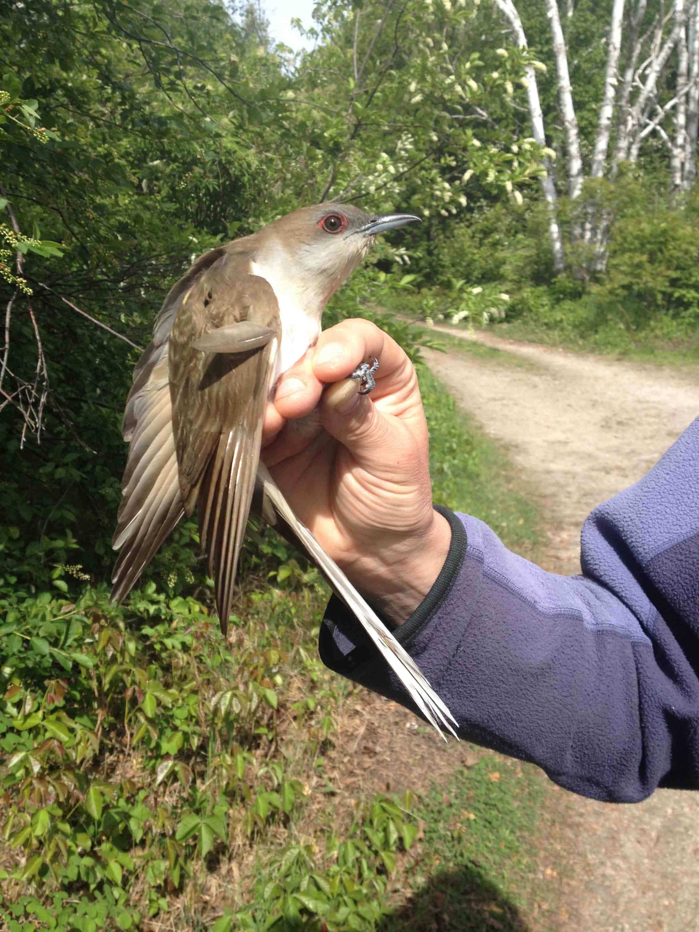
Photo 2: The Black-billed Cuckoo captured on June 7.

3.0 Unusual Records

No new species was added for the Cabot Head area this spring. There are many ways an observation can be considered an unusual record at Cabot Head: a bird out of range; a bird with an overall low population on the Northern Bruce; a bird which preferred habitats are not present at Cabot Head; a bird which is rare overall, either at provincially or continentally levels.
One American Black Duck was seen on April 19 this spring, the 4th spring only when this species was observed (2011, 2013, and 2014 were the other springs). A little flock of 4 American Widgeons was seen flying over Wingfield Basin on May 2. It is a more common of waterfowl, with sightings in 7 other springs between 2002 and 2014. An American Bittern was seen on census on May 4; usually heard more than seen, it was missed only in 5 springs.
Cooper’s Hawks and Northern Goshawks are the largest Accipiter and are not seen often at Cabot Head. Cooper’s hawks were observed only twice this spring, on April 30 and May 13. This species has been seen almost every spring (missed in 2004 and 2007) but only with 2 to 9 days with observations. Surprisingly, there were more observations of Northern Goshawk this spring: on April 19 and 28, and on May 18, when a young mobbed briefly a Red-tailed Hawk. As the Cooper’s, it was missed only during 2 springs but otherwise was detected only a few days each season. Golden Eagles have been seen every spring, except in 2002, 2013, and 2014. This spring, only 2 observations were made, both of immature: on April 21 and on May 18. This later date is only the 3rd observation after May 7, the other ones being on May 25 and 29 of 2011.
Chimney Swifts are fast flying, cigar-shaped, birds of the ether. They only perched at their breeding site, either deep in a chimney, or, extremely rarely these days, in a big, hollowed-out tree trunk, their original breeding place. As the other members of the aerial insectivore guild, its population is declining. If detected at all at Cabot Head, it is usually a few seconds of high-speed interaction. This spring, observations of one individual happened on May 8 and 29. Despite the intrinsic difficulties of detection, this species was not seen only in 3 springs.
Another declining species across southern Ontario, an adult Red-headed Woodpecker was observed briefly on May 21. This species has been observed in 8 years, with sightings every spring since 2011. A captured male Northern Flicker had a black moustache with a thin strip of red in it, although every shaft of its wing and tail feathers was yellow (Photo 3).
Horned Larks are birds of open spaces, as much at home in ploughed fields of southern Ontario as in treeless tundra. Usually migrating in a group, a lone bird was observed on the shore on May 16. It has been observed in 6 previous springs, from April 18 to May 27, with the biggest group observed of 25 birds on May 15, 2005. One of the captured Palm Warblers, a drab species even in spring, had an unusual greater covert, black with a brown corner (Photo 4).
Wood Thrush is detected every spring at Cabot Head, although the habitats surrounding the research station are not its preferred ones. This year, 2 young and one adult were banded throughout May. Another species at the limit of its range is the Northern Mockingbird, observed this spring at the very end of the monitoring period, on June 7 and 9. The Northern Mockingbird was observed in 9 out of the 13 previous springs (but banded only once!).
A Golden-winged Warbler was banded on May 29. Like the previous species, it was missed only in 4 springs. It is detected usually only once or twice by season, with the exception of 3 times in 2002 and 4 times in 2012. A Clay-coloured Sparrow was banded on May 7, the only “observation” of the spring for this species. A very common bird in the western prairies, its breeding range extends a narrow finger into the Great Lakes. It is detected only in very small numbers and occasions at Cabot Head and was completely missed in 2006, 2008, 2010 and 2012.
The most unusual bird this spring was a young male Orchard Oriole, seen feeding in a cedar treetop alongside an adult male Baltimore Oriole on May 15. It is the 3rd sighting ever of this species at Cabot Head, with previous sightings being on May 24, 2002, and on April 29, 2004. In Ontario, Orchard Orioles breed in a thin band along Lakes Erie and Ontario.
Some Evening Grosbeaks were heard, but not seen, during census on April 29. A highly mobile seed-eater, it migrates early and is easily missed at Cabot Head, where it was observed in only 6 other springs.
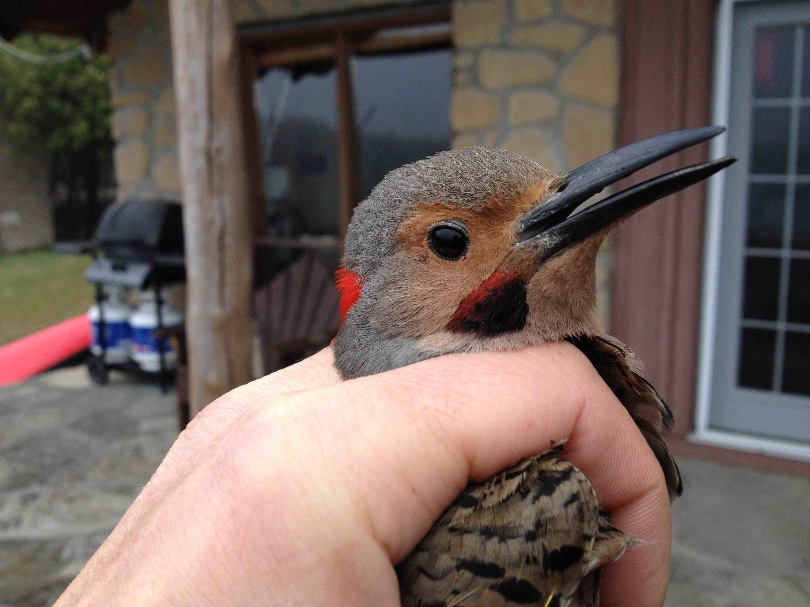
Photo 3: A potential intergrade Flicker with a black and red moustache.

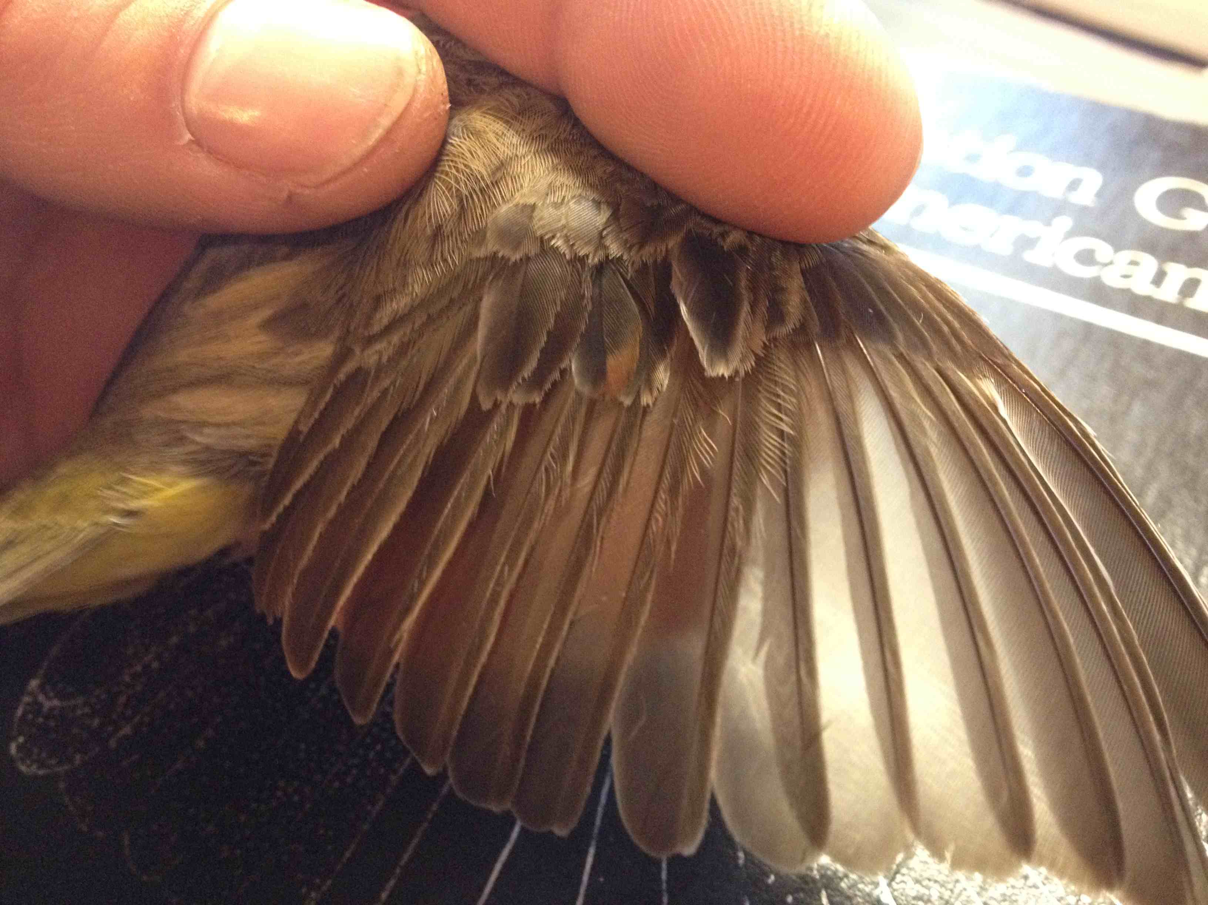
Photo 4: View of the Palm Warbler wing, with an unusual great covert (red arrow).

4.0 Banding Data Analysis

Spring 2015 has the lowest banding total since migration monitoring started in its present form in 2002 with 876 birds banded of 61 species (Table 1). It is almost 300 birds less than the previous lowest total of 1145 birds in spring 2010 (banding average of birds captured in mist nets: 1504 ± 383 birds). It is most definitively a below-average season, with 10 of the banded species having the lowest total ever and an additional 20 species having below-average total. This spring, 9 species that are otherwise regularly captured were not captured at all, including: Yellow Warbler banded in every spring prior; Indigo Bunting and Blackburnian Warbler missed previously in only one spring; Savannah Sparrow, Blue-headed Vireo, and Cape May Warbler banded in 11 springs out of 13; etc. It is quite striking that so many species were not captured, so many were captured in record low numbers, and that the spring total is so low.
Spring 2015 will now stand as an outlier in the migration monitoring at Cabot Head, in the same – but opposite – way than spring 2002, which still holds the highest banding record, with 2419 birds banded. As for spring 2002, it is likely a combination of factors that lead to the low total. The persistent cold weather of the spring must have had an impact, especially in the emergence, abundance, and activity of insects, a main source of food for many migrants. With a potential paucity of food, migrant birds in need of replenish their fat reserves during the day might have stayed at Cabot Head only for a short time or bypassed the area completely.
Only 3 species (in decreasing order), American Redstart, Slate-coloured Junco, and Ruby-crowned Kinglets account for 30% of the banding total. Typically, only a few species are captured in numbers over 50 individuals while most species are banded in low to very low numbers (Table 2).
Numerous variables could affect the capture rates: population dynamics, weather conditions during migration, vegetation changes at the site, food availability, etc.
Capture rates varied greatly on a weekly basis (Figure 5; NB: 2012-2014 data are not available in an electronic format and are thus not included in the following analysis). The capture rate is determined by dividing the number of birds caught in a net, or a group of nets, by the number of hours for which the net or nets were operated. Thus, variation in capture rate reflects variation in those two parameters, which are themselves dependent upon various conditions (weather being the major one). Mist net hours are primarily lost when weather conditions (i.e. rain or strong wind) are unsafe to birds in nets, forcing net closure. Spring 2002 is not included in the average as this season was highly unusual in terms of capture. In spring 2015, weekly capture rates were very low throughout the season, with only the last week of April and first week of May having capture rates around average. Oddly, these 2 weeks had the highest capture rate in spring 2015, while capture rates usually peak in mid-May.
Weekly numbers of banded birds were well below average for most of the season, except during the last week of April (Figure 6). The first week of monitoring is extremely variable: many birds can be missed if it is an early spring and many mist net hours can also be lost due to bad weather. Weekly banded totals for this week has ranged from 15 in 2004 to 640 in 2009. With 19 birds banded during this week in 2015, it is the second-lowest total ever. It should be noted, though, that banding started only on April 20 and only 1 day of banding was possible during this truncated week of bad weather. Maybe as a consequence of the blocked migration, the following week has the 5th-highest ever number of birds banded, with 175 birds. The first week of May showed a slightly below-average banding total of 113 birds. Extreme variations in number of banded birds occur during this week, with a low of 35 birds in 2008 and a high of 648 birds in 2014! The rest of the 2015 season experienced lower than average numbers of banded birds, with record-breaking lows: the second-lowest total of 113 birds in May 8-14 (111 birds in 2010); the lowest ever in May 22-28, with 110 birds; and only 40 birds, another all-time low in the last week of monitoring.
In spring 2015, 77% of the potential mist net hours were realized, compared to 58% to 92% for the other springs (no data for 2012-2014). Except for the truncated first week of monitoring, weather conditions were generally very favourable this spring for banding, resulting in a high percentage of realized mist-net hours (Figure 7). Rain, snow, and/or wind precluded any banding on 9 days, about 17% of the monitoring period, with 3 of these days during the first week. For the rest of the season, conditions allowed for a near-complete banding operation (all 15 mist nets opened for 6 hours) during over 70% of the monitoring period. Coverage was thus excellent this spring: the low numbers of birds banded are definitively not due to a lack of trying capturing them! Daily numbers of banded birds at Cabot Head show extreme fluctuations, reflecting weather conditions and, at least to some extent, the high variability in volume of migrants aloft (Figure 8).

Table 1. Banding total of species in spring 2015 at Cabot Head Research Station, average (and standard deviation) over 2002-2014, maximum and minimum totals and their respective year.
Species | 2015 | Average | stdev | Max | Year | Min | Year*
Sharp-shinned Hawk | 25 | 18 | 7 | 34 | 2011 | 10 | 2004-2005
Black-billed Cuckoo | 1 | 2 | 1 | 4 | 2008 | 1
Yellow-bellied Sapsucker | 1 | 2 | 1 | 5 |  | 1
Hairy Woodpecker | 1 | 2 | 1 | 3 | 2010 | 1
Yellow-Shafted Flicker | 5 | 5 | 3 | 12 | 2007 | 1
Eastern Wood-pewee | 3 | 2 | 1 | 3 |  | 1
Yellow-bellied Flycatcher | 24 | 13 | 7 | 22 | 2005 | 3 | 2014
Traill’s Flycatcher | 16 | 16 | 9 | 32 | 2009 | 4 | 2014
Least Flycatcher | 9 | 15 | 5 | 22 | 2004 | 8 | 2006
Eastern phoebe | 5 | 4 | 3 | 10 | 2009 | 1
Philadelphia Vireo | 1 | 3 | 2 | 6 | 2009 | 1
Red-eyed Vireo | 13 | 15 | 6 | 31 | 2013 | 9 | 2010
Blue Jay | 24 | 32 | 24 | 88 | 2004 | 10 | 2011
Black-capped Chickadee | 2 | 56 | 97 | 342 | 2002 | 4 | 2003-2005
Red-breasted Nuthatch | 5 | 8 | 8 | 25 | 2013 | 1 | 2012-2014
Brown Creeper | 25 | 34 | 27 | 86 | 2011 | 6 | 2002-2009
Winter Wren | 4 | 2 | 1 | 3 | 2004-2008 | 1
Golden-crowned Kinglet | 34 | 109 | 122 | 431 | 2009 | 3 | 2008
Ruby-crowned Kinglet | 56 | 128 | 70 | 258 | 2014 | 54 | 2012
Veery | 6 | 10 | 6 | 21 | 2006 | 1 | 2002
Gray-cheeked Thrush | 3 | 3 | 2 | 8 | 2010 | 1
Swainson’s Thrush | 36 | 26 | 10 | 43 | 2011 | 12 | 2004
Hermit Thrush | 17 | 14 | 4 | 21 | 2007 | 6 | 2004
Wood Thrush | 3 | 2 | 1 | 5 | 2006 | 1
American Robin | 1 | 8 | 4 | 15 | 2014 | 3 | 2008
Gray Catbird | 5 | 11 | 4 | 18 | 2006 | 3 | 2013
Brown Thrasher | 3 | 6 | 3 | 12 | 2008 | 2 | 2007
Cedar Waxwing | 1 | 9 | 8 | 21 | 2009 | 1
Golden-winged Warbler | 1 | 2 | 1 | 4 | 2012 | 1
Orange-crowned Warbler | 6 | 9 | 8 | 29 | 2002 | 1 | 2014
Nashville Warbler | 23 | 50 | 55 | 227 | 2002 | 18 | 2004
Chestnut-sided Warbler | 5 | 15 | 5 | 26 | 2002 | 8 | 2008
Magnolia Warbler | 36 | 98 | 36 | 184 | 2002 | 53 | 2013
Black-throated Blue Warbler | 18 | 28 | 12 | 64 | 2003 | 18 | 2005
Myrtle Warbler | 16 | 68 | 61 | 244 | 2002 | 21 | 2011
Black-throated Green Warbler | 26 | 25 | 6 | 38 | 2002 | 15 | 2005
Pine Warbler | 1 | 2 | 1 | 4 | 2002-2011 | 1
Western Palm Warbler | 34 | 75 | 51 | 216 | 2002 | 37 | 2014
Species | 2015 | Average | stdev | Max | Year | Min | Year*
Bay-breasted Warbler | 1 | 4 | 4 | 11 | 2002 | 1
Blackpoll Warbler | 1 | 2 | 1 | 4 | 2002 | 1
Black and White Warbler | 25 | 55 | 16 | 85 | 2014 | 31 | 2008
American Redstart | 124 | 185 | 36 | 273 | 2009 | 146 | 2011
Ovenbird | 12 | 29 | 7 | 40 | 2002 | 19 | 2011
Northern Waterthrush | 3 | 5 | 3 | 13 | 2010 | 1 | 2008
Mourning Warbler | 4 | 9 | 4 | 17 | 2009 | 2 | 2014
Common Yellowthroat | 26 | 37 | 13 | 56 | 2002 | 23 | 2007-2012
Wilson’s Warbler | 4 | 16 | 7 | 32 | 2002 | 6 | 2014
Canada Warbler | 11 | 18 | 4 | 24 | 2013 | 11 | 2008
American Tree Sparrow | 16 | 8 | 12 | 42 | 2014 | 1 | 2010
Chipping Sparrow | 5 | 16 | 10 | 47 | 2002 | 7 | 2008
Clay-coloured Sparrow | 1 | 2 | 1 | 2 | 2002-2013 | 1
Fox Sparrow | 1 | 2 | 1 | 4 | 2009 | 1
Song Sparrow | 6 | 12 | 6 | 26 | 2009 | 4 | 2010
Lincoln’s Sparrow | 6 | 12 | 6 | 25 | 2005 | 4 | 2012
Swamp Sparrow | 3 | 5 | 2 | 9 | 2009 | 3
Eastern White-crowned Sparrow | 10 | 57 | 20 | 69 | 2005 | 4 | 2011
White-throated Sparrow | 30 | 53 | 41 | 91 | 2005 | 25 | 2004
Slate-coloured Junco | 87 | 4 | 2 | 150 | 2007 | 15 | 2010
Rose-breasted Grosbeak | 1 | 2 | 1 | 8 | 2014 | 1 | 2007
Pine Siskin | 1 | 6 | 12 | 3 | 2009 | 1
American Goldfinch | 3 | 23 | 17 | 41 | 2002 | 1
Total | 876 | 1540 | 422 | 2610 | 2002 | 1145 | 2010
Highest and lowest totals for 2015 highlighted in red and blue, respectively.
stdev: standard deviation.
*: no date indicates multiple years with this total.

Table 2. Number of species banded in spring 2015 at Cabot Head Research Station according to their banding total.
Banding total | 1 - 10 | 11 – 50 | 51 – 100 | 101 – 200
Number of species | 37 | 21 | 2 | 1

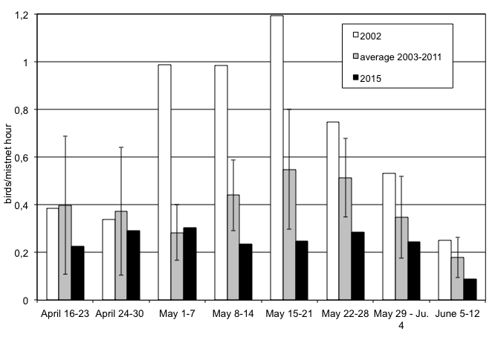
Figure 5. Weekly capture rates at Cabot Head Research Station for springs (2002, average 2003-2008 and 2015). Error bars show Standard Deviation.
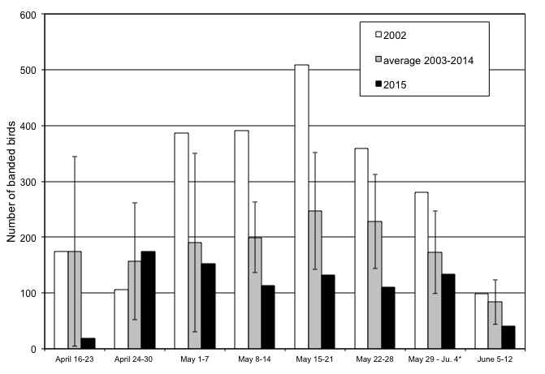
Figure 6. Weekly number of banded birds at Cabot Head Research Station for springs (2002, average 2003-2008 and 2015). Error bars show Standard Deviation.
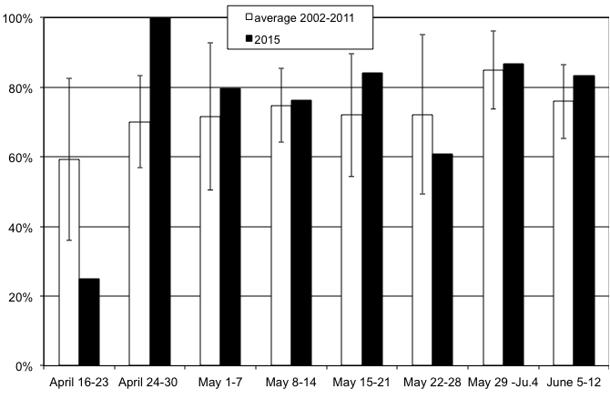
Figure 7. Weekly proportion of realized mist net hours at Cabot Head Research Station for springs (average 2002-2007 and 2015). Error bars show Standard Deviation.
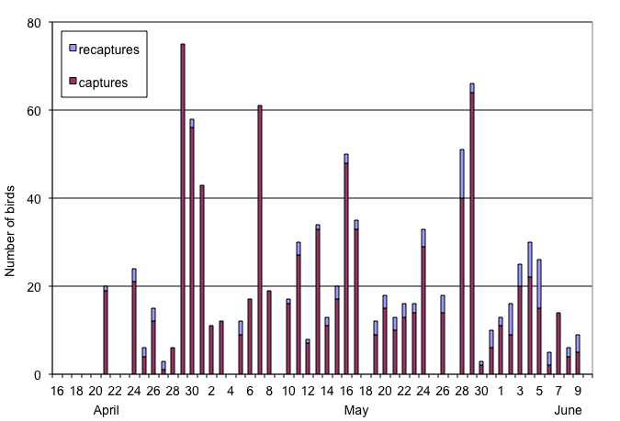
Figure 8. Daily number of captured and recaptured birds at Cabot Head Research Station, spring 2015.

4.1 Weather

As mentioned earlier, the weather was extremely variable this spring, but usually cold. The notable characteristics of the spring were many periods of precipitation, fog, and/or strong winds. There were 7 days with recorded precipitation, sometimes heavy and lasting all day, during the count period, with 3 more days of rain occurring in afternoon and/or evening. Spring 2015 was also characterized with frequent foggy conditions during the monitoring period: a total of 9 days experienced fog, sometimes heavy, sometimes just drifting in and out. Rain was associated with fog in 4 of these days. Fog could sometimes help in capturing birds, as birds tend to get grounded and disoriented. There were 4 days with fog when all the nets were up and running for 6 hours. However, captures were high only in one of these occasions, on May 16, with 48 birds banded. Periods of high wind also occurred very frequently this spring, mostly in May: storm-force winds (5 or more on the Beaufort scale) occurred in 19 days (15 in May), i.e. about a third of the season! These strong winds did not last all the time during the entire morning but they nonetheless affected banding operations, as nets in their paths had to be closed. Half of the storm-force winds were from the south, bringing warm, humid air to the Peninsula and were often followed by periods of precipitation and/or fog.
With rain, wind is a major factor that influences migration. It is difficult to accurately quantify such a dynamic component of the weather, especially because wind strength and direction are recorded only at the start and end of the count period. To characterize wind strength (on the Beaufort scale) and direction, we considered only the strongest wind during the count period of 7 hours. Undoubtedly, this method would tend to over-represent strong winds. However, strong winds affect migration tremendously and their effect could probably be felt before they develop into a full windstorm. This spring, strong winds (at least 5 on the Beaufort scale) occurred on 19 days (36% of the season), about half of them from the south. Another third of the season experienced moderate wind (3 to 4 on the Beaufort scale). Therefore, most of the monitoring period experienced strong or moderate winds. It is also noteworthy that winds were almost perfectly divided evenly among the 4 cardinal directions this spring (Figure 9).

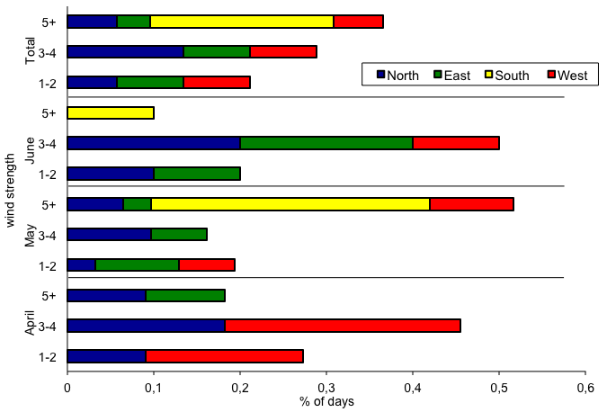
Figure 9. Wind pattern (strength on the Beaufort scale, direction and proportion of time) at Cabot Head Research Station, spring 2015.

4.2 Recaptures

The rate of recapture (recaptures include birds banded within the spring season and birds from previous years or other locations) at Cabot Head was relatively low in spring 2015. There were a total of 113 recaptures for 59 individuals of 18 species from April 21 to June 9. Among the recaptured birds this spring, 24 individuals of 5 species were banded in previous seasons at Cabot Head and 5 American Redstarts and one Black-capped Chickadee were “foreign recaptures”, that is, banded at another location. Over half of the recaptured birds (34 individuals) were recaptured only once but 15 birds were recaptured on more than 2 occasions, with a Black-capped Chickadee recaptured a record 8 times. Most birds recaptured 3 times or more were American Redstarts (11 birds), being certainly local breeders at Cabot Head. The other birds, beside the already mentioned Chickadee, are another Black-capped Chickadee recaptured 3 times; a Black-throated Green Warbler, recaptured 4 times; and a Rose-breasted Grosbeak, also recaptured 4 times. Besides American Redstarts, the low rate of multiple recaptures demonstrates that birds are not heavily using this site as a stopover location for rest and refueling in the spring.
The Black-throated Warbler recaptured 4 times was initially banded this spring on May 28, weighing only 7.9 g, the second-lowest weight of the 26 birds of this species captured this spring (average of 8.62 ± 0.49 g; range: 7.3 – 9.4; n = 26). Its weight increased at each recaptured, reaching 10.3 g (and a fat score of 3) on June 5, its last recapture, 8 days after its initial capture. The other 2 Black-throated Warblers banded and recaptured once during the spring did not show such a difference in their weight.
Only one Rose-breasted Grosbeak was banded this spring, a second-year male, on May 10. It was afterward seen often feeding on the dried berries on trees around the nets A1 and A2 and was also recaptured 4 times. It was last recaptured on May 17. During these 8 days, there were 3 days of rain and 2 days of fog, with weather being generally cold. The grosbeak weighed 40 g at first capture, maintained its weight around 38 g for the first 3 recaptures, but its weight dropped to 36.5 g when it was last recaptured on May 17. Its ultimate fate is unclear but losing almost 10% of its weight in such a short period of time does not bode well.
The two Black-capped Chickadees recaptured multiple times this spring were local breeders: on their last respective recapture, one showed a developing brood patch, enabling us to determine it as a female; the other one had a cloacal protuberance, which males develop in spring during breeding season. It is the male that got recaptured 8 times: males tend to move more than females as they patrol their territory. Both individuals were already present at Cabot Head last fall: the male, of foreign origin, was captured on September 3 and the female was banded as a hatch-year on October 7.
Of the 29 American Redstarts recaptured this spring, only 6 were newly banded (i.e. from spring 2015), 5 are of “foreign” origin, and the remaining 18 were banded in the previous seasons at Cabot Head, mostly in the previous 2 years. The oldest known recapture this spring is of an American Redstart banded as an after-second-year female in spring 2011, thus at least 6 years old. Age and sex composition of recaptured American Redstarts differs greatly from the one of newly captured individuals (Figure 10). No young American Redstarts banded last fall were recaptured this spring, whereas about half of the newly captured birds this spring are second-year birds. Among recaptured redstarts banded in previous years, males were more than twice as many than females. In contrast, after-second-year redstarts first captured this spring are evenly divided between male and female. If returning birds are local breeders, it is possible that males are more often captured as they establish territory, chase other males, and in general move more than females. It is also possible that site faithfulness is stronger in males or that there is a differential mortality among sexes in the wintering grounds, where adult males tend to occupy the best quality habitats, fiercely excluding young and females from them.

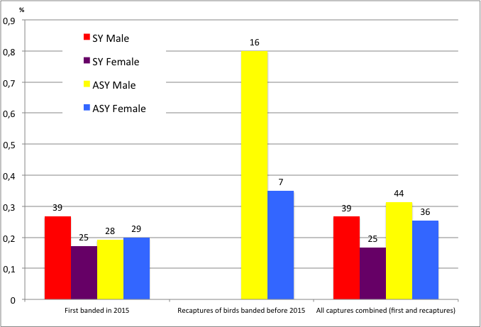
Figure 10. Age and sex composition of captures and recaptures (according to time of capture) of American Redstarts at Cabot Head in spring 2015 (sample sizes on top of bars).

Birds banded in previous years and recaptured in the spring are most likely local resident breeders, such as American Redstarts (18 birds, banded between 2011 and 2014), 2 Red-eyed Vireos from fall 2013, 2 Black-throated Green Warblers banded in 2014, and 2 Black-capped Chickadees originally banded/recaptured in the previous fall (Table 3).

Table 3. Total recaptures by species in relation with the year of banding. (Only one recapture per individual is included and within-season recaptures are excluded)
Species | 2011 |  | 2012 |  | 2013 |  | 2014 |  | Foreign recapture | Total
 | S | F | S | F | S | F | S | F
Red-eyed Vireo |  |  |  |  |  | 2 |  |  |  | 2
Black-capped Chickadee |  |  |  |  |  |  |  | 1 | 1 | 2
Red-breasted Nuthatch |  |  |  |  |  |  |  | 1 |  | 1
Black-throated Green Warbler |  |  |  |  |  |  | 1 | 1 |  | 2
American Redstart | 1 |  | 1 |  | 3 | 6 | 3 | 4 | 5 | 23
Total Recaptures | 1 |  | 1 |  | 3 | 8 | 4 | 7 | 6 | 30
Species Total | 1 |  | 1 |  | 1 | 2 | 2 | 3 | 2 | 5
S: spring; F: fall.

Case study: the Amazonian Red-eyed Vireo
Red-eyed Vireos arrive at Cabot Head in mid-May after spending the winter in the Amazon Basin. They spend a lot of time high up in the canopy, which makes them elusive to capture. Nonetheless, from 2002 to 2015, a total of 220 Red-eyed Vireos have been captured at Cabot Head in spring. The vast majority of birds of known age captured in spring are after-second-year birds (78% of 156 individuals). Determining age is not so easy in spring, as it is based on very subtle differences in wear and tear in wing feathers, compared to fall when red eyes mean adult and brown eyes mean a young bird. It is unfortunately possible that some birds’ age is not determined correctly in spring, with a higher chance of mistaking an after-second-year bird for a second-year. For example, half of the 12 birds aged in spring 2003 were determined second-year, the highest percentage along with spring 2014, possibly due to some lack of experience from the banders. Still in spring 2014, 2 of the 3 recaptured vireos were wrongly determined to be second-year birds: at time of banding in the previous fall, they were identified as after-hatch-year by eye colour, which makes them after-second-year birds in spring.
Compared to 16 other songbirds species banded in spring in good numbers, Red-eyed Vireos have by far the lowest proportion of second-year birds (22%; Fig.11). All the other species have more than half – and up to 82% - of second-year birds in the spring capture, even for species difficult to age (Ovenbird, Canada Warbler, Mourning Warbler, for example).
From 2002 to 2014, in both spring and fall seasons, a total of 1375 red-eyed vireos have been banded at Cabot Head (85% banded in fall). Of them, 30 individuals have ever been recaptured in spring at Cabot Head, i.e. a recapture rate of 2.2%. Proportionally, more birds banded in spring are recaptured in spring (9 birds out of 30, that is, 30%). There is an even split in recaptured birds regarding timing of banding: about half the recaptured birds were banded in the previous year (spring or fall) of their recapture; and the other half was banded 2 or more years before recapture. The most remarkable recapture is a Red-eyed Vireo that was banded as an after-second year in spring 1998 at the Cabot Head Lighthouse. Never recaptured until spring 2006 at Cabot Head, it was at least 10 years old at the time of its recapture! What is also remarkable is that so few young birds (i.e. second-year) are recaptured in spring: only 2 birds out of the total of 30 recaptured vireos. More precisely, of a total of 1059 hatch-year birds banded in the fall, only two of them were ever recaptured the following spring, an “immediate” return rate of 0.2%. In sharp contrast, of the 75 adult vireos banded in the fall, 10 of them returned the following spring, an “immediate” return rate of 13%.
In short, the migration monitoring at Cabot Head provides convincing evidence that very few young (i.e. second-year) Red-eyed Vireos return to the Bruce Peninsula the following spring after their birth. Since it is difficult to imagine that so many young birds die overwinter, the obvious question is then: where are they? Where do they spend their second summer? Do they stay in the Amazon?

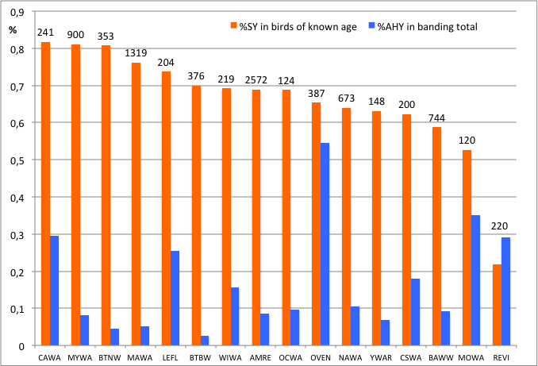
Figure11: Proportion of second-year birds among birds of known age (second-year and after-second-year birds) and of after-hatch-year birds in banding totals in spring banding at Cabot Head from 2002 to 2015 in a selection of species. Numbers of banded birds are on top of bars.
CAWA: Canada Warbler; BTNW: Black-throated Green Warbler; MYWA: Myrtle Warbler; MAWA: Magnolia Warbler; LEFL: Least Flycatcher; BTBW: Black-throated Blue Warbler; AMRE: American Redstart; WIWA: Wilson’s Warbler; OCWA: Orange-crowned Warbler; OVEN: Ovenbird; NAWA: Nashville Warbler; YWAR: Yellow Warbler; CSWA: Chestnut-sided Warbler; MOWA: Mourning Warbler; REVI: Red-eyed Vireo.

4.3 Net Analysis

Mist net locations at Cabot Head have been permanently set in place and any changes to this array will have to be carefully considered with respect to protocol and existing data sets. The standard net array in spring, 2015 has not been changed since 2002 and is located primarily in forest edge assemblages although a few nets are in relatively open, shrub habitat (A1-2, B8, & C14). As usual, there was a significant amount of variation in capture rates for each net (Figure 12; no electronic data for 2012-2014). The five nets with the highest capture rate (A1 & 2, B9, C15, and A3, in decreasing order) were scattered throughout the net array but with the best nets located in or close to the shrubby areas. The least productive nets this spring were the usual ones (A5, B6, B7, C11, and C12). Unlike most springs, captures were more spread out across nets this spring, as the five best nets accounted for only 44% of the total capture instead of about 60%. The bottom 5 nets still accounted for only 12%. All nets have approximately the same numbers of hours in operation. Almost all nets have capture rates below average, except for C11. This spring, beavers have cut down a number of small trees (chokecherries and birches) in the proximity of nets A1 and A2 before monitoring started. Our presence might actually have stopped them, as a half-chewed birch remained standing (Photo 5). It remains to be seen how – if any – that could affect the capture rates of these nets in the future. This spring, capture rates for A1, especially, and A2 are below the 2003-2011 average. However, all nets have very poor capture rates, including C15. That net, definitively not affected by any beaver activity, has a capture rate in spring 2015 almost half of the long-term average.
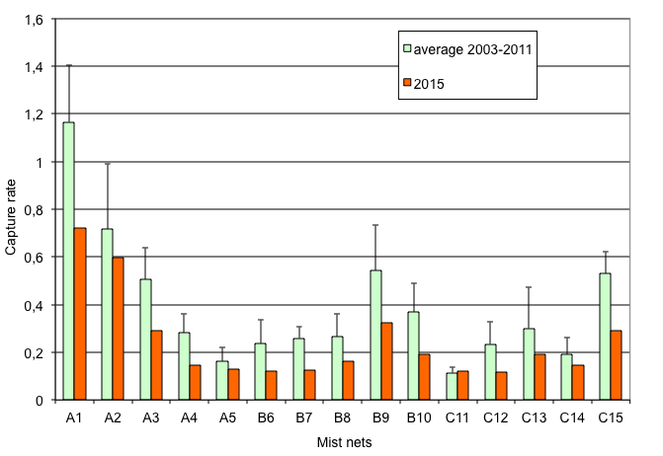
Figure 12. Capture rates per mist net for springs (average 2003-2011 and 2015). A1-C15 are net codes referring to specific net locations.

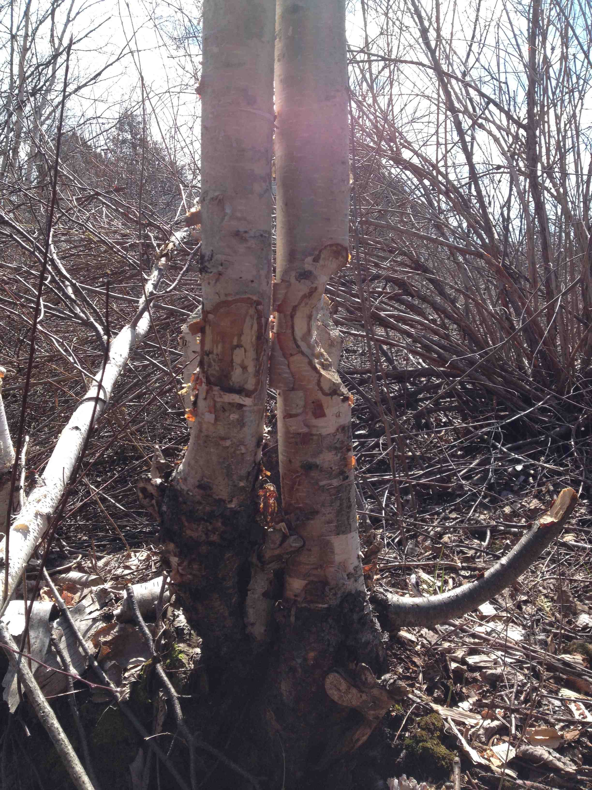
Photo 5: Birches still standing near A1.

5.0 Mist net coverage

Despite frequent bad weather (rain and south), only about 22% of mist netting coverage (in hours) was lost. This spring, there were an above-average number of days with complete coverage (27 out of 52, i.e. 52%)(Figure 13). There were 9 days of no mist net coverage, the third highest since 2003 (range of 1 to 11 days with no banding from 2003 to 2011). Due to the density of habitat at Cabot Head, at least a portion of the nets can usually be operated on windy days.
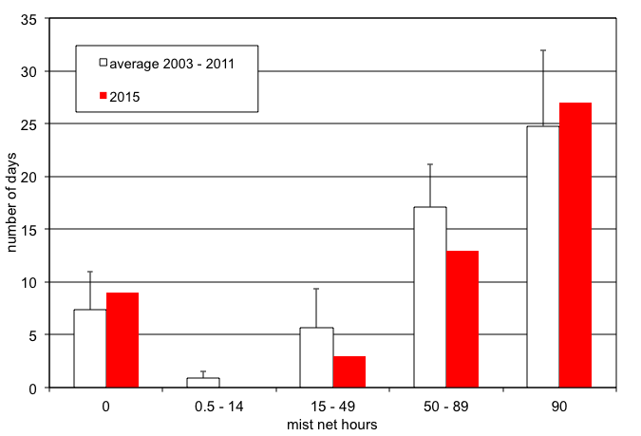
Figure 13. Coverage (in mist net hour) at Cabot Head Research Station, spring 2015.

6.0 Personnel

Ten volunteers contributed 93 person-days to the spring migration monitoring season (Table 4). The volunteers this spring were a healthy mix of local and faraway people.
Table 4. Volunteer effort, spring 2015.
14+ Days | 4-14 Days | 1-3 Days
Blaine Landsborough | Esme Batten | Michael Butler
Emery Young | Justin Silverton | Tobin Day
 | Jackie Lamport | Lindsay Miller
 | Al Woodhouse | Tyler Miller

7.0 Conclusion

Despite a cold spring, bird migration monitoring was done daily from April 19 to June 10, thanks notably to a dedicated team of volunteers. The continuing monitoring throughout the years keeps providing a more detailed and precise picture of bird migration on the Bruce Peninsula, revealing insights in bird migration.
As always with nature, this spring brought its share of surprises, but the most unexpected one was the very low number of birds banded and observed! Besides population fluctuations, regional and local weather most likely influenced greatly the migration patterns this spring. Ice conditions and changes in water levels certainly had an impact this spring on numbers of waterfowl staging around Cabot Head. The persistent cold kept insects low, a key food for many landbird migrants, while the short periods of “migration-friendly” weather (tailwind, rising temperatures) could have induced long flights without prolonged stops on the Bruce Peninsula. Being present every day during the spring is the key in not missing any unusual events, as migration is a highly variable phenomenon. It is paramount to monitor daily in order to get first sightings, big “waves”, and so on. This spring was definitively on the quiet side, with barely any noticeable waves, notably in mid-May. Some species seemed to have shunned Cabot Head, with only a few individuals detected at all and none banded (for example, Blue-headed Vireo, Blackburnian and Yellow Warblers). Despite the weather, there were a fair number of unusual records, indicating a good observation pressure. The most notable sighting was a young male Orchard Oriole, the third record for Cabot Head since 2002. The most remarkable sighting of the spring must be the first ever-recorded Mississippi Kite on the Bruce Peninsula. It was seen at a small wetland within the Lindsay Tract (County forest) on May 16 and 17, only a short 25 km from Cabot Head, as the kite flies. Unfortunately, it did not choose to fly our way to Cabot Head.
Even without Mississippi Kites, Cabot Head is truly an amazing place to experience and share the beauty of nature. Continuing migration monitoring at Cabot Head Research Station contributes to the efforts of the Canadian Migration Monitoring Network and ultimately to the understanding and monitoring of bird populations.

Acknowledgements

As a non-profit, volunteer-based initiative, the Bruce Peninsula Bird Observatory would not be operable without the overwhelming support of its membership, financial supporters and volunteers. BPBO wishes to thank Ontario Park and Parks Canada (Bruce Peninsula National Park), for their continued support.
The author wishes to thank all the members of the Bruce Peninsula Bird Observatory, as well as the hard-working Mike and Sara Jane Van Der Laap for their support during the field season. I would also like to commend the 10 volunteers who helped make the field season efficient and enjoyable. It is an honour and a privilege to work again for BPBO.

Literature Cited

Badzinski, D.S. and C.M. Francis. 2000. An evaluation of species coverage by the Canadian Migration Monitoring Network. Unpublished report by Bird Studies Canada.

Beheler, A.S., O.E. Rhodes, and P.W. Jr. Harmon. 2003. Breeding site fidelity in Eastern Phoebes (Sayornis phoebe) in Indiana. The Auk 120(4): 990-999.

Cadman, M.D., D.A. Sutherland, G.G. Beck, D. Lepage, and A.R. Couturier (eds.). 2007. Atlas of the breeding birds of Ontario, 2001-2005. Bird Studies Canada, Environment Canada, Ontario Field Ornithologists, Ontario Ministry of Natural Resources, and Ontario Nature, xxii+706pp.

Cheskey, E.D. and W.G. Wilson. 2001. Cabot Head Important Bird Area Conservation Plan. Can. Nature Fed., Bird Studies Canada., Fed. Of Ont. Naturalists. 32 pp.

Derbyshire, D. G. July, 2002. Migration Monitoring at Cabot Head, Spring 2002.Unpublished report for Bruce Peninsula Bird Observatory

Heagy, A., E.D. Cheskey, and D. G.Derbyshire. March 2003. Migration Monitoring at Cabot Head Research Station, Cabot Head, Ontario: Recommended Protocol for Monitoring Small Landbirds.

Heagy, A.. April 2002. Migration Monitoring at Cabot Head Research Station, Cabot Head, Ontario: Recommended Protocol for Monitoring Small Landbirds.

Heagy, Audrey. January 2000. Landbird Migration Monitoring at Cabot Head, Ontario, 2001. Unpublished report by Bruce Peninsula Bird Observatory.

Hussell, D.J.T. and C.J.Ralph. Recommended Methods for Monitoring Bird Populations by Counting and Capture of Migrants. Report of Intensive Sites Technical Committee of the US/Canada Migration Monitoring Council.

Menu, S. 2007. Bird Migration Monitoring at Cabot Head: The First Five Years (2002-2006). Report for Bruce Peninsula Bird Observatory

Appendix

Table 5. Estimated Total of species observed in spring 2015 at Cabot Head Research Station, with daily average, maximum and minimum daily ET, and dates of first and last observation.

Group | Species | Season Total | Average | Max. Daily ET | Min. Daily ET | Days with obs. | First date | Last date
waterbirds | Common Loon | 348 | 9 | 100 | 1 | 38 | 21 Ap. | 9 Ju.
 | Pied-billed Grebe | 6 | 1 | 1 | 1 | 6 | 27 Ap. | 25 Ma.
 | Horned Grebe | 18 | 3 | 5 | 1 | 6 | 20 Ap. | 16 Ma.
 | Red-necked Grebe | 16 | 5 | 9 | 3 | 3 | 21 Ap. | 21 Ma.
 | Double-crest. Cormorant | 340 | 9 | 50 | 1 | 38 | 19 Ap. | 7 Ju.
 | American Bittern | 1 | 1 | 1 | 1 | 1 | 4 May
 | Great Blue Heron | 18 | 2 | 9 | 1 | 9 | 21 Ap. | 3 Ju.
raptors | Turkey Vulture | 313 | 8 | 50 | 1 | 40 | 19 Ap. | 9 Ju.
waterbirds | Canada Goose | 1664 | 44 | 442 | 1 | 38 | 19 Ap. | 9 Ju.
 | Wood Duck | 5 | 1 | 2 | 1 | 4 | 22 Ap. | 5 Ju.
 | American Widgeon | 4 | 4 | 4 | 4 | 1 | 2 May
 | American Black Duck | 1 | 1 | 1 | 1 | 1 | 19 Ap.
 | Mallard | 65 | 2 | 6 | 1 | 27 | 21 Ap. | 9 Ju.
 | Ring-necked Duck | 64 | 3 | 5 | 1 | 21 | 19 Ap. | 27 Ma.
 | White-winged Scoter | 6 | 6 | 6 | 6 | 1 | 15 May
 | Long-tailed Duck | 96 | 14 | 50 | 2 | 7 | 21 Ap. | 15 Ma.
 | Bufflehead | 246 | 6 | 30 | 1 | 38 | 19 Ap. | 28 Ma.
 | Common Goldeneye | 58 | 5 | 26 | 1 | 12 | 19 Ap. | 7 Ju.
 | Hooded Merganser | 13 | 2 | 6 | 1 | 6 | 22 Ap. | 20 Ma.
 | Common Merganser | 461 | 9 | 29 | 1 | 52 | 19 Ap. | 10 Ju.
 | Red-breasted Merganser | 49 | 2 | 5 | 1 | 23 | 19 Ap. | 10 Ju.
raptors | Osprey | 10 | 1 | 2 | 1 | 9 | 20 Ap. | 5 Ju.
 | Bald Eagle | 96 | 2 | 6 | 1 | 49 | 19 Ap. | 10 Ju.
 | Northern Harrier | 13 | 1 | 2 | 1 | 12 | 21 Ap. | 24 Ma.
 | Sharp-shinned Hawk | 401 | 11 | 50 | 1 | 36 | 19 Ap. | 8 Ju.
 | Cooper's Hawk | 6 | 3 | 5 | 1 | 2 | 30 Ap. | 13 Ma.
 | Northern Goshawk | 3 | 1 | 1 | 1 | 3 | 19 Ap. | 18 Ma.
 | Red-shouldered Hawk | 14 | 2 | 6 | 1 | 7 | 1 May | 29 Ma.
 | Broad-winged Hawk | 407 | 27 | 100 | 3 | 15 | 30 Ap. | 2 Ju.
 | Red-tailed Hawk | 19 | 1 | 4 | 1 | 13 | 21 Ap. | 1 Ju.
 | Rough-legged Hawk | 12 | 2 | 5 | 1 | 8 | 21 Ap. | 18 Ma.
 | Golden Eagle | 2 | 1 | 1 | 1 | 2 | 21 Ap. | 18 Ma.
 | American Kestrel | 16 | 1 | 3 | 1 | 13 | 20 Ap. | 27 Ma.
 | Merlin | 59 | 1 | 2 | 1 | 41 | 19 Ap. | 10 Ju.
 | Peregrine Falcon | 12 | 1 | 2 | 1 | 10 | 21 Ap. | 19 Ma.
grouse | Ruffed Grouse | 50 | 1 | 3 | 1 | 36 | 19 Ap. | 9 Ju.
 | Wild Turkey | 5 | 1 | 1 | 1 | 5 | 27 Ap. | 19 Ma.
shorebirds | Sandhill Crane | 86 | 2 | 7 | 1 | 35 | 21 Ap. | 7 Ju.
 | Killdeer | 8 | 1 | 1 | 1 | 8 | 29 Ap. | 3 Ju.
 | Greater Yellowlegs | 12 | 1 | 2 | 1 | 11 | 19 Ap. | 15 Ma.
 | Spotted Sandpiper | 35 | 1 | 3 | 1 | 25 | 8 May | 9 Ju.
 | Wilson's Snipe | 2 | 1 | 1 | 1 | 2 | 26 Ap. | 4 May
 | American Woodcock | 1 | 1 | 1 | 1 | 1 | 26 Ap.
gulls | Ring-billed Gull | 460 | 9 | 39 | 1 | 50 | 19 Ap. | 10 Ju.
 | Herring Gull | 311 | 7 | 37 | 1 | 44 | 19 Ap. | 8 Ju.
 | Caspian Tern | 17 | 1 | 2 | 1 | 12 | 2 May | 7 Ju.
 | Common Tern | 37 | 2 | 3 | 1 | 17 | 21 May | 10 Ju.
columbidae | Mourning Dove | 20 | 2 | 6 | 1 | 12 | 25 Ap. | 9 Ju.
cuckoos | Black-billed Cuckoo | 9 | 2 | 3 | 1 | 5 | 29 May | 9 Ju.
caprimulgidae | E. Whip-poor-will | 2 | 1 | 1 | 1 | 2 | 16 May | 5 Ju.
apodidae | Chimney Swift | 2 | 1 | 1 | 1 | 2 | 8 May | 29 Ma.
hummingbirds | Ruby-thr. Hummingbird | 83 | 3 | 8 | 1 | 28 | 7 May | 9 Ju.
kingfishers | Belted Kingfisher | 19 | 1 | 2 | 1 | 18 | 19 Ap. | 21 Ma.
woodpeckers | Red-head. Woodpecker | 1 | 1 | 1 | 1 | 1 | 21 May
 | Yellow-bellied Sapsucker | 6 | 1 | 2 | 1 | 5 | 24 Ap. | 4 Ju.
 | Downy Woodpecker | 10 | 1 | 1 | 1 | 10 | 19 Ap. | 6 Ju.
 | Hairy Woodpecker | 14 | 1 | 3 | 1 | 10 | 4 May | 6 Ju.
 | Northern Flicker | 587 | 17 | 200 | 1 | 35 | 19 Ap. | 6 Ju.
 | Pileated Woodpecker | 8 | 1 | 2 | 1 | 7 | 26 Ap. | 8 Ju.
flycatchers | Olive-sided Flycatcher | 1 | 1 | 1 | 1 | 1 | 6 Ju.
 | Eastern Wood-Pewee | 18 | 2 | 4 | 1 | 12 | 24 May | 10 Ju.
 | Yellow-bellied Flycatcher | 61 | 9 | 30 | 1 | 7 | 28 May | 7 Ju.
 | Traill's Flycatcher | 46 | 7 | 20 | 1 | 7 | 28 May | 7 Ju.
 | Alder Flycatcher | 3 | 1 | 1 | 1 | 3 | 17 May | 30 Ma.
 | Least Flycatcher | 12 | 1 | 2 | 1 | 8 | 3 May | 3 Ju.
 | Eastern Phoebe | 20 | 2 | 3 | 1 | 13 | 19 Ap. | 6 May
 | Great Crested Flycatcher | 7 | 1 | 2 | 1 | 6 | 18 May | 9 Ju.
 | Eastern Kingbird | 13 | 2 | 4 | 1 | 6 | 10 May | 29 Ma.
vireos | Blue-headed Vireo | 4 | 1 | 1 | 1 | 4 | 6 May | 1 Ju.
 | Philadelphia Vireo | 2 | 2 | 2 | 2 | 1 | 22 May
 | Red-eyed Vireo | 110 | 4 | 20 | 1 | 26 | 16 May | 10 Ju.
corvids | Blue Jay | 2740 | 70 | 309 | 1 | 39 | 25 Ap. | 10 Ju.
 | American Crow | 556 | 12 | 57 | 1 | 45 | 19 Ap. | 9 Ju.
 | Common Raven | 126 | 3 | 12 | 1 | 39 | 21 Ap. | 10 Ju.
larks | Horned Lark | 1 | 1 | 1 | 1 | 1 | 16 May
swallows | Tree Swallow | 98 | 3 | 13 | 1 | 32 | 19 Ap. | 9 Ju.
 | N. Rough-wing. Swallow | 8 | 2 | 2 | 1 | 5 | 18 May | 6 Ju.
 | Bank Swallow | 6 | 2 | 2 | 1 | 4 | 14 May | 6 Ju.
 | Cliff Swallow | 5 | 1 | 2 | 1 | 4 | 14 May | 6 Ju.
 | Barn Swallow | 273 | 7 | 12 | 2 | 38 | 29 Ap. | 10 Ju.
paridae | Black-capped Chickadee | 249 | 6 | 24 | 1 | 44 | 19 Ap. | 9 Ju.
nuthatches | Red-breasted Nuthatch | 101 | 3 | 10 | 1 | 37 | 19 Ap. | 9 Ju.
 | White-breast. Nuthatch | 5 | 1 | 1 | 1 | 5 | 25 Ap. | 17 Ma.
creepers | Brown Creeper | 71 | 8 | 50 | 1 | 9 | 21 Ap. | 3 May
wrens | Winter Wren | 22 | 1 | 2 | 1 | 20 | 25 Ap. | 8 Ju.
kinglets | Golden-crowned Kinglet | 357 | 26 | 100 | 1 | 14 | 19 Ap. | 15 Ma.
 | Ruby-crowned Kinglet | 425 | 17 | 100 | 0 | 25 | 19 Ap. | 18 Ma.
gnatcatchers | Blue-gray Gnatcatcher | 14 | 7 | 14 | 0 | 2 | 16 May | 26 Ma.
turdidae | Eastern Bluebird | 94 | 3 | 16 | 0 | 27 | 25 Ap. | 10 Ju.
 | Veery | 9 | 2 | 2 | 1 | 6 | 13 May | 5 Ju.
 | Gray-cheeked Thrush | 3 | 2 | 2 | 1 | 2 | 15 May | 29 Ma.
 | Swainson's Thrush | 74 | 4 | 50 | 1 | 17 | 8 May | 4 Ju.
 | Hermit Thrush | 43 | 5 | 20 | 0 | 9 | 24 Ap. | 5 Ju.
 | Wood Thrush | 4 | 1 | 1 | 1 | 4 | 5 May | 30 Ma.
 | American Robin | 464 | 10 | 120 | 0 | 45 | 19 Ap. | 10 Ju.
mimidae | Gray Catbird | 25 | 1 | 3 | 1 | 19 | 8 May | 9 Ju.
 | Northern Mockingbird | 2 | 1 | 1 | 1 | 2 | 7 Ju. | 9 Ju.
 | Brown Thrasher | 32 | 1 | 2 | 1 | 26 | 19 Ap. | 10 Ju.
starlings | European Starling | 68 | 5 | 14 | 1 | 14 | 19 Ap. | 17 Ma.
pipits | American Pipit | 13 | 2 | 3 | 1 | 7 | 3 May | 20 Ma.
bombycillidae | Cedar Waxwing | 465 | 29 | 140 | 1 | 16 | 23 May | 10 Ju.
warblers | Golden-winged Warbler | 1 | 1 | 1 | 1 | 1 | 29 May
 | Tennessee Warbler | 2 | 1 | 1 | 1 | 2 | 17 May | 23 Ma.
 | Orange-crown. Warbler | 8 | 2 | 4 | 1 | 4 | 7 May | 10 Ju.
 | Nashville Warbler | 103 | 4 | 30 | 1 | 26 | 6 May | 10 Ju.
 | Northern Parula | 4 | 1 | 1 | 1 | 4 | 7 May | 2 Ju.
 | Yellow Warbler | 25 | 2 | 4 | 0 | 13 | 14 May | 10 Ju.
 | Chestnut-sided Warbler | 21 | 3 | 5 | 1 | 7 | 12 May | 25 Ma.
 | Magnolia Warbler | 128 | 5 | 30 | 1 | 26 | 8 May | 10 Ju.
 | Cape May Warbler | 7 | 1 | 2 | 1 | 5 | 7 May | 25 Ma.
 | Black-thr. Blue Warbler | 45 | 3 | 10 | 1 | 17 | 6 May | 5 Ju.
 | Myrtle Warbler | 606 | 21 | 100 | 1 | 29 | 19 Ap. | 6 Ju.
 | Black-thr. Green Warbler | 264 | 7 | 30 | 1 | 36 | 2 May | 10 Ju.
 | Blackburnian Warbler | 10 | 2 | 3 | 1 | 5 | 10 May | 25 Ma.
 | Pine Warbler | 35 | 1 | 3 | 1 | 29 | 29 Ap. | 8 Ju.
 | Western Palm Warbler | 191 | 10 | 50 | 1 | 20 | 1 May | 5 Ju.
 | Bay-breasted Warbler | 4 | 2 | 3 | 1 | 2 | 8 May | 23 Ma.
 | Blackpoll Warbler | 7 | 1 | 2 | 1 | 6 | 16 May | 7 Ju.
 | Black-and-white Warbler | 156 | 5 | 20 | 1 | 33 | 6 May | 10 Ju.
 | American Redstart | 792 | 24 | 100 | 2 | 33 | 8 May | 10 Ju.
 | Ovenbird | 82 | 3 | 22 | 1 | 28 | 5 May | 9 Ju.
 | Northern Waterthrush | 12 | 1 | 2 | 1 | 11 | 4 May | 8 Ju.
 | Mourning Warbler | 8 | 2 | 3 | 1 | 4 | 24 May | 9 Ju.
 | Common Yellowthroat | 146 | 6 | 30 | 1 | 26 | 15 May | 10 Ju.
 | Wilson's Warbler | 7 | 1 | 3 | 1 | 5 | 17 May | 1 Ju.
 | Canada Warbler | 14 | 1 | 2 | 1 | 12 | 11 May | 2 Ju.
tanagers | Scarlet Tanager | 13 | 1 | 3 | 1 | 11 | 13 May | 8 Ju.
sparrows | Eastern Towhee | 4 | 1 | 1 | 1 | 4 | 18 May | 9 Ju.
 | American Tree Sparrow | 76 | 8 | 50 | 1 | 9 | 20 Ap. | 13 Ma.
 | Chipping Sparrow | 56 | 2 | 6 | 1 | 26 | 20 Ap. | 10 Ju.
 | Clay-coloured Sparrow | 1 | 1 | 1 | 1 | 1 | 8 May
 | Savannah Sparrow | 1 | 1 | 1 | 1 | 1 | 16 May
 | Fox Sparrow | 2 | 2 | 2 | 2 | 1 | 21 Ap.
 | Song Sparrow | 120 | 3 | 7 | 1 | 45 | 19 Ap. | 9 Ju.
 | Lincoln's Sparrow | 10 | 1 | 1 | 1 | 10 | 6 May | 3 Ju.
 | Swamp Sparrow | 4 | 1 | 2 | 1 | 3 | 29 Ap.
 | White-throated Sparrow | 209 | 9 | 75 | 1 | 23 | 21 Ap. | 4 Ju.
 | White-crowned Sparrow | 97 | 7 | 50 | 1 | 14 | 4 May | 30 Ma.
 | Dark-eyed Junco | 610 | 44 | 300 | 1 | 14 | 19 Ap. | 14 Ma.
 | Rose-breasted Grosbeak | 10 | 1 | 3 | 1 | 8 | 10 May | 18 Ma.
 | Indigo Bunting | 17 | 1 | 3 | 1 | 12 | 25 May | 9 Ju.
icteridae | Bobolink | 6 | 1 | 2 | 1 | 5 | 15 May | 30 Ma.
 | Red-winged Blackbird | 495 | 13 | 100 | 1 | 37 | 19 Ap. | 10 Ju.
 | Rusty Blackbird | 7 | 1 | 3 | 1 | 5 | 1 May | 19 Ma.
 | Common Grackle | 769 | 20 | 129 | 1 | 39 | 19 Ap. | 9 Ju.
 | Brown-headed Cowbird | 6 | 1 | 2 | 1 | 5 | 28 Ap. | 21 Ma.
 | Orchard Oriole | 1 | 1 | 1 | 1 | 1 | 15 May
 | Baltimore Oriole | 12 | 1 | 3 | 1 | 9 | 14 May | 8 Ju.
finches | Purple Finch | 23 | 2 | 9 | 1 | 13 | 21 Ap. | 7 Ju.
 | Pine Siskin | 160 | 7 | 30 | 1 | 24 | 19 Ap. | 3 Ju.
 | American Goldfinch | 312 | 8 | 50 | 1 | 40 | 25 Ap. | 10 Ju.
 | Evening Grosbeak | 2 | 1 | 1 | 1 | 2 | 29 Ap. | 12 Ma.

