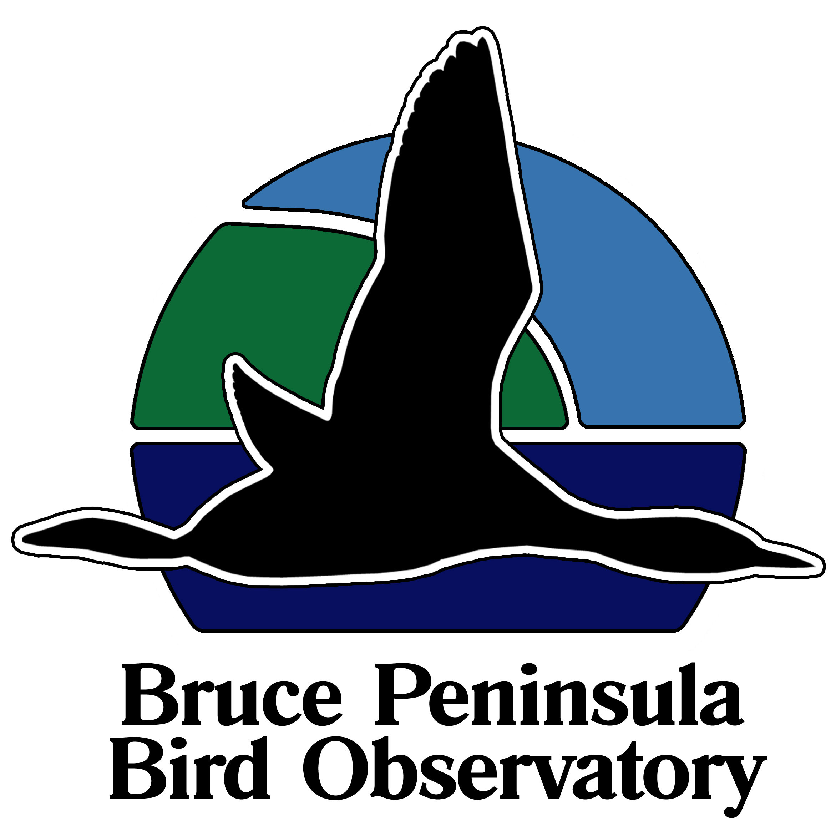

BIRD MIGRATION MONITORING

at

CABOT HEAD RESEARCH STATION,

BRUCE PENINSULA:
THE FIRST TEN YEARS (2002-2012)

by

Stéphane Menu, Ph.D.
27 Andrew Street, Kitchener
Ontario, N2H 5R1
stefmenu@gmail.com

prepared for

BRUCE PENINSULA BIRD OBSERVATORY and
BRUCE PENINSULA NATIONAL PARK

March 2012

Citation: Menu, S. March 2012. Bird Migration Monitoring at Cabot Head Research Station, Bruce Peninsula: the first ten years (2002-2012). Unpublished report for Bruce Peninsula National Park and Bruce Peninsula Bird Observatory

