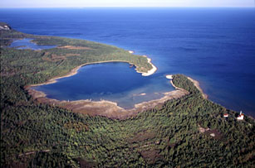

MIGRATION MONITORING AT

CABOT HEAD

FALL 2017

*by*

Stéphane Menu, Ph.D.

Station Scientist

Cabot Head Research Station

Bruce Peninsula - Ontario

stefmenu@gmail.com

*prepared*

*for*

#### BRUCE PENINSULA BIRD OBSERVATORY

November, 2017

**Citation:** Menu, S. November 2017. Migration Monitoring at Cabot Head, Fall 2017. Unpublished report for Bruce Peninsula Bird Observatory

**Table of Contents**

Preface 4

Executive Summary 5

1.0 Methods 8

2.0 Season Summary 9

August 9

September 13

October 24

3.0 Unusual Records 30

4.0 Banding Data Analysis 31

4.1 Weather 35

4.2 Recaptures 38

4.3 Net Analysis 41

5.0 Special Project 42

6.0 Coverage and Protocol 43

7.0 Personnel 44

8.0 Conclusion 44

Acknowledgements 45

Literature Cited 45

Appendix I. Fall banding total 2017 with statistics from 2002-2016 46

Appendix II. Detected Totals of species observed in fall 2017 at Cabot Head Research Station 48

Figure 1: Daily number of species observed at Cabot Head, fall 2017. 6

Figure 2: Frequency (in days) of observation for species observed at Cabot Head, fall 2017. 6

Table 1: Summary of coverage and species detected and banded at CHRS, fall 2017. 7

Figure 3. Detected Totals of the most common species throughout the monitoring period at CHRS, fall 2017. 8

Figure 4. Number of American Redstarts banded in August and the rest of the season during the fall at CHRS, 2002-2017. 10

Figure 5. Number of banded birds and mist net hours in September at CHRS, 2002-2017. (NB: mist net hours data are not available in that format for 2002). 14

Figure 6. Banding totals of Gray-cheeked and Swainson’s Thrushes in the fall at CHRS from 2002 to 2017. 16

Figure 7. Cumulative numbers of banded Swainson’s and Gray-cheeked Thrush in fall 2017 at CHRS. (Missing dates in x-axis represent days with no banding). 16

Figure 8. 5-day total numbers of warbler species (right Y-axis) and 5-day Estimated Totals of warblers (all species combined; left Y-axis) at CHRS in fall 2017. 18

Figure 9. Numbers of Black-throated Green Warbler banded and observed at CHRS, 2002 - 2017. 18

Table 2: Phenology of migration for warbler species. 19

Figure 10. 3-day average of Estimated Totals of Canada Goose for 2017 and the combined years of 2002 to 2016 at CHRS. 20

Figure 11. Detected Totals of Double-crested Cormorants at CHRS, 2002 – 2017. 21

Figure 12. 3-day average of Estimated Totals of Yellow-shafted Flickers for 2017 and the combined years of 2002 to 2016 at CHRS. 22

Figure 13. 3-day average of Estimated Totals of Blue Jays for 2017 and the combined years of 2002 to 2016 at CHRS. 22

Figure 14. Detected Totals of Common Loons detected at CHRS, in relation to year and time of monitoring. 23

Figure 15. Banding totals for Golden-crowned Kinglets at CHRS, 2002 - 2017. 25

Figure 16. Banding totals and mist net hours for October at CHRS, 2002 - 2017. 26

Figure 17. Banding totals for Black-capped Chickadees at CHRS, 2002 - 2017. 26

Figure 18. Banding totals for Red-breasted Nuthatches at CHRS, 2002 - 2017. 27

Figure 19. Banding totals for Brown Creepers at CHRS, 2002 - 2017. 27

Figure 20. Numbers of warbler species detected in October at CHRS, 2002 - 2017. 29

Figure 21. Number of years warbler species were observed in October at CHRS between 2002 and 2017. 29

Figure 22. Banding total of the most common captured species (at least 15 individuals) compared to average total of 2002-2010 (highest total in red and lowest in blue). Differences from average in decreasing order from left to right. Error bars show Standard Deviation. 33

Figure 23. Daily banding and recapture total at CHRS, fall 2017. 33

Figure 24. Fall weekly capture rates at CHRS. Error bars show Standard Deviation. 34

Figure 25. Fall weekly number of banded birds at CHRS. Error bars show Standard Deviation. 34

Figure 26. Fall weekly proportion of mist net hours at CHRS. Error bars show Standard Deviation. 35

Figure 27. Wind pattern (strength on the Beaufort scale, direction and proportion of time) at CHRS, fall 2017. 37

Figure 28. Banding total and number of mist net hours for the September 20 – 26 period at CHRS, 2002 - 2017. 37

Table 3. Total recaptures by species in relation with year and season of banding (only one recapture per individual is included) at CHRS, fall 2017. 40

Figure 29. Capture rates per mist net for average 2003-2011/2015 and for 2017 at CHRS (data not available for 2002, 2012, 2013, & 2014). 41

Figure 30. Number of Swainson’s Thrush banded and marked (or not) with nanotags in relation with time at CHRS, fall 2017. 42

Table 4. Morphometric (weight and wing chord) for Swainson’s Thrush captured at CHRS, fall 2017. 43

Figure 31. Coverage in mist net hour at CHRS (data not available for 2002), fall 2017. 43

Table 5. Volunteer effort, fall 2017. 44

# Preface

Cabot Head is a promontory of the northeast headland of the upper Bruce Peninsula in south-central Ontario, at the northern end of the Niagara Escarpment, in the mixed-wood plains ecozone. Cabot Head Research Station (CHRS) is situated on a small spit of land (at 45°15’N, 81°18’W), bordered north by Georgian Bay and south by the western side of Wingfield Basin near the community of Dyer’s Bay. In 2001, Cabot Head was designated as an Important Bird Area by Birdlife International for its significant concentrations of migratory bird species (Cheskey and Wilson, 2001; https://www.ibacanada.org/site.jsp?siteID=ON099), the Red-necked Grebe in particular. Situated in a provincial nature reserve, CHRS is managed jointly by Ontario Parks and Bruce Peninsula Bird Observatory (BPBO).

The Breeding Bird Survey (BBS) is the principle method for monitoring bird populations in the United States and the southern part of Canada. However, breeding ranges of many species in northern Canada are inaccessible to roadside surveys and are therefore poorly monitored by the BBS method. The Canadian Migration Monitoring Network (CMMN) is a nation-wide, Bird Studies Canada-led initiative, intended to assess changes in bird populations during migration (<http://www.bsc-eoc.org/volunteer/cmmn>). There are 25 stations across Canada where data are being collected for each bird species during the spring and fall migrations, typically through a standardized capture and observation protocol. Through continuous data collection since 2001, BPBO has demonstrated that Cabot Head is a significant site for monitoring migratory landbirds. In recognition of its importance and established migration monitoring effort, BPBO became a member of the CMMN in fall 2003.

BPBO was incorporated as a charitable non-profit organization in 2001 to initiate and direct ornithological assessments and monitoring at Cabot Head and surrounding areas.Migration monitoring has been the primary focus of bird research at Cabot Head since 1998. This document reports on results of the fall 2017, migration monitoring season at CHRS.

# Executive Summary

In this document, the results of migration monitoring at Cabot Head from the fall of 2017 are summarized and analysed. It is the 16th year of consecutive monitoring following a research protocol that was established in 2002. Keeping a consistent monitoring effort helps ensure that trends can be detected and quantified.

Fall fieldwork began on August 15 and ended on October 24 for a total of 71 consecutive days of coverage. This fall, monitoring ended one week earlier than usual in order for the station scientist to attend the 2nd International Bird Observatory Conference held in Cape May (New Jersey). At Cabot Head, a total of 120 species of birds were detected in the standard count area over the course of the field season. Among them, 77 species have been seen every fall, with only three species previously observed in every other fall that were not seen in the fall of 2017 (Common Goldeneye, Fox Sparrow, Snow Bunting, all very late migrants missed because of closing the station one week early). The number of species detected this fall was well below the 2002-2016 average of 137 ± 9 (range: 127 species in falls 2006 and 2008 – 156 species in fall 2002). The highest one-day species total was 42, recorded on September 14 (see Fig.1 for daily number of species observed). Most species are seen only on a few occasions (less than 10 days during the whole monitoring period), whereas only a few are observed almost daily (Fig.2). Highlights of the season were the observations of one Short-eared Owl, a new species for Cabot Head, and of a Townsend’s Solitaire, a vagrant from the Rocky Mountains.

In total, 1,037 birds of 61 species were banded and 90 birds of 22 species were recaptured (Table 1). This is the lowest banding total ever for the fall season, with most species (45 out of 61) banded below average and another 12 species at or slightly above average. Only four species were captured in numbers well above average (see Appendix I for banding fall totals per year and Appendix II for species detected). Notably, Cape May Warblers were banded in record numbers, with 12 individuals, while previous numbers were between one to seven birds (with no capture during four fall seasons).

The fall 2017 migration monitoring season was a success in part thanks to the efforts of the sixvolunteers who contributed their time and enthusiasm to the project.

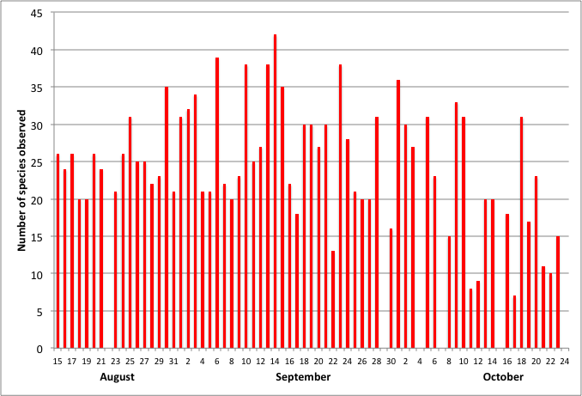

Figure 1: Daily number of species observed at Cabot Head, fall 2017.

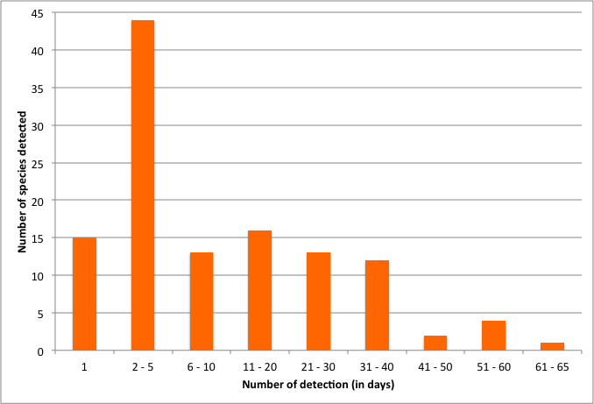

Figure 2: Frequency (in days) of observation for species observed at Cabot Head, fall 2017.

Table 1: Summary of coverage and species detected and banded at CHRS, fall 2017.

|  |  |  |  |  |
| --- | --- | --- | --- | --- |
|  | August | September | October | Total |
| Days with coverage | 17 | 30 | 24 | 71 |
| Species detected | 71 | 98 | 72 | 120 |
| Days with no banding (% of total) | 1* (6%) | 5 (17%) | 12 (50%) | 18 (26%) |
| MN hours realized  (% of potential) | 85% | 77% | 40% | 65% |
| Number of birds banded | 229 | 367 | 441 | 1037 |
| Number of species banded | 30 | 47 | 30 | 61 |
| Average daily number of birds banded** | 15 | 14 | 37 | 20 |
| Maximum daily banding total  (with date) | 44 (30 Aug.) | 35 (6, 14 Sep.) | 115 (6 Oct.) |  |
| Minimum daily banding total  (with date) | 2 (19 Aug.) | 2 (20 Sep.) | 10 (13, 20 Oct.) |  |

MN: Mist net.

*: Eight nets were open for only half an hour before being closed again when rain began

**: Days with no banding are not included

# 1.0 Methods

The migration monitoring program at CHRS follows a field protocol (established by Heagy et al., 2003) as it is essential for the production of population indices that data collection be consistent over the long term. Specifically, 15 mist nets are operated for six hours commencing a half hour before sunrise (or later, depending on weather). Personnel also complete a one-hour census along a fixed route, where all bird seen or heard are recorded, usually starting an hour after sunrise. Casual observations are also taken and all of the methods are used to determine a detected total (DT) for each species within the area of the station during the sampling period each day. Supplemental surveys such as visible migration counts and bay watches are completed when circumstances permit. As expected, there is a tremendous variation in diversity and abundance throughout the season (Fig.3).

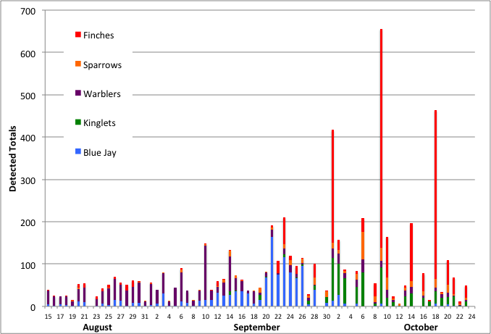

Figure 3. Detected Totals of the most common species throughout the monitoring period at CHRS, fall 2017 (kinglets comprised of both Golden-crowned and Ruby-crowned Kinglets).

# 2.0 Season Summary

## 

## August

Fieldwork for fall migration monitoring began at CHRS on August 15 with fifteen mist nets in operation. August is normally a quiet month of migration in southern Ontario. Banding was possible for every day but one in this period, with only a few net hours lost to bad weather (85% of the potential mist net hours were realized. See Table 1). Specifically, there was only one day with very bad weather, where only nine nets were open for half an hour and no further monitoring was done. A total of 71 species, including 17 species of warblers, were detected in August, with an average of 23 species per day (range of 20 species on August 18 and 19 to a high of 35 on August 30). Only five species were detected on every single day in August: Red-eyed Vireo, Black-capped Chickadee, Red-breasted Nuthatch, and American Redstart. Double-crested Cormorant and Ring-billed Gull, two common species at this time of year, were missed only on one day. The resident Bald Eagle pair makes observation of this species quite common: it was missed only one day during August and seen every other day during the rest of the monitoring period. A total of 17 species (including the previous ones) were seen on ten days or more during the 17 days of monitoring in August. On the other end of the scale, 18 species were detected only once during this period, with two species not seen again (American Woodcock and Eastern Bluebird). A total of 229 birds of 30 species were banded, well below the 16-year average of 290 ± 76 birds. As in most years, American Redstart was the most common species caught, with 32% of the monthly banding total, followed by Red-eyed Vireo and Black-throated Green Warbler (10% and 9% respectively). The banding total for American Redstart in fall 2017 is 96 birds (including 23 individuals banded after August), which is just above the average of 92 (±39). However, there are major variations in numbers banded between years, with a low of 44 in fall 2007 and a high of 171 in 2008 (Fig.4).

The 4-day period from August 27 to 30 was the most diverse in August with a total of 48 species detected (68% of the August total), including 12 species of warblers. Out of the 48 species observed, only 13 were seen every day of that 4-day period and another 21 only observed on one day. The first Bay-breasted and Wilson’s Warblers, “true migrants”, that is, species that don’t breed on the Bruce Peninsula, were detected during this period. A female hatch-year (HY) Scarlet Tanager was banded on August 28. The only other detection of this species is a bird seen on August 24 during census.

The Eastern Whip-poor-will was heard at dawn and dusk only a few times this fall, compared to previous years. It is not clear why the local birds were less vocal, after a “normal” spring season. There are typically about three singing Eastern Whip-poor-wills in the Cabot Head area.

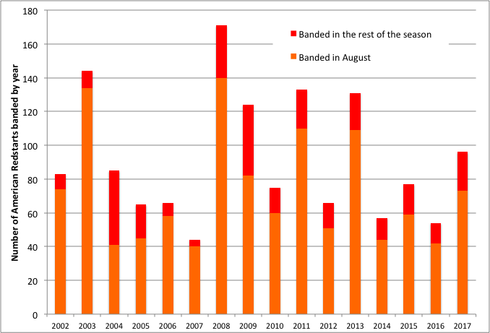

Figure 4. Number of American Redstarts banded in August and the rest of the season during the fall at CHRS, 2002-2017.

In August, migration monitoring is complicated by the presence of local birds. Even though they could also be migratory species, they may not be migrating at the exact time of capture/observation. For example, an American Redstart observed in August may not be migratory, but rather a local bird. Most adult songbirds moult their flight feathers in the summer before starting their migration. However, it appears that adults investing in high levels of reproduction late in the season adopt a unique combination of moult and migration (Norris et al. 2004). It means that a moulting adult may have bred much further north than the location of its moulting, making inferences more complicated. Of the 15 adult American Redstarts captured at Cabot Head this fall, ten of them were in active moult, all in August from the 15th to the 24th. The five adults with no active moult were captured from August 25 to September 18. Most of the captures of American Redstarts occur in August: depending on years, from 66% (in 2009) to 93% (in 2003) of all redstarts have already been banded at the end of August, with the fall of 2004 being an outlier with only 48% of American Redstart banded in August (Fig.4). In 2017, 76% of American Redstarts were banded in August.

Nevertheless, migration does occur in August, as shown by the appearance of species that do not breed on the Bruce Peninsula. For example, Greater Yellowlegs was noted first this fall on August 25. The first boreal warblers and “true” migrants were the Cape May (detected on August 15), Wilson’s (on August 25), and Bay-breasted (on August 30) Warblers. Cape May Warblers are always detected in very small numbers in the fall at Cabot Head. However, this fall, there were nine days with actual detection, starting on August 15 with the last on September 10, for a total of 15 individuals. There were only between one and four days of detection of Cape May Warbler in the previous falls. Most of the detections this fall came from banding, as it is often the case for this species. A total of 12 Cape May Warblers were banded, whereas only between one and three individuals are usually banded, with a previous record of seven birds in fall 2015 and no Cape May banded at all in four fall seasons.

This fall, Barn Swallows were seen in extremely low numbers, continuing a constant trend of declining abundance, at multiple scales: locally on the Bruce Peninsula, provincially, according to the Ontario Breeding Bird Atlas, and continentally, according to BBS data. There were only two observations of Barn Swallows at Cabot Head, with one bird on August 17 and five individuals on August 24. Barn Swallows are extremely visible, especially so at Cabot Head, since they use the shipwreck in Wingfield Basin as a breeding and roosting site. When present, they are observed daily, first heard chipping from within the wreck as the sun warms the day, then flying out and around conspicuously. It is thus very unlikely that Barn Swallows or other species of swallows are missed in the fall. It is possible, though, that the slow and gradual deterioration of the shipwreck partly explains the decline in Barn Swallow numbers: it may now be too decrepit to offer a good breeding and roosting habitat for them. Tree Swallows were observed twice as well this fall, with two birds on August 17 and a single one on August 21.

As mentioned earlier, many species are detected only a few times. That was the case of Common Terns, which were seen only on three occasions this summer. Common Terns were heard and seen on August 15 and 17, with one and two birds, respectively. One Common Tern was also detected on September 25, the third latest date for this species (there were observations on October 5, 2005 and October 15, 2013). Common Terns are detected almost every fall, having been missed only in four seasons, but numbers of detection during a season are usually quite small, from one to 17. Among other factors like water levels and local food availability, it is possible that breeding success in the local colonies (on islands off the tip of the Bruce Peninsula) influences numbers of Common Terns seen at Cabot Head. The recent high water level of Georgian Bay has all but submerged rocks in Wingfield Basin where bird species like gulls, cormorants, and terns, like to rest. No Caspian Terns were seen this fall, a species missed in the fall season every year since 2012 (except for 2014), even though it is detected every spring, like Common Tern.

Another species potentially impacted by high water level is the Spotted Sandpiper. It is observed every fall, albeit in varying numbers. It appears that there are usually only a few individuals present at any given time. Over the years, the highest daily total has been three birds, in three different days in 2003. Observations of Spotted Sandpipers in fall 2017 occurred in only six days with only one individual observed on each occasion, from August 21 to September 23 (which represents the second-latest on record, after September 24, 2014).

Eastern Bluebird was detected only once on August 20. This species has been detected previously in only five falls of the past 15 seasons, with observations spread throughout the monitoring period and the latest date on October 18, 2003. Eastern Kingbird, on the other hand, was detected multiple times in August this year, with two observations in early September as well. This species prefers the marshy margins of the shallow lakes at the base of West and Middle Bluffs: it is thus not rare at Cabot Head and is regularly seen around the station - albeit in small numbers - when moving from and to its preferred habitats. This species has been detected every August since 2002, except in 2012, 2013, and 2014, with usually multiple observations.

## September

Weather in September this year was mostly warm and dry, with only three days of showers or rain during the month. There was a short but fierce heat wave from September 20 to 26, with temperatures reaching almost 30°C in the second half of this period, well above the season normal. As with birds, it is a time of transition between summer and fall. A total of six full days of banding were lost due to high wind and/or rain, as well as two other partial days, resulting in 23% loss of possible mist net hours. A total of 98 species were detected during the month. The most frequently detected species were Ring-billed Gull, Blue Jay, Black-capped Chickadee, Red-breasted Nuthatch and Myrtle (Yellow-rumped) Warbler, with only a few days in the month missed (83% and more of days with observation for these species). An additional six species were detected on at least 20 different days, while 49 species were rarely detected (on 5 days or less). A total of 367 birds of 47 species, well below the average of 613 ±187 birds, were banded in September. It is the second-lowest total for September, after 2007, which had a total of 331 banded birds (with 29% of mist net hours lost). The most common species caught were Swainson’s Thrush (with 47 birds banded, accounting for about 13% of the monthly total), followed by Black-throated Green Warbler (36 birds banded, i.e. 10% of the monthly total), then Myrtle Warbler and Gray-cheeked Thrush (about 7% each). Through time, BPBO has documented huge variations in number of banded birds and capture rates in September, with a low of 331 birds in 2007 and a high of 1029 in 2005 (Fig.5). It does not appear that a clear relation exists between numbers of birds banded and mist net hours. In fall 2017, numbers of mist net hours in September were low but within normal variations, whereas numbers of birds banded were markedly lower than average (Fig.5).

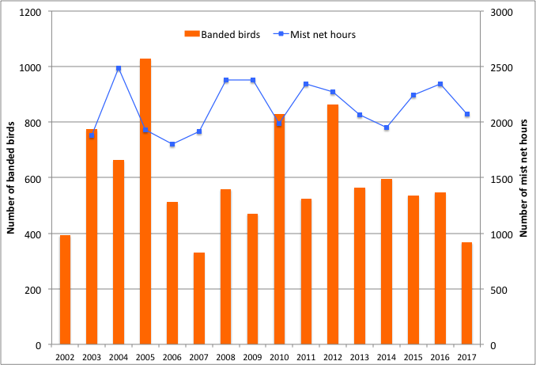

Figure 5. Number of banded birds and mist net hours in September at CHRS, 2002-2017. (NB: mist net hours data are not available in that format for 2002).

September is the most diverse month: 47 species were caught compared to 30 for August and October and 98 species detected compared to 71 and 72 for August and October, respectively. Many species migrate mainly during this month (i.e., warblers, White-throated Sparrow and Swainson’s Thrush), while early migrants are still moving through (American Redstart and Black-and-White Warbler, for example). The earliest individuals of the late migrants can also be encountered at the end of the month (Kinglets, Hermit Thrush, a few species of sparrow). Banding in September was extremely slow with an average of 15 birds a day (range from two to 35 birds). September 6 and 14 were the busiest day for the month, with 35 birds banded of 17 and 18 species, respectively. All 15 nets were open for the full six hours of monitoring in both days. On September 6, captures were widespread across species but Swainson’s Thrush had the highest capture rates, with nine individuals banded. On September 14, Black-throated Green Warblers were dominant, with eight birds banded. Daily species-specific captures in September were all in the single digits, except in two occasions: on September 10, 11 Black-throated Green Warblers were captured; on September 13, ten Gray-cheeked Thrushes were banded, which represents a record daily high for this species. From 2002 to 2016, there were 126 days in the fall with captures of Gray-cheeked Thrush and only seven of them implied five or more birds. In fall 2017, the other occasions of capture for that species were of only one bird, except on September 23 and 24, with three and four birds, respectively. These two days were quite warm but with light wind, following three days of strong East or South winds. They were the last days with captures for Gray-cheeked Thrush. In total, 26 birds of this species were banded, the second-highest number after the 2016 record of 41 thrushes (Fig.6).

Swainson’s Thrushes were banded in good numbers as well, with 49 birds banded, one shy of the third highest total (Fig.6; See the Special Project section about marking Swainson’s Thrushes with nanotags). Captures were relatively spread out throughout September up to early October (Fig.7). Migration through Cabot Head for both Gray-cheeked and Swainson’s Thrushes is mostly in September but it appears that some differences in phenology exist between the two species, as expressed through capture (Fig.7). Gray-cheeked Thrush is a northern breeder, from Siberia to Newfoundland, occupying the northern reaches of the boreal forest and into the tundra. It is thought to breed in extreme northern Ontario, albeit in very small numbers (OBBA 2007). On the other hand, Swainson’s Thrush is practically ubiquitous in the conifer-dominated Northern Shield of Ontario, with a small breeding population on the Bruce Peninsula (OBBA 2007).

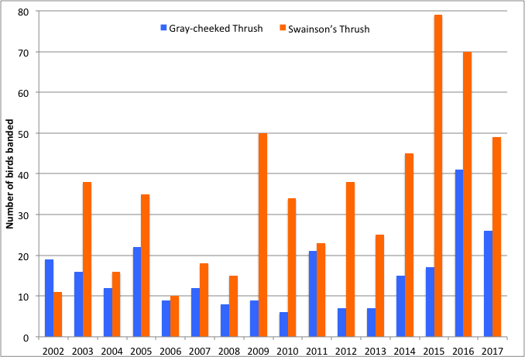

Figure 6. Banding totals of Gray-cheeked and Swainson’s Thrushes in the fall at CHRS from 2002 to 2017.

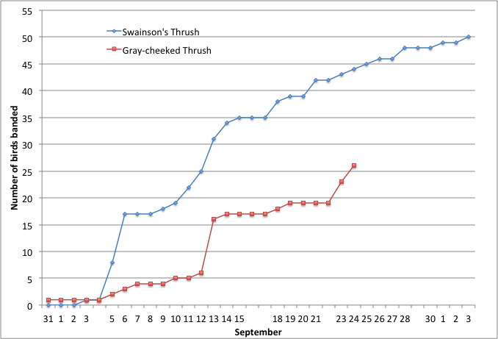

Figure 7. Cumulative numbers of banded Swainson’s and Gray-cheeked Thrush in fall 2017 at CHRS. (Missing dates in x-axis represent days with no banding).

Diversity reached some high points throughout the month, especially in the middle of the month. A total of 55 species were detected between September 13 and 15, with a daily high of 42 on the 14th, the highest total of the season. The first Brown Creeper, Golden-crowned Kinglet, and American Pipit of the season were detected during this 3-day period. The only Brown Thrasher of the season was also seen during this time. The group most represented in mid-September was the warblers, with 14 species detected in that period.

Diversity and abundance of warblers peaked from late August to mid-September (Fig.8 and Table 2). In the 5-day period between August 31 and September 4, a total of 17 warbler species was detected, with American Redstart, Myrtle Warbler, and Black-throated Green Warbler, being the most abundant. Between September 10 and 14, 20 species of warblers were detected, the highest total this fall. The most abundant species were the same as previously noted, in addition to Common Yellowthroat and Palm Warbler. After 20 days of monitoring, the cumulative number reached 20 species of warblers on September 4. The remaining 50 days of monitoring added only three species (Orange-crowned and Mourning Warblers as well as Northern Parula). After the peak in mid-September, there was a sharp drop in abundance, even if diversity stayed relatively high, with a cumulative total of 15 species from September 15 to 24. The decline in diversity and abundance is drastic in October. Even though a total of 12 species of warblers were detected during that month, only Myrtle Warblers were seen in significant number. Throughout the season, American Redstart, Myrtle Warbler, Black-throated Green Warbler, and Common Yellowthroat were the species most often detected and in the highest numbers (in decreasing order).

Black-throated Green Warblers were detected and banded in much higher numbers this fall than the previous fall. It appears that this species shows large fluctuations over the years, with highest numbers occurring in the first four years of the 16 years of monitoring (Fig.9). With most of its breeding range in the boreal forest, this species likely experiences large and widespread yearly variations in breeding success.

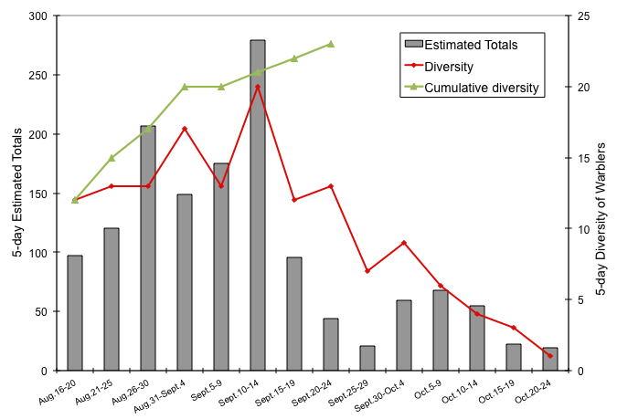

Figure 8. 5-day total numbers of warbler species (right Y-axis) and 5-day Estimated Totals of warblers (all species combined; left Y-axis) at CHRS in fall 2017.

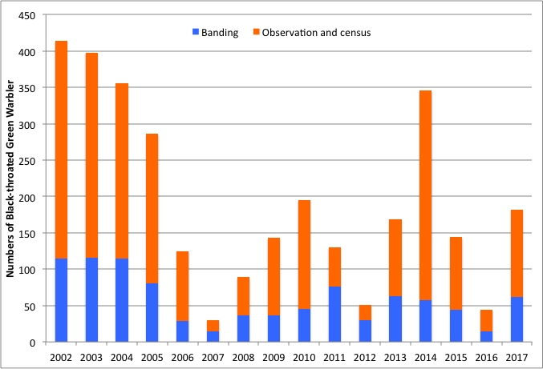

Figure 9. Numbers of Black-throated Green Warbler banded and observed at CHRS, 2002 - 2017.

Table 2: Phenology of migration for warbler species, with dates of first and last observation, number of days between first and last observation, number of days with observation, and estimated totals.

|  |  |  |  |  |  |  |
| --- | --- | --- | --- | --- | --- | --- |
|  | Dates of first and last observations | | | Number of days | | Estimated Total |
| August | September | October | between first and last observation | with observation |
| Myrtle Warbler B | 15 |  | 23 | 70 | 57 | 389 |
| Common Yellowthroat B | 15 |  | 6 | 61 | 39 | 138 |
| American Redstart B | 15 | 24 |  | 41 | 38 | 397 |
| Black-throated Green Warbler B | 15 |  | 5 | 52 | 34 | 182 |
| Black-and-White Warbler B | 15 | 21 |  | 38 | 30 | 82 |
| Western Palm Warbler |  | 1 | 11 | 41 | 18 | 58 |
| Nashville Warbler B | 18 |  | 16 | 60 | 17 | 25 |
| Magnolia Warbler B | 15 |  | 5 | 52 | 16 | 27 |
| Black-throated Blue Warbler B | 17 |  | 3 | 48 | 16 | 19 |
| Ovenbird B | 21 | 20 |  | 31 | 15 | 34 |
| Orange-crowned Warbler |  | 23 | 14 | 22 | 9 | 18 |
| Cape May Warbler | 15 | 10 |  | 27 | 9 | 15 |
| Blackpoll Warbler |  | 4 | 1 | 28 | 9 | 15 |
| Pine Warbler B | 17 |  | 1 | 46 | 8 | 13 |
| Mourning Warbler |  | 15/23 |  | 9 | 6 | 6 |
| Chestnut-sided Warbler B | 26 | 10 |  | 16 | 5 | 9 |
| Bay-breasted Warbler | 30 | 15 |  | 17 | 5 | 7 |
| Northern Waterthrush B | 16 | 23 |  | 29 | 5 | 5 |
| Tennessee Warbler |  | 3 | 3 | 31 | 4 | 5 |
| Wilson's Warbler | 25 | 11 |  | 18 | 4 | 4 |
| Yellow Warbler B | 15 | 14 |  | 31 | 3 | 5 |
| Canada Warbler B | 25 | 10 |  | 17 | 3 | 4 |
| Northern Parula B |  | 10 | 1 | 22 | 2 | 2 |

B: These species breed on the northern Bruce Peninsula (according to the Ontario Breeding Bird Atlas)

Many species not monitored by banding migrate mostly in September. Canada Geese usually migrate in early September but with large variations across the years (Fig.10). Large movements are strongly influenced by weather: north winds tend to bring numerous flocks flying through. It was the case on August 31, when a total of 684 Canada Geese were counted while a strong north wind blew in an overcast day. No movement as large occurred afterwards, with the second high count being 186 on September 16. Double-crested Cormorants were seen daily from the start of monitoring period until September 7. This species roosts in Wingfield Basin making it difficult to differentiate migrants from local residents. Water levels this year were at a record high (as they were in 2016), covering rocks that cormorants (and other birds like gulls) like to use as resting areas. As a consequence, numbers detected were lower than earlier years with cormorants crowding the few rocks still available, as well as the navigation markers (Fig.11). After September 7, Cormorants were no longer observed, except on September 21 with two individuals.

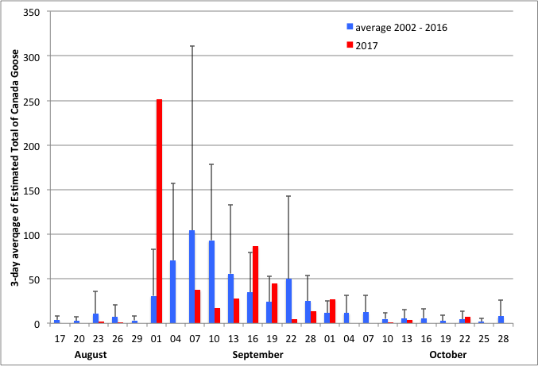

Figure 10. 3-day average of Estimated Totals of Canada Goose for 2017 and the combined years of 2002 to 2016 at CHRS.

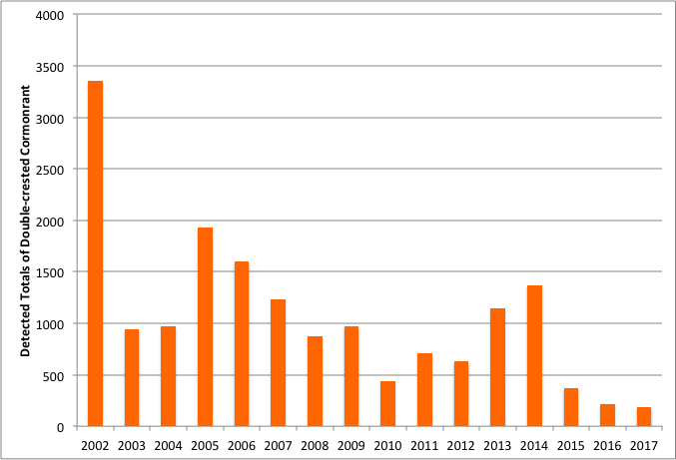

Figure 11. Detected Totals of Double-crested Cormorants at CHRS, 2002 – 2017.

The overwhelming majority of Blue Jays and Yellow-shafted Flickers migrate in September: in 2017, 87% and 62% of Estimated Totals, respectively, occurred during this month. Even though the bulk of migration is in September for both species, their phenology could be quite different (Fig.12&13): in years of small numbers of Yellow-shafted Flickers, their movements through Cabot Head are spread throughout September, whereas Blue Jays almost always tend to peak over a few days in mid-month. That was again the case this fall, as Yellow-shafted Flickers were detected in relatively low numbers, with 113 birds (2002-2016 average of 171 ET ± 111; low of 72 in 2007 and high of 394 in 2014). The migration peak of Blue Jays occurred in mid-September, as in previous years: from the 19 to 25, when 667 blue jays were counted, representing 55% of the seasonal total of 1212 birds (2002-2016 average of 1055 ET ± 568; low of 490 in 2007 and high of 2825 in 2014). Most of the time, between one half and two-thirds of the Blue Jay season total is detected in a seven-day period.

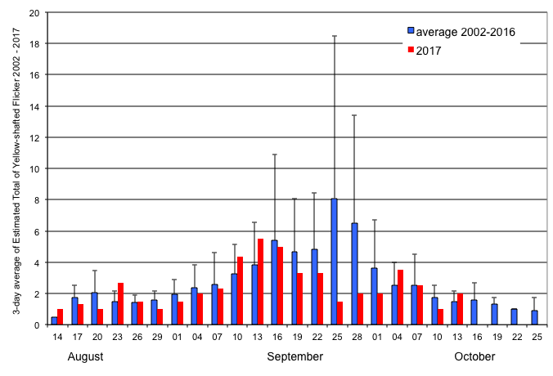

Figure 12. 3-day average of Estimated Totals of Yellow-shafted Flickers for 2017 and the combined years of 2002 to 2016 at CHRS.

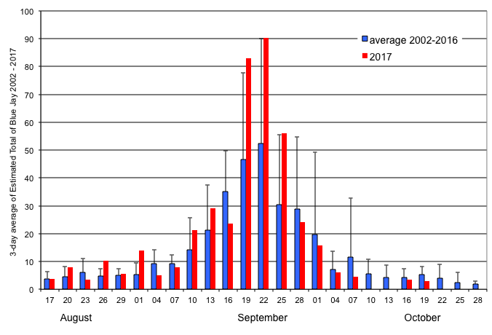

Figure 13. 3-day average of Estimated Totals of Blue Jays for 2017 and the combined years of 2002 to 2016 at CHRS.

Common Loons were seen throughout the entire season with about 73% of all observations made in September. Loons can usually be seen in small rafts on Georgian Bay or flying in a southeast direction, either over water or land. This fall, a total of 138 Common Loons was detected, within the range of totals detected since 2010 (with the exception of the fall of 2014; Fig.14). This species is a strong flyer and moves through the area rapidly, making detection difficult. Another potential problem is that it routinely flies, low or high, over Georgian Bay at any time of the day, which makes accurate monitoring difficult as well. However, detection probabilities should stay relatively consistent between years. It is possible that the apparent decline results in differences in use of Georgian Bay offshore from Cabot Head. In the first few years of monitoring, it was common to see good numbers of loons resting on the water of Georgian Bay, making detection much easier than with birds flying through.

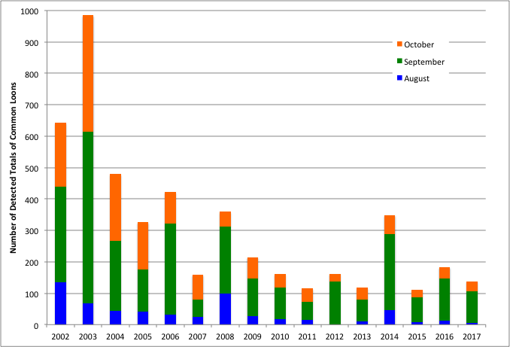

Figure 14. Detected Totals of Common Loons detected at CHRS, in relation to year and time of monitoring.

## October

October is usually the busiest – although less diverse - banding period of the fall migration season at CHRS. This was again the case in 2017, as 441 birds of 30 species were banded (47% of the seasonal total), for a daily average of 37 birds captured. Banding was hampered by weather often in October this year, with 12 days completely lost due to rain and/or wind (half of the banding period in October!) and two other days with only limited monitoring. The most common species caught were Golden-crowned Kinglet, with 206 individuals banded (representing 47% of the monthly total), followed by Slate-coloured Junco and Myrtle Warbler (with 13% and 5%, respectively of the monthly total). A total of 72 species were detected during the month, including a Short-eared Owl observed for the first time at the CHRS.

When banding was possible, daily numbers of birds banded in October were very variable, ranging from 10 to 115 (highest daily total of the season - Fig.15). Captures were concentrated in a few days, most notably in the first week of the month. The first Golden-crowned Kinglets were detected on September 14 with sparse observations of small numbers through the rest of September. They arrived in good numbers in early October, with strong movements, frequently interrupted by strong south winds, until October 9. Numbers afterwards were quite small, likely as a result of the very unfavourable weather during this period: strong south and east winds occurred extremely frequently (see Weather). One consequence of the bad weather is the lowest number of mist net hours for the month of October in 16 years (only 40% of the potential mist net hours were realized), which, almost certainly, affected the banding total in October, also the lowest in 16 years (Fig.16).

Black-capped Chickadee is a well-known irruptive species: some falls, due to high breeding success, large flocks of young birds disperse across wide areas in search of new territories. There was no notable movement of chickadees this fall at Cabot Head. Furthermore, no apparent pattern emerges from 16 years of banding at Cabot Head (Fig.17). The Red-breasted Nuthatch is a species also showing large variations in banded and detected numbers at Cabot Head across the years but with no apparent patterns. This fall, 44 Red-breasted Nuthatches were banded, whereas a much higher number was detected through observation and census, the second highest after 2005 (Fig.18). This fall, there was an abundant crop of spruce and cedar cones and nuthatches were often seen foraging high in these trees. Unlike in spring, the Brown Creeper migration is fully covered during the fall monitoring. In 2017, a total of 19 Brown Creepers were banded, the lowest total to date (Fig.19). There are large fluctuations in the number of Brown Creepers banded throughout the years, but it is quite possible that the low numbers of this fall are partly due to the disruption of banding by bad weather.

Other species, which migrate mostly in October, were also captured in relatively low numbers this fall. Only 22 White-crowned Sparrow were banded, the third lowest total (lowest of 19 birds in 2006). A total of 32 White-throated Sparrows were banded, the lowest banding total (previous low of 39 birds in 2007). Hermit Thrushes were also banded in record low numbers, with only 15 birds (previous low of 16 birds in 2002). Variations in fall banding total are quite important for these three species but, again, weather patterns particularly impacted banding this fall.

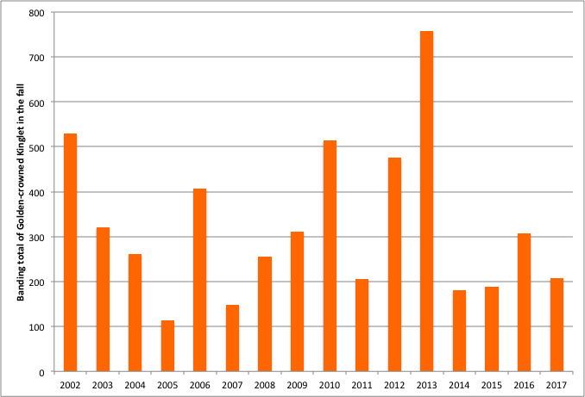Figure 15. Banding totals for Golden-crowned Kinglets at CHRS, 2002 - 2017.

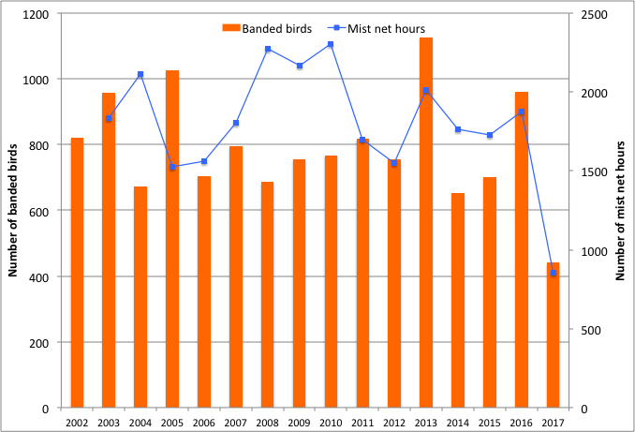

Figure 16. Banding totals and mist net hours for October at CHRS, 2002 - 2017.

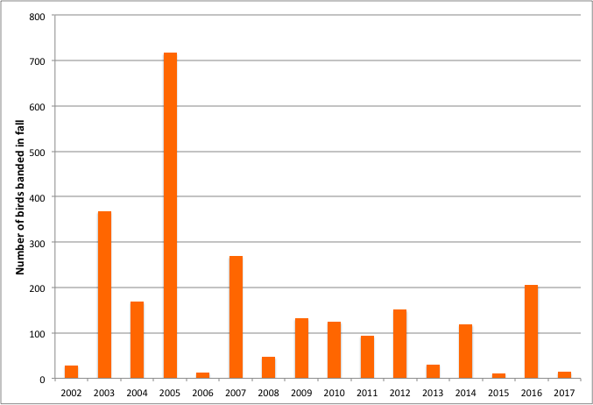

Figure 17. Banding totals for Black-capped Chickadees at CHRS, 2002 - 2017.

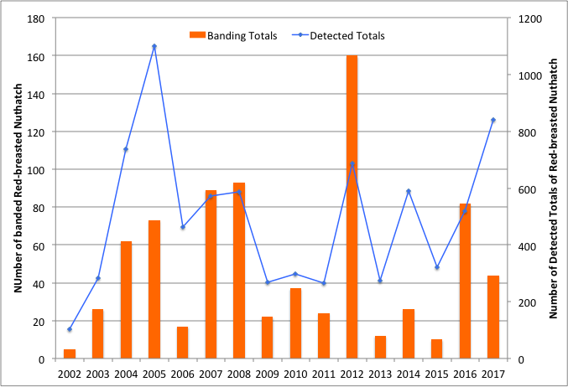

Figure 18. Banding totals for Red-breasted Nuthatches at CHRS, 2002 - 2017.

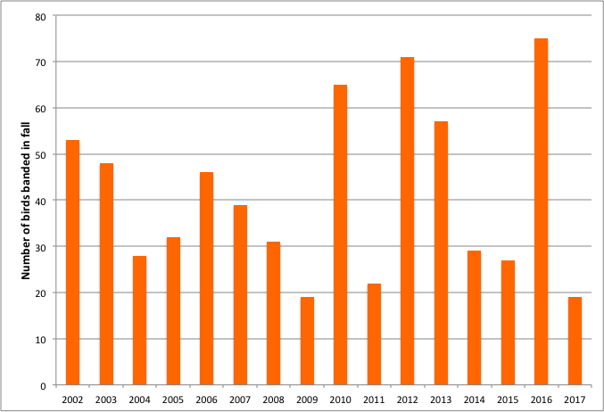Figure 19. Banding totals for Brown Creepers at CHRS, 2002 - 2017.

In October, most warblers have usually already gone through the area (with the exception of Orange-crowned and Yellow-rumped Warblers, which are late migrants) it is therefore mostly stragglers that are observed. Nonetheless, an average of 9 (± 1) species of warblers are detected every October, ranging from a low of 5 species (in 2005, 2007, and 2011) to a high of 15 in 2014, for an overall total of 19 species of warblers (Fig.20). Three species (Orange-crowned, Nashville, and Yellow-rumped Warblers) have been observed every October, with Palm Warbler only missed once in 2004 (Fig.21). This fall, 12 species of warblers were detected in October, the second highest total. One Northern Parula was seen on October 1 along with five other species of warblers that day. It was only the fifth time this species was detected in October. Northern Parula is a species observed in very low numbers in the fall, with only one to three observations per season, only one of them including two birds (on September 7, 2003). The species was also missed in six fall seasons out of 16. Black-throated Green and Black-throated Blue Warblers are present more regularly in October: this fall, they were observed on the 2nd, 3rd, and 5th for the former and on the 3rd for the later. Some late dates were noted for a few species this fall: a Common Yellowthroat was banded on October 14, the latest detection date for this species. Its weight and fat level were at good levels. The last Nashville Warbler was on September 16. This species is not uncommon in October and has been detected after that date on five previous seasons (latest on October 28, 2004).

Orange-crowned Warblers were observed from September 23 to October 14, and 17 individuals were banded. The latest detection for this species over the years is October 26, 2015. Myrtle Warblers were detected first on August 15, mostly breeders from the Bruce Peninsula. Numbers increased after mid-September, when the much larger population of the boreal forest starts to migrate south, and peaked in late September-early October. The last birds were observed on October 23.

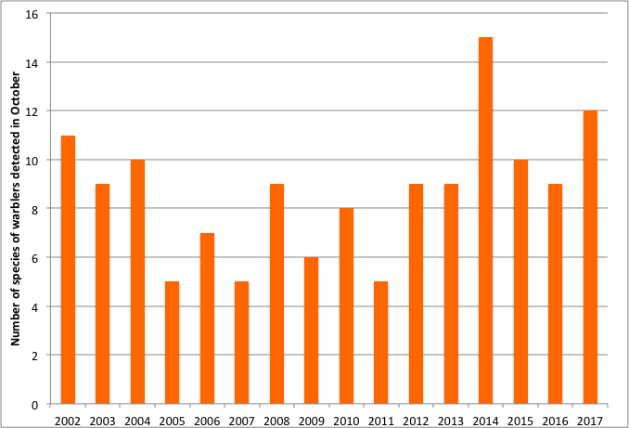

Figure 20. Numbers of warbler species detected in October at CHRS, 2002 - 2017.

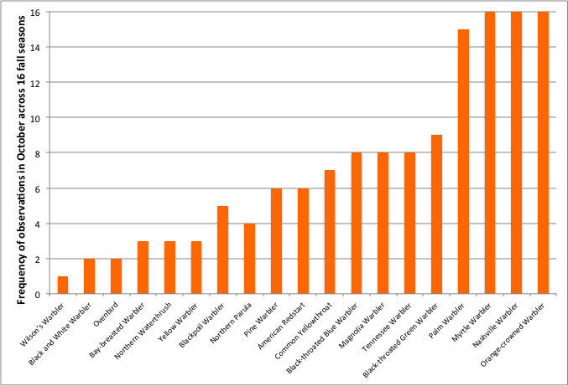

Figure 21. Number of years warbler species were observed in October at CHRS between 2002 and 2017.

# 3.0 Unusual Records

A new species, the Short-eared Owl, was added to the area checklist this fall. It was seen flying against a strong south wind over Georgian Bay, heading south, on October 18. One Townsend’s Solitaire was seen very briefly on October 1. It was only the fourth individual of this species seen at Cabot Head (two in the falls of 2004 and 2005, and one in spring 2016). This species resides mostly in the Rocky Mountains but is well known for its vagrancy tendency, being recorded well east of its range almost every year. According to eBird (ebird.org), a number of Townsend’s Solitaire were seen around Lake Superior between August and November of this year, but none in Southwest Ontario (besides Cabot Head).

Some species are banded rarely or in very small numbers in the fall. One Wood Thrush was banded on September 7, the fourth season only with captures of this species. Previous captures, interestingly, happened three fall seasons in a row (2005, 2006, and 2007). Wood Thrush breed on the Bruce Peninsula but they do not favor the kind of habitats around the mist nets. Other species are banded more regularly across the years but always in very small numbers. For example, this fall, two Belted Kingfishers were banded, both young males, on August 30 and September 19. This species was captured in eight previous fall seasons, with one to three birds banded in each season. Two other species, captured this fall, had also been captured in eight previous years in very small numbers: one young male Pileated Woodpecker was banded on September 25 and one young female Scarlet Tanager was banded on August 28.

Rusty Blackbirds are seen every fall in variable numbers (from one in 2010 to 91 in 2016). This fall, a total of 20 birds were detected from September 18 (the third earliest date) to October 11.

Other noteworthy observations are (by chronological order): rarely detected, Eastern Bluebirds were heard on August 20, making 2017 the sixth fall with detections. Baltimore Oriole was detected on August 25 and 26 with one bird each. It is only the fourth fall season with observation for this species (falls of 2003, 2008, and 2013). White-breasted Nuthatches are seen almost every fall (being missed only in four seasons) but always in a few occasions with only one or two birds at once. This fall, there were only two detections, on August 30 and on September 6, both dates being the earliest ever.

Red-tailed Hawks, on the other hand, are observed every fall season but this species can be surprisingly sparse, with half of the 16 fall seasons having only one or two days with detection. That was the case this fall with one bird detected on August 25 and 26. Similarly, Sandhill Cranes are detected every fall but always in relatively small numbers and on few occasions. This fall, two birds were seen together on September 16, 23, and 24. One and two Blue-gray Gnatcatchers were seen on September 1 and 2, respectively. This species has only been seen in seven previous fall seasons. One Warbling Vireo was observed on September 2, a species rarely observed in fall (detected in six other fall seasons). Chimney Swifts are detected even less than the previous two species. One bird was seen this year on September 4, only the fifth fall with an observation. There was only one day with observations of Philadelphia Vireos this fall, on September 10, but with eight birds, it was the second highest daily total for this species observed almost every fall. One Red-bellied Woodpecker was heard on October 1.

Except for a few species, the monitoring area at Cabot Head does not offer great habitat for ducks, especially dabbling ducks. This fall, a large group of 15 American Green-winged Teals was seen flying by on September 3. Wood Ducks and Hooded Mergansers use the shallow lakes next to the research area quite extensively. They are therefore seen more frequently during monitoring, albeit still in relatively small numbers. This fall, no Wood Ducks were observed, whereas small flocks of four to five Hooded Mergansers were seen relatively often on Wingfield Basin from August 15 to October 1.

Peregrine Falcons were not detected during the monitoring period, despite a local presence in the spring. The only observation was of an immature bird perched on Middle Bluff, seen in the afternoon in late September. Likewise, no Northern Goshawks were detected this fall, although this species has been detected in ten previous fall seasons.

# 

# 4.0 Banding Data Analysis

With 1037 birds banded of 61 species, the fall 2017 banding total is the lowest total ever, almost 700 birds less than the 15-year average. For the 15 species with more than 20 individuals captured, ten species have banding totals below average and, among the five species above average, only three depart strongly from the seasonal average (Fig.22). Among the 61 species banded this fall, seven species have the lowest banding total ever, most notably species migrating in October (Brown Creeper, Hermit Thrush, and White-throated Sparrow). A total of 45 species (74% of the number banded this fall) have banding totals lower than the 2002-2016 average. Only one species, Cape May Warbler, was banded in record high numbers.

Numerous variables could affect the capture rates, including population dynamics, weather conditions during migration, food availability and vegetation changes at stopover sites. As a consequence, daily captures are highly variable and one week (September 30 - October 6) concentrates 28% of the season total (Fig.23). This fall, as previously mentioned, weather prevented banding on many days, which affected overall capture rates, especially in October.

Capture rates varied greatly on a monthly, and even weekly, basis (Fig.24). The capture rate is determined by dividing the number of birds caught in a net by the number of hours for which the net was operated. Thus, variation in capture rate reflects variation in those two parameters, which are themselves dependent upon various conditions (weather being the major one). Mist net hours can be lost when weather conditions (i.e. rain or strong wind) or the presence of a predator pose a threat to the birds, forcing us to close nets.

In comparison to previous falls, weekly capture rates this fall were consistently below the 2002-2016 average for eight weeks out of the ten with banding this year, especially so in the first two weeks of monitoring and in the week of September 20 - 26 (Fig.24). The weekly banding total shows a similar pattern (Fig.25), except for the last two weeks of banding when banding totals were extremely low, a reflection of the very low number of mist net hours during that period. There were four weeks this fall where banding total reached its lowest ever (August 16 – 22; September 20 – 26; October 11 – 17 and 18 – 24). When all years are combined, weekly mist net hours average around 80% in the first nine weeks of fall monitoring but drop to around 60% for the remaining three weeks. However, variations between years are substantial (Fig.26). In 2017, the coverage of 65% of potential mist net hours realized was significantly lower than the 2002 – 2016 average of 74% (low of 54% in 2007 and high of 86% in 2008). Coverage, as usual, varied widely throughout the season. Mist net hours were near or above average for about only a third of the season but negatively departed strongly from it in the first and last three weeks of monitoring. Mist net hours reached their lowest ever total in two weeks in October (October 4 – 10 and 18 - 24) but with opposite results in terms of numbers of birds banded. Despite three days without banding between October 4 and 10, numbers of banding birds were average, due to the capture of 115 birds on October 6, the highest daily total of the season. On the contrary, there was only one full day of banding between October 18 and 24, resulting in the lowest ever weekly banding total.

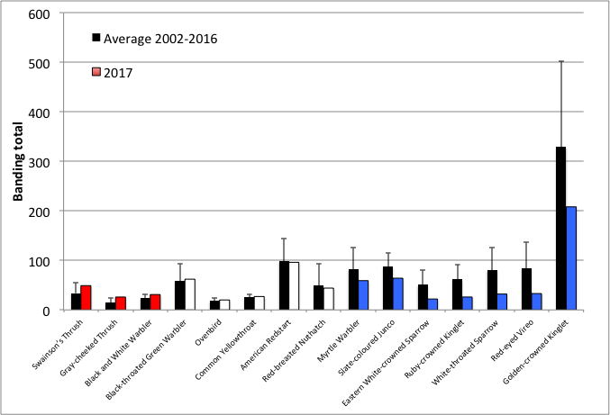Figure 22. Banding total of the most common captured species (at least 15 individuals) compared to average total of 2002-2010 (highest total in red and lowest in blue). Differences from average in decreasing order from left to right. Error bars show Standard Deviation.

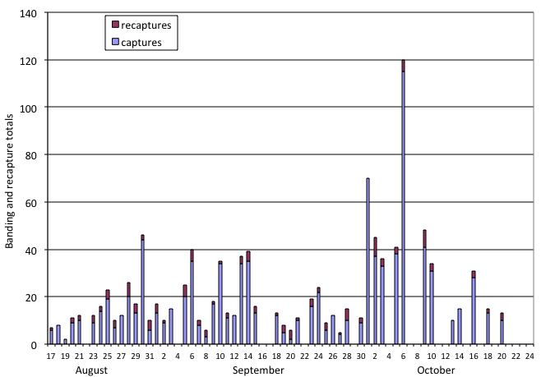Figure 23. Daily banding and recapture total at CHRS, fall 2017.

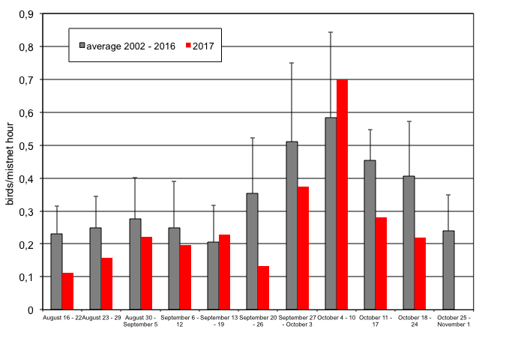Figure 24. Fall weekly capture rates at CHRS. Error bars show Standard Deviation.

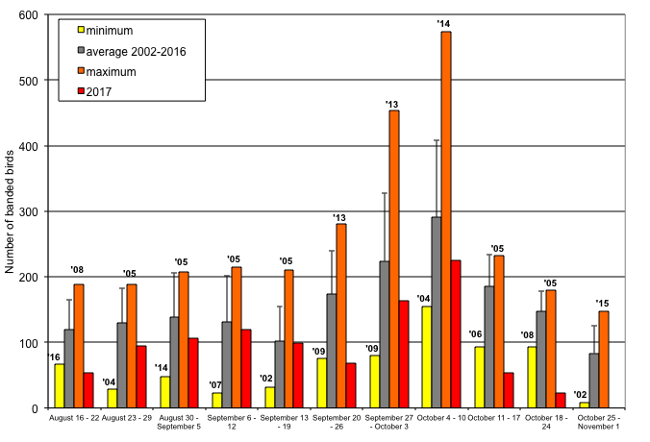Figure 25. Fall weekly number of banded birds at CHRS. Error bars show Standard Deviation.

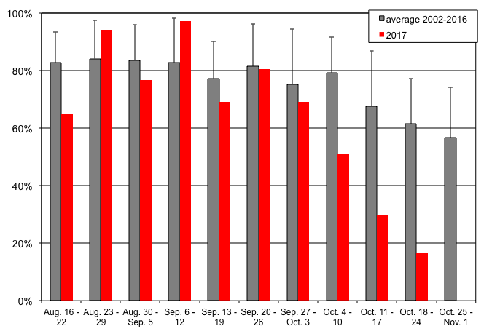Figure 26. Fall weekly proportion of mist net hours at CHRS. Error bars show Standard Deviation.

# 4.1 Weather

Weather is a dynamic system at various scales of space and time. It is thus very difficult to determine its effect on migration without precise data at local, regional, and even continental scales. Here, we present data collected daily at the station, wind direction and strength, temperatures, and cloud cover. In Southern Ontario, the first part of summer this year was marked by more rain than usual. At Cabot Head, from August 15 to the fall equinox, September 22, there were five days with periods of precipitation. Afterwards, there were another five days with rain. On September 29, rain was particularly intense, lasting all day, with, at first, a strong east wind. The wind quickly shifted in late morning to north and became even stronger, reaching 7 on the Beaufort scale: it was the strongest episode of wind during the fall season (taking down power lines). Strong to very strong winds predominated during the monitoring period, especially so in October (Fig.27). A defining characteristic of the 2017 fall season is the relatively small proportion of north wind, notably in October when they usually are common. On the contrary, south winds dominated this year, with half the days in October experiencing south winds of 5 or 6 on the Beaufort scale.

It is difficult to accurately quantify such a dynamic component of the weather, especially because wind strength and direction are recorded only at the start and end of the count period. To characterize wind strength (on the Beaufort scale) and direction, we considered only the strongest wind during the count period of seven hours. Undoubtedly, this method would tend to over-represent strong winds. However, strong winds affect migration tremendously. This fall, strong winds (at least 5 on the Beaufort scale) occurred very frequently (41% of the season) and were mostly from south (69% of the strong winds). There were marked differences throughout the season in wind strength and direction: for example, west winds occurred a quarter of the time in August but were almost non-existent in October (only 4% of the wind in October were from the west).

As mentioned earlier, a heat wave struck Cabot Head and southern Ontario from September 20 to 26, with temperatures reaching almost 30°C in mid-day. During this time, there was little visible migration and very few birds were captured. The weekly banding total is indeed the lowest across the year for that period, despite good coverage in term of netting effort (Fig.28).

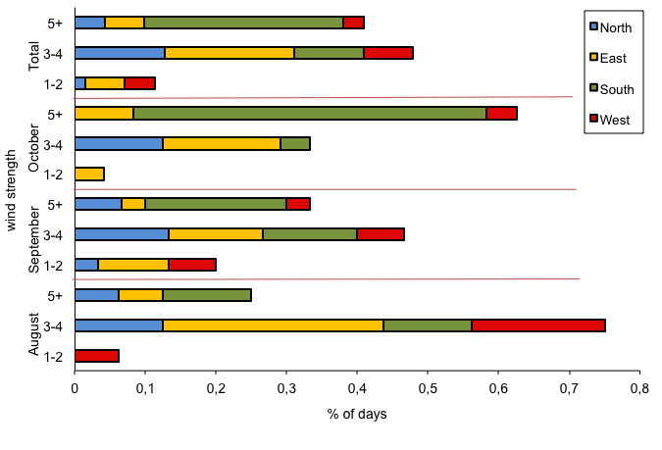

Figure 27. Wind pattern (strength on the Beaufort scale, direction and proportion of time) at CHRS, fall 2017.

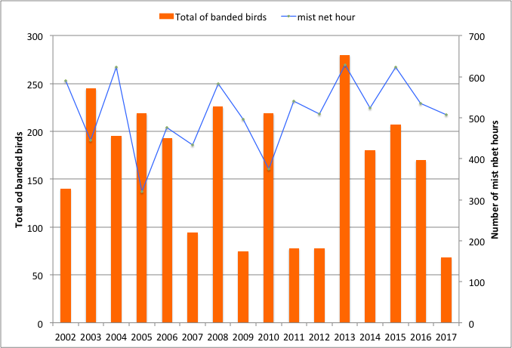

Figure 28. Banding total and number of mist net hours for the September 20 – 26 period at CHRS, 2002 - 2017.

# 4.2 Recaptures

The rate of recapture at Cabot Head was relatively low in fall 2017: a total of 134 recaptures for 90 individuals of 22 species were recaptured from August 15 to October 20 (Table 2). The vast majority (82%) of the 90 recaptured individuals came from birds banded in the fall, representing an overall recapture rate of 7%. There were 16 recaptured birds from previous seasons at Cabot Head, comprised of six species banded from fall 2014 to spring 2017 (Table 3). Among them, one Black-capped Chickadee was banded in the fall of 2014 as a hatch-year (HY); one Red-eyed Vireo was banded in spring 2016 as an after-second-year; the first ever recaptured Pileated Woodpecker was banded in the spring of 2017 as a second-year female; and one Ovenbird was banded as a HY in fall 2016. Most of the remaining between-season individuals were American Redstarts, with ten individuals originally banded from fall 2015 to spring 2017. Among the six American Redstarts banded before 2017, one banded in fall 2015 and one banded in fall 2016 were both also recaptured in spring 2017.

Most of the recaptured birds were recaptured only once (63 out of 90 individuals, 70%) or twice (21%). Five birds of three species (all banded during the fall) were recaptured four times or more. The Red-breasted Nuthatches and Black-capped Chickadees recaptured four times or more may have been local birds or, in the case of Nuthatches, exploiting the abundant cone crop. The other bird recaptured often was a Mourning Warbler. The only individual of this species banded this fall, it was first captured on September 15, weighing 12.1g at that time. Two days of strong south wind followed, when banding was not possible. Afterwards, this Mourning Warbler was recaptured every single day with banding from September 18 to 23 (September 22 was another day of blustery south wind with no banding). Its weight had dropped to 10.8g on first recapture, reached 11g on September 21, and 11.3g on last recapture. The prolonged stopover of this particular bird was most likely the result of its poor condition. The average weight for the 28 Mourning Warblers banded in the fall from 2002 to 2016 was 11.9 ± 0.9g.

Within-season recapture rates are variable between species but relatively small (Table 3). For species with significant numbers banded (50 individuals or more), recapture rate in fall 2017 were very low: 3% for Golden-crowned Kinglets, Black-throated Green and Myrtle Warblers; 6% for Slate-colored Junco. But they reach 18% for American Redstarts, an indication that some birds of this species are local and use Cabot Head extensively.

For species with ten to 50 banded birds, a few species have high rates of recapture: 20% for Ovenbird (from a total of 20 birds banded during the fall) and an impressive 50% of the 14 Black-capped Chickadees banded this fall. Chickadees this year were likely local birds, as no irruptive movement was noted, increasing the likelihood of recaptures. Gray-cheeked and Swainson’s Thrushes were recaptured in quite different rates this fall: only 6% of the 49 banded Swainson’s Thrushes were recaptured, whereas 12% of the 26 Gray-cheeked Thrushes were. For both species, the sample size of recaptured birds is very small: only three individuals of each species, making it difficult to draw inferences. One recaptured Swainson’s Thrush had the second lowest weight (at capture), 24.6g, while the average weight was 30.1 ± 2.3 g. However, the other recaptured thrushes had a weight at capture around average, regardless of species. Capture and recapture depend on several factors: presence of a local breeding population, different foraging behaviour between species and individuals, variations in individual quality between- and within-season (for example, birds in bad conditions could require a longer stopover in the area, regardless or not on food availability).

Despite being captured in high numbers, Golden-crowned Kinglets are always recaptured in a quite low percentage: between 5 and 11%. An even smaller proportion was recaptured this fall: only six kinglets of the 208 banded were recaptured (i.e. 3%), likely indicating that the vast majority of Golden-crowned Kinglets move through the area quickly, without lingering to feed or rest. Recaptures of kinglets most often occur the following day (or few days) after initial banding. This fall, there was no banding for two days after October 6, when 46 Golden-crowned Kinglets were banded (the highest daily total for this species).

American Redstarts, on the other hand, are usually recaptured in greater proportion and tend to stay longer at Cabot Head. This fall, 18% of newly banded birds were recaptured at least once. However, only 3% of the 87 HY redstarts were recaptured, whereas 28% of the 29 adult birds were. All eight recaptured adult American Redstarts were banded before August 25, with four of them banded on the first day of monitoring (August 15). And all of them but one were showing active moult in their flight and tail feathers at time of banding.

Table 3. Total recaptures by species in relation with year and season of banding (only one recapture per individual is included) at CHRS, fall 2017.

|  |  |  |  |  |  |  |  |
| --- | --- | --- | --- | --- | --- | --- | --- |
| Species | 2014 | 2015 | 2016 | | 2017 | | % |
| fall | fall | spring | fall | spring | fall |
| Pileated Woodpecker |  |  |  |  | 1 |  |  |
| Red-eyed Vireo |  |  | 1 |  |  | 2 | 14% |
| Black-capped Chickadee | 1 |  |  | 1 |  | 7 | 50% |
| Red-breasted Nuthatch |  |  |  |  |  | 6 | 32% |
| Brown Creeper |  |  |  |  |  | 1 | 5% |
| Winter Wren |  |  |  |  |  | 1 | 20% |
| Golden-crowned Kinglet |  |  |  |  |  | 6 | 3% |
| Gray-cheeked Thrush |  |  |  |  |  | 3 | 12% |
| Swainson’s Thrush |  |  |  |  |  | 3 | 6% |
| Chestnut-sided Warbler |  |  |  |  |  | 1 | 100% |
| Myrtle Warbler |  |  |  |  |  | 2 | 3% |
| Black-throated Green Warbler |  |  |  |  |  | 2 | 3% |
| Black and White Warbler |  |  |  |  | 1 | 3 | 10% |
| American Redstart |  | 2 | 3 | 1 | 4 | 17 | 18% |
| Ovenbird |  |  |  | 1 |  | 4 | 20% |
| Mourning Warbler |  |  |  |  |  | 1 | 100% |
| Common Yellowthroat |  |  |  |  |  | 4 | 15% |
| Song Sparrow |  |  |  |  |  | 2 | 25% |
| Lincoln’s Sparrow |  |  |  |  |  | 1 | 25% |
| White-throated Sparrow |  |  |  |  |  | 3 | 9% |
| White-crowned Sparrow |  |  |  |  |  | 1 | 5% |
| Slate-coloured Junco |  |  |  |  |  | 4 | 6% |
| Total | 1 | 2 | 4 | 3 | 6 | 74 | 7% |

%: Proportion of birds banded in fall 2017 recaptured.

# 4.3 Net Analysis

Mist net locations at Cabot Head have been permanently set in place in 2002 to ensure standardized capture data. This fall, all nets were open for an average of 60 to 67% of the potential time, except for C13, which was open only 55% of the time. This net is the most exposed of all, being closer to the Georgian Bay shore in an open area; it is thus relatively often affected by winds, especially northeast to northwest.

As usual, there was a significant amount of variation in capture rates for each net: captures were localized in a few very productive nets, as in previous seasons (Fig.29). Location, and thus difference in habitats, can explain variation in capture rates. However, differences in species behaviour may also account for variation. The five nets with the highest capture rate (in decreasing order, B9, A1, C15, C14, and C13) accounted for 56% of the total capture during 33% of the realized mist net hours. The least productive nets (in decreasing order, C11, C12, A5, A4, and B7) accounted for only 14% of the total capture during basically the same amount of time (33%).

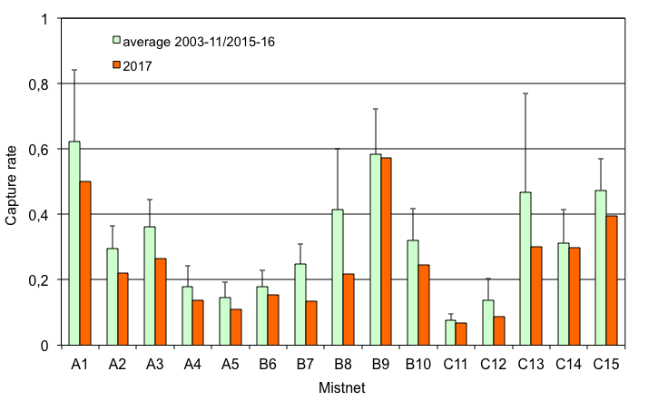Figure 29. Capture rates per mist net for average 2003-2011/2015 and for 2017 at CHRS (data not available for 2002, 2012, 2013, & 2014).

# 5.0 Special Project

This fall, we initiated a special project in collaboration with Greg Mitchell of Environment and Climate Change Canada: marking Swainson’s Thrushes with nanotags. The ultimate goal of the project is to learn more about timing, routes and decision-making during migration. Nanotags are very small, coded, radio transmitters that can be affixed to birds (either with leg loops, our choice, or glued). Each nanotag has a unique identification number on a given frequency that is transmitted at regular intervals. These signals can be picked up by hand-held receivers or through an array of towers integrated into the Motus network (Motus.org). A flying bird marked with a nanotag should be detected by a Motus tower up to 10 km in a clear line of sight.

We had a total of 28 nanotags to deploy this fall on Swainson’s Thrush. Nanotags weigh 0.9g and should be put on birds of at least 30g. Given these conditions, we managed to deploy 25 nanotags from September 6 to October 1 (Fig.30) on birds slightly heavier than average (Table 4).

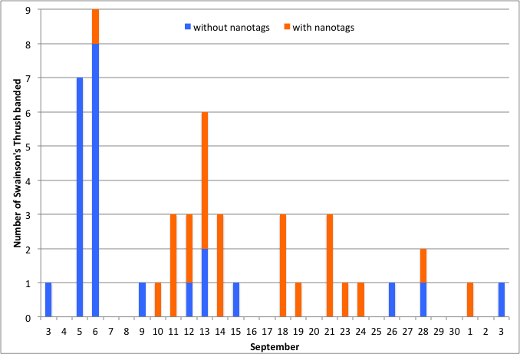

Figure 30. Number of Swainson’s Thrush banded and marked (or not) with nanotags in relation with time at CHRS, fall 2017.

Table 4. Morphometric (weight and wing chord) for Swainson’s Thrush captured at CHRS, fall 2017.

|  |  |  |  |
| --- | --- | --- | --- |
| Swainson’s Thrush | *n* | Weight (av. ± SD) | Wing chord (av. ± SD) |
| Without nanotags | 24 | 29.1 ± 2.4 | 95.1 ± 3.4 |
| With nanotags | 25 | 31.1 ± 1.8 | 96.0 ± 2.4 |

*n*: number of marked birds; av. ± SD: average ± Standard Deviation

# 6.0 Coverage and Protocol

This fall, 34% of the possible mist netting coverage (in hours) was lost due to weather, as high wind and precipitation were significant factors in determining daily net opening and closure (Fig.31). Due to the density of habitat at Cabot Head, at least a portion of the nets can usually be operated on windy days. Coverage was very low this fall as there was no banding in 17 days (out of 71 days, i.e. 24%), the highest number ever in the 16-year period. The daily average for days with banding was a relatively high 78 mist net hours (out of a potential of 90). A census was carried out every day, except during heavy rain.

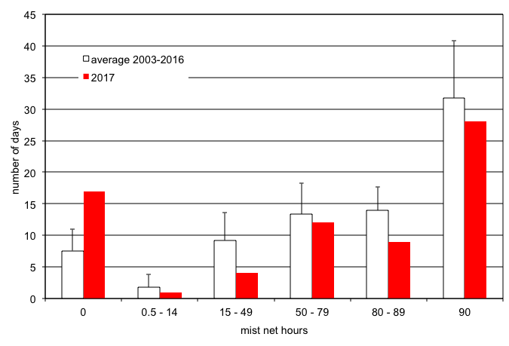

Figure 31. Coverage in mist net hour at CHRS (data not available for 2002), fall 2017.

# 7.0 Personnel

Six volunteers contributed a total of 68 person-days to the fall migration monitoring season (Table 5). This fall, volunteers hailed from Ontario, Québec, British Columbia, and Texas. Volunteers are an essential part of the success of the operations at Cabot Head and all help is appreciated. A special thank goes to Ariel, who cheerfully endured days without power (12 consecutive days, followed shortly by another five!).

Table 5. Volunteer effort, fall 2017.

|  |  |  |
| --- | --- | --- |
| **20+ Days** | **5-10 Days** | **2-4 Days** |
| Ariel Lenske (BC) | Heidi Van Vliet (BC) | Rachel Vallender (QC) |
| Shelby Simons (Texas) | Al Woodhouse (ON) | Heather Fotherby (ON) |

# 8.0 Conclusion

For a sixteenth consecutive fall, bird migration monitoring at Cabot Head was done daily from August 15 to October 24, thanks notably to a dedicated team of volunteers. The continuing monitoring effort throughout the years continually adds detail and refines the picture of bird migration on the Bruce Peninsula.

As always with nature, this fall brought its share of surprises, with one new species, the Short-eared Owl, detected at the station but, most notably, the very low number of birds banded! The seasonal banding total was the lowest in 16 falls, with a high number of species having total well below the 2002-2016 average. Many days were impacted by inclement weather (strong wind and/or rain), negatively influencing the banding and observation. There was an unusual preponderance of strong south winds.

BPBO was excited to participate in a new project: deploying nanotags on Swainson’s Thrush, which will eventually provide new understanding on this species’ migration.

Continuing migration monitoring at CHRS contributes to the efforts of the CMMN and ultimately to the understanding and monitoring of bird populations.

# Acknowledgements

As a non-profit, volunteer-based initiative, BPBO would not be operable without the overwhelming support of its membership, financial supporters and volunteers. BPBO wishes to thank Ontario Parks for their generous on-site management assistance.

The author wishes to thank all the members of Bruce Peninsula Bird Observatory, as well as Ontario Parks for their support during the field season. A special thank is due to Elijah Lederman as he graciously helped me in so many and various ways. I would also like to commend the 6 volunteers who helped make the field season efficient and enjoyable.

# Literature Cited

Cadman, M.D., D.A. Sutherland, G.G. Beck, D. Lepage, and A.R. Couturier (eds.). 2007. Atlas of the Breeding Birds of Ontario, 2001-2005. Bird Studies Canada, Environment Canada, Ontario Field Ornithologists, Ontario Ministry of Natural Resources, and Ontario Nature, Toronto, xxii + 706pp.

Cheskey, E.D. and W.G. Wilson. 2001. Cabot Head Important Bird Area Conservation Plan. Can. Nature Fed., Bird Studies Canada., Fed. of Ont. Naturalists. 32 pp.

Derbyshire, D. G. December, 2002. Migration Monitoring at Cabot Head, Fall 2002. Unpublished report for Bruce Peninsula Bird Observatory

Heagy, A., E.D. Cheskey, and D. G. Derbyshire. March 2003. Migration Monitoring at Cabot Head Research Station, Cabot Head, Ontario: Recommended Protocol for Monitoring Small Landbirds.

Heagy, A. January 2002. Landbird Migration Monitoring at Cabot Head, Ontario, 2001. Unpublished report by Bruce Peninsula Bird Observatory.

Norris, R.D., P.P. Marra, R. Montgomerie, T.K. Kyser and L.M. Ratcliffe. Reproductive effort, molting latitude, and feather color in a migratory songbird. Science 306, 2249 (2004).

# 

# Appendix I. Fall banding total 2017 with statistics from 2002-2016

|  |  |  |  |  |  |  |  |  |
| --- | --- | --- | --- | --- | --- | --- | --- | --- |
| Group | Species | 2017 | Av. ± stdev | Max. | Year | Min. | Year | # |
| Hawks | Sharp-shinned Hawk | 3 | 2,9 ± 1,3 | 5 | 2011 - 2013 | 1 | 2009 - 2012 | 15 |
| Kingfishers | Belted Kingfisher | 2 | 1,5 ± 0,8 | 3 | 2013 | 1 | several years | 9 |
| Woodpeckers | Yellow-bellied Sapsucker | 1 | 1,7 ± 0,8 | 3 | 2011 - 2014 | 1 | several years | 11 |
| Downy Woodpecker | 5 | 9,9 ± 7,9 | 31 | 2009 | 2 | 2002 | 16 |
| Hairy Woodpecker | 1 | 5,9 ± 2,9 | 12 | 2007 | 2 | 2005 - 2015 | 14 |
| Yellow-Shafted Flicker | 5 | 4,1 ± 2,2 | 8 | 2012 - 2016 | 1 | 2005 | 15 |
| Pileated Woodpecker | 1 | 1,1 ± 0,4 | 2 | 2015 |  |  | 9 |
| Flycatchers | Yellow-bellied Flycatcher | 4 | 2,6 ± 1,7 | 7 | 2014 | 1 | several years | 14 |
| Traill’s Flycatcher | 2 | 6,5 ± 3,8 | 16 | 2007 | 1 | 2011 | 16 |
| Eastern phoebe | 1 | 2,3 ± 1,2 | 4 | 2008 |  |  | 10 |
| Vireos | Blue-headed Vireo | 3 | 6,4 ± 3,7 | 13 | 2015 | 1 | 2002 - 2007 | 16 |
| Philadelphia Vireo | 2 | 2,7 ± 1,8 | 6 | 2016 | 1 | several years | 12 |
| Red-eyed Vireo | 33 | 83,7 ± 52,8 | 239 | 2005 | 24 | 2009 | 16 |
| Jays | Blue Jay | 5 | 5,1 ± 3,7 | 16 | 2014 | 1 | 2007 | 15 |
| Chickadees | Black-capped Chickadee | 14 | 165,3 ± 182,4 | 717 | 2005 | 11 | 2015 | 16 |
| Nuthatches | Red-breasted Nuthatch | 44 | 49,2 ± 43,2 | 160 | 2012 | 10 | 2015 | 16 |
| Creepers | Brown Creeper | 19 | 42,8 ± 18,1 | 75 | 2016 | 19 | 2009 | 16 |
| Wrens | Winter Wren | 5 | 4,6 ± 2,3 | 8 | 2007/08/13 | 1 | 2003 | 15 |
| Kinglets | Golden-crowned Kinglet | 208 | 329,3 ± 173,0 | 758 | 2013 | 113 | 2005 | 16 |
| Ruby-crowned Kinglet | 26 | 61,3 ± 30,7 | 122 | 2003 | 20 | 2005 | 16 |
| Thrushes | Veery | 3 | 4,3 ± 2,7 | 8 | 2016 | 1 | 2010 | 13 |
| Gray-cheeked Thrush | 26 | 14,7 ± 9,0 | 23 | 2016 | 6 | 2010 | 16 |
| Swainson’s Thrush | 49 | 33,8 ± 20,7 | 79 | 2015 | 10 | 2006 | 16 |
| Hermit Thrush | 15 | 40,5 ± 18,9 | 87 | 2011 | 16 | 2002 | 16 |
| Wood Thrush | 1 | 1,3 ± 0,6 | 2 | 2005 |  |  | 4 |
| American Robin | 7 | 17,7 ± 8,5 | 36 | 2006 | 1 | 2007 | 16 |
| Mockingbirds | Gray Catbird | 5 | 5,4 ± 3,0 | 17 | 2002 | 2 | 2010/14/16 | 16 |
| Waxwings | Cedar Waxwing | 5 | 35,8 ± 35,6 | 117 | 2005 | 1 | 2014 | 15 |
| Finches | Purple Finch | 2 | 4,6 ± 4,8 | 17 | 2011 | 1 | 2012 - 2016 | 15 |
| New World Warblers | Ovenbird | 20 | 18,1 ± 5,6 | 31 | 2012 | 10 | 2007 | 16 |
| Northern Waterthrush | 4 | 6,5 ± 3,8 | 15 | 2010 | 1 | 2005 | 16 |
| Black and White Warbler | 31 | 23,7 ± 7,5 | 37 | 2013 | 12 | 2006 - 2007 | 16 |
| Tennessee Warbler | 5 | 11,3 ± 13,0 | 44 | 2005 | 2 | 2009 | 15 |
| Orange-crowned Warbler | 17 | 15,3 ± 8,6 | 28 | 2014 | 3 | 2005 | 16 |
| Nashville Warbler | 14 | 35,3 ± 15,4 | 78 | 2005 | 19 | 2010 | 16 |
| Mourning Warbler | 1 | 2,5 ± 0,9 | 4 | 2009 - 2012 | 1 | 2002 | 12 |
| Common Yellowthroat | 27 | 25,2 ± 6,6 | 39 | 2010 | 17 | 2008 | 16 |
| American Redstart | 96 | 98,5 ± 45,4 | 198 | 2003 | 44 | 2007 | 16 |
| Cape May Warbler | 12 | 2,2 ± 1,8 | 7 | 2015 | 1 | several years | 12 |
| New World Warblers | Magnolia Warbler | 14 | 22,3 ± 5,0 | 34 | 2005 | 16 | 2012 - 2013 | 16 |
| Bay-breasted Warbler | 2 | 6,5 ± 5,5 | 23 | 2016 | 1 | 2009 | 14 |
| Yellow Warbler | 2 | 3,8 ± 3,2 | 13 | 2003 | 1 | several years | 16 |
| Chestnut-sided Warbler | 1 | 2,0 ± 1,2 | 5 | 2002 | 1 | several years | 14 |
| Blackpoll Warbler | 8 | 12,9 ± 8,4 | 31 | 2015 | 5 | 2006 | 16 |
| Black-thr. Blue Warbler | 16 | 13,1 ± 5,0 | 22 | 2002 | 2 | 2014 | 16 |
| Western Palm Warbler | 2 | 7,7 ± 5,7 | 22 | 2012 | 1 | 2004 | 16 |
| Pine Warbler | 2 | 1,7 ± 0,8 | 3 | 2011 |  |  | 8 |
| Myrtle Warbler | 59 | 81,8 ± 44,5 | 204 | 2005 | 34 | 2004 | 16 |
| Black-thr. Green Warbler | 62 | 58,4 ± 35,2 | 120 | 2002 | 14 | 2016 | 16 |
| Wilson’s Warbler | 2 | 7,1 ± 2,9 | 12 | 2009 | 2 | 2004 | 16 |
| Canada Warbler | 2 | 4,0 ± 2,0 | 8 | 2002 | 1 | 2004 - 2006 | 16 |
| New World Sparrows | American Tree Sparrow | 2 | 31,7 ± 26,5 | 94 | 2015 | 11 | 2002 | 16 |
| Chipping Sparrow | 1 | 2,6 ± 1,8 | 7 | 2015 | 1 | 2003/07/14 | 15 |
| Savannah Sparrow | 1 | 2,8 ± 2,2 | 8 | 2007 |  |  | 10 |
| Song Sparrow | 8 | 13,4 ± 5,1 | 28 | 2002 | 7 | 2015 | 16 |
| Lincoln’s Sparrow | 4 | 6,1 ± 3,1 | 13 | 2010 | 2 | 2003 | 15 |
| Swamp Sparrow | 6 | 4,2 ± 2,4 | 11 | 2003 | 1 | 2015 | 16 |
| White-throated Sparrow | 32 | 79,9 ± 45,4 | 199 | 2005 | 39 | 2007 | 16 |
| E. White-crowned Sparrow | 22 | 50,5 ± 29,3 | 126 | 2007 | 11 | 2013 | 16 |
| Slate-coloured Junco | 64 | 87,1 ± 27,2 | 141 | 2015 | 47 | 2002 | 16 |
| Cardinals | Scarlet Tanager | 1 | 1,6 ± 0,5 | 2 | several years | 1 | 2002/10/16 | 9 |
| Total of banded birds | | 1037 | 1757,8 ± 314,3 | 2477 | 2005 | 1418 | 2007 | 14 |
| Number of species banded | | 61 |

Record for fall 2017: highest number highlighted in red; lowest number highlighted in yellow

Black-thr. Blue Warbler: Black-throated Blue Warbler

Black-thr. Green Warbler: Black-throated Green Warbler

E. White-crowned Sparrow: Eastern White-crowned Sparrow

Av. ± stdev.: Average ± standard deviation

Max. : Maximum; Min.: Minimum

#: number of fall seasons with banding

# Appendix II. Detected Totals of species observed in fall 2017 at Cabot Head Research Station

|  |  |  |  |  |  |  |  |  |
| --- | --- | --- | --- | --- | --- | --- | --- | --- |
| Group | Species | Season Total | Average | Max Daily | Min Daily | Days  with obs. | First date | Last date |
| Ducks, Geese & Swans | Canada Goose | 1335 | 58 | 684 | 1 | 23 | 24 Au. | 18 Oc. |
| Mallard | 5 | 2 | 3 | 1 | 3 | 27 Au. | 10 Oc. |
| Green-winged Teal | 18 | 6 | 15 | 1 | 3 | 24 Au. | 10 Oc. |
| Surf Scoter | 2 |  |  |  | 1 | 18 Oc. |  |
| White-winged Scoter | 24 | 12 | 21 | 3 | 2 | 18 Oc. | 19 Oc. |
| Long-tailed Duck | 6 | 3 | 5 | 1 | 2 | 16 Oc. | 23 Oc. |
| Hooded Merganser | 32 | 3 | 6 | 1 | 11 | 16 Au. | 1 Oc. |
| Common Merganser | 36 | 2 | 5 | 1 | 16 | 24 Au. | 23 Oc. |
| Red-breasted Merganser | 26 |  |  |  | 1 | 18 Oc. |  |
| Grouse & Turkeys | Ruffed Grouse | 28 | 2 | 7 | 1 | 15 | 5 Se. | 22 Oc. |
| Wild Turkey | 1 |  |  |  | 1 | 23 Oc. |  |
| Grebes | Horned Grebe | 5 | 2 | 3 | 1 | 3 | 9 Oc. | 20 Oc. |
| Red-necked Grebe | 34 | 11 | 27 | 3 | 3 | 25 Au. | 18 Oc. |
| Pigeons and Doves | Mourning Dove | 2 |  |  |  | 2 | 20 Au. | 10 Se. |
| Goatsuckers | Eastern Whip-poor-will | 2 |  |  |  | 2 | 2 Se. | 24 Se. |
| Swifts | Chimney Swift | 1 |  |  |  |  | 4 Se. |  |
| Hummingbirds | Ruby-throated Hummingbird | 72 | 3 | 7 | 1 | 28 | 15 Au. | 15 Se. |
| Cranes | Sandhill Crane | 6 | 2 | 2 | 2 | 3 | 16 Se. | 24 Se. |
| Sandpipers & Phalaropes | Greater Yellowlegs | 6 | 1 | 2 | 1 | 5 | 25 Au. | 6 Oc. |
| Lesser Yellowlegs |  |  |  |  |  |  |  |
| Spotted Sandpiper | 6 | 1 | 1 | 1 | 6 | 21 Au. | 23 Se. |
| American Woodcock | 1 |  |  |  | 1 | 31 Au. |  |
| Gulls & Terns | Ring-billed Gull | 438 | 8 | 47 | 1 | 55 | 16 Au. | 23 Oc. |
| Herring Gull | 43 | 2 | 6 | 1 | 21 | 19 Au. | 23 Oc. |
| Common Tern | 4 | 1 | 2 | 1 | 3 | 15 Au. | 25 Se. |
| Loons | Common Loon | 138 | 4 | 39 | 1 | 31 | 19 Au. | 21 Oc. |
| Cormorants | Double-crested Cormorant | 182 | 8 | 37 | 1 | 23 | 15 Au. | 21 Se. |
| Herons & Bitterns | Great Blue Heron | 18 | 1 | 2 | 1 | 14 | 17 Au. | 23 Se. |
| Vultures | Turkey Vulture | 45 | 2 | 8 | 1 | 22 | 17 Au. | 14 Oc. |
| Hawks, Kites & Eagles | Bald Eagle | 76 | 2 | 5 | 1 | 46 | 15 Au. | 22 Oc. |
| Northern Harrier | 3 | 2 | 2 | 1 | 2 | 10 Se. | 23 Oc. |
| Sharp-shinned Hawk | 10 | 1 | 1 | 1 | 10 | 15 Au. | 13 Oc. |
| Broad-winged Hawk | 27 | 5 | 14 | 1 | 5 | 29 Au. | 6 Se. |
| Red-tailed Hawk | 2 | 1 | 1 | 1 | 2 | 30 Au. | 2 Se. |
| Typical Owls | Short-eared Owl | 1 |  |  |  | 1 | 18 Oc. |  |
| Kingfishers | Belted Kingfisher | 41 | 1 | 3 | 1 | 32 | 18 Au. | 10 Oc. |
| Woodpeckers | Red-bellied Woodpecker | 1 | 1 | 1 | 1 | 1 | 1 Oc. |  |
| Yellow-bellied Sapsucker | 4 | 1 | 1 | 1 | 4 | 23 Se. | 5 Oc. |
| Downy Woodpecker | 86 | 2 | 6 | 1 | 36 | 30 Au. | 22 Oc. |
| Hairy Woodpecker | 16 | 1 | 2 | 1 | 13 | 30 Au. | 19 Oc. |
| Northern Flicker | 113 | 3 | 8 | 1 | 44 | 15 Au. | 18 Oc. |
| Pileated Woodpecker | 20 | 1 | 2 | 1 | 18 | 30 Au. | 18 Oc. |
| Falcons | Merlin | 17 | 1 | 2 | 1 | 15 | 15 Au. | 23 Oc. |
| Tyrant Flycatchers | Yellow-bellied Flycatcher | 5 | 1 | 1 | 1 | 5 | 24 Au. | 20 Se. |
| Traill's Flycatcher | 2 | 1 | 1 | 1 | 2 | 18 Au. | 30 Au. |
| Least Flycatcher | 2 | 1 | 1 | 1 | 2 | 16 Au. | 6 Se. |
| Eastern Phoebe | 7 | 2 | 5 | 1 | 3 | 24 Se. | 10 Oc. |
| Eastern Kingbird | 8 | 1 | 2 | 1 | 7 | 15 Au. | 5 Se. |
| Vireos | Blue-headed Vireo | 4 | 1 | 1 | 1 | 4 | 9 Se. | 23 Se. |
| Warbling Vireo | 1 |  |  |  | 1 | 3 Se. |  |
| Philadelphia Vireo | 8 |  |  |  | 1 | 10 Se. |  |
| Red-eyed Vireo | 161 | 5 | 20 | 1 | 34 | 15 Au. | 2 Oc. |
| Crows & Jays | Blue Jay | 1212 | 22 | 165 | 1 | 55 | 15 Au. | 21 Oc. |
| American Crow | 58 | 2 | 8 | 1 | 27 | 15 Au. | 20 Oc. |
| Common Raven | 63 | 2 | 4 | 1 | 37 | 15 Au. | 23 Oc. |
| Larks | Horned Lark | 8 | 2 | 2 | 1 | 5 | 14 Se. | 28 Se. |
| Swallows | Tree Swallow | 3 | 2 | 2 | 1 | 2 | 17 Au. | 21 Au. |
| Barn Swallow | 6 | 3 | 5 | 1 | 2 | 17 Au. | 24 Au. |
| Chickadees | Black-capped Chickadee | 617 | 11 | 37 | 1 | 55 | 15 Au. | 23 Oc. |
| Nuthatches | Red-breasted Nuthatch | 841 | 13 | 46 | 1 | 63 | 15 Au. | 23 Oc. |
| White-breasted Nuthatch | 2 | 1 | 1 | 1 | 2 | 30 Au. | 6 Se. |
| Creepers | Brown Creeper | 21 | 2 | 5 | 1 | 11 | 14 Se. | 20 Oc. |
| Wrens | House Wren | 2 | 1 | 1 | 1 | 2 | 27 Au. | 17 Se. |
| Winter Wren | 17 | 1 | 3 | 1 | 13 | 23 Se. | 18 Oc. |
| Gnatcatchers | Blue-gray Gnatcatcher | 3 | 2 | 2 | 1 | 2 | 2 Se. | 3 Se. |
| Kinglets | Golden-crowned Kinglet | 658 | 24 | 94 | 1 | 27 | 14 Se. | 23 Oc. |
| Ruby-crowned Kinglet | 71 | 3 | 10 | 1 | 21 | 23 Se. | 20 Oc. |
| Thrushes | Townsend's Solitaire | 1 |  |  |  | 1 | 1 Oc. |  |
| Eastern Bluebird | 1 | 1 | 1 | 1 | 1 | 20 Au. |  |
| Veery | 3 | 1 | 1 | 1 | 3 | 26 Au. | 18 Se. |
| Gray-cheeked Thrush | 30 | 2 | 11 | 1 | 13 | 31 Au. | 24 Se. |
| Swainson's Thrush | 68 | 3 | 11 | 1 | 22 | 3 Se. | 3 Oc. |
| Hermit Thrush | 16 | 2 | 3 | 1 | 9 | 26 Se. | 13 Oc. |
| Wood Thrush | 1 |  |  |  | 1 | 7 Se. |  |
| American Robin | 83 | 3 | 8 | 1 | 33 | 15 Au. | 20 Oc. |
| Mockingbirds & Thrashers | Gray Catbird | 9 | 1 | 2 | 1 | 7 | 21 Se. | 18 Oc. |
| Brown Thrasher | 1 |  |  |  | 1 | 13 Se. |  |
| Waxwings | Cedar Waxwing | 353 | 10 | 32 | 1 | 34 | 15 Au. | 28 Se. |
| Pipits | American Pipit | 16 | 2 | 5 | 1 | 9 | 15 Se. | 20 Oc. |
| Finches | Purple Finch | 5 | 1 | 1 | 1 | 5 | 29 Au. | 18 Oc. |
| White-winged Crossbill | 28 | 7 | 13 | 1 | 4 | 16 Au. | 20 Oc. |
| Pine Siskin | 1754 | 65 | 515 | 1 | 27 | 11 Se, | 23 Oc. |
| American Goldfinch | 196 | 6 | 29 | 1 | 33 | 15 Au. | 23 Oc. |
| New World Warblers | Ovenbird | 34 | 2 | 8 | 1 | 15 | 21 Au. | 20 Se. |
| Northern Waterthrush | 5 | 1 | 1 | 1 | 5 | 16 Au. | 23 Se. |
| Black-and-white Warbler | 82 | 3 | 10 | 1 | 30 | 15 Au. | 21 Se. |
| Tennessee Warbler | 5 | 1 | 2 | 1 | 4 | 3 Se. | 3 Oc. |
| Orange-crowned Warbler | 18 | 2 | 3 | 1 | 9 | 23 Se. | 14 Oc. |
| Nashville Warbler | 25 | 1 | 3 | 1 | 17 | 18 Au. | 14 Oc. |
| Mourning Warbler | 6 | 1 | 1 | 1 | 6 | 15 Se. | 23 Se. |
| Common Yellowthroat | 138 | 4 | 16 | 1 | 39 | 15 Au. | 14 Oc. |
| American Redstart | 397 | 10 | 28 | 1 | 38 | 15 Au. | 24 Se. |
| Cape May Warbler | 15 | 2 | 4 | 1 | 9 | 15 Au. | 10 Se. |
| Northern Parula | 2 | 1 | 1 | 1 | 2 | 10 Se. | 16 Oc. |
| Magnolia Warbler | 27 | 2 | 6 | 1 | 16 | 15 Au. | 5 Oc. |
| Bay-breasted Warbler | 7 | 1 | 2 | 1 | 5 | 30 Au. | 15 Se. |
| Blackburnian Warbler | 4 | 1 | 2 | 1 | 3 | 16 Au. | 28 Au. |
| Yellow Warbler | 5 | 2 | 2 | 1 | 3 | 15 Au. | 14 Se. |
| Chestnut-sided Warbler | 9 | 2 | 4 | 1 | 5 | 26 Au. | 10 Se. |
| Blackpoll Warbler | 15 | 2 | 6 | 1 | 9 | 4 Se. | 1 Oc. |
| Black-throat. Blue Warbler | 19 | 1 | 2 | 1 | 16 | 17 Au. | 3 Oc. |
| Western Palm Warbler | 58 | 3 | 12 | 0 | 18 | 1 Se. | 11 Oc. |
| Pine Warbler | 13 | 2 | 4 | 1 | 8 | 17 Au. | 1 Oc. |
| Myrtle Warbler | 389 | 7 | 26 | 1 | 57 | 15 Au. | 23 Oc. |
| Black-thr. Green Warbler | 182 | 5 | 43 | 1 | 34 | 15 Au. | 5 Oc. |
| Wilson's Warbler | 4 | 1 | 1 | 1 | 4 | 25 Au. | 11 Se. |
| Canada Warbler | 4 | 1 | 2 | 1 | 3 | 25 Au. | 10 Se. |
| New World Sparrows | American Tree Sparrow | 3 | 2 | 2 | 1 | 2 | 16 Oc. | 20 Oc. |
| Chipping Sparrow | 4 | 1 | 1 | 1 | 4 | 4 Se. | 19 Oc. |
| Savannah Sparrow | 1 |  |  |  | 1 | 6 Se. |  |
| Song Sparrow | 78 | 2 | 7 | 1 | 36 | 15 Au. | 19 Oc. |
| Lincoln's Sparrow | 7 | 1 | 2 | 1 | 6 | 15 Se. | 28 Se. |
| Swamp Sparrow | 6 | 3 | 5 | 1 | 2 | 6 Oc. | 9 Oc. |
| White-throated Sparrow | 99 | 5 | 13 | 1 | 22 | 9 Se. | 20 Oc. |
| White-crowned Sparrow | 54 | 3 | 8 | 1 | 17 | 14 Se. | 16 Oc. |
| Dark-eyed Junco | 176 | 8 | 42 | 1 | 23 | 9 Se. | 23 Oc. |
| Cardinals & allies | Scarlet Tanager | 2 | 1 | 1 | 1 | 2 | 24 Au. | 28 Au. |
| New World Blackbirds | Red-winged Blackbird | 5 | 1 | 1 | 1 | 5 | 4 Se. | 28 Se. |
| Rusty Blackbird | 20 | 3 | 4 | 1 | 8 | 18 Se. | 11 Oc. |
| Common Grackle | 1 |  |  |  | 1 | 3 Oc. |  |
| Baltimore Oriole | 2 | 1 | 1 | 1 | 2 | 25 Au. | 26 Au. |

Average: Daily average.

Au.: August; Se.: September; Oc.: October