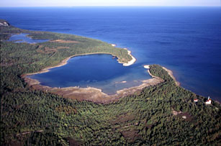

MIGRATION MONITORING AT

CABOT HEAD

FALL 2011

*by*

Stéphane Menu, Ph.D.

Station Scientist

Cabot Head Research Station

Bruce Peninsula - Ontario

stefmenu@gmail.com

*prepared*

*for*

#### BRUCE PENINSULA BIRD OBSERVATORY

November, 2011

**Citation:** Menu, S. November 2011. Migration Monitoring at Cabot Head, Fall 2011. Unpublished report for Bruce Peninsula Bird Observatory

**Table of Contents**

Preface 3

Executive Summary 4

1.0 Methods 5

2.0 Season Summary 5

August 5

September 9

October 17

3.0 Unusual Records 22

4.0 Banding Data Analysis 24

4.1 Weather 32

4.2 Recaptures 34

4.3 Net Analysis 37

5.0 Coverage and Protocol 38

6.0 Personnel 39

7.0 Conclusion 40

Acknowledgements 41

Literature Cited 41

Appendix I. Fall banding totals 2002-2011. 42

Appendix II. Detected Totals of species observed in fall from 2002 to 2011 at Cabot Head Research Station 45

# Preface

Cabot Head is a promontory of the northeast headland of the upper Bruce Peninsula in south-central Ontario, at the northern end of the Niagara Escarpment, in the mixedwood plains ecozone. Cabot Head Research Station (CHRS) is situated on a small spit of land (at 45°15’N, 81°18’W), bordered north by Georgian Bay and south by the western side of Wingfield Basin near the community of Dyer’s Bay. In 2001, Cabot Head was designated as an Important Bird Area (IBA) by Birdlife International for its significant concentrations of migratory bird species (Cheskey and Wilson, 2001) and Red-necked Grebe in particular. Situated in a provincial nature reserve, Cabot Head Research Station is managed conjointly by Ontario Parks and Bruce Peninsula Bird Observatory (BPBO).

The Breeding Bird Survey (BBS) is the principle method for monitoring bird populations in the United States and the southern part of Canada. However, breeding ranges of many species in northern Canada are inaccessible to roadside surveys and are therefore poorly monitored by the BBS method. The Canadian Migration Monitoring Network (CMMN) is a nation wide Bird Studies Canada initiative, enacted to assess changes in populations during migration (<http://www.bsc-eoc.org/volunteer/cmmn>). There are around 25 stations across Canada where data are being collected for each bird species during spring and fall migrations, through a standardized capture and observation protocol. Bruce Peninsula Bird Observatory has demonstrated through data collection since 1998 that Cabot Head is a significant site for monitoring migrating landbirds and has been part of the CMMN since 2003.

Bruce Peninsula Bird Observatory was incorporated as a charitable non-profit organization in 2001 to initiate and direct ornithological assessments and monitoring at Cabot Head and surrounding areas.Migration monitoring has been the primary focus of bird research at Cabot Head since 1998. This document reports on results of the fall 2011, migration monitoring season at Cabot Head Research Station.

# Executive Summary

In this document, the results of migration monitoring at Cabot Head in fall 2011 are summarized and analysed. It is the 10th year of consecutive monitoring following a research protocol established in 2002. Keeping a consistent monitoring effort helps insure the relevance of the information collected.

Fall fieldwork began on August 16 and ended on October 31 for a total of 77 consecutive days of coverage. A total of 132 species of birds were detected in the standard count area over the course of the field season. Among them, 88 species have been seen every fall (67%). In total, 1,719 birds of 69 species were banded and 159 birds of 32 species were recaptured. Recapture data indicate that stopover rates at Cabot Head are generally low but highly variable depending on species and year. It appears that some species, like thrushes, could extensively use Cabot Head as a stopover habitat, to rest and refuel, principally in years of local high food availability (like chokecherry or cone seeds). Analysis of capture rate per net location indicates a large degree of variation associated with habitat characteristics and species behaviour.

The defining characteristic of fall migration in 2011 was a good coverage; however, a below average number of species were seen this fall (range: 128 species in falls 2006 and 2008 – 157 species in fall 2002; average: 139). Most species were caught at average numbers this fall but only a few were caught in record numbers, most notably Hermit Thrush. As a consequence, the banding total is above average (see Appendix I for banding fall totals per year and Appendix II for species detected). A second ever Yellow-breasted Chat was banded this fall at Cabot Head. A new species for the area, Ruddy Turnstone, was added this fall!The highest one-day species total was 42, recorded on September 14.

The fall 2011 migration monitoring season was a success thanks to the efforts of the 5volunteer field biologists who contributed their time to this project.

# 1.0 Methods

The migration monitoring program at Cabot Head as any CMMN station follows a field protocol (established by Heagy et al, 2003) as it is essential for the production of population indices that data collection be consistent over the long term. At Cabot Head Research Station, fifteen mist nets are operated for 6 hours commencing no later than 1 half hour before sunrise, weather permitting. Personnel also complete a census done for one hour along a fixed route, where all bird seen or heard is recorded. Casual observations are also taken and all of the methods are used to determine an estimated total (ET) for each species within the area of the station during the sampling period each day. Supplemental surveys such as visible migration counts and bay watches are completed when circumstances permit.

# 2.0 Season Summary

## August

Fieldwork for fall migration monitoring began at Cabot Head Research Station on August 16 with fifteen mist nets in operation. August is normally a quiet month of migration in southern Ontario. Banding was possible for every day but one in this period, with only a few net hours lost to bad weather (85% of the potential mist net hours were realized). A total of 83 species were detected in August. On average, 28 species per day were detected. Only 4 species were seen on every single day in August: Double-crested Cormorant, Ring-billed Gull, Barn Swallow, and Ruby-throated Hummingbird. A total of 19 species (including the previous ones) were seen on 10 days or more during the 16 days of monitoring in August. On the other end of the scale, 23 species (like Osprey, Eastern Bluebird, Eastern Wood-Pewee, etc.) were detected only once during this period. A total of 375 birds of 36 species – the second-highest total for August after 2005 - were banded and American Redstart was again the most common species caught, with 30% of the banding total, followed by Black-throated Green Warbler and Red-eyed Vireo (about11% and 8%, respectively). The best days were the 16, 18, and 31 August with 37 (for the former 2 days) and 46 birds banded of 14, 13, and 18 species, respectively; the most common birds banded these days were American Redstart and Red-eyed Vireo. A relatively high of 25 birds per day, on average, were caught and banded during this month.

The American Redstart is usually the most abundant species during this period, both observed and banded, because of a large breeding population around the station and a rather early fall migration. This fall, the banding total for American Redstart is the third highest of the 10 years of fall monitoring, with 133 birds banded (with 83% of the redstarts banded in August). Detection of redstarts was relatively low this fall, as more birds were captured than censused or observed (Fig.1).

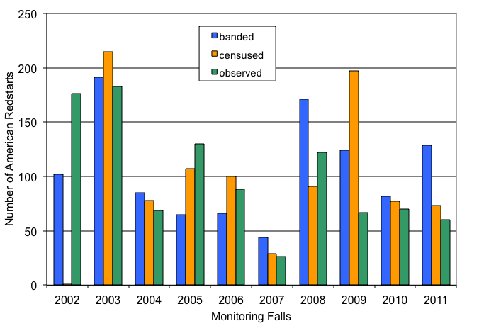Fig.1. American Redstarts monitored at Cabot Head Research Station in fall, in relation to year and monitoring method.

On August 31, 40 species were recorded (either caught or observed), including 14 species of warblers, one of the highest total of the season. On August 18 and 27, 34 species were detected, the second-highest total for August.

In August, migration monitoring is complicated by the presence of local birds. Even though they could also be migratory species, they may not be migrating at this time. For example, an American Redstart observed in August may not be yet in migration mode, simply being a local bird. Nevertheless, migration does occur in August, as shown by the appearance of species that do not breed on the Bruce Peninsula. For example, both Yellowlegs were noted first this fall in August, on the 19, 20, and 21 for the Lesser, and on the 22 and 29 for the Greater. The first boreal warblers and “true” migrants were the Wilson’s Warblers, on August 26 and 28, the Western Palm Warblers, on August 30 and 31, and the Tennessee Warblers on August 30. Two other species, the Philadelphia Vireo and Lincoln’s Sparrow, that mostly breed in the Boreal Forest have, according to the Ontario Breeding Bird Atlas, a small foothold as possible or probable breeders on the Bruce Peninsula. The Lincoln’s Sparrow was detected in August only in 2 years (2010 and 2011) and both years only once at the end of the month. They are most likely migrants, as it is probable that if this species were breeding in the area, it would have been captured more often at this time of year. Likewise, the Philadelphia Vireo was detected only slightly more in August: one individual in 4 years, the earliest on August 21 in 2011. Again, it seems more likely that these birds belong to a more northerly breeding population.

A very unlikely species was banded in August: 2 adult Eastern White-crowned Sparrows were captured on August 17 and 21. Both were heavily moulting their wing and tail feathers. Because this moult happens in the summer grounds, before migration, it means that these individuals have spent its summer on the Bruce Peninsula! It is very surprising for a species that breeds, in Ontario, exclusively in the far north (near, and north of, the treeline adjacent to Hudson’s Bay)! The White-crowned Sparrow banded on August 17 was seen the next following 2 days. Afterwards, it was not detected again for almost a month, until it was recaptured on September 14! At that time, its moult was finished. It is interesting that this individual, while certainly staying in the area, avoided detection for such a long time. This bird was recaptured 3 more times, all in October (on the 4th, 22nd, and 26th).

White-crowned Sparrows were detected in August only in 2 other years: in 2004, one individual was observed on August 28 (with the next observation this year on September 18); in 2007, one bird was observed on August 19, one was banded on August 24 (possibly the same one?), with active moult in its wings, and it was recaptured on September 3. White-crowned Sparrows on the Bruce Peninsula in the summer are thus not totally unusual. It is possible that they are (second-year?) birds in poor conditions in spring, which make then unable to finish their migration to their northern breeding grounds.

This fall, Barn Swallows were seen in more “normal” numbers after last year’s scarcity. The highest daily total was of 20 on August 26, compared to 5 in 2010 (Fig.2). The last Barn Swallows (a total of 8) were seen on September 2. This fall, there were no lingering individuals, as all of them were gone the following day! Swallows are extremely visible, especially so at Cabot Head, since they use the shipwreck in the basin as a breeding ground. They are daily observed, when present, first heard chipping from within the wreck as the sun warms the day, then flying out and around conspicuously. It is thus very unlikely that Barn Swallows or other species of swallows are missed in the fall, even if only one observer was present in August. Barn Swallow is the only species of swallow seen every fall, certainly because they breed yearly in the shipwreck. Tree Swallows are the second most often observed. They used to breed or attempt to breed in a nest box next to the station that is now completely derelict! Other species of swallows could be seen as transient or migratory. A pair of Northern Rough-winged Swallow used to breed in a tube with an opening on the wreck hull in early years (2002 and 2003) but have not been recorded since.

Other birds of summer were rarely observed this year: Common and Caspian Terns were detected this summer only 2 times above Wingfield Basin, with a maximum of 3 birds for the Common Tern. A common species in spring, the Eastern Bluebird is rarely detected in fall, with its presence noted in only 4 years out of 10. This fall, it was detected only once, on August 19.

Weather in August was warm, with only 2 occasions of rain. There were few calm periods (winds no stronger than 2 on the Beaufort scale) as moderately strong to very strong wind occurred relatively frequently: 7 days (out of 17) had winds – mostly from the south - of at a force at least 5 during the morning.

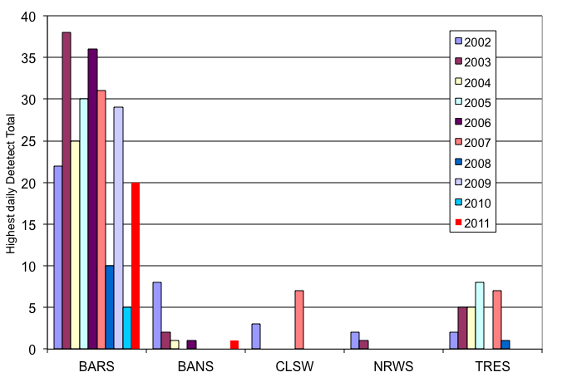Fig.2. Highest daily Detected Total for Swallows at Cabot Head Research Station in fall 2002-2011, in relation to year. BARS: Barn Swallow; BANS: Bank Swallow; CLSW: Cliff Swallow; NRSW: Northern Rough-winged Swallow; TRES: Tree Swallow.

## September

Weather in September was mostly warm and dry, with only 4 days with episodes of rain during the month. As with birds, it is a time of transition between summer and fall. Only 2 full days of banding were lost because of rain, as well as part of 2 other days. Only 13% of the possible mist net hours were lost, concentrated mostly in these 4 days with precipitation. A total of 93 species were detected during the month, not the least being the Whip-poor-will calling across Wingfield Basin as late as September 29. Only one species, the Ring-billed Gull, was detected every day with monitoring. A total of 11 species were detected at least on 20 different days, while 55 species were rarely detected (less than 5 days). A total of 525 birds of 54 species, well below the average of 618 birds, were banded in September. The most common species caught were Red-eyed Vireo and Cedar Waxwing (with 71 and 67 birds banded, respectively, accounting for about 13% of the monthly total), then Myrtle and Black-throated Warblers (about 6% each). Huge variations in capture rates and number of banded birds occur in September, with a low of 331 birds in fall 2007 and a high of 1029 in fall 2005.

September is the most diverse month: 54 species were caught compared to 37 for August and 38 for October and 93 species were detected in total (compared to 83 and 79 for August and October, respectively). Many species migrate mainly during this month (i.e., warblers, White-throated Sparrow and Swainson’s Thrush), while early migrants are still moving through (American Redstart and Black and White Warbler, for example). The earliest individuals of the late migrants can also be encountered at the end of the month (Kinglets, Hermit Thrush, Sparrows). Banding in September was relatively slow with an average of 19 birds a day (range from 2 to 61 birds). September 29 was the best day for the month: In 90 mist net hours, 61 birds of 22 species were banded. Captures were widespread across species, with thrushes (both Gray-cheecked and Swainson’s), kinglets, and Myrtle Warblers being the most captured.

Diversity reached high points throughout the month: 41 species detected on September 14, 39 on the 29, 34 both on September 11 and 24. Of a total of 75 species detected on these 4 days, only 9 were detected on each day. Almost half of the total (34 species) were detected just in one day.

Diversity and abundance of warblers peaked in late August and early September (Fig.3 and Table 1): in the 5-day period between August 31 and September 4, a total of 21 warbler species was detected, with Myrtle Warbler, Black-throated Green Warbler, and American Redstart being the most abundant. A few species (Pine, Tennessee, Mourning, Blackburnian Warblers) were only detected by one or two individuals during this period. After that day, both diversity and abundance of warblers dropped remarkably: over 5-day periods, only between 9 and 14 species of warblers were detected up to the end of September. The decline in diversity and abundance is even more drastic in October, when only a handful of species of warblers are detected. Throughout the season, Myrtle Warbler, Common Yellowthroat, American Redstart, and Black-throated Green Warbler were the species most often detected and in the highest numbers. Last observations were in September for about 75% of the warbler species, as early as the 1st (for Chestnut-sided Warbler and Northern Waterthrush) or as late as the 29th (Black-throated Green and Tennessee Warblers). A few species were seen up to the early days of October but only Myrtle and Orange-crowned Warblers were seen in significant number for longer period during this month (Table 1).

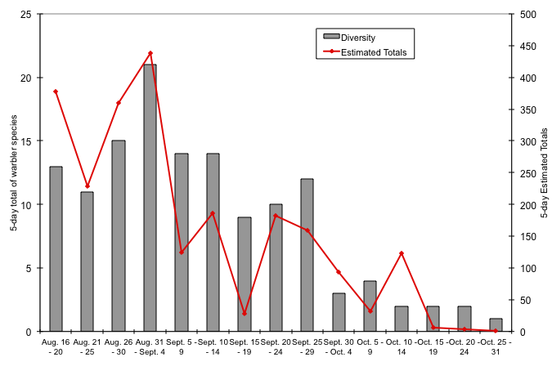

Fig.3. 5-day average of numbers of warbler species and 5-day Estimated Totals of warblers (all species combined) at Cabot Head Research Station in fall 2011.

Table1: Phenology of migration for warbler species, with dates of first and last observation, number of days between first and last observation, number of days with observation, and estimate totals.

|  |  |  |  |  |  |  |
| --- | --- | --- | --- | --- | --- | --- |
|  | Dates of first and last observations | | | Number of days | | Estimated Total |
| August | September | October | between first and last observation | with observation |
| Myrtle Warbler B | 16 |  | 26 | 72 | 53 | 762 |
| Common Yellowthroat B | 16 | 24 |  | 40 | 32 | 154 |
| American Redstart B | 16 | 25 |  | 41 | 28 | 531 |
| Black-throated Green Warbler B | 16 | 26 |  | 42 | 26 | 306 |
| Black-and-White Warbler B | 16 | 18 |  | 34 | 25 | 140 |
| Nashville Warbler B | 16 |  | 23 | 69 | 22 | 83 |
| Magnolia Warbler B | 16 | 29 |  | 45 | 19 | 39 |
| Black-throated Blue Warbler B | 19 |  | 5 | 48 | 15 | 20 |
| Blackpoll Warbler | 31 | 28 |  | 29 | 13 | 71 |
| Ovenbird B | 16 | 28 |  | 35 | 12 | 34 |
| Western Palm Warbler | 30 |  | 3 | 35 | 12 | 53 |
| Orange-crowned Warbler |  | 14 | 18 | 35 | 10 | 10 |
| Wilson's Warbler | 26 | 21 |  | 27 | 10 | 12 |
| Yellow Warbler B | 16 | 3 |  | 19 | 9 | 33 |
| Northern Waterthrush B | 16 | 1 |  | 17 | 6 | 28 |
| Pine Warbler B | 30 | 29 |  | 31 | 6 | 15 |
| Tennessee Warbler | 31 | 27 |  | 28 | 5 | 5 |
| Bay-breasted Warbler |  | 3 – 20 |  | 18 | 3 | 13 |
| Chestnut-sided Warbler B | 16 | 1 |  | 17 | 3 | 4 |
| Canada Warbler B | 18 – 26 |  |  | 9 | 2 | 2 |
| Cape May Warbler |  | 1 – 9 |  | 9 | 2 | 3 |
| Mourning Warbler B | 29 - 31 |  |  | 3 | 2 | 2 |
| Blackburnian Warbler |  | 4 |  | 1 | 1 | 1 |
| Yellow-breasted Chat |  | 24 |  | 1 | 1 | 1 |

B: These species breed on the northern Bruce Peninsula (according to the Ontario Breeding Bird Atlas)

Many species not monitored by banding migrate mostly in September. The first flocks of Canada Geese were seen in early September, as usual, with a few days of Estimated Totals of 100. The peak was on September 12, on a clear and warm morning, with a strong wind shifting from South to West, when an estimated total of 600 Canada Geese were counted. Flocks of Double-crested Cormorant were seen daily since August. However, this species tends to roost on rocks in Wingfield Basin instead of flying through like the geese. It is thus harder to differentiate migrants from local residents. However, the numbers of Cormorant dropped drastically after mid-September from an average of 30 to less than 10, indicating that most of them have left. The last individual of the month was seen on September 25. A very late and lonely Cormorant was also seen on October 19.

An overwhelming majority of Blue Jays and Yellow-shafted Flickers migrate in September: this fall, 77% and 83% of Detected Totals, respectively, occurred during this month. Even though the bulk of migration is in September for both species, their phenology is quite different (Fig.4&5). Yellow-shafted movements through Cabot Head are spread throughout September and involve small numbers: this fall, a below average year, a total of only 58 Flickers were detected, with observations almost daily in September and a daily high of only 13 birds on September 20. On the opposite, Blue Jays movements usually involve a peak concentrated in a few days, which varies slightly between years. Most of the time, between a third and a half of the season total is detected in a 7-day period. This fall, between September 15 and 25, 77% of all Blue Jays were detected, with a high of 109 DT on September 19 for a below-average seasonal total of 570 birds (Fig.5).

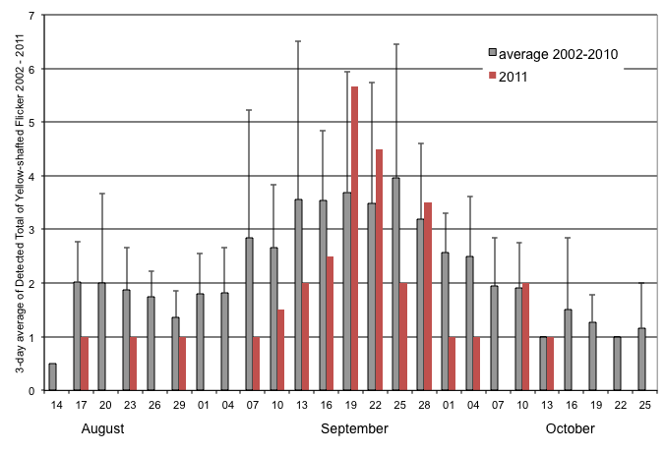Fig.4. 3-day average of Detected Totals of Yellow-shafted Flickers for 2011 and the combined years of 2002 to 2010.

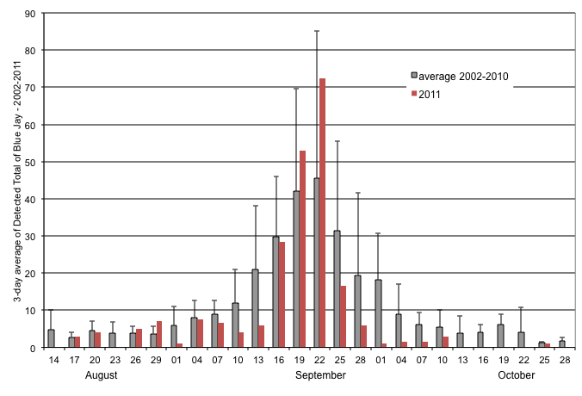Fig.5 3-day average of Detected Totals of Blue Jays for 2011 and the combined years of 2002 to 2010.

Common Loons were seen throughout the entire season with about 50% of all observations made in September. Loons can usually be seen in small rafts on Georgian Bay or flying in a southeast direction, either over water or land. This fall, a total of only 115 Loons was detected, the lowest number in 10 years (range of 159 in 2007 and 997 in 2003). This species is a strong flyer and moves through the area rapidly, making detection difficult. Another potential problem is that it routinely flies, low or high, over Georgian Bay at any time of the day, which makes accurate monitoring difficult as well. It would probably require a standardized lake watch, i.e. constant effort of observation throughout the day and season. Presently, none is in place and, with limited staff, it could be difficult to establish one. Based on observations, it also seems that daily and seasonal loon movements are “patchy”, meaning that small numbers of loons could be seen moving through in a rather short period of time, interspersed with extended periods of apparently no movement. Thus, a lake watch done on a limited time (5 or 10 minutes every hour, for example) is likely to miss most of the movements. There seems to be no regular seasonal peak of migration, as shown by the extreme variation between years in temporal proportion of observations (Fig.6).

The one-hour daily census records, seasonally, between 29 to 63% of all Common Loons detected (excluding 2002, when census was not done daily because of limited staff). While doing census, the observer spends a maximum of 5 to 10 minutes along the Georgian Bay shoreline, which means that most loons recorded during the census are seen flying overland. Because census is standardized along a route and time, it is probably the best method to get an idea of yearly variations in Common Loons. In fall 2011, census recorded the third-lowest number of Loons (excluding 2002, when census was not carried every day). Numbers detected in census vary by more than a ten-fold factor, with a low of 48 birds in 2007 and a high of 556 (!) in 2003. However, the fall of 2003 appears to be exceptional in its loon migration. Between 2004 and 2011, the average number of loons seen on census was 104, indicating that this fall was just below average. Estimated Totals comprise the Detected Totals and an estimate of the number of birds that may have been missed by the monitoring methods. There seems to be no consistency between years (Fig.7).

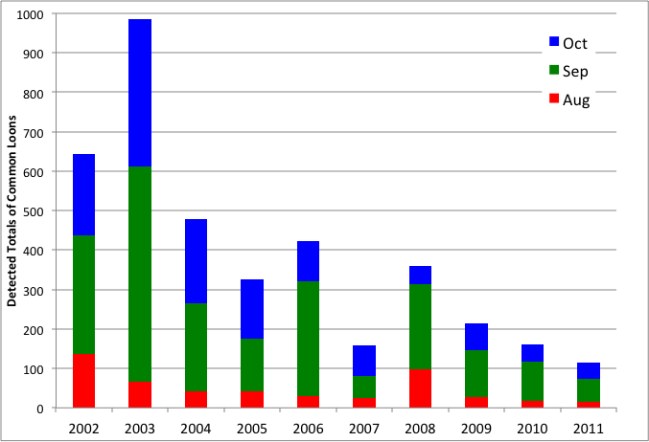Fig.6. Detected Totals of Common Loons detected at Cabot Head Research Station, in relation to year and time of monitoring.

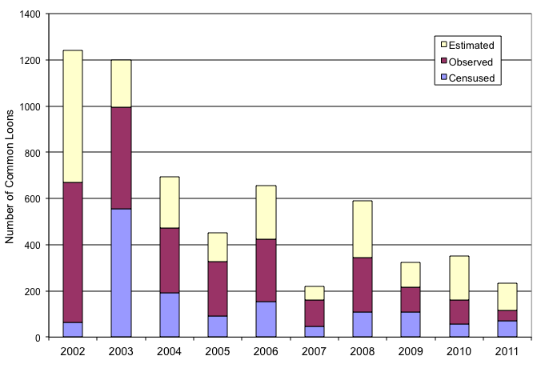Fig.7. Number of Detected and Estimated Loons according to methods of monitoring at Cabot Head Research Station, in fall from 2002 to 2011.

## October

October is usually the busiest – although less diverse - banding period of the fall migration season at Cabot Head Research Station. This was again the case in 2011, as 818 birds of 38 species were banded (almost 50% of the seasonal total), for a daily average of 33 birds captured. Banding was hampered by weather relatively often in October, with 6 complete days lost due to rain and/or wind and 4 other days with only limited monitoring (either a few nets open for the full 6 hours or most nets open for a short time). As a consequence of the bad weather, a below average of the potential mist net hours was realized in October (61%).The most common species caught were Golden-crowned Kinglet, with 188 individuals banded (23% of the monthly total), followed by Pine Siskin (with 170 individuals banded! About 21% of the monthly total), and Slate-colored Juncos and Hermit Thrush (with 11% and 10%, respectively). A total of 79 species were detected during the month, not the least being the Vesper Sparrow observed on October 1 (previously detected only in 2002 and 2003).

The weather during the first two weeks of the month was mostly clear and warm, with some periods of strong wind and one episode of rain, strongly affecting the banding. Consequently, a relatively low 69% of potential mist net hours were realized. However, an average of 40 birds per day was caught during this period. Daily numbers of birds banded were very variable, ranging from 10 to 119 during this period. Surprisingly, Pine Siskins account for 30% of the 566 birds banded during these 2 weeks! On October 2 and 3, huge flocks of Pine Siskins were milling around Cabot Head, swarming down on trees to feed on the plentiful cone crops. We estimated a total of 1,000 and 1,200 siskins for these 2 days. The following day, on October 4, only 500 siskins remained and even less afterwards. It seems that such numerous flocks cannot stay long at the same spot, as food is probably depleted fast when so many birds are together. Even though siskins are mostly canopy feeders, with such massive flocks, it did not take much to have quite a few in our nets. On October 2, 59 siskins got banded, representing 75% of all the birds banded that day. Even more striking, 106 siskins (89% of all captured birds of the day!) were banded the next day. In particular, at the very last net check, when it was time to close them all, 85 Pine Siskins were caught in the first net A1! It was quite a remarkable sight to have so many birds in one net, especially since they were concentrated on just half of the net length! With a crew of 4, it took an hour to process them all and close all the nets. Luckily, siskins are relatively easy to extract: chickadees they are not!

The other species captured in significant numbers during these 2 weeks were Golden-crowned Kinglets (22% of the period total), and Hermit Thrush (13%). On October 10 and 11, Golden-crowned Kinglets represented 36 and 55%, respectively, of the banding total. Golden-crowned Kinglets typically have a 2-peak migration pattern in October (Fig.8; phenology in 2010 is not depicted, as it was totally unusual with one day of more than 2000 kinglets!). This year, kinglets arrived later than average but their numbers increased quickly in a well-marked peak between October 5 and 11. Their numbers declined rapidly afterwards, with a much smaller second peak in the second part of October.

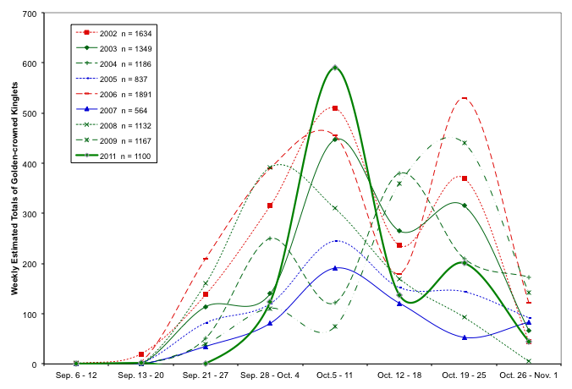

Fig.8. Migration phenology of Golden-crowned Kinglets in 2011 and in 2002 – 2009 (weekly average of Estimated Total).

Hermit Thrushes were also captured in significant numbers in the first 2 weeks of October. A record-breaking 75 Hermit Thrushes were banded during this period, more than usually banded in a season! On October 10, after 2 days of extremely strong south wind and warm temperatures, it was finally calm though still warm. In 6 hours of banding, a record of 30 Hermit Thrushes was banded! Good numbers of thrushes were also banded during the following days. From October 10 to 12, 54 Hermit Thrushes were banded, more thrushes in 3 days than the seasonal total of all previous years (except for 2006, where 57 Hermit Thrushes were banded, the previous highest fall total). Many thrushes were recaptured during this period as well (see Recaptures below).

The remaining 2 weeks of October were characterized by highly variable weather conditions, with 7 days of strong wind and/or rain. Consequently, the proportion of mist net hours lost (46%) is relatively high, below average from previous years. Golden-crowned Kinglets were still the most captured birds during the last 2 weeks of October, although in smaller numbers, accounting for 26% of the 252 birds captured during this period. Captures of all species were concentrated in only 4 days (October 18, 21, 22, and 23), with 63% of the 2-week total. More than 75% of these captures were of only 4 species: Golden-crowned Kinglets (55 birds, or 35%), Slate-colored Juncos (37 birds; 23%), Black-capped Chickadees (19 birds; 12%), and Hermit Thrushes (10 birds; 6%).

Starting on October 21, American Tree Sparrows were caught every day (except on October 24, when rain and wind precluded banding), albeit in small numbers most of the time. The biggest captures were of 9, on October 28, and 7 on October 21, a far cry from last fall’s record of 41 birds banded in a day. The season total of 29 is nonetheless the third highest after 2004 and 2010 (and tied with 2007).

In October 5 species of warblers were observed: a young male Black-throated Blue Warbler was captured on October 5. Though this species migrates mostly in late August and early September, it is not unusual to see it later in the season: Black-throated Blue Warblers have been detected in October in 5 years at Cabot Head, with the latest date on October 25 in 2008. A few Nashville Warblers were also detected this fall in October, mostly early in the month. It is a species of warbler detected every single year in October, with the last individual this year on October 23, almost as the late as the record of October 28 in 2004. On the opposite, the Palm Warbler was barely seen this October, with the last bird on the 3rd, when it is usually seen up to mid-October.

A late-fall migrant warbler, the Orange-crowned Warbler, was not observed often this fall: detected on only 10 days (from September 14 to October 18), with a low of 5 captured. A more common species, Myrtle Warbler, which also regularly migrates in October, was detected almost daily, and in higher numbers: DTs were regularly between 10 and 20 with a high of 50 on October 10. However, numbers dropped markedly after mid-October, with the last Myrtle Warbler observed on October 26.

Contrary to previous falls, only one (one!) Snow Bunting was detected this year, on October 28. No flocks of this very visible species were seen at Cabot Head this fall. Likewise, no Northern Shrikes were detected making 2011 the second ever fall (with 2006) when this species was missed. Another species – for the first time in fall - missed was the Bufflehead. Usually, it is detected from mid-October onward. On the other hand, a Black Scoter was seen on Wingfield Basin from October 21 to 31, certainly the same individual. Previously, this species had been detected only in 2002 and 2008. Likewise, one Surf Scoter was also seen on Wingfield Basin, almost daily from October 16 to 31. Interestingly, a lone White-winged Scoter, as well as a Long-tailed Duck, was also seen on the basin: it is very infrequent to see these “sea ducks” on such a small body of water, and, in the case of the first 2 species, for such an extended period of time.

Case study: A tale of Eagles and Cormorants.

Since 2009, Bald Eagles have dramatically increased in (apparent) numbers and in length of presence in the fall at Cabot Head. Between 2002 and 2008, it was rare to see a Bald Eagle in August and September: with some exceptions, there were observations in less than 10% of the days with monitoring (Fig.A). In the last 3 years, however, Eagles have been detected much more frequently during these months (between 33 and 81%, a remarkable increase). At the same time, numbers of Bald Eagles seen have increased as well. It is not always possible to distinguish individuals in different days, especially adults, but the increase of days when 2, 3, or more Bald Eagles are observed is particularly striking (Fig.B). Possibility of local breeders was suspected early, especially with observations of courtship behaviour in spring, but it is only in the fall of 2010 that a nest was found and only this fall that breeding was confirmed (with one eaglet taking its first flight on a windless, overcast day, on August 21). The constant presence of Bald Eagles at and around Cabot Head has certainly introduced subtle changes in the dynamics of nature, some visible, some harder to detect. This species was seen preying on cormorants twice in the spring, with several more unsuccessful attacks. Bald Eagles are definitively recognized as predator by Double-crested Cormorants, and even Gulls, as these species take flight from their roosting rocks in Wingfield Basin every time an Eagle fly close by. So much so that very often Bald Eagles are detected because the Cormorants that were drying their wings on the rocks are suddenly all swimming in a tight formation on the basin! Except for a few flocks seen flying through, the vast majority of Cormorants detected at Cabot Head are seen roosting in the basin. It appears that numbers and length of stay of cormorants are decreasing since 2008 (Fig.C): almost no cormorants are now seen after September 15, with numbers seen in the first half of September decreasing as well (especially since 2010). Other factors than the Bald Eagle presence could, of course, also affect Cormorants numbers, like food availability at Cabot Head, or breeding success in near and distant colonies. It is nonetheless quite striking that the presence of a powerful predator, the Bald Eagle, at Cabot Head has the potential to alter the roosting behaviour of a prey species, the Double-crested Cormorant.

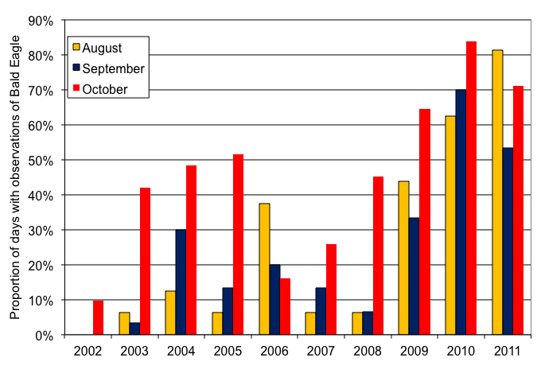

Fig.A. Proportion of days with observations of Bald Eagle at Cabot Head Research Station, in falls 2002-2011.

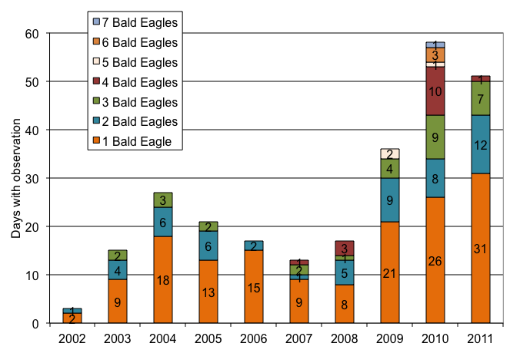

Fig.B. Days with observation of Bald Eagle and number of Bald Eagles observed at Cabot Head Research Station, in falls 2002-2011.

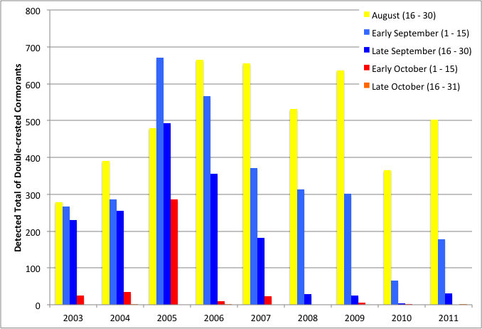

Fig.C. Detected Totals of Double-crested Cormorants in relation to season and year at Cabot Head Research Station, in falls 2003-2011.

# 3.0 Unusual Records

A new species was added to the area checklist, confirming again the unofficial motto that “the unexpected is always to be expected at a migration station”: 5 Ruddy Turnstones were seen taking off from Cabot Head shore and flying fast over Georgian Bay. The area, with almost no mudflats, does not provide good habitats for shorebirds. Very few species of this group are thus seen at the station.

Some interesting birds banded this fall were: The second-ever Yellow-breasted Chat (a young like the one in 2009) was banded on September 24; 2 White-winged Crossbills were banded on the last day, October 31, the second time only as well for this species (a flock of 22 were banded in 2008); other rarely caught species were: 2 American Woodcocks (on the same day!), the second time ever; 2 Scarlet Tanagers (third time in the fall); one Belted Kingfisher (5th time). Even though captured every fall (except in 2002), the 5 Sharp-shinned Hawks banded this fall represent the highest total ever: this species is much more abundant in the spring, when the Bruce Peninsula acts like a giant funnel to northbound migrants. In the fall, the extensive Georgian Bay is a watery barrier to this thermal-loving bird of prey and very few individuals move through the peninsula. Although nocturnal, Northern Saw-whet Owls are captured relatively often in daytime (usually just after dawn). This fall, 2 birds were captured, the most unusual being a young in juvenile plumage in August 27. On October 22, a young female Pileated Woodpecker was banded. This species is a common resident at Cabot Head but its large size prevents easy capture, as birds can relatively easily escape from the nets. Thus, only a total of 9 Pileated Woodpeckers (3 in spring and 6 in fall) have been banded since 2002.Strangely, no Hairy Woodpeckers were banded this fall, the first time since 2002 that this species was not captured.

Other noteworthy observations are: 2 Semipalmated Sandpipers were heard and seen on August 18; on the evening of August 29, 5 Common Nighthawks were seen flying above the station, a rare sight of a declining species; an Osprey was seen on August 21, the 4th fall only that this species is detected; observed slightly more, one American Green-winged Teal was observed on September 24; a Yellow-billed Cuckoo was seen on September 24 and 26, certainly the same individual; Peregrine Falcons were seen only 2 times this fall, in September 28 and October 10; for the 3rd time only in the fall, a Vesper Sparrow was observed feeding on the road during census on October 1; White-breasted Nuthatches were heard on 3 occasions on October 4, 6, and 10; a young Red-headed Woodpecker was seen briefly hawking from insects right in front of the station (October 18); a young Red-bellied Woodpecker was seen on October 23; 5 American Widgeons were seen flying far over Georgian Bay on October 24, the first time this species was observed in fall! Northern Cardinals were detected only twice (October 25 and 30); three Evening Grosbeaks were heard, then seen, flying high on October 27; a single Common Redpoll was detected amidst a small flock of American Goldfinches on the last day of monitoring, October 31; finally, several small flocks of White-winged Crossbills (up to 50 birds) were easily heard and seen during the last 10 days of October. A single individual was seen first on August 26: a scout for this notoriously nomadic species?

No Northern Goshawks were detected during the monitoring period, but 3 individuals (one adult and 2 young) were seen soaring together on afternoon in October over Cabot Head.

# 4.0 Banding Data Analysis

Banding totals for fall 2011 represent a well above average year, being the fourth-highest total ever (Table 2). For the 26 species with more than 15 individuals captured, 15 species have banding totals above average and 11 have banding totals below average, although 7 species are very close to the average (Fig.9). Only 3 species, Hermit Thrush, Pine Siskin, and Purple Finchhave the highest banding total ever this fall. On the opposite, no species has the lowest banding total. Numerous variables could affect the capture rates: population dynamics, weather conditions during migration, food availability and vegetation changes at the site. As a consequence, daily captures are highly variable (Fig.10)

After a small irruption in fall 2003 and an intensive one in fall 2005, Black-capped Chickadees were caught in intermediate numbers this fall, with 94 individuals banded. Important yearly variations in numbers of Chickadees banded make comparison between years delicate. However, the highest number caught was in 2005, which was also a rather exceptional year for other species as well (see Menu, 2005). As a consequence, for better comparisons between years, banding totals are now presented with fall 2005 separated from the years 2002-2008.

A total of 24 species of warblers were banded, including the second ever Yellow-breasted Chat in the fall. Of the 10 species of warblers with more than 15 birds banded this fall, most are within range of the variation observed between seasons. No species have either the highest or lowest totals this fall. Because numbers of warblers banded are generally small, they are difficult to interpret: any stochastic events, in relation to weather, food availability, breeding success – either local or regional – could easily influence their numbers up or down. For example, Black-throated Green Warblers have highly variable banding totals between years, from high numbers in the period 2002-2004 (with 81 to 116 birds banded) to low numbers between 2006 and 2009 (with as little as 15 birds banded). This year, with 75 individuals banded, it seems that numbers are going back up again (Fig.11). It would be interesting to see if the trend continues over the years. As noted before, the migration of Black-throated Green Warbler peaks from late August to mid-September, the first 10 days of September being particularly important. Weather conditions during this period could be critical in numbers caught and detected. This year, weather was ideal for net coverage in these 10 days but only 10 Black-throated Green warblers were banded (13% of the season total) whereas in the last 10 days of August, more than 50% of the total were captured (39 birds). Except in 2005, Nashville Warbler is always captured in low numbers (i.e. less than 50 individuals), which is quite striking considering that this species it the most abundant breeding bird of the province! Its population is estimated at 15 million birds in Ontario (Ontario Breeding Bird Atlas, 2011).

Table 2. Monthly capture rates, fall 2011.

|  |  |  |  |
| --- | --- | --- | --- |
| **Month** | **Birds Banded** | **Net Hour** | **Captures/**  **Net Hour** |
| August | 376 | 1230.75 | 0.30 |
| September | 525 | 2347 | 0.22 |
| October | 818 | 1698.5 | 0.48 |
| Total | 1719 | 5276.25 | 0.32 |

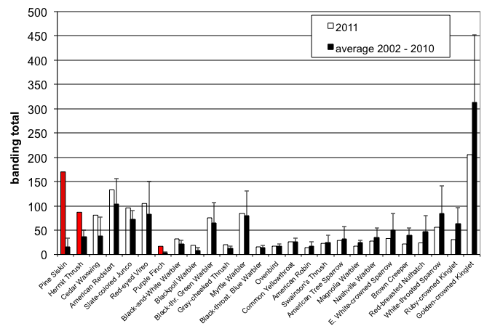

Fig.9. Banding total of the most common captured species (at least 15 individuals) compared to average total of 2002-2010. Species with higher than average total are on the left side (and highest total in red) and with lower than average total on the right.

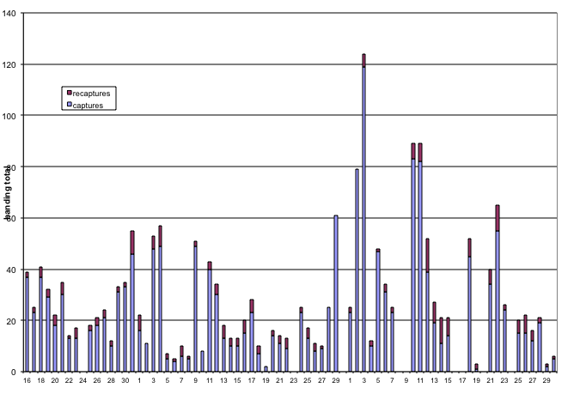

Fig.10. Daily banding and recapture total at Cabot Head Research Station, fall 2011.

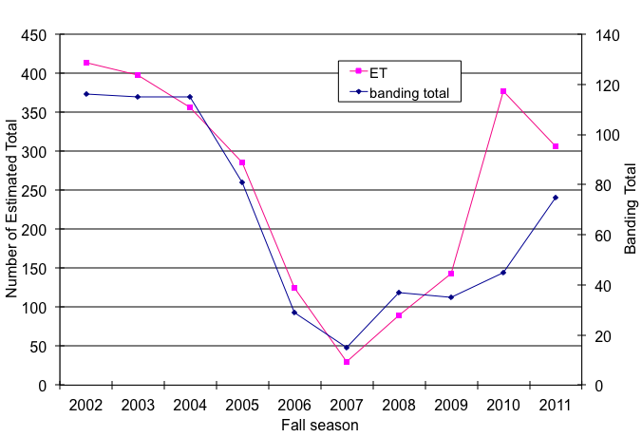Fig.11: Banding and Estimated Totals of Black-throated Green Warblers in fall seasons 2002 to 2011 at Cabot Head Research Station.

This fall only 22 Brown Creepers were banded, the second lowest total after 2009 (when only 19 Creepers were banded). This species shows important variation in the numbers of individuals captured, with a high of 65 birds in 2010. Interestingly, most of the detected Brown Creepers come from banding: more birds were observed than banded in only 3 years (2002, 2003, and 2006). This species is indeed very cryptic, with high-pitched songs and calls and a well-camouflaged plumage. It can easily be overlooked, which makes estimating its abundance quite difficult (Fig.12).

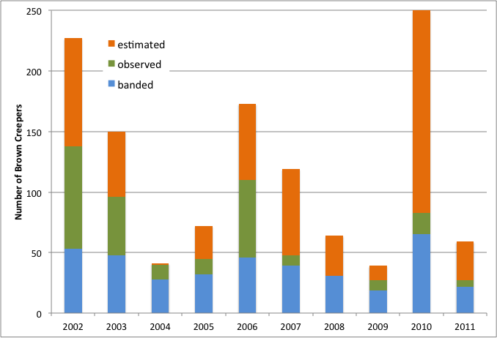Fig.12. Brown Creepers monitored at Cabot Head Research Station in fall, in relation to year and monitoring method.

As in the previous fall seasons, about 50% of the banding total is made up of only 5 species (Fig.13). This “top 5” species assemblage is quite different from year to year except for Golden-crowned Kinglet: this species has been in the “top 5” every year but one, 2005. In proportion, it is also the first (in 6 years) or second (the remaining 2 years) species, comprising between 10 to 32% of the banding total. This fall, a relatively low 12% of birds banded were Golden-crowned Kinglets. The second most abundant species was the Pine Siskin, representing a surprising 10% of the banding total. A brief but numerous movement of this species throughout Cabot Head in early October resulted in the chance capture of many of them. American Redstarts and Red-eyed Vireos were banded in high numbers this fall, their third and fourth highest total, respectively. As was the case for the last 6 years, Slate-colored Juncos were among the “top 5”. This species is a local breeder on the tip of the Bruce Peninsula but the core of its breeding grounds in Ontario is in the northern part of the Hudson Bay Lowlands. Some Juncos were detected this fall in August and early September but most individuals arrived in October, with a good proportion in the last 10 days.

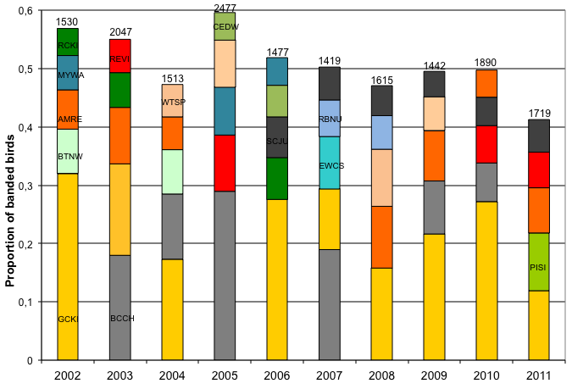

Fig19. Proportion of banding totals for the first 5 species at Cabot Head Research Station across the years 2002 – 2011. (numbers on top of bars are banding totals; species are colour-coded)

Capture rates varied greatly on a monthly, and even weekly, basis (Table 2 & Fig.14). The capture rate is determined by dividing the number of birds caught in a net, or a group of nets, by the number of hours for which the net or nets were operated. Thus, variation in capture rate reflects variation in those two parameters, which are themselves dependent upon various conditions (weather being the major one). Mist net hours can be lost when weather conditions (i.e. rain or strong wind) or the presence of a predator pose a threat to the birds, forcing us to close nets.

In comparison to previous falls, weekly capture rates this fall were highly variable with strong departure from average for 3 weeks: the capture rates were at a record high for the first week of monitoring in August and between September 27 and October 3 (Fig.14). Interestingly, this latter week followed a week with the lowest ever capture rate. Between September 27 and October 3, it was the highest number of banded birds ever with 316 birds (Fig.15). Weekly variations in mist net hours are usually important but variable among years (Fig.16). Whereas an average of 28% (range 14% - 46%) of the potential mist net hours (90 hours per day) were lost in the previous falls, it was only 24% in fall 2011, achieving an excellent overall coverage. However, coverage, as usual, was very variable throughout the season. Mist net hours realized were at or above average from beginning to the end of September (with the first 2 weeks of September achieving almost 100%!). More mist net hours were lost in October, reflecting poorer weather conditions. Coverage was then below average, except for the last week. However, it was within normal yearly variations.

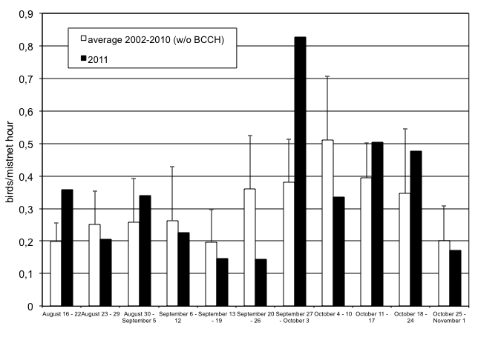Fig.14. Fall weekly capture rates at Cabot Head Research Station (without Black-capped Chickadee for average 2002-2010). Error bars show Standard Deviation.

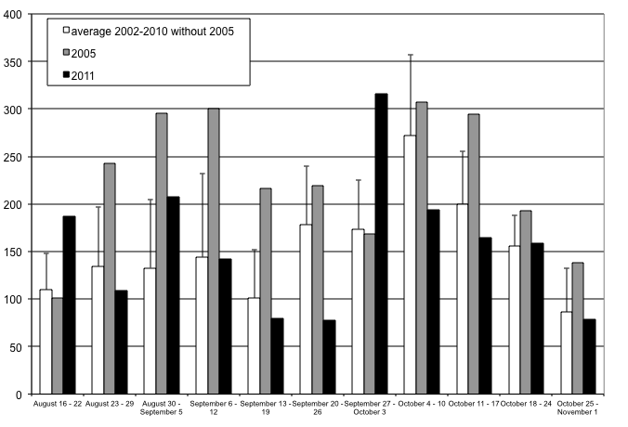Fig.15. Fall weekly number of banded birds at Cabot Head Research Station. Error bars show Standard Deviation.

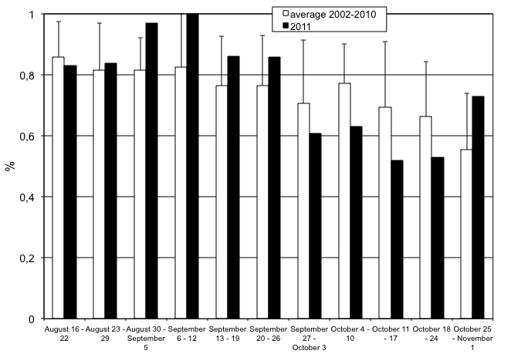Fig.16. Fall weekly proportion of realized mist net hours at Cabot Head Research Station. Error bars show Standard Deviation.

# 4.1 Weather

Weather during the fall migration monitoring in August and early September was typical of summer: generally warm and sunny. As summer wanes into fall, the weather became more variable, mostly involving windier days. Fall this year was very dry, as only 3 episodes of rain occurred between August 16 and October 12! In the remaining 19 days of monitoring, rain happened – for short or long periods – during 8 days. Banding was precluded completely for 9 days because of rain (for 5 days, often with high wind) or wind (for 4 days). The first 2 weeks of October were unseasonably warm (with a high of 26°C). It also experienced 3 consecutive days of extremely strong south wind between October 7 and 9. Afterwards, conditions were more typical of fall, with strong winds, overcast skies, and periods of rain. A powerful wind and rain storm happened on October 15: a western wind blew all day with rain, heavy at times, starting at 9:00 in the morning and lasting until the evening. Many trees got uprooted or lost branches that day. One such tree fell down on the power and telephone lines, breaking them all!

With rain, winds are a major factor that influences migration. It is difficult to accurately quantify such a dynamic component of the weather, especially because wind strength and direction are recorded only at the start and end of the count period. To characterize wind strength (on the Beaufort scale) and direction, we considered only the strongest wind during the count period of 7 hours. Undoubtedly, this method would tend to over-represent strong winds. However, strong winds affect migration tremendously and their effect could probably be felt before they developed into full windstorm. This fall, strong winds (at least 5 on the Beaufort scale) occurred relatively often (35% of the season) and were mostly from North or West. There were marked differences throughout the season in wind strength and direction: for example, there was almost no period of light winds in October (Fig.17). East winds were the least common throughout the season, occurring about 10% of the time.

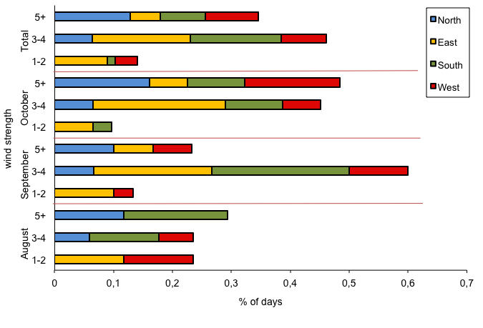Fig.17. Wind pattern (strength on the Beaufort scale, direction and proportion of time) at Cabot Head Research Station, fall 2011.

# 4.2 Recaptures

The rate of recapture at Cabot Head was relatively high in fall 2011: A total of 246 recaptures for 159 individuals of 32 species were recaptured from August 16 to October 31 (Table 3). The vast majority of recaptures (147 i.e. 92%) came from birds banded this fall, which represent only 8.5% of birds banded during the season. There were also a few recaptures from the previous banding done at Cabot Head: A Red-eyed Vireo banded as a second-year previously in spring of 2011 was recaptured on September 1. A Black-throated Green Warbler banded as a second-year female in spring 2009 was recaptured twice this fall. The other recaptured birds banded in a previous season were all, as expected, American Redstarts, with 9 individuals originally banded from spring 2008 to spring 2010. Surprisingly, of the 6 birds with known age at banding, all but one were females.

Most of the recaptured birds were recaptured only once (113 out of 159 individuals, 71%) or twice (15%). However, a few birds were definitively unlucky in trying to avoid our mist nets, as they were recaptured more than 4 times, including an impressive 8 times for 2 Black-capped Chickadees: originally banded on September 17 and 18, they were last recaptured on October 25 and 31.

For species with significant numbers banded (50 individuals or more), recapture rate in fall 2011 varied greatly between 5% (for Golden-crowned Kinglet) to 18 and 26% (for Hermit Thrush and Black-capped Chickadee, respectively). A few other species also have high rates of recapture: Gray-cheeked Thrush, with 24%, and Red-eyed Vireo, with 17%. Capture and recapture depend on several factors, which affect length of stay in the area and probability of capture: presence of a local breeding population, different foraging behaviour between species and individuals, variations in individual quality between- and within-season (for example, young birds in bad conditions during a year of poor reproduction could require a longer stopover in the area, regardless or not on food availability).

Despite being captured in high numbers, Golden-crowned Kinglets are always recaptured in a quite low percentage: between 5 and 11%. This fall is no exception: only 10 Kinglets of the 205 banded were recaptured, usually the following day or within a few days of banding. It shows that the vast majority of Golden-crowned Kinglets move through the area quickly, without lingering to feed or rest. All the recaptured Kinglets were recaptured only once this fall.

Swainson’s and Gray-cheeked Thrushes migrate approximately at the same time, in September. They are always captured in relatively small numbers in fall (a season average of 25 and 13 birds, respectively). This fall, 5 of the 21 banded Gray-cheeked Thrushes were recaptured but none of the 21 Swainson’s Thrushes. It is a pattern that has been occurring quite often over the last 10 years, when there are sometimes striking differences in recapture rates between these 2 species. It is unclear why. Of the 5 recaptured Gray-cheeked Thrushes, 3 gained weight (of up to 15% in 5 days) but 2 lost weight: the latter ones lost about 7% of their weight overnight! On average, gray-cheeked thrush weight was 32.0g (± 2.9). The heaviest thrush weighed 36.2g at first capture but an astonishing 40.7g 5 days later when it was last recaptured!

Every fall, between 11 and 33% of Hermit Thrushes are recaptured. This fall, the recapture rate was on the high end, at 26%, or 23 birds out of 87 thrushes. All recaptured Hermit Thrushes but 3 gained weight between original and last captures.

Table 3. Total recaptures in decreasing order by species in relation with year and season of banding (only one recapture per individual is included) at Cabot Head Research Station, fall 2011.

|  |  |  |  |  |  |  |  |  |
| --- | --- | --- | --- | --- | --- | --- | --- | --- |
| Species | 2008 | | 2009 | 2010 | | 2011 | | ?? |
| spring | fall | spring | spring | fall | spring | fall |
| American Redstart | 1 | 1 | 1 | 1 | 3 | 2 | 15 |  |
| Black-capped Chickadee |  |  |  |  |  |  | 24 |  |
| Red-eyed Vireo |  |  |  |  |  | 1 | 18 |  |
| Hermit Thrush |  |  |  |  |  |  | 16 |  |
| Golden-crowned Kinglet |  |  |  |  |  |  | 10 |  |
| Black-and-white Warbler |  |  |  |  |  |  | 6 |  |
| White-throated Sparrow |  |  |  |  |  |  | 6 |  |
| Common Yellowthroat |  |  |  |  |  |  | 5 |  |
| Gray-cheeked Thrush |  |  |  |  |  |  | 5 |  |
| Slate- coloured Junco |  |  |  |  |  |  | 5 |  |
| White-crowned Sparrow |  |  |  |  |  |  | 4 |  |
| Cedar Waxwing |  |  |  |  |  |  | 3 |  |
| Magnolia Warbler |  |  |  |  |  |  | 3 |  |
| Red-breasted Nuthatch |  |  |  |  |  |  | 3 |  |
| Ruby-crowned Kinglet |  |  |  |  |  |  | 3 |  |
| American Tree Sparrow |  |  |  |  |  |  | 2 |  |
| Brown Creeper |  |  |  |  |  |  | 2 |  |
| Black-throated Blue Warbler |  |  |  |  |  |  | 2 |  |
| Downy Woodpecker |  |  |  |  |  |  | 2 |  |
| Nashville Warbler |  |  |  |  |  |  | 2 |  |
| Ovenbird |  |  |  |  |  |  | 2 |  |
| Black-throated Green Warbler |  |  | 1 |  |  |  |  |  |
| Gray Catbird |  |  |  |  |  |  | 1 |  |
| House Wren |  |  |  |  |  |  | 1 |  |
| Myrtle Warbler |  |  |  |  |  |  | 1 |  |
| Northern Waterthrush |  |  |  |  |  |  | 1 |  |
| Orange-crowned Warbler |  |  |  |  |  |  | 1 |  |
| Pine Siskin |  |  |  |  |  |  |  | 1 |
| Purple Finch |  |  |  |  |  |  | 1 |  |
| Rose-breasted Grosbeak |  |  |  |  |  |  | 1 |  |
| Veery |  |  |  |  |  |  | 1 |  |
| Winter Wren |  |  |  |  |  |  | 1 |  |
| Total Recaptures | 1 | 1 | 3 | 1 | 7 | 8 | 147 | 1 |
| Total Species | 1 | 1 | 2 | 1 | 1 | 2 | 31 | 1 |

# 4.3 Net Analysis

Mist net locations at Cabot Head have been permanently set in place in 2002 to ensure standardized capture data. The standard net array is located primarily in forest edge assemblages although 4 nets are operating in relatively open, shrub habitat (A1-2, C14-15). Once again this fall, there was very little variation in the proportion of potential mist net hours realized for all nets, except for C13. This net is the most exposed of all, being closer to the Georgian Bay shore in an open area; it is thus relatively often affected by winds, especially northeast to northwest. All nets but C13 were open for an average of 72 to 82% of the time. C13 was open only 62% of the time. For example, throughout the season, this net was not open at all in 8 occasions, when all the other nets were in operation during the 6 hours of monitoring of these days.

As usual, there was a significant amount of variation in capture rates for each net: As in previous seasons, captures were localized in a few very productive nets (Fig. 24). Location, and thus difference in habitats, can explain variation in capture rates. However, differences in species behaviour may also account for variation. The five nets with the highest capture rate (in decreasing order, A1, B9, C15, B10, and B8) accounted for 60% of the total capture during 34% of the realized mist net hours. The least productive nets (in decreasing order, C11, C12, A5, A4, and B6) accounted for only 9% of the total capture during basically the same amount of time (33%). There are little variations between “good” and “bad” nets across the years: B8&9 have been in the “top 5” every year; similarly, C11 and A5 have always been in the “bottom 5”. A1, a nest nestled among low shrubs, almost always has the highest capture rate of all nets, showing the importance of microhabitats in banding.

This fall, 4 mist nets (A4, B6, C12&13) had the lowest ever capture rate for these nets across the years. On the other hand, C15 experienced its highest capture rate.

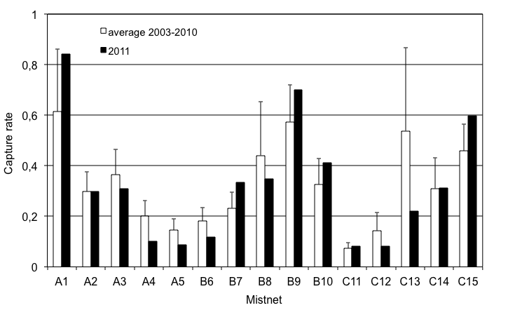Fig.18. Capture rates per mist net for average 2003-2009 and for 2011 at Cabot Head Research Station.

# 5.0 Coverage and Protocol

This fall, 24% of the possible mist netting coverage (in hours) was lost due to weather, as high wind and precipitation were significant factors in determining daily net opening and closure (Fig. 25). Fortunately, due to the density of habitat at Cabot Head, at least a portion of the nets can usually be operated on windy days. Coverage was good to excellent as there was no banding in only 9 days (out of 77 days) and the daily average for days with banding was 68 mist net hours (out of a potential of 90). Species coverage at Cabot Head is consistent with coverage elsewhere in the Great Lakes region of the CMMN (Badzinski and Francis, 2000). According to the protocol, a census was carried out every day, except during heavy rain.

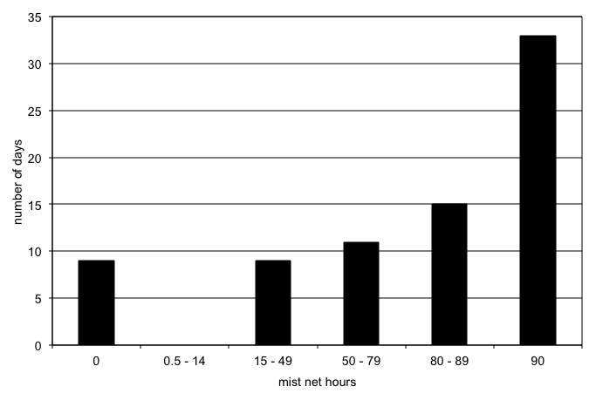

Fig.19. Coverage (in mist net hour) at Cabot Head Research Station, fall 2011.

# 6.0 Personnel

This fall,6 volunteers contributed 109 person-days to the fall migration monitoring season. Amélie Rousseau spent the first week of monitoring, rejoicing in warbler watching on her first trip back East in 12 years of living on the West Coast. Patrick Herzog, an adventure-loving German from way of Alaska, replaced her. Cabot Head was his base camp for almost 6 weeks of his year-long around-the-world trip! Erica Lagios escaped from her office job for a week of banding. In mid-September, Norlan Zambrana, our second intern from Nicaragua, arrived for a month of discovery in Canada. He got not only the chance to the monitoring station in operation, but he also exchanged with schools, birders, and visitors. He was extremely happy with his stay. And he also provided a refreshing perspective on birds: he was so excited on seeing his first Black-capped Chickadee! Finally, coming from her natal B.C., Kendal Benesh brought her enthusiasm and baking skills for the month of October! One other volunteer, Katherine St. James, provided help in 2 weekends. Volunteers greatly assured the success of the operations at Cabot Head and all help is appreciated. John Haselmeyer kindly took charge of the station for 2 days.

# 7.0 Conclusion

This fall marks the 10th consecutive year of migration monitoring at Cabot Head. It is a major milestone, as a 10-year period is considered the minimum timeframe to start exploring population trends. With 10 years of monitoring, we have now a better understanding of how bird migration unravels on the northern reaches of the Bruce Peninsula. BBPO work has created a huge database, providing a unique window of a magnificent and still mysterious phenomenon. Patterns are starting to appear: For example, we now know that the Northern Parula, a small wood warbler which frequents the higher canopy of wet forest habitats, is a very rare fall migrant at Cabot Head, even though it was found breeding in the northern Bruce Peninsula. It was not seen this fall and previously detected only in 5 falls, always only one individual (except in 2003 with 3 birds). It is also extremely rare in spring, as the highest total was of only 6 birds in 2003 and 2008. On the other hand, the story of the Bald Eagle is one of increasing observations, leading to the discovery of a breeding pair at Cabot Head on 2010. This year, we documented the fledgling of one young. The constant presence of Bald Eagles around Cabot Head has introduced subtle changes in the dynamics of nature, as exemplified by a reduction of roosting cormorants in Wingfield Basin. It is a change that would not have been apparent without long-term monitoring.

Bird migration always brings continuity and surprises. Beyond numbers (of species detected, of individuals counted, of birds banded), I certainly always get enthralled by the sheer spectacle of birds moving across landscapes, across the emptiness of the night sky, bridging continents with their travels, connecting disparate places of the Earth. Holding a Gray-cheeked Thrush in my hand is to behold a living link between the farthest, harsh, reaches of the boreal forest and the hot, humid tropical forests of the Andean foothills. It is to slowly realize the strengths and skills of life, its tenacity and resilience.

Simply said, migration monitoring at Cabot Head has given me the privilege to combine scientific studies and an intense poetic immersion in nature. I was able, hopefully, to share my sense of awe to volunteers, visitors, and groups coming to this special place.

# Acknowledgements

As a non-profit, volunteer-based initiative, the Bruce Peninsula Bird Observatory would not be operable without the overwhelming support of its membership, financial supporters and volunteers. BPBO wishes to thank Ontario Parks, especially Park Warden Bob Lesperance, for their generous on-site management assistance.

The author wishes to thank all the members of the Bruce Peninsula Bird Observatory, as well as Ontario Parks for their support during the field season. A special thank is due to Ron Baker and Bob Lesperance as they always graciously helped me in so many and various ways. I would also like to commend the 6 volunteers who helped make the field season efficient and enjoyable.

# Literature Cited

Badzinski, D.S. and C.M. Francis. 2000. An evaluation of species coverage by the Canadian Migration Monitoring Network. Unpublished report by Bird Studies Canada.

Cadman, M.D., D.A. Sutherland, G.G. Beck, D. Lepage, and A.R. Couturier (eds.). 2007. Atlas of the Breeding Birds of Ontario, 2001-2005. Bird Studies Canada, Environment Canada, Ontario Field Ornithologists, Ontario Ministry of Natural Resources, and Ontario Nature, Toronto, xxii + 706pp.

Cheskey, E.D. and W.G. Wilson. 2001. Cabot Head Important Bird Area Conservation Plan. Can. Nature Fed., Bird Studies Canada., Fed. of Ont. Naturalists. 32 pp.

Derbyshire, D. G. December, 2002. Migration Monitoring at Cabot Head, Fall 2002. Unpublished report for Bruce Peninsula Bird Observatory

Heagy, A., E.D. Cheskey, and D. G. Derbyshire. March 2003. Migration Monitoring at Cabot Head Research Station, Cabot Head, Ontario: Recommended Protocol for Monitoring Small Landbirds.

Heagy, Audrey. January 2002. Landbird Migration Monitoring at Cabot Head, Ontario, 2001. Unpublished report by Bruce Peninsula Bird Observatory.

Menu, S. November 2003 to 2010. Migration Monitoring at Cabot Head, Fall 2003 to 2010.Unpublished report for Bruce Peninsula Bird Observatory

# 

# Appendix I. Fall banding totals 2002-2011.

|  |  |  |  |  |  |  |  |  |  |  |
| --- | --- | --- | --- | --- | --- | --- | --- | --- | --- | --- |
| Species | 2002 | 2003 | 2004 | 2005 | 2006 | 2007 | 2008 | 2009 | 2010 | 2011 |
| American Woodcock |  |  |  |  |  |  |  | 1 |  | 2 |
| Sharp shinned Hawk |  | 2 | 2 | 3 | 3 | 3 | 2 | 1 | 3 | 5 |
| Cooper's Hawk | 1 |  |  |  |  |  |  |  |  |  |
| Merlin |  |  | 1 |  |  | 1 |  |  |  |  |
| Yellow-billed Cuckoo | 2 | 2 |  | 1 |  | 2 | 2 |  | 1 |  |
| Black-billed Cuckoo | 2 | 5 |  |  |  |  |  |  |  |  |
| Northern Saw-whet Owl | 1 |  |  |  | 1 | 1 | 1 | 1 |  | 2 |
| Belted Kingfisher | 1 | 1 | 2 |  | 1 |  |  |  |  | 1 |
| Red bellied Woodpecker |  | 1 | 1 |  |  |  |  |  | 1 |  |
| Yellow bellied Sapsucker |  | 1 |  | 1 | 1 | 2 |  |  | 1 | 3 |
| Downy Woodpecker | 1 | 12 | 4 | 3 | 6 | 7 | 4 | 31 | 13 | 4 |
| Hairy Woodpecker |  | 5 | 5 | 2 | 4 | 11 | 8 | 8 | 6 |  |
| Black-backed Woodpecker |  |  |  |  | 1 |  |  |  |  |  |
| Yellow-shafted Flicker |  | 3 | 2 | 1 | 6 | 2 | 3 | 4 | 6 | 4 |
| Pileated Woodpecker | 1 |  |  |  | 1 | 1 | 1 |  | 1 | 1 |
| Eastern Wood-Pewee |  |  |  |  |  |  |  | 1 |  |  |
| Yellow-bellied Flycatcher | 3 | 1 | 1 |  |  | 3 | 1 | 3 | 2 | 2 |
| Traill's Flycatcher | 3 | 5 | 3 | 6 | 6 | 16 | 5 | 7 | 12 | 1 |
| Least Flycatcher | 3 | 5 | 5 | 7 | 3 | 6 | 4 | 3 | 9 | 6 |
| Olive-sided Flycatcher |  |  |  |  |  |  |  |  | 1 |  |
| Eastern Phoebe | 4 | 1 |  |  | 3 | 2 | 4 | 1 | 1 |  |
| Great Crested Flycatcher |  |  |  |  |  | 1 | 1 |  | 1 |  |
| Eastern Kingbird | 1 |  |  |  |  |  |  |  |  |  |
| Northern Shrike | 2 | 1 | 3 | 1 |  | 2 |  |  |  |  |
| Blue-headed Vireo | 1 | 3 | 4 | 11 | 8 | 1 | 8 | 3 | 9 | 7 |
| Philadelphia Vireo |  | 1 |  | 2 |  | 1 |  | 2 | 1 | 4 |
| Red-eyed Vireo | 51 | 117 | 31 | 239 | 52 | 49 | 66 | 24 | 121 | 105 |
| Blue Jay | 3 | 4 | 3 | 6 |  | 1 | 4 | 2 | 3 | 4 |
| Black-capped Chickadee | 29 | 368 | 169 | 717 | 12 | 269 | 47 | 131 | 125 | 94 |
| Red-breasted Nuthatch | 5 | 26 | 62 | 73 | 17 | 89 | 93 | 22 | 37 | 24 |
| White-breasted Nuthatch |  |  |  | 1 |  | 2 |  |  |  |  |
| Brown Creeper | 53 | 48 | 28 | 32 | 46 | 39 | 31 | 19 | 65 | 22 |
| House Wren |  | 2 | 1 |  |  |  | 1 | 2 | 1 | 1 |
| Winter Wren | 3 | 1 | 5 | 4 | 4 | 8 | 8 | 6 | 2 | 6 |
| Golden-crowned Kinglet | 490 | 321 | 262 | 113 | 407 | 148 | 255 | 312 | 514 | 205 |
| Ruby-crowned Kinglet | 71 | 122 | 62 | 20 | 106 | 40 | 63 | 48 | 41 | 31 |
| Blue-gray Gnatcatcher | 1 |  |  |  |  |  |  |  |  |  |
| Veery |  |  | 3 | 5 | 3 | 6 | 4 | 2 | 1 | 2 |
| Gray-cheeked Thrush | 19 | 16 | 12 | 22 | 9 | 12 | 8 | 9 | 6 | 21 |
| Swainson's Thrush | 11 | 38 | 16 | 36 | 10 | 18 | 15 | 50 | 34 | 23 |
| Hermit Thrush | 16 | 34 | 24 | 48 | 57 | 28 | 39 | 32 | 49 | 87 |
| Wood Thrush |  |  |  | 2 | 1 | 1 |  |  |  |  |
| American Robin | 11 | 19 | 16 | 10 | 36 | 1 | 21 | 20 | 17 | 15 |
| Gray Catbird | 10 | 7 | 7 | 12 | 7 | 5 | 2 | 5 | 2 | 4 |
| Brown Thrasher | 1 |  |  |  |  |  |  |  |  |  |
| American Pipit | 1 |  | 1 |  |  |  |  |  |  |  |
| Cedar Waxwing | 43 | 10 | 16 | 117 | 80 | 2 | 45 | 4 | 26 | 81 |
| Blue-w.x Golden-w.Warbler | 1 |  |  |  |  |  |  |  |  |  |
| Golden-winged Warbler |  |  | 1 |  |  |  |  |  |  |  |
| Tennessee Warbler | 3 | 8 | 38 | 44 | 5 |  |  | 2 | 6 | 4 |
| Orange-crowned Warbler | 10 | 23 | 9 | 3 | 23 | 23 | 4 | 6 | 15 | 5 |
| Nashville Warbler | 41 | 48 | 24 | 78 | 32 | 37 | 22 | 21 | 19 | 27 |
| Northern Parula |  |  |  | 1 |  |  | 1 |  |  |  |
| Yellow Warbler | 6 | 13 | 3 | 4 | 4 | 1 | 1 | 2 | 3 | 8 |
| Chestnut-sided Warbler | 5 | 2 |  | 1 | 3 | 3 | 1 | 1 | 1 | 1 |
| Magnolia Warbler | 17 | 29 | 25 | 34 | 20 | 21 | 20 | 25 | 26 | 18 |
| Cape May Warbler |  | 3 | 1 | 1 |  | 3 | 2 | 1 |  | 1 |
| Black-throat. Blue Warbler | 21 | 18 | 14 | 7 | 14 | 11 | 18 | 18 | 13 | 16 |
| Myrtle Warbler | 90 | 92 | 34 | 204 | 70 | 50 | 59 | 54 | 70 | 84 |
| Black-thr. Green Warbler | 116 | 115 | 115 | 81 | 29 | 15 | 37 | 35 | 45 | 75 |
| Blackburnian Warbler | 5 | 3 | 3 | 10 |  | 5 |  |  | 3 | 2 |
| Pine Warbler | 2 |  | 2 |  |  |  | 2 |  | 1 | 3 |
| Western Palm Warbler | 6 | 10 | 1 | 10 | 18 | 8 | 2 | 3 | 7 | 6 |
| Bay-breasted Warbler |  | 2 |  | 6 | 2 | 5 | 5 | 1 | 7 | 5 |
| Blackpoll Warbler | 6 | 6 | 7 | 23 | 5 | 7 | 6 | 10 | 8 | 19 |
| Black-and-White Warbler | 26 | 30 | 17 | 15 | 12 | 12 | 25 | 33 | 21 | 32 |
| American Redstart | 103 | 198 | 85 | 65 | 66 | 44 | 171 | 124 | 82 | 133 |
| Ovenbird | 10 | 16 | 16 | 24 | 17 | 10 | 16 | 25 | 19 | 18 |
| Northern Waterthrush | 11 | 4 | 4 | 1 | 7 | 4 | 8 | 7 | 15 | 11 |
| Connecticut Warbler |  | 1 |  | 1 |  |  |  |  |  |  |
| Mourning Warbler | 1 |  |  | 2 | 3 | 3 | 2 | 4 | 3 | 2 |
| Common Yellowthroat | 17 | 35 | 31 | 23 | 26 | 18 | 17 | 25 | 39 | 26 |
| Hooded Warbler |  |  |  |  |  |  |  |  | 1 |  |
| Wilson's Warbler | 5 | 4 | 2 | 10 | 4 | 11 | 9 | 12 | 9 | 8 |
| Canada Warbler | 7 | 4 | 1 | 4 | 1 | 3 | 5 | 3 | 7 | 2 |
| Yellow-breasted Chat |  |  |  |  |  |  |  | 1 |  | 1 |
| Scarlet Tanager | 1 |  |  | 2 |  |  |  |  |  |  |
| American Tree Sparrow | 10 | 19 | 56 | 12 | 18 | 29 | 28 | 27 | 88 | 29 |
| Chipping Sparrow | 3 | 1 | 6 | 6 | 1 | 4 |  | 1 | 2 | 1 |
| Clay-colored Sparrow |  | 1 |  |  |  |  |  |  |  |  |
| Savannah Sparrow | 1 | 3 | 1 | 2 | 2 | 8 |  |  | 4 |  |
| Fox Sparrow |  | 1 | 3 | 2 | 2 | 1 | 3 | 5 | 2 | 5 |
| Song Sparrow | 20 | 17 | 10 | 10 | 15 | 13 | 22 | 20 | 18 | 12 |
| Lincoln's Sparrow | 9 | 2 | 4 | 7 | 8 | 9 | 4 |  | 13 | 5 |
| Swamp Sparrow | 4 | 11 | 7 | 2 | 4 | 2 | 5 | 4 | 4 | 5 |
| White-throated Sparrow | 49 | 42 | 84 | 199 | 43 | 39 | 158 | 84 | 58 | 56 |
| E. White-crowned Sparrow | 29 | 22 | 79 | 26 | 19 | 127 | 53 | 56 | 41 | 33 |
| Slate-colored Junco | 43 | 65 | 63 | 56 | 103 | 80 | 83 | 63 | 92 | 96 |
| Eastern Towhee |  |  |  |  |  |  | 1 | 1 |  |  |
| Snow Bunting |  |  |  |  | 1 |  |  |  | 3 |  |
| Northern Cardinal | 1 | 3 | 1 | 1 |  | 1 | 1 | 2 | 1 | 1 |
| Rose-breasted Grosbeak | 1 | 6 |  |  |  | 2 | 1 |  |  | 8 |
| Indigo Bunting |  | 5 | 5 | 1 | 1 |  | 5 |  | 1 |  |
| Summer Tanager |  |  | 1 |  |  |  |  |  |  |  |
| Scarlet Tanager |  |  |  | 1 |  |  |  |  | 1 | 2 |
| Rusty Blackbird |  |  |  |  |  | 1 |  |  |  |  |
| Baltimore Oriole |  | 1 |  |  |  |  | 1 |  |  |  |
| Pine Grosbeak |  |  |  | 2 |  | 5 |  |  |  |  |
| Purple Finch | 2 | 3 | 5 | 2 | 2 | 3 | 4 | 7 | 2 | 17 |
| White-winged Crossbill |  |  |  |  |  |  | 22 |  |  | 2 |
| Pine Siskin |  |  | 4 |  |  | 3 | 44 | 5 | 22 | 170 |
| American Goldfinch | 3 |  |  |  | 6 | 1 | 1 |  | 1 | 3 |
| Common Redpoll |  |  |  |  |  | 6 |  |  | 5 |  |
| Total | 1530 | 2047 | 1513 | 2477 | 1477 | 1419 | 1615 | 1442 | 1890 | 1719 |
| Species Total | 68 | 68 | 65 | 67 | 62 | 74 | 68 | 63 | 73 | 69 |

Record **high** for fall 2011: species name highlighted in red

Data: for 2002: Derbyshire, 2002; for 2003 to 2009: Menu, 2003 to 2010

Blue-w.x Golden-w.Warbler: Hybrid of Blue-winged and Golden-winged Warbler

Black-throat. Blue Warbler: Black-throated Blue Warbler

Black-thr. Green Warbler: Black-throated Green Warbler

E. White-cr. Sparrow: Eastern White-crowned Sparrow

# Appendix II. Detected Totals of species observed in fall from 2002 to 2011 at Cabot Head Research Station

(by alphabetical order and decreasing frequency of observation as expressed by number of years when the species was detected, starting with species observed in 2011)

