Fall 2010 Migration Monitoring Report
(from the report produced for BPBO by Station Scientist Dr. Stéphane Menu, Nov 2010)
Fall fieldwork began on August 15 and ended on October 31 for a total of 78 consecutive days of coverage. A total of 143 species of birds were detected in the standard count area over the course of the field season. Among them, 89 species have been seen every fall. In total 1,442 birds of 73 species were banded and 204 birds of 32 species were recaptured. Recapture data indicate that stopover rates at Cabot Head are generally low but highly variable depending on species and year. It appears that some species could extensively use Cabot Head as a stopover habitat, to rest and refuel, principally in years of local high food availability (like chokecherry or cone seeds). Analysis of capture rate per net location indicates a large degree of variation associated with habitat characteristics and species behaviour.

Month | Birds Banded | Net Hour | Captures/  Net Hour
August | 276 | 1207.5 | 0.23
September | 828 | 1987.5 | 0.42
October | 768 | 2305.75 | 0.33
Total | 1890 | 5500.75 | 0.34

Fig. 1 Monthly capture rates, fall 2010

The defining characteristic of fall migration in 2010 was a good coverage, which lead to an average number of species seen this fall (range: 128 species in falls 2006 and 2008 – 157 species in fall 2002; average: 139). Most species were caught at average numbers this fall but a few were caught in record numbers, most notably Golden-crowned Kinglets. As a consequence, the banding total is above average. An Olive-sided Flycatcher was banded for the first time at Cabot Head. A new species for the area, the Boreal Chickadee, was added this fall! The highest one-day species total was 47, recorded on September 2.
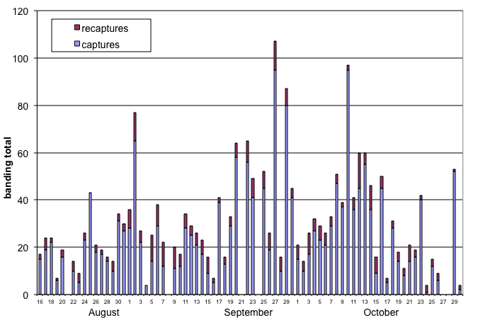
Fig. 2 Daily banding and recapture total at Cabot Head Research Station, fall 2010
The 9th consecutive fall migration monitoring (following a research protocol established in 2002) at Cabot Head brought continuity and surprises, as migration always does! Weather, despite some days with strong wind and/or rain, was particularly clement this fall, especially from late September to mid-October allowing a very good coverage. Monitoring was a success as coverage was good and complete and the data collected was of high quality. Cabot Head is an excellent location for this program as bird concentrations are significant, the facilities are ideal and there is a skilled, enthusiastic, and more and more local, base of volunteer support. Migration monitoring at Cabot Head Research Station is an ongoing project and contributes to the efforts of the Canadian Migration Monitoring Network and ultimately to the understanding and monitoring of bird populations.

